The Solar Powered Boat "RA" named after the Egyptian sun God, arrived in Newark on Friday, August 9th. The boat left New Port Richie, FL January 12, 2013 with the intent to set a Guiness record for the first true powered solar boat to circumnavigate the Great Loop. So far they have traveled over 3200 miles of the 6600 mile course.

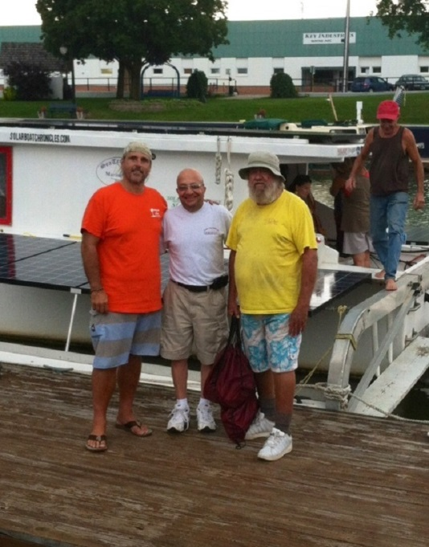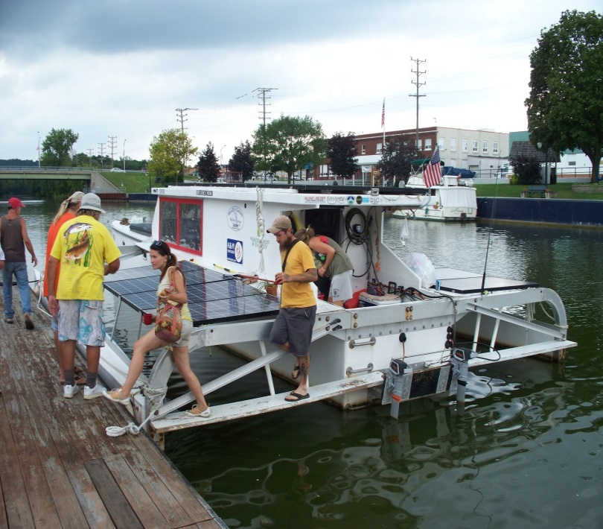
Mayor Blandino welcomes “RA” Crew members disembark at Port of Newark
Captain and crew

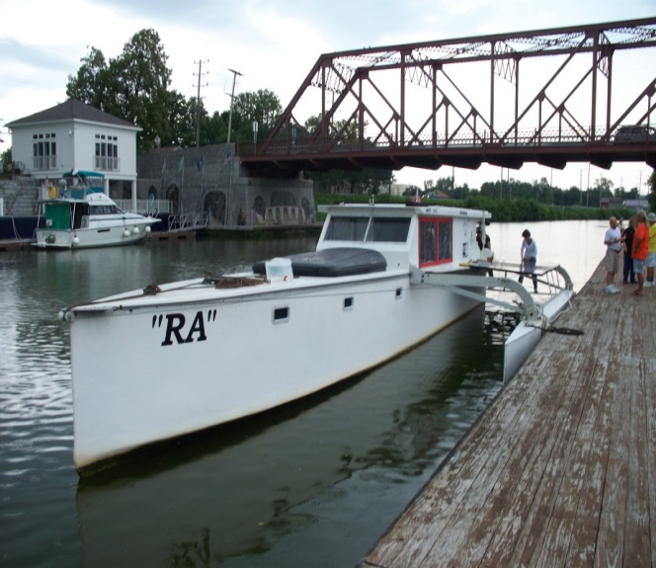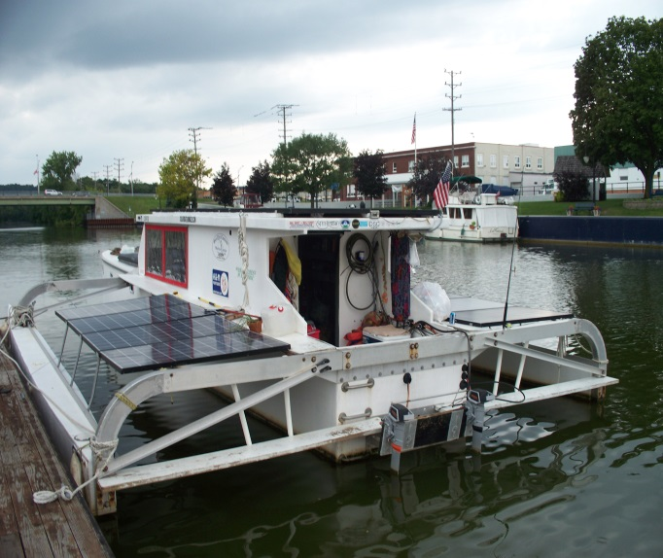
Bow of solar-powered boat “RA” Stern of solar-powered boat “RA”

