**2023 EASTERN OKLAHOMA STATE**

**SPELLING BEE**

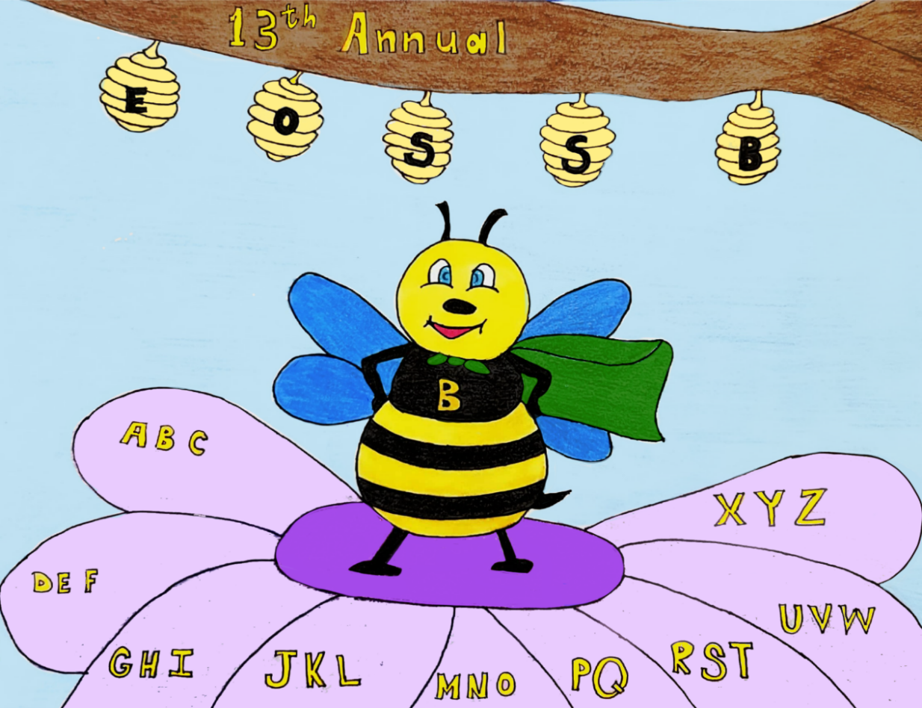

April 21, 2023

6:30 P.M.

Muskogee Civic Center

425 Boston Street

Muskogee, OK 74401

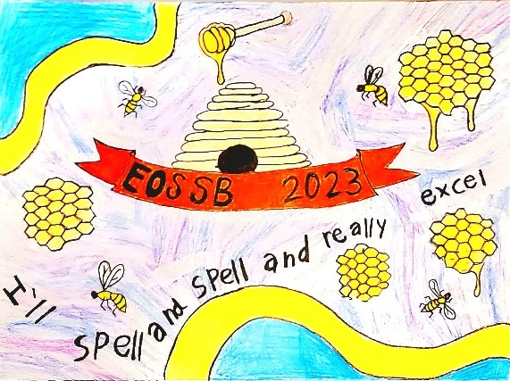

4th Place

Leah Sailors

Oklahoma School

for the Blind

Quincy Pearce

Porum Public School

Kinli Murphy

Peavine Public School

Jayne Baldridge

Keota Public School

3rd Place

2nd Place

1st Place

***Cassandra Gaines Art Winners***

**Welcome to the 12th annual Eastern Oklahoma State Spelling Bee**

The purpose of this competition is to help students improve their spelling, increase their vocabularies, learn concepts, and develop correct English usage that will help them all their lives.

**Eastern Oklahoma State Spelling Bee Procedure**

This is an oral competition conducted in rounds until only one speller remains. Each speller has been assigned a random number. There is no advantage associated with a particular high or low number.

The speller approaches the microphone when it is his or her turn to spell. A speller who correctly spells his or her word remains on stage and waits for the next round.

One of the judges will ring a bell after a speller completes the misspelling of a word. The speller is asked to leave the stage and sit with family members. Once a speller has misspelled a word, he or she should not leave the auditorium until the end of the round.

A speller may question the pronouncer about a word’s pronunciation, definition, part of speech, use in a sentence, and origin. Once having started to spell a word, the speller may start over, but the letters or sequence of letters already spoken may not be changed.

**Protest Procedure for Spelling Bees**

Any question relating to the spelling of a word should be referred to the Spelling Bee Coordinator immediately in writing, on an official protest form. This should take place before the student affected would have received their next word had they stayed in the contest.

**The judges are in complete control of the BEE.**

**Their decision shall be final regarding all questions and protests.**

**2023**

**EASTERN OKLAHOMA STATE SPELLING BEE**

**2023 Director’s Choice**

## Eastern Oklahoma State Spelling Bee

## Hosts & Hostesses

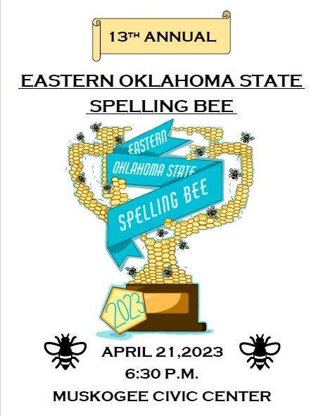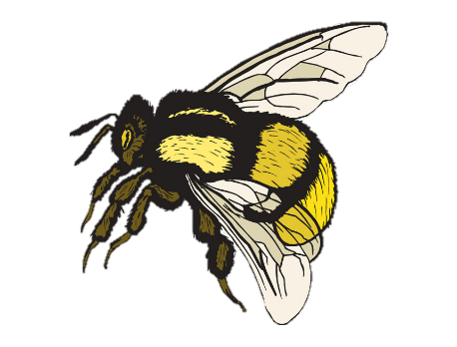

Cindy Lumpkin

Jonita Mullins

Shawna Nakedhead

Jan O’Neal

Carly Osazuwa

Brad Perez

Sharon Radekar

Cheryl Sanders

Pat Stout

Carlene Strong

Gary Thompson

Kay Turner

Jose Puentes

Caney Valley High School

Susan Hoog, Director

Alice Adair

David Bemo

Erlene Bemo

Deborah Carment

Tom Carment

Phyllis Derrick

Greta Dumas

Dee Dun

Kristi Gates

Stephanie Hunt

Donna Le

**Tonight’s event is dedicated to the memory of:**

**Gordon F. Wallace**

*EOSSB Volunteer, Friend & Donor*

2012-2021

**Thank You Volunteers!**

**Special Thanks!**

**Tom Carment**

**Marlon Coleman**

**John Cruz**

**Jonathan Francis**

**Joseph Fuller**

**Amanda Guthrie**

**Leslie Hamil**

**Dana Mims**

**QuikTrip Corporation**

**Nathan Roberts**

**Ben Robinson**

**Cheryl Sanders**

**Chelsie Sullivan**

**Darren Armstrong**

**Kassity Beatty**

**David Bemo**

**Erlene Bemo**

**Johnny Bybee**

**Mary Downing**

**Katrina Fine**

**Miriam Goodin**

**Stormi Hollingshead**

**Mike Massey**

**Sure McBride**

**Shane McDonald**

**Isabelle Munez**

**Larry Ross**

**Bailey Sexton**

**Cobey Soap**

**Gary Thomson**

**Jackie Tripp**

**David Bemo**

*Photographer*

**Samara Cain**

*Competition Video Monitor*

*Protest Monitor*

**Marlon Coleman**

*Mayor, City of Muskogee*

**John Cruz**

*GM, Muskogee Civic Center*

**DJ DEC**

*Urban Country Entertainment*

**Hunter Frazier**

*Sr., Okay High School*

*Red Carpet Emcee*

**Amanda Guthrie**

*Medal Presentations*

**Heather Newell**

*Photographer*

**Kyle Newell**

*Assistant to Director*

*Coweta High School*

*2019 EOSSB Champion*

*Metal Presentations*

***“THANK YOU”***

**EASTERN OKLAHOMA STATE SPELLING BEE JUDGES**

**Robin Adair, Pronouncer**

Muskogee County District Judge

**Samantha Cain, Judge**

Program Analyst Office of Human Capital Services

Department of Veteran Affairs

**Missy Chandler, Head Judge**

HR Manager

Chandler Pilot Car Service



**Thank You!!**

**Charlie Randolph**

*Owner, Charlie’s Chicken*

*Medal Presentations*

**Oscar Ray**

*CEO, Bare Bones Filmworks – Muskogee*

**Nathan Roberts**

*Action Imprints*

*Photographer*

**Ben Robinson**

*American Bank of Oklahoma*

*Medal Presentations*

**Alaura Stamps**

*Sr., Okay High School*

*2023 EOSSB Intern*

*2023 EOSSB Webmaster*

*Red Carpet Emcee*

**Pat Stout**

*Photographer*

**Gary Thomson**

*Photographer*

z

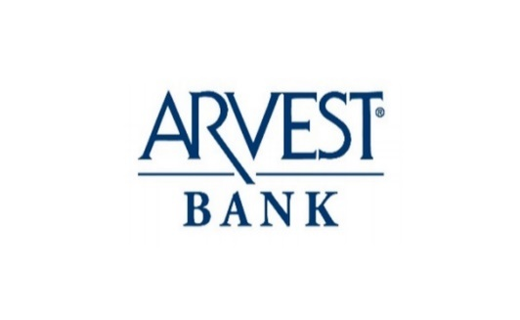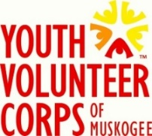

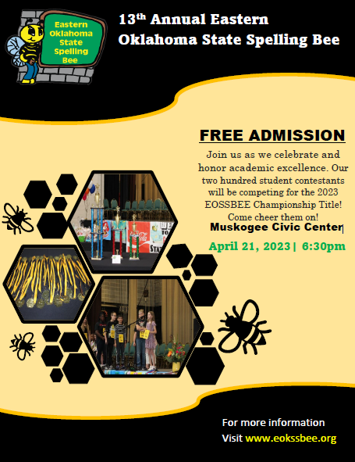

## Eastern Oklahoma State Spelling Bee

## School Representatives 2023

**Caney Valley Middle School**

**Kelli Corder #176**

**Braxton Escoe #**

**Cave Springs Public Schools**

**Lola Workman #90**

**Audree Cochran #118**

**Central Public Schools**

**Michael Reed #139**

**Rylen Caughman #16**

**Checotah Intermediate School**

Addison Williams #66

Liliana Buchanan #123

Chouteau Elementary School

**Jeff Xiong #19**

**Rylan Morrison #53**

Chouteau Middle School

Naveiahh Osborn #143

Brock Plank #166

**C.O.A.C.H.E.S.**

**Ian Connell #23**

Chuck Graham #89

**Depew Elementary School**

**Lucy VanOrsdol #26**

**Raelynn Childress #11**

**Depew Middle School**

Malachi Groves #186

Wade Gardner #173

Afton Public Schools

Valynn George #20

Cade Victor #49

Allen Bowden Schools

Lillian Back #171

Juno Fitzhugh #93

**Atoka Elementary School**

Jake Robertson #

Lakenzie Crawford #82

**Bearden Public Schools**

**Cale Anderson #128**

**Georgiana Williams #174**

**Braggs Elementary School**

**Logan Shirley #101**

**Kye Isbell #17**

**Braggs Middle School**

**Alex Wheat-Wilson #187**

**Ryker Ellis #**

**Briggs School**

**Scarlett Smith #177**

**Brenlei Smith #135**

**Canadian Elementary School**

**Paisley Miller #95**

**Nathan Hardin #142**

**Caney Valley Elementary School**

**Micah Kern #87**

**Hannah Robinett #110**

## Eastern Oklahoma State Spelling Bee

## School Representatives 2023

Depew Public Schools

Harper Gaudet #21

Chase Thompson #8

Dewar Public School

Malaziah Carter #26

Jacob Tucker #9

Dunbar School

Levi Rucker-Fink #192

Winter Rock #151

Eufaula Elementary School

Savannah Burns #47

Ailly Bailey #23

Eufaula Middle School

Aleaya Wise #146

Sapphire Whelpley-Hoff #126

**Fairland Elementary School**

**Ethan Weaver #115**

**Audrey Davis #107**

**Fanshawe Public School**

**Aaliyah Nix #59**

**Daisey Billy #73**

**Fort Gibson Middle School**

**Sophie West #172**

**Dawson Steveson #181**

**Gore Lower Elementary School**

**Ian Munson #57**

**Ashlynn Munson #74**

**Gore Upper Elementary School**

**Mikayla Randolph #130**

**Jaydan Gates #121**

**Graham-Dustin Public School**

**Keylee Palmer #150**

**Alisha Vannasdall #189**

**Grand View School**

**Jocie Presley #178**

**Carly Johnson 397**

**Haileyville Public Schools**

**Kymbria Suterfield #188**

**Connor Labor #106**

**Hartshorne Public Schools**

**Kaylee Harp #70**

**Haskell Middle School**

**Colson Jernigan #190**

**Kloe Nelson #162**

**Heavener Public School**

**Sophia Facundo #12**

**Avril Vasquez #7**

**Henryetta Elementary School**

**Jacob McConnell #39**

**Khai Girty #81**

**Henryetta Middle School**

**Grace Marder #68**

**Olivia Craig #122**

## Eastern Oklahoma State Spelling Bee

## School Representatives 2023

**Westville Elementary School**

**Ben Harp #78**

**Nathan Tran #37**

**Westville Junior High School**

**Haylee Hill #154**

**Alyssa Carrington #108**

**Wister Public Schools**

**Maddison Herman #170**

**Kinley Rice #72**

**Zion Public School**

**Aspyn James #105**

**Izzy Sidebottom #6**

## Eastern Oklahoma State Spelling Bee

## School Representatives 2023

**Roosevelt Elementary School**

**Ava Neighbors #40**

**Carson Cates #55**

**Salina Elementary School**

**Tenley Sorum #15**

**Ryan Schaffer #48**

**Shady Point School**

**Roman Rutledge #141**

**Sarah Chamberlain #113**

**Shiloh Christian School**

**Logan Taylor #132**

**Oliver Center #2**

**Stidham Public School**

**Abbie Paterson #60**

**Autumn Lee #78**

**Stigler Grade School**

**Ariyah Bell #64**

**Daxton Rogers #83**

**Stilwell Grade School**

**Tyce Eubanks #24**

**Bralei Byrd #48**

**St. Joseph Catholic School**

**Alex Yosef #148**

**Khloe Jones #114**

**St. Joseph Middle School**

**Ethan Yosef #133**

**Josh Cheong #152**

**Stonebridge Academy**

**Kian Martinez #30**

**Devon Garrison #79**

**Tahlequah Public School**

**Mia Cravatt #125**

**Ravyn Moore #15**

**Thomas Intermediate Elementary School**

**Elizabeth Schuler #31**

**Crixus Bryant #18**

**Vian Middle School**

**Kelby Girdner #136**

**Axl Branham #94**

**Wainwright Public School**

**Kyler Zachary #124**

**Aubree Logan #44**

**Warner Elementary School**

**Connor Honeycutt #61**

**Draven Yochum #45**

**Warner Middle School**

**Xaleigh Torix #88**

**Lucas Yang #134**

**Webbers Falls Public School**

**Jemma Peevy #138**

**Bryson Franco #79**

**Weleetka public Schools**

**Weston Piper #36**

**Madison Johnson #52**

## Eastern Oklahoma State Spelling Bee

## School Representatives 2023

**Hilldale Elementary School**

**Lauren Gillispie #54**

**Hudson Farris #71**

**Hilldale Middle School**

**Jenna Varner #91**

**Jentry Goad #167**

**Hulbert Elementary School**

**Gavin Rankin #25**

**Cedar Slaton #43**

**Hulbert Middle School**

**Boone Whitekiller #147**

**Cade McClure #165**

**Jefferson Elementary School**

**Emma Vance #69**

**Olivia Watkins #4**

**Justus-Tiawah Public School-**

**South Campus**

**Stephanie Hoag #127**

**Adelyn Harrolle #140**

**Justus-Tiawah Junior High School**

**Elena Howard #189**

**Addison Hamilton #169**

**Keota Public School**

**Zaylee Dameal #32**

**Lane Gray #164**

**Kiowa Public School**

**Landen Martin #6**

**Mariska Shields #84**

**Krebs Public Schools**

**Harper Nixon #56**

**Trenton Welch #182**

**Leach Public School**

**Joshua Drake #41**

**Sarah Drake #85**

**Liberty School**

**Garrett Hyatt #34**

**Hunter Cahill #175**

Garrett

**Lincoln Elementary School**

**Sophie Barlow #46**

**Ava Miller #65**

**Maryetta Public Schools**

**Hannah Stewart #180**

**Reese Smith #1**

**Mary White Elementary School**

**Barrett Webb #13**

**Serena Lee #27**

**McCall Middle School**

**Giovanni Bacerra #163**

**Jackson Bates #154**

**McCurtain Elementary School**

**Kade Vigus #3**

**Whitley Lawrence #10**

**Miami Junior High School**

**Brett Williams #136**

**Adalynn VanHorn #154**

**Gold Sponsors**

## Eastern Oklahoma State Spelling Bee

## School Representatives 2023

**Moffett Elementary School**

**Majoli Kursh #88**

**Luke Castleberry #170**

**Muldrow Elementary**

**Lucye Rose #14**

**Olivia Hildreth #38**

**Muldrow Middle School**

**Audrie Shepard #161**

**Sam Horne #185**

**Norwood Public School**

**Brooke - Lynne Norton #158**

**Brooks Allen #5**

**Okay Public Schools**

**Issac Smith #58**

**Oklahoma School for the Blind**

**Leah Sailors #160**

**Hunter Puah #112**

**Okmulgee Primary School**

**Connelle Thompson #42**

**Cooper Snow #27**

**Oktaha Elementary School**

**Aniston Bales #33**

**Karsyn Shrum #14**

**Oktaha Middle School**

**Kadence Strube #157**

**Hayden Walls #132**

**Pansey Kidd Middle School**

**Jaelyn Vongnarath #102**

**Connor Flores #76**

**Peavine Public School**

**Scarlett Vizueth #149**

**Skylar Sam #131**

**Peggs Public School**

**Kyah Vann #155**

**Sonny Fisher #86**

**Porter Elementary School**

**Bryar Mason #104**

**Charlee Mernitt #77**

**Porter Middle School**

**Rian Seals #159**

**Maggie Dozier #137**

**Porum Public School**

**Dani Berryhill #152**

**Takoda Hodges #111**

**Preston Elementary School**

**Kyli Johnson #125**

**Ayaan Zia #29**

**Pryor Middle School**

**Cyanna Bagent #144**

**Allison Martin #117**

**Quinton Public Schools**

**Lily Rook #145**

**Daycie Etchison #87**

### **3 Rivers Auto Collision – Muskogee**

### **Acme Engineering & Manufacturing Corp.**

### **Action Imprints – Muskogee**

### **Advanced Workzone Services**

### **AIP Insurance –Muskogee Allstate: Albritton Agency – Muskogee**

### **American Bank of Oklahoma**

### **Armstrong Bank**

### **Arvest Bank – Muskogee**

### **AT&T Oklahoma**

### **BancFirst – Muskogee**

### **BancFirst – Tahlequah**

**BancFirst – Wagoner**

### **Bank of Cherokee County**

### **Bank of Eufaula**

### **Bank of Oklahoma – Muskogee**

### **Bare Bones Filmworks – Muskogee**

### **Bebb’s Flowers – Muskogee**

### **Boomarang Diner, Inc.**

### **Cagle’s Flowers & Gifts – Muskogee**

### **Casey’s General Store**

### **Central Trailer Sales-Broken Arrow**

### **Charlie’s Chicken East – Muskogee**

### **Cherokee Nation**

### **City of Muskogee**

**Chick-fil-A- Muskogee**

### **Connors State College**

### **Communication Federal Credit Union**

### **Cook Construction – Fort Gibson**

### **Cruis’n Angels**

### **Dal-Tile, INC.**

### **David S. Wilson, M.D.**

**Dr. T’s Detail – Muskogee**

**Eastside Citgo**

### **Ed Gage**

### **Economy Pharmacy**

### **Elite Self Storage – Muskogee**

### **Farmers Insurance – Cobey Soap**

### **First National Bank & Trust of**

### **Okmulgee**

### **First Family Federal Credit Union**

### **Henryetta**

### **Firstar Bank**

### **Georgia-Pacific Muskogee Mill**

### **Golden Corral – Muskogee**

### **Gore Green Country Drug, Inc.**

### **Grease Monkey – Muskogee**

### **Green Country LED – Muskogee**

### **Griffin Food Company**

### **Harps Food Stores**

**Harrison Tire & Supply**

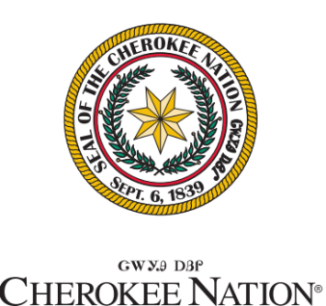



**ArchFellow McDonald’s**

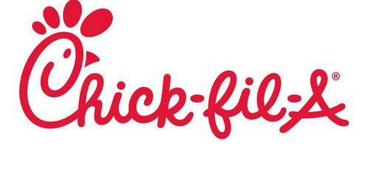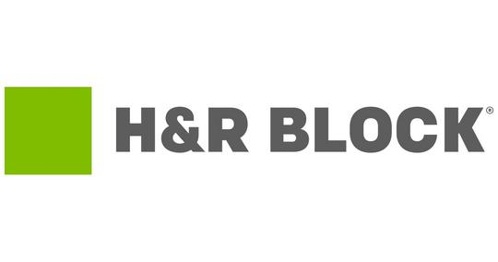





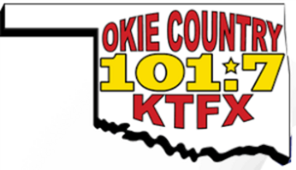

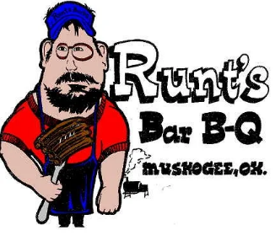

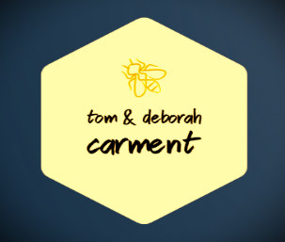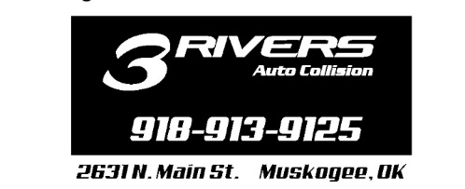



## Platinum Sponsors

**2023 EOSSB Presenting Sponsor**



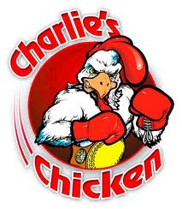

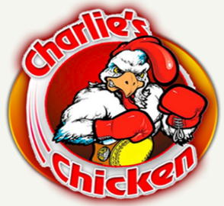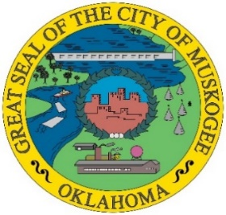



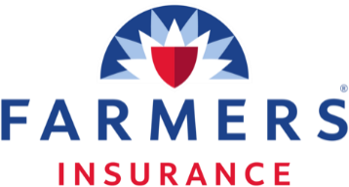

**Cobey Soap & Stephanie Hunt**



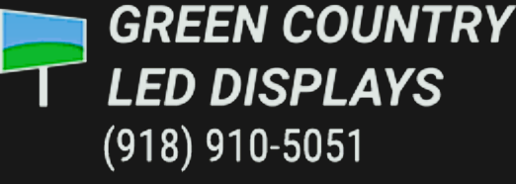

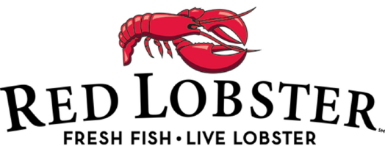

**2023 Eastern Oklahoma State**

**Spelling Bee Prizes!**

**For the Champion:**

The champion will receive a $1,000.00 check for his or her school from the Eastern Oklahoma State Spelling Bee nonprofit organization. The Champion will receive for himself or herself the EOSSB championship trophy and a $500.00 cash prize.

**For Second Place:**

The runner-up will receive a $500.00 check for his or her school from the Eastern Oklahoma State Spelling Bee nonprofit organization. The second-place winner will receive for himself or herself the EOSSB second place trophy and a $250.00 cash prize.

**For Third Place:**

The third-place student will receive a $250.00 check for his or her school from the Eastern Oklahoma State Spelling Bee nonprofit organization. The third-place winner will receive for himself or herself the EOSSB third place trophy and a $100.00 cash prize.

**For All Spellers:**

Each contestant will receive a 2023 commemorative t-shirt and an engraved medal.

**Please note that during the first intermission the EOSSB will be giving away tablets, watches, gift baskets, and other prizes. Random student numbers will be drawn to determine the winners. All students are encouraged to stay in the arena until the drawing has taken place.**

**Cruis’n Angels Car Club Scholarship to be given as additional monies to the top three winners of tonight’s academic event.**

## C:\Users\lanej\Downloads\Cruising Angels Logo.jpg

**Precision Woodcrafting**

**Red Lobster**

**Red River Brick- Muskogee**

**Royce Concrete & Dozer- Muskogee**

**Runt’s Bar-B-Q- Muskogee**

**Servepro**

**Sooner Surplus Sales**

**Southlake Boarding & Grooming – Gore**

**Southlake Veterinary Clinic – Gore**

**Sunburst Spraying – Muskogee**

**Tender Touch Car Wash- Muskogee**

**Texas Roadhouse – Tulsa**

**The Community State Bank – Poteau**

**The Muscogee Nation**

**Tom & Deborah Carment**

**Town & Country Pup Grooming – Muskogee**

**TTCU – Federal Credit Union – Muskogee**

**Union Pacific Railroad**

**Walmart – Muskogee**

**Walmart – Tahlequah**

**Walmart – Wagoner**

**Yaffe Iron & Metal CO., INC.**

**3 Rivers Auto Collision – Muskogee**

**Acme Engineering & Manufacturing Corp.**

**Action Imprints – Muskogee**

**Advanced Workzone Services**

**Allstate: Albritton Agency – Muskogee**

**American Bank of Oklahoma**

**Amish Store & Restaurant- Muskogee**

**Andy Simmons –**

**Muskogee County Sheriff**

**ArchFellow McDonald’s**

**Armstrong Bank**

**Arvest Bank – Muskogee**

**AT&T**

**BancFirst – Muskogee**

**BancFirst – Tahlequah**

**BancFirst – Wagoner**

**Bank of Eufaula**

**Bank of Oklahoma**

**Bare Bones Filmworks – Muskogee**

**Buff City Soap- Muskogee**

**Bullseye Wealth Management- Muskogee**

**Cagle’s Flowers & Gifts – Muskogee**

**Canyon Road Bait Shop**

**Century 21 First Choice Realty**

**Charlie’s Chicken East – Muskogee**

**Green Country LED – Muskogee**

**Griffin Food Company**

**Haley & Loyd Jewelry - Muskogee**

**Harps Food Stores**

**Henderson’s Coffee Co. Muskogee**

**H&R Block – Muskogee**

**Homeland**

**House of Webster – Springdale, AR**

**Hunt Rentals LLC- Gore**

**I-40 Awards & Engraving**

**Lakes Country 102.1**

**Lamar Outdoor Advertising- Tulsa**

**Linda & Carlile Roberts**

**Local Bank**

**Love Bottling Company – Muskogee**

**McAlister’s Deli - Muskogee**

**M3 Bee Farm**

**Muskogee Art Guild**

**Muskogee Beacon**

**Muskogee Civic Center**

**OG&E**

**Okie Country 101.7, KTFX**

**Okie Mart- Muskogee**

**Optimum**

**Precision Woodcrafting**

**The Eastern Oklahoma State Spelling Bee**

**Gratefully Acknowledges These Generous Sponsors**

**The Eastern Oklahoma State Spelling Bee**

**Gratefully Acknowledges These Generous Sponsors**

**Cherokee Nation**

**Chili’s - Muskogee**

**City of Muskogee**

**Chick-fil-A – Muskogee**

**Cliff Casteel**

**Communication Federal Credit Union**

**Connors State College**

**Cruis’n Angels Car Club**

**Dal-Tile, INC.**

**Dr. David & Fran Wilson**

**Dr. T’s Detail – Muskogee**

**Dumas Tax Service**

**Elite Self Storage – Muskogee**

**Enhabit Home health & Hospice**

**Farmers Insurance –**

**Cobey Soap & Stephanie Hunt**

**First Family Federal Credit Union**

**First National Bank & Trust of Okmulgee**

**Firstar Bank**

**Fish Shack – Coweta**

**Georgia-Pacific- Muskogee Mill**

**Golden Corral – Muskogee**

**Gore Green Country Drug, Inc.**

**Grease Monkey – Muskogee**

