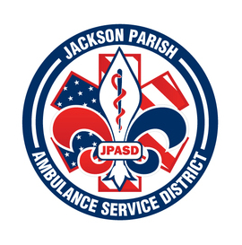
JACKSON PARISH AMBULANCE SERVICE DISTRICT
115 Watts Street
Jonesboro, LA 71251
Office: (318)-259-2877 Fax: (318)-259-2099
jacksonparishambulance@jpasd.com
Aaron Johnson BOARD MEMBERS
EMS Director Allen Lindsay, Chairman
Paula Parkerson , MD Joe Vail, Vice-Chairman
Medical Director Conchita Doyle
Alma Williams
Deidre Hollis
Notice Posted: Tuesday, December 6, 2022 @ 12:00 PM

NOTICE OF PUBLIC HEARING

A public hearing will be held as follows:
DATE: December 8, 2022
TIME: 12:00 PM (Noon)
PLACE OF MEETING: Jackson Parish Ambulance Service District
115 Watts Street, Jonesboro, LA 71251

Public Hearing 2023 Proposed Budget 12:00 PM (Noon) AGENDA:
1. Call to Order
2. Roll Call
3. Invocation
4. Pledge of Allegiance
5. Recognition of guests
6. Open floor for public comments on the Proposed 2023 Budget.

In accordance with the Americans with Disabilities Act, if you need special assistance, please contact Aaron Johnson, EMS Director at 318-259-2891 describing the assistance that is necessary.

