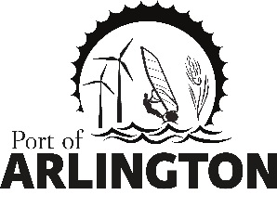
Port of Arlington
Budget Hearing

REVISED
Port of Arlington
AGENDA
5:00 pm
Tuesday, February 4, 2020
Meeting Location:
Port of Arlington
100 Port Island Road

- Call meeting to order

- Public Comment on non-agenda items

- Consent Agenda:
- Approval of December 10, 2019 Commission meeting minutes
- Approval of December 2019 and January 2020 payables

- Presidents Report

- Commissioner’s Reports

- Small Business Assistance Quarterly Grant Update
  - Pheasant Grill / Pat Shannon

- Executive Session per ORS 192.660(2)(h): To consult with your attorney regarding your legal rights and duties in regard to current litigation or litigation that is more likely than not to be filed.

- Executive Session per ORS 192.660(2)(g): To consider preliminary negotiations involving matters of trade of
commerce in which the governing body is in competition with governing bodies in other states or nations.

- Approve or Deny Resolution 2019-144 - Port of Arlington Establishing A No Harassment Policy and Statement Of Employee Rights That Seeks To Prevent Workplace Harassment

- EDO Report

- Administration
11.1 Schedule Budget Workshop - Big Picture

Upcoming Meetings:
Regular Commission Meeting on Tuesday, March 10, 2020 at 5pm – Port of Arlington, Arlington, Or.
This meeting location is accessible to persons with disabilities. A request for an interpreter for the hearing impaired or for other accommodations for persons with disabilities should be made at least 48 hours before the meeting by contacting Kelly.margheim@portofarlington.com / 541-454-2868
Posted: Thursday, January 29, 2020: Bank of Eastern Oregon - Condon & Arlington; U.S. Post Office - Condon & Arlington; Condon Times-Journal; Arlington City Hall; Port Office and Website.
PO Box 279, Arlington, Oregon 97812

