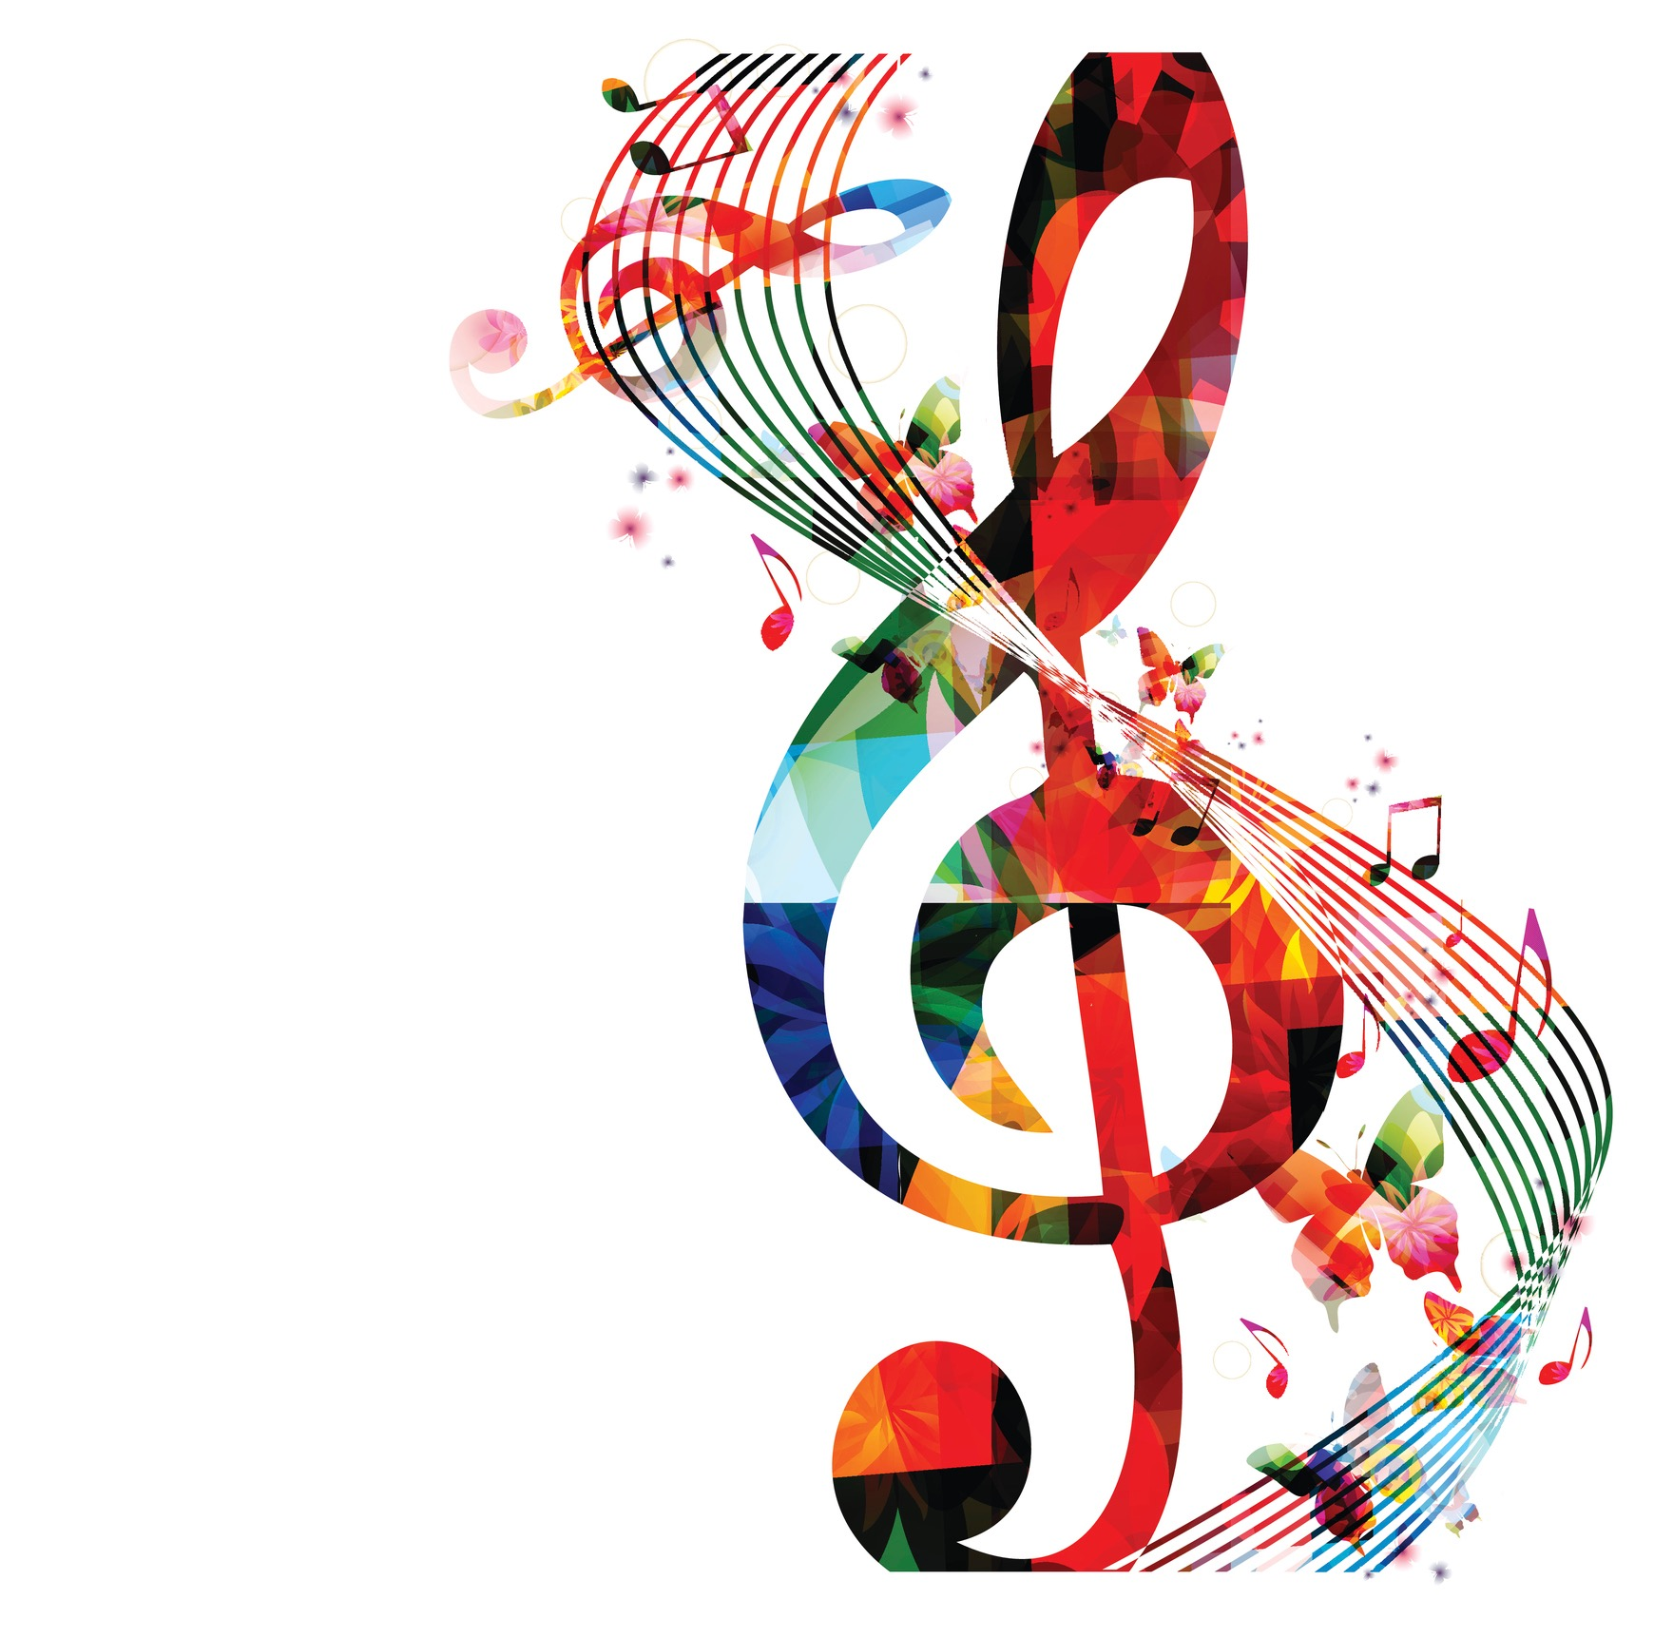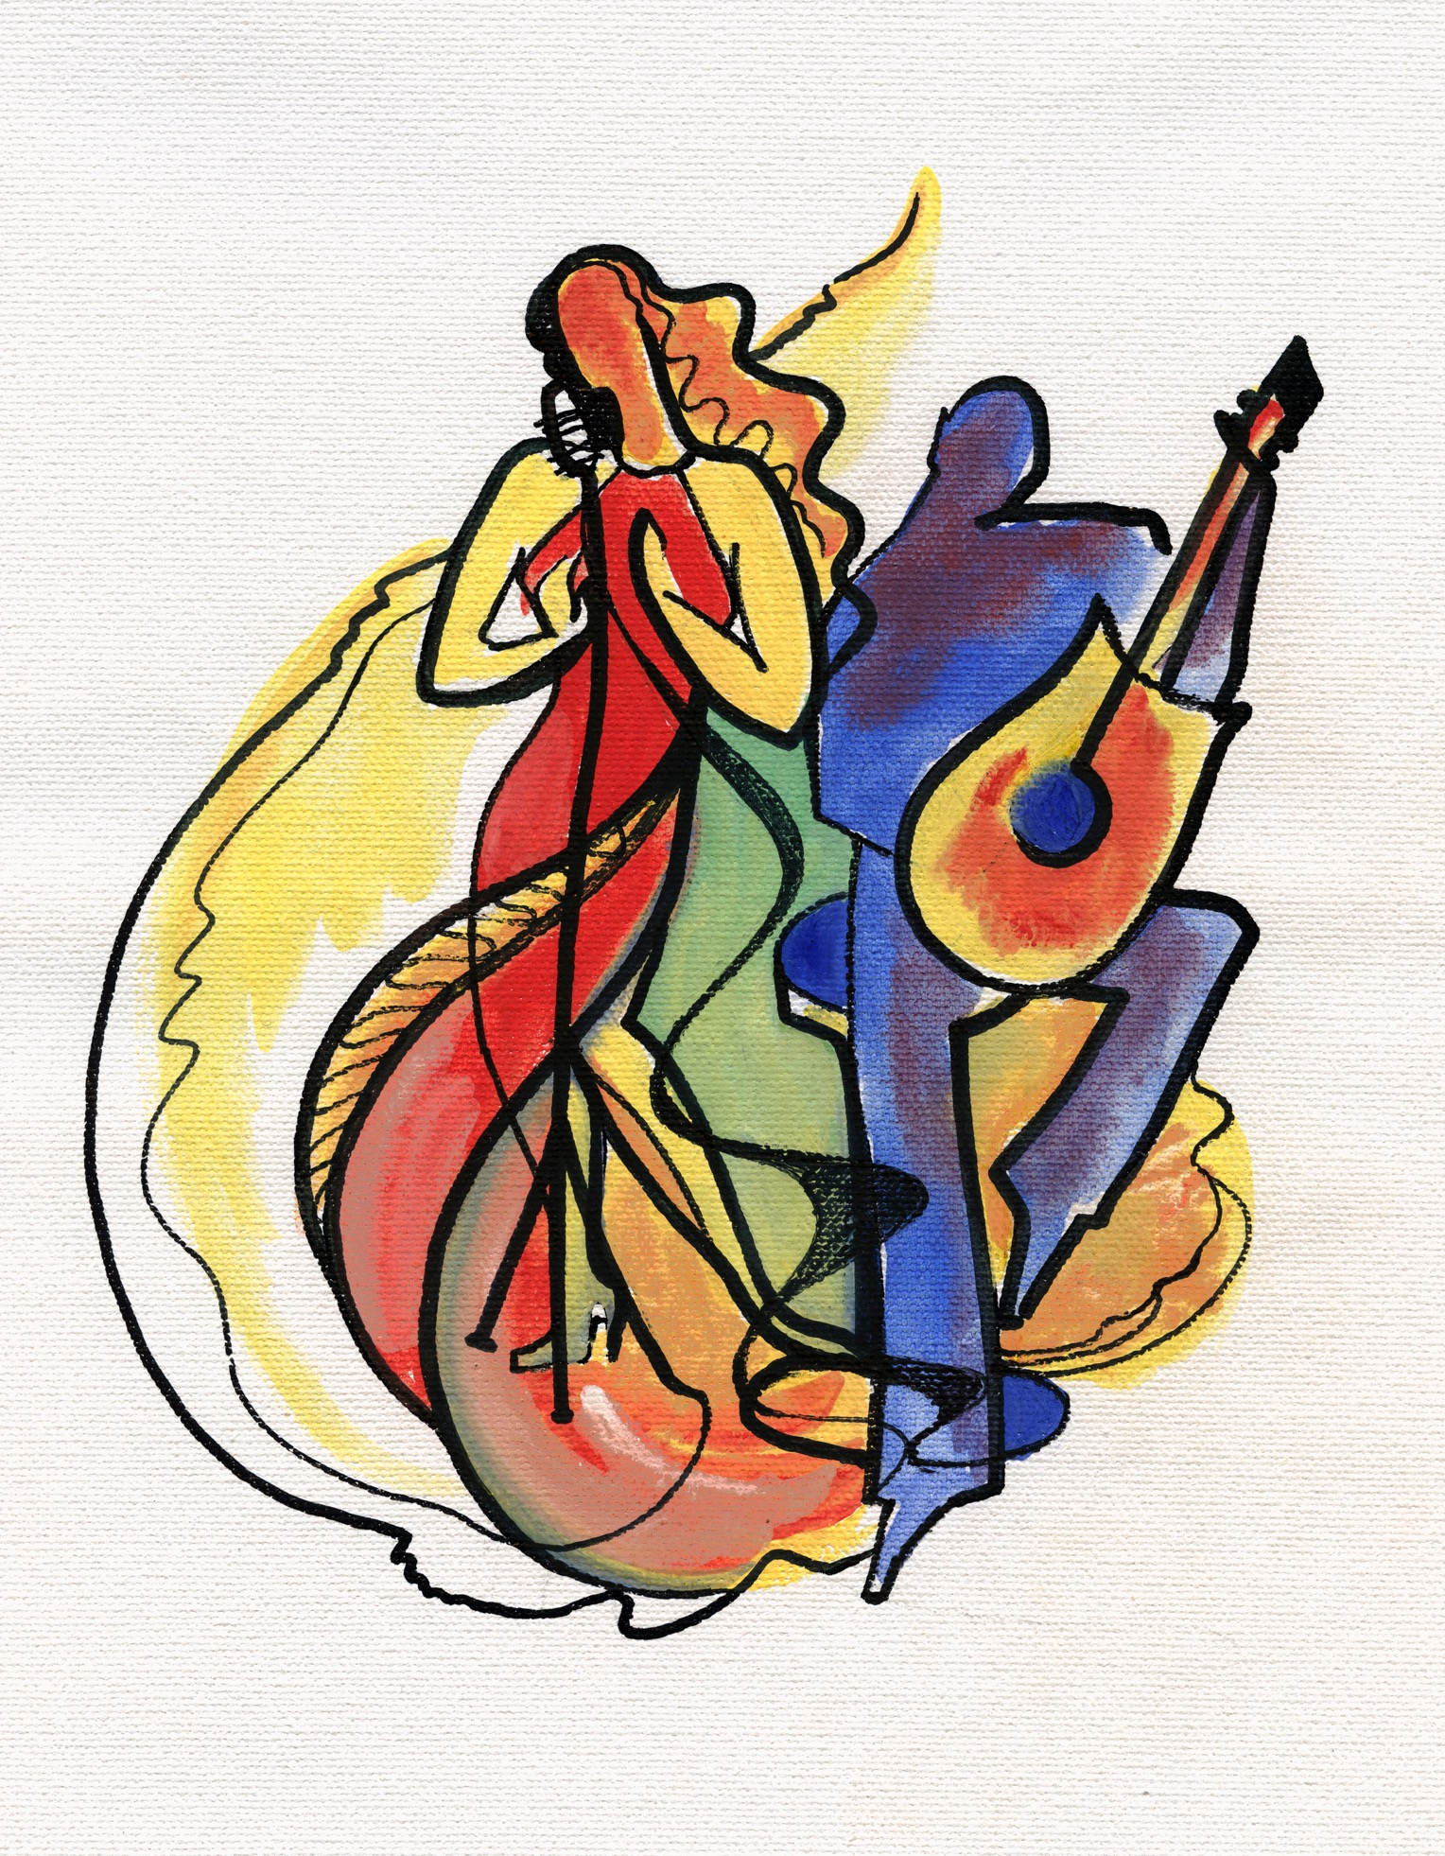

**2021 Kelowna Kiwanis Festival**

**CALENDAR**

**\*SUBJECT TO CHANGE**

**DANCE**

Mary Irwin Theatre, RCA; Kelowna

**Ballet/Contemporary** – February 23-25

**Stage** –Feb 28th, March 1, 2, 3 & 4

**VOICE**

Mary Irwin Theatre, RCA; Kelowna

**Choral** . **POSTPONED**

**Classical Voice** . March 29 & 30

**Musical Theatre** . April 6, 7 & 8

**Popular Voice** . April 9, 10 & 11

**Speech Arts** . April 12

**MUSIC**

**Brass/Woodwinds .** **POSTPONED**

**Concert Band** . **POSTPONED**

**Strings** . April 26, 27 & 28 (Salloum Room, RCA; Kelowna)

**Orchestra/Chamber** . Apr. 26-pm (Mary Irwin Theatre, RCA; Kelowna)

**Piano** . May 2, 3, 4, 5, 6 (Upstairs Boardroom, RCA; Kelowna)

**\*\*\***

**(DRAFT)**