November Member Meeting and Program

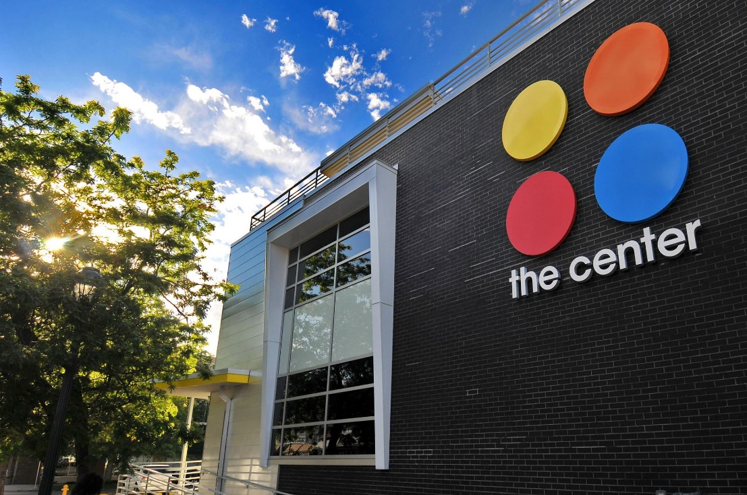

WHAT: RMGA November MEMBERSHIP MEETING –Today
WHEN: November 14th at 6:OO pm
WHERE: Via Zoom
Rocky Mountain Guides is inviting you to a scheduled Zoom meeting.
Topic: Rocky Mountain Guides' Zoom Meeting
Time: Nov 14, 2022 06:00 PM Mountain Time (US and Canada)
Join Zoom Meeting -- https://us06web.zoom.us/j/86772091685
Meeting ID: 867 7209 1685
One tap mobile -- +17207072699,,86772091685# US (Denver)
PROGRAM: The Center on Colfax
Member Mark Blaising will present via Zoom the October program “Tour for Rocky mountain Tour Guides Association” created by Dave Duffield. The Center has created three walking tours focusing on LGBTQ in Denver. These tours bring to life the history of the LGBTQ community in Denver. RMGA may have an involvement in walking tours during June (Pride Month).
Dave Duffield is the Center's Historian who helped curate the History Center of Colorado's recent exhibit on display during Pride Month.
The Center serves members of the LBGTQ community of Colorado. It sponsors the Pride Weekend Celebrations and parade in June and provides services year-round that collects and archives oral histories of the community, provides walking tours, curates museum exhibits and shares stories to a wider audience. bonus, hear about the wild historical event in Denver Crimefighting history that took place on the site around a 100 years ago.
The importance of diversity and inclusion was made repeatedly at the Colorado Tourist Office’s Governors Conference this year. This is especially relevant to the foreign travelers the CTO hopes to lure back to Colorado. The RMGA needs your attendance and support. This program is being repeated because many members expressed an interest in attending, but were unable to make it.

GUESTS: Members are encouraged to invite potential members as guests to meeting.

GUEST FEES: 1st and 2nd Time Guest: Free, Third thru Fifth Time, Same Guest Visit is $10 each time. Succeeding Times, Same Guest Must Join RMGA.

MEETING NIGHT CONTACT: Mark Blaising. Contact Blaising303@gmail.com or by text 303-263-8647

