REGULAR MEETING

FEBRUARY 27, 2025

The Regular Meeting of the Town Board of the Town of Hampton, County of Washington and the State of New York was held at the Town Hall, 2629 State Route 22A, Hampton, New York, on the 27th day of February 2025.

PRESENT: David K. O’Brien------------Supervisor

Donald Sady----------------- Councilman

Tamme Taran----------------Councilwoman

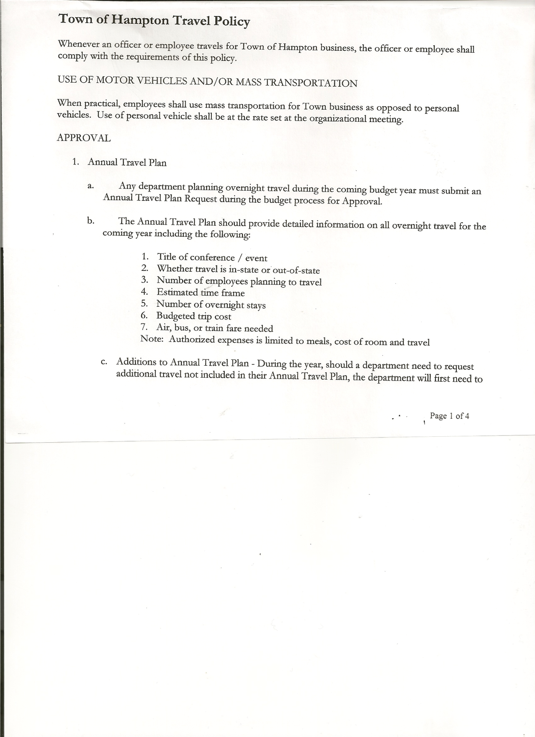 Michael Pietryka------------Councilman

Andrea Kugler---------------Councilwoman - absent

Rebecca Jones---------------Town Clerk

Camilla Shaw----------------Deputy Town Clerk

Tyler McClure---------------Highway Superintendent - absent

Planning Board Member (s):… Bonnie Hawley, Chair and Matthew Pratt

Others present at the Town Hall: EJ Conzola (NYVT Media Reporter), John Mashak

and Artie Pratt

The Regular Meeting was called to order by Supervisor O’Brien at 7:30pm, followed by the Pledge of Allegiance. Location of Fire Exits was given. Quorum of board members present.

The Regular Monthly Meeting was held a week later than normal. There was not a quorum of members present for the February 20th, 2025 meeting.

Supervisor O’Brien asked for a moment of silence in memory of Nora Miller, Grant Scott,

Sylvia Kugler (Councilwoman Kugler’s mom) and Shirley Poalino.

**RESOLUTION NO. 21-2025**

**APPROVAL OF THE MINUTES**

On a motion of Councilwoman Taran, seconded by Councilman Sady, the following resolution was ADOPTED: AYES 4 O’Brien, Sady, Pietryka, Taran

NAYS 0

ABSENT 1 Kugler

RESOLVED, the Regular Town Board Meeting Minutes for January 16th, 2025 are approved.

**PERMITS/SUBDIVISIONS**

A subdivision application from John Mashak was presented to the Board for consideration. The subdivision consists of Proposed Lot 1 of 6.46 acres and Proposed Lot 2 of 28.06 acres.

TOWN BOARD MEETING

FEBRUARY 27, 2025 PAGE 2

**RESOLUTION NO. 22-2025**

**MASHAK-SHORT ENVIRONMENTAL ASSESSMENT FORM/NEGATIVE DECLARATION**

On a motion of Councilwoman Taran, seconded by Councilman Sady, the following resolution was ADOPTED: AYES 4 O’Brien, Sady, Pietryka, Taran

NAYS 0

ABSENT 1 Kugler

RESOLVED, that the Short Environmental Assessment Form is complete and to adopt a negative declaration and finding that there will be no adverse environmental impacts and to consider it a minor subdivision, therefore waving the public hearing.

**RESOLUTION NO. 23-2025**

**MASHAK-APPROVAL OF SUBDIVISION**

On a motion of Councilman Sady, seconded by Councilwoman Taran, the following resolution was ADOPTED: AYES 5 O’Brien, Sady, Pietryka, Taran

NAYS 0

ABSENT 1 Kugler

RESOLVED, to approve the Mashak subdivision.

Dog Control Officer….no report

Tax Collector Report….January 2025 Report attached. The Town Clerk/Collector had Board Members review and sign bank reconciliation statements for the Tax Collector Account dated January 31st, 2025.

Bonnie Hawley, Chair Planning Board….Planning Board Meeting was held February 12th, 2025, copy of the minutes is attached. Next meeting will be March 12, 2025 @7:00 at the Town Hall.

HIGHWAY – BID for the 2012 Dodge 3500 1-ton.

The bid received at the January 16th, 2025 meeting was rejected. Another notice was put out for new bids. One bid was received from John G. Thomas Excavating, LLC, 2375 County Route 18, Hampton, NY for $4600.00.

Following a discussion, the following resolution was made:

**RESOLUTION NO. 24-2025**

**HIGHWAY – BID**

On a motion of Councilman Pietryka, seconded by Councilman Sady, the following resolution was ADOPTED: AYES 4 O’Brien, Sady, Pietryka, Taran

NAYS 0

ABSENT 1 Kugler

RESOLVED, to accept the bid received.

Tyler McClure, Highway Superintendent…submitted his report, copy of which is attached.

TOWN BOARD MEETING

FEBRUARY 27, 2025 PAGE 3

**SUPERVISOR’S REPORT/COUNTY UPDATES/COMMUNICATIONS**

**RESOLUTION NO. 25-2025**

**APPROVAL OF THE SUPERVISOR’S MONTHLY REPORT**

On a motion of Councilman Sady, seconded by Councilwoman Taran, the following resolution was ADOPTED: AYES 5 O’Brien, Sady, Pietryka, Taran

NAYS 0

ABSENT 1 Kugler

RESOLVED that, the Supervisor’s Monthlyreport be accepted as submitted for **JANUARY.**

ACCOUNT 01/01/25 Receipts Disbursed 01/31/25

Citizens Cemetery $ 3,028.84 $ .13 $ .00 $ 3,028.97

Citizens Total $ 3,028.84 $ .13 $ .00 $ 3,028.97

GFNB Fire, Trust & Agency $ 1,418.04 $ 609.50 $ 2,027.54 $ 0.00

GFNB Fire, Trust & Agency ICS $ 609.50 $ $ 609.50 $ 0.00

GFNB Health Insurance $ 2,591.23 $ $ $ 2,591.23

GFNB Trust & Agency $ 7,712.83 $ 8,045.79 $ 5,699.73 $ 10,058.89

GFNB General Fund $ 6,129.12 $252,826.07 $255,642.57 $ 3,312.62

GFNB General Fund ICS $ 46,320.77 $ 37,161.51 $ 0.00 $ 83,482.28

GFNB Total $ 64,781.49 $298,642.87 $263,979.34 $ 99,445.02

GFNB Highway Fund $ 14,459.97 $328,828.58 $328,677.07 $ 14,611.48

GFNB Highway Fund ICS $ 77,378.35 $296,107.99 $ 5,000.00 $368,486.34

GFNB Capital Reserve $ 1,005.02 $ $ 0.00 $ 1,005.02

GFNB Capital Reserve ICS $ 66,689.94 $ 129.27 $ $ 66,819.21

GFNB Total $ 159,533.28 $625,065.84 $333,677.07 $450,922.05

TOTALS $227,343.61 $923,708.84 $ 597,656.41 $553,396.04

All Board Members present signed Supervisor’s Report.

**OLD BUSINESS**

Assessor Reval Presentation….a recorded presentation done by Town Assessor, Arek Gordon was shown to those present at this meeting. The Assessor gave an update on the Town's 2025 revaluation project. At this time data collection, data mailers, sales analysis, and valuation have been completed. Property owners will be receiving a letter around March 1st with their preliminary assessment on them. The letter will also show what their taxes were last year and an estimate of what their taxes would have been if the new value had been their assessment. Special District taxes and new exemptions will not be shown on this letter. If property owners are okay with their new assessment then they do not have to do anything else. If they feel that the preliminary assessment is incorrect, they should sign up for a preliminary review appointment with the assessor in one of the ways listed on the letter. These numbers are the preliminary assessment and are subject to change before the tentative roll is published on May 1, 2025.  If properties have recent building permits or other changes, they will receive a letter around the first week of May with a tentative assessment. Please direct all questions about this process to the Assessor.

TOWN BOARD MEETING

FEBRUARY 27, 2025 PAGE 4

**RESOLUTION NO. 26-2025**

**ASSESSOR RE-APPOINTMENT**

On a motion of Councilman Pietryka, seconded by Councilman Sady, the following resolution was ADOPTED: AYES 4 O’Brien, Sady, Pietryka, Taran

NAYS 0

ABSENT 1 Kugler

RESOLVED to reappoint Arek Gordon as the Sole Assessor for the Town of Hampton.

**RESOLUTION NO. 27-2025**

**STANDARD WORKDAY AND REPORTING RESOLUTION**

On a motion of Councilman Sady, seconded by Councilwoman Taran, the following resolution was ADOPTED: AYES 4 O’Brien, Sady, Pietryka, Taran

NAYS 0

ABSENT 1 Kugler

RESOLVED that, the Standard Workday and Reporting Resolution for Elected and Appointed Officials (RS 2417-A) be approved. (copy is attached)

**NEW BUSINESS**

Supervisor O’Brien handed out a copy of a proposed resolution to Board members for them to consider for the next meeting. The resolution is in regard to “Imposing a Moratorium on locating a Battery Energy Storage System” in the Town.

Town Clerk/Tax Collector, Rebecca Jones submitted yearly reports for 2024 for Board members to review and sign.

**RESOLUTION NO. 28-2025**

**TOWN HALL USE**

On a motion of Councilman Pietryka, seconded by Councilman Sady, the following resolution was ADOPTED: AYES 4 O’Brien, Sady, Pietryka, Taran

NAYS 0

ABSENT 1 Kugler

RESOLVED, to approve the request of Rebecca Jones to use the Town Hall on Saturday, March 1, 2025 from 4 to 8 pm for Board Game Night.

Following a suggestion from the January Town Board Meeting, the following Resolution was introduced in regard to lowering the Speed Limit on County Route 11.

TOWN BOARD MEETING

FEBRUARY 27, 2025 PAGE 5

**RESOLUTION NO. 29-2025**

**SPEED LIMIT REDUCTION ON COUNTY ROUTE 11**

MOTION BY: COUNCILMAN DONALD SADY

SECONDED BY: COUNCILWOMAN TAMME TARAN

**RESOLUTION REQUESTING SPEED LIMIT REDUCTION ON COUNTY ROUTE 11 IN THE TOWN OF HAMPTON**

**WHEREAS**, pursuant to Section 1622(1) of the Vehicle and Traffic law of the State of New York, the Town Board (the “Board”) of the Town of Hampton (the “Town”) may request a review of the speed limit on highways located in the Town of Hampton; and

**WHEREAS**, the Board has become aware of an increase in presence of slower moving vehicles including horse drawn buggies and carriages, farm equipment and larger trucks on County Route 11 in the Town of Hampton; and

**WHEREAS**, the Board wishes to request that the Department of Transportation review the speed limit on County Route 11 in the Town of Hampton in accordance with Section 1622(1) of the Vehicle and Traffic Law.

**NOW, THEREFORE BE IT:**

**RESOLVED**, that in accordance with Section 1622(1) of the Vehicle and Traffic Law the Town Board of the Town of Hampton hereby requests that the Department of Transportation review the current speed limit on County Route 11 in the Town of Hampton and, if prudent given the findings of the Department of Transportation, reduce the speed limit on County Route 11 to a safe and reasonable speed, recommended by the Town Board of 45 MPH; and be it further

**RESOLVED**, that the Town Supervisor pass the Town Board’s concerns as noted above to the Department of Transportation and the Washington County Superintendent of Highways for their review and consideration; and be it further

**RESOLVED**, that his resolution shall take effect immediately

**RESOLUTION NO. 30-2025**

**AUDIT OF CLAIMS**

On a motion of Councilwoman Taran, seconded by Councilman Pietryka the following resolution was ADOPTED:

AYES 4 O’Brien, Sady, Pietryka, Taran

NAYS 0

ABSENT 1 Kugler

RESOLVED that the bills have been reviewed by the Town Board and are authorized for payment in the following amounts.

General Fund No. 13 through No 26 $ 19,352.31

Highway Fund No. 13 through No.26 $ 14,669.93

Total both funds $ 34,022.24

TOWN BOARD MEETING

FEBRUARY 27, 2025 PAGE 6

The Town Clerk’s report for January 2025 was submitted to the Board. The Town Clerk had Board Members review and sign bank reconciliation statements for the Town Clerk Account and Special Town Clerk Account dated January 31st, 2025.

**RESOLUTION NO. 31-2025**

**MEETING ADJOURNED**

On a motion of Councilman Pietryka, seconded by Councilwoman Taran the following resolution was ADOPTED:

AYES 4 O’Brien, Sady, Pietryka, Taran

NAYS 0

ABSENT 1 Kugler

RESOLVED that the meeting adjourned at 8:24pm.

Respectfully submitted,

Rebecca S. Jones, RMC

Town Clerk