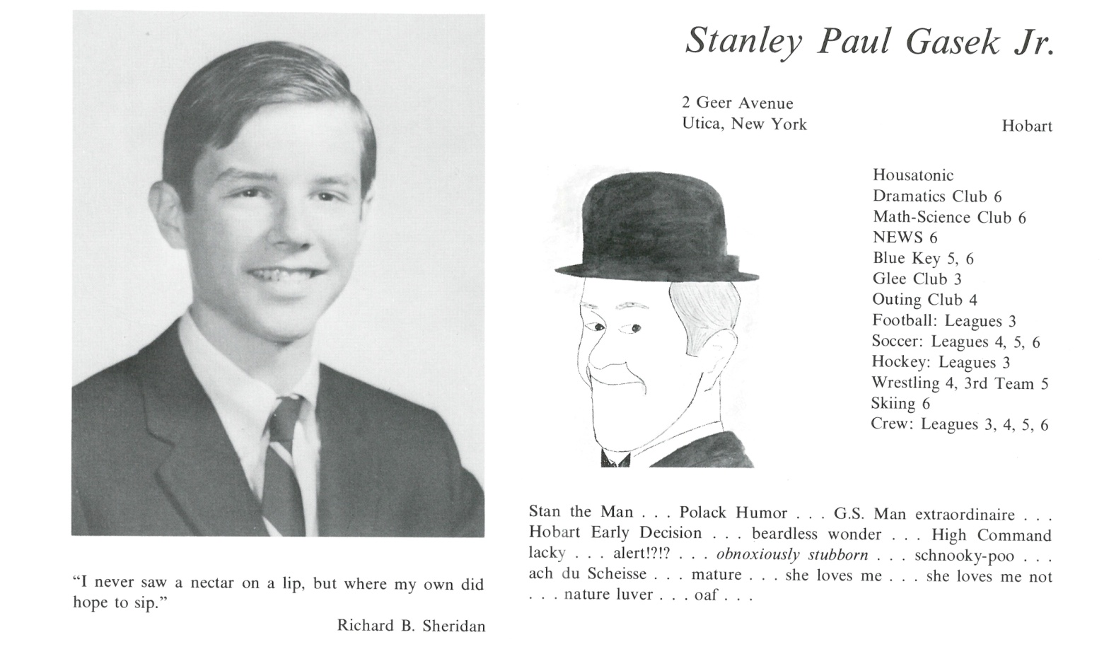

S. Paul Gasek, Jr.

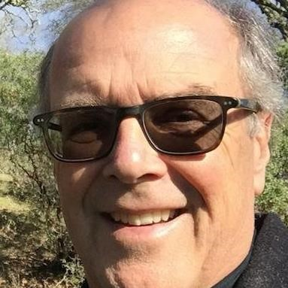Back in 1963, I got into two schools – Kent and St. Paul’s – and my parents left it up to me which school it would be. I picked Kent … and have thought about that fateful choice over the last 50 years. It set so much in train. I remember walking around St. Paul’s on the day of my interview, and feeling kind of lost among all the buildings. But when I interviewed at Kent, there was the school – but also, the valley, the mountain, the river. These were of intense interest to me, left a deep impression - so I chose Kent.

Wasn’t a great student in the conventional sense … but as a student of that *place* with all its natural treasures, I did very well. And now, 50 years later, looking back, I see clearly how important Kent School was, particularly Bill Armstrong, who seemed to see me tho’ I felt invisible. But of somewhat greater importance was the lovely Valley, that imposing Mountain, the ever-changing River. Those things would shape the direction my life and career would take more than any class.

So I’m grateful for those four years, and for all my classmates – such excellent company through life. Life’s experience isn’t one thing or another – it’s everything all wrapped up together. That was Kent, for me – and I still love to catch a trout in the Massie even today.



______________________________________________________________

______________________________________________________________ ______________________________________________________________ ______________________________________________________________ ______________________________________________________________ ______________________________________________________________ ______________________________________________________________ ______________________________________________________________ ______________________________________________________________

Attach Picture in .jpg Format

______________________________________________________________

______________________________________________________________

___________________________________________________________________________________ _________________________________________________________________________________________________________________________________________________________________________________________________________________________________________________________________________________________________________________________________________________________________________________________________________________________________________________________________________________________________________________________________________________________________________________________________________________________________________________________________________________________________________________________________________________________________________________________________________________________________________________________________________________________________________________________________________________________________________________________________________________________________________________________________________________________________________________________________________________________________________________________________________________________________________________________________________________________________________________________________________________________________________________________________________________________________________________________________________________________________________________________________________________________________________________________________________________________________________

___________________________________________________________________________________