3/29/2016 The Gravity of the Situation

Yesterday, 3/28/2016, my wife and I viewed a program from the National Geographic Channel concerning the life of Albert Einstein.

The Hand of our Creator

We may expect the hand of our Creator, YaHuWaH Elohim, to be evident in the affairs of man, and also in the workings of the heavens above, concerning things of major importance to all mankind. YaHuWaH Elohim is a revealer of secrets. As such, we might expect His hand to be evident as He revealed the workings of general relativity to young Albert Einstein. Albert Einstein was a Jew, a descendant of Abraham. YaHuWaH Elohim had promised Abraham that He would bless all peoples though his descendants.

While watching the above mentioned television program, my attention was peaked at the mention of Crimea being chosen as a place for the first attempt at proving Einstein’s theory of general relativity.

There is a prophecy by a Jewish Rabbi known as the Vilna Gaon stating that when Russia takes Crimea, the coming of Messiah is near. The first solar eclipse to be chosen to prove Einstein’s theory passed over Crimea on 8/21/1914. Crimea was annexed by Russia in 2014, a step in confirming the prophecy of the renowned Kabbalist Rabbi Elijah ben Shlomo Zalman, the Vilna Gaon (the genius of Vilna, Lithuania).

Note: Einstein would not have developed his theories unless he was willing to think outside the box. In our search for truth, we also need to be prepared to think outside the box, and not discount everything outside our preconceived intellectual and spiritual comfort zone. Christians, Jews, Muslims, Kabbalists, Hindus, Evolutionists, etc., fail in the search for truth when they refuse to consider data outside their respective religious comfort zones.

But we must be led into all truth by the Spirit of YaHuWaH Elohim to avoid being led astray. He has promised to lead us and guide us into all truth, as we walk with Him.

Proving Einstein’s Theory of General Relativity

Professor Einstein enlisted the help of astronomers Erwin Finlay-Freundlich and William Wallace Campbell to help prove his theory of general relativity. His theory of general relativity required that light from distant stars would be bent as the light passed near the sun. The only time that stars near the sun could be photographed at that time in history was during a total solar eclipse, hence the need for the help of astronomers to position themselves in the path of the eclipse.

The total solar eclipse of 8/21/1914 that painted a stripe across Russia and the Crimea gave the astronomers the first opportunity to prove Einstein’s theory. Erwin Freundlich went to Crimea and William Campbell went to Kiev to photograph the solar eclipse. Both expeditions failed. Erwin Freundlich was a German. His equipment was seized by the Russian government because war had just broken out between Germany and Russia. Campbell’s expedition failed when clouds obscured the observation site in Kiev.

There was another eclipse on 6/8/1918. That total solar eclipse painted a stripe across the United States, and it also passed near the home of William Campbell in Washington State. Campbell set up his equipment, but clouds obscured the sky before the eclipse. During the eclipse, a hole suddenly opened in the clouds and he was able to get the desired photographs. The photographs were examined later and no visible evidence was found that would confirm Einstein’s general theory of relativity.

The reason it caught my attention was that 6/8 is very close to 6/7, and the date 6/7/1967 when Israel took complete control of Jerusalem (for a few days) after over 2000 years of subjugation to foreign powers. Control of the Temple Mount was again surrendered to Jordan a few days after 6/7/1967.

Astronomer Sir Arthur Stanley Eddington, the son of Quaker parents, would photograph the solar eclipse on 5/29/1919 that painted a stripe across Brazil and Africa. His photographs from the island of Principe, near Africa, would finally confirm Einstein’s theory.

In 1922 William Campbell and four or five other astronomers led expeditions to photograph a solar eclipse in Australia in order to verify Einstein’s theory. Because of clouds, all the expeditions failed to obtain photographs except for Campbell. His photographs agreed with Sir Arthur Eddington’s photos from 1919 and verified Einstein’s theory of general relativity.

Einstein then received the Nobel Prize in Physics in 1921, not for the Theory of General Relativity, but for his work in the photoelectric effect which led to modern quantum theory.

Here’s the path of the 6/8/1918 total solar eclipse across the United States.

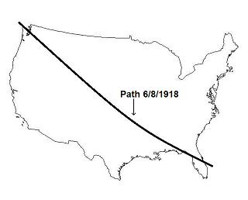

Here’s a graphic that shows a precise relationship that centers on the taking of Jerusalem by Israel on 6/7/1967:
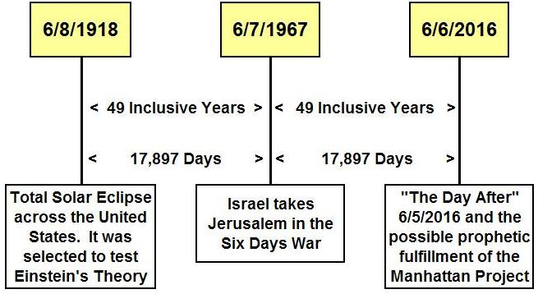

49 inclusive years means that 49 completely filled years have elapsed from the beginning of the day on 6/7/1967 to the end of the day 6/6/2016.

6/7/2016 is the first day of the 50th year from 6/7/1967, and it’s precisely 70 days from today, 3/29/2016.

I don’t know what’s coming, all I can do is show you what YaHuWaH Elohim has shown me. I was made aware of the information on the above graphic on 3/28/2016.
The Jubilee Year

The 50th year is a special year to YaHuWaH Elohim. It’s the year of the Yobel, the Jubilee. The Jubilee is announced on the Day of Atonement in the 49th year from when Israel “entered the land”. When Israel took Jerusalem on 6/7/1967, they “entered the land”. The Day of Atonement in the 49th prophetic year from 6/7/1967 was 9/23/2015.

To announce the 50th year Jubilee of Jerusalem on the Day of Atonement in a special way that would get our attention, YaHuWaH Elohim had Pope Francis and President Obama meet in the White House on 9/23/2015. Did any realize the spiritual importance of this event and the special significance of this particular day?

It should be noted that 6/7/1967 + exactly 17,640 days = 9/23/2015. That means that the Day of Atonement in 2015 was exactly 49 prophetic years (49 X 360 days) from 6/7/1967.

If Israel had taken Jerusalem a day later or a day earlier in the Six days War, the prophetic importance of the taking of Jerusalem pointing to the Jubilee year that would have to be announced precisely on 9/23/2015 would have been missed. YaHuWaH Elohim knows exactly what He’s doing, and has the abilities to accomplish anything He wills.

The date 6/7/1967 + 49 prophetic years points precisely to 9/23/2015, the exact day that the 50th year Jubilee would need to be announced according to YaHuWaH ’s own instructions in His Torah.

We are now in that one year Jubilee period. The Temple Mount was surrendered back into the hands of the King of Jordan shortly after it was acquired by Israel on 6/7/1967.

According to the instructions of YaHuWaH Elohim, the Temple Mount area must be given back to Israel by the end of this current Jubilee year this autumn. Control of the Temple Mount area can’t go from the King of Jordan to the United Nations, it must return to the nation of Israel.

Warning: If control of the Temple Mount is not returned to the nation of Israel this year, Messiah Himself may come to take it by force.

Leviticus 27:24 In the year of the Jubilee the field shall return unto him of whom it was bought, even to him to whom the possession of the land did belong.

YaHuWaH Elohim is not someone to play games with, or to be taken lightly. The world may be about to know without a doubt that there is an Elohim in Israel.

Here’s a summary of the timeline surrounding the 49th anniversary of the Israeli Six Day War. As you can see there are a number of events that involve astronomy, nuclear energy, and Jerusalem that point to 6/5/2016. Our Creator seems to be over emphasizing that particular day for some reason.

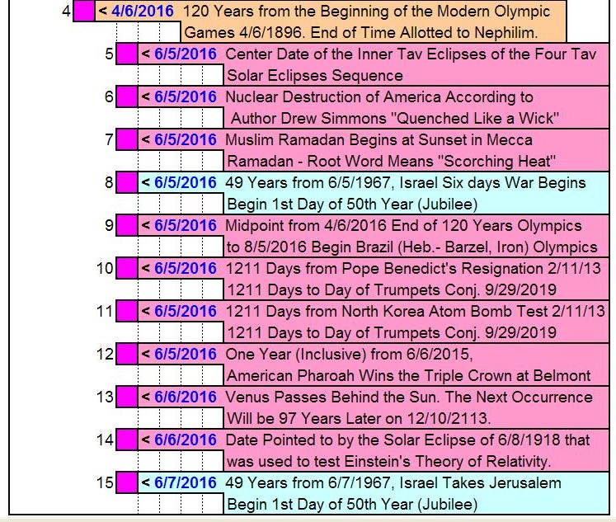

Many of the events listed on the timeline above are explained in prior research articles that are available on this page: http://www.joybysurprise.com/Articles.html

