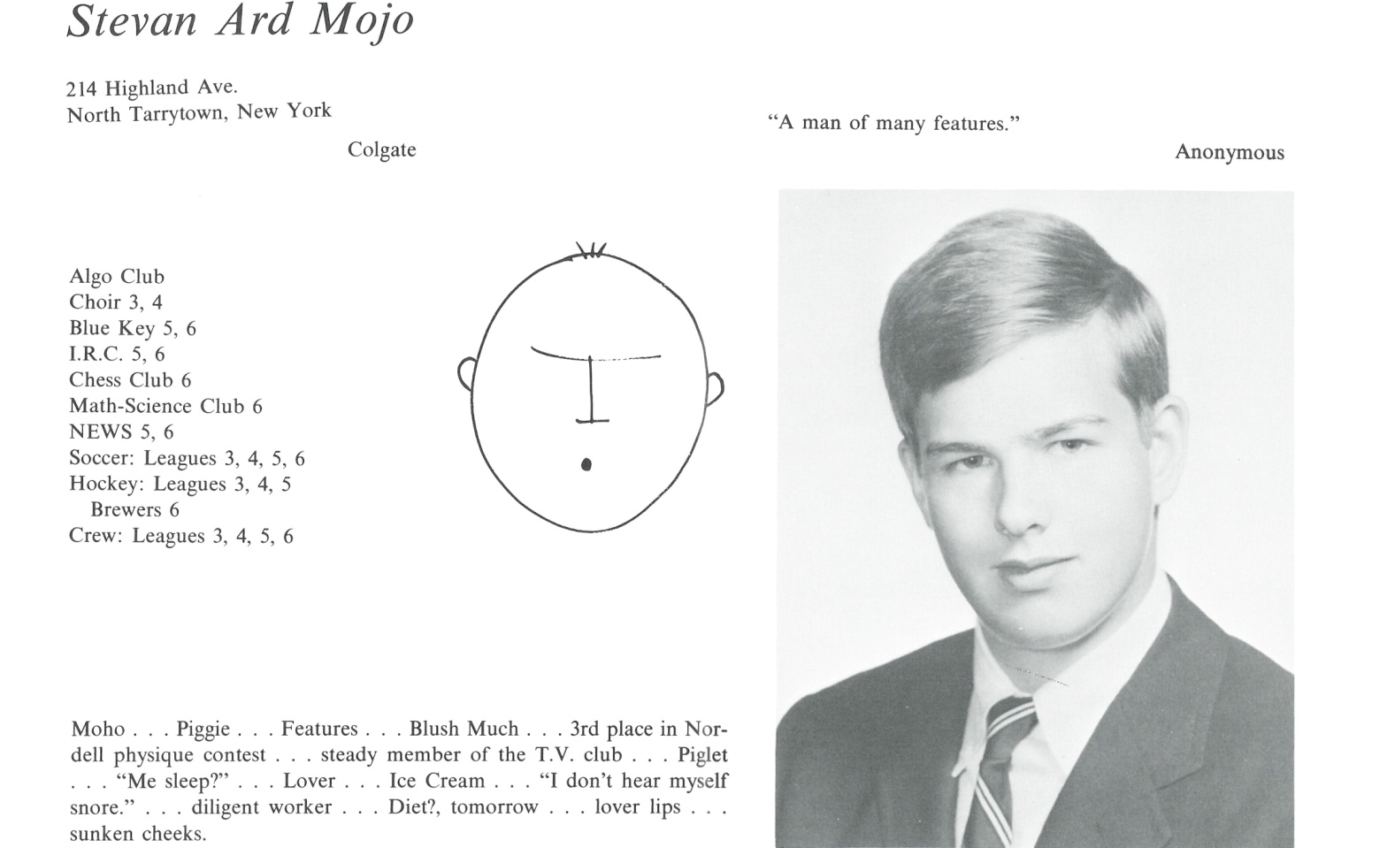

Steven A. Mojo

BS Economics: Colgate Univ. 1971

MBA: Pace Univ. 1977

Retired in 2016 after working in the field of biodegradable plastics for 25 years. During this time I founded the Biodegradable Products Institute and served as its first Executive Director. Prior to that I worked for Warner Lambert in marketing management for their consumer health care and confectionery products.

My wife, Jean, and I live on Cape Cod and we celebrated our 40th wedding anniversary. I am an active sailor and curler and also volunteer for a community sailing program.



______________________________________________________________

______________________________________________________________ ______________________________________________________________ ______________________________________________________________ ______________________________________________________________ ______________________________________________________________ ______________________________________________________________ ______________________________________________________________ ______________________________________________________________

Attach Picture in .jpg Format

______________________________________________________________

______________________________________________________________

___________________________________________________________________________________ _________________________________________________________________________________________________________________________________________________________________________________________________________________________________________________________________________________________________________________________________________________________________________________________________________________________________________________________________________________________________________________________________________________________________________________________________________________________________________________________________________________________________________________________________________________________________________________________________________________________________________________________________________________________________________________________________________________________________________________________________________________________________________________________________________________________________________________________________________________________________________________________________________________________________________________________________________________________________________________________________________________________________________________________________________________________________________________________________________________________________________________________________________________________________________________________________________________________________________

___________________________________________________________________________________