Historical treasure
Research bolsters Donna Meredith’s fascinating tale of Tallahassee high society

Rhett DeVane
Special to the Tallahassee Democrat

In towns and cities across the nation, people rush by rich history overlaid by the present, seldom pausing to wonder about those who had once passed the same way.
Such is true of Florida’s capital city, Tallahassee. If not for dedicated museum curators, archival librarians, and those curious enough to question, all would dissipate beneath the relentless flow of progress, lost to time.
“Margaret: The Rose of Goodwood” by Donna Meredith (Wild Women Writers, 2024) brings to life the fascinating story of Margaret Wilson, the young shop girl, daughter of a tenant farmer and seamstress, who became the wife of aristocrat William Cabot Hodges and developed into one of Tallahassee’s most influential ladies.
“Hodges had the sort of confidence that came from money…from knowing he belonged in high places,” Margaret observed. “The kind of man who flattered and nattered and educated all within earshot.”
At first, the May/December romance flourished, sweeping 18-year-old Margaret into an unfamiliar whirl at the heart of the young city’s aristocratic society. Through dedicated training, she learned the fine art of playing hostess to governors, supreme court justices, and the haughty elite. Yet, when she failed to provide an heir, Margaret’s fairytale existence took a disheartening turn.
But life has a way of shifting, and Margaret proved she could rise above the obstacles pitched in her direction: loss, betrayal, tragedy, and the snarled rigors imposed by her position in society.
Ultimately, fate led her into a second marriage based on mutual love and respect.
“Margaret: The Rose of Goodwood” provides a fascinating view into Margaret’s era.
More importantly, the story doesn’t gloss over the unsavory aspects of navigating Tallahassee high society, the racial issues of the Deep South, or the inequality faced by women.
Because of Margaret Wilson Hodges Hood and the dedication of curators and volunteers, Goodwood managed to survive the ravages of time and progress. The museum and its gardens are treasures of Florida’s capital city.
Weaving heartfelt historical fiction requires a masterful touch. Donna Meredith’s experience and hours of thorough research paid off. The inclusion of actual correspondence and photographs from Margaret’s life bolsters the story of a woman who lived and loved during a pivotal time in U.S. history.
“Margaret: The Rose of Goodwood” reminds the reader of the importance of looking back, taking time to reflect on how far we’ve come and how far we still must go.
Meredith is the author of six awardwinning novels and one nonfiction book. She is currently the editor of Southern Literary Review. A retired English and journalism instructor, Donna now writes full time.
She is past president of Tallahassee Writers Association, a member of Florida Writers Association and West Virginia Writers, Inc., as well as a long-time member of the Tallahassee Garden Club. Originally from Clarksburg, West Virginia, she has called Tallahassee home for over three decades. For more information about Donna Meredith and her writing, visit donnameredith.com.
Rhett DeVane is the award-winning published author of poetry, middle grade chapter books, and fiction for adults. A native of the Florida Panhandle, she has made her home in Tallahassee for over 40 years.
Advertisement
TREASUREfrom page B4 to B5
If you go
What: A wine/cheese reception for the launch of “Margaret: The Rose of Goodwood”
When: 5-7 p.m. April 10. The event is free and open to the public
Where: Goodwood Museum & Gardens (main house), 1600 Miccosukee Road
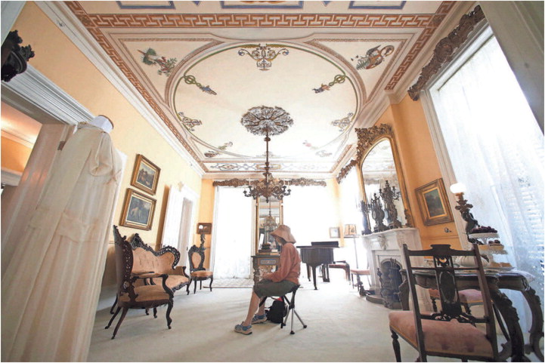
Inside the main house at the Goodwood Museum and Gardens. JOE RONDONE/TALLAHASSEE DEMOCRAT FILE
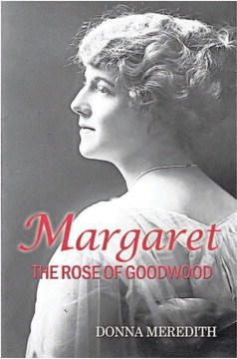
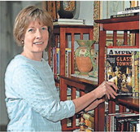
Tallahassee author Donna Meredith, has a new book “Margaret: The Rose of Goodwood.” PHOTOS PROVIDED BY DONNA MEREDITH
Advertisement

