**THE EUCHARISTIC PRAYER**

V. Blessed are you, Lord of heaven and earth, in mercy for our fallen world you gave

your only Son, that all those who believe in Him should not perish, but have

eternal life. We give thanks to you for the salvation you have prepared for us

through Jesus Christ. Send now your Holy Spirit into our hearts that we may

receive our Lord with a living faith as He comes to us in His holy supper.

**C. Amen. Come, Lord Jesus.**

V. In the night in which he was betrayed our Lord Jesus took bread,

he gave thanks; broke it, and gave it to his disciples, saying:

*Take and eat; this is my body, given for you.*

*Do this for the remembrance of me.*



V. Again, after supper, He took the cup, he gave thanks,

and gave it for all to drink, saying:

*This cup is the new covenant in my blood,*

*shed for you and for all people for the forgiveness of sin.*

*Do this for the remembrance of me.*

**

**THE LORD’S PRAYER**

(We ring the bell throughout the Lord’s Prayer at all services to

invite those in the community to join in praying the Lord’s Prayer.)

V. May we now join with one another and pray together as Jesus has taught us.

**C. Our Father, who art in heaven, hallowed be thy name, thy kingdom come,**

**thy will be done, on earth as it is in heaven. Give us this day our daily**

**bread; and forgive us our trespasses, as we forgive those who trespass**

**against us; and lead us not into temptation, but deliver us from evil. For**

**thine is the kingdom, and the power, and the glory, forever and ever.**

**Amen.**

**LAMB OF GOD**

**C:\Users\Vince and Heather\Downloads\Lamb of God, ELW Setting Four (Melody).tif**

(We invite you to be seated.)

**HOLY COMMUNION**

V. Communion here is pretty simple, and all who believe in Jesus Christ are

welcome at this very table.

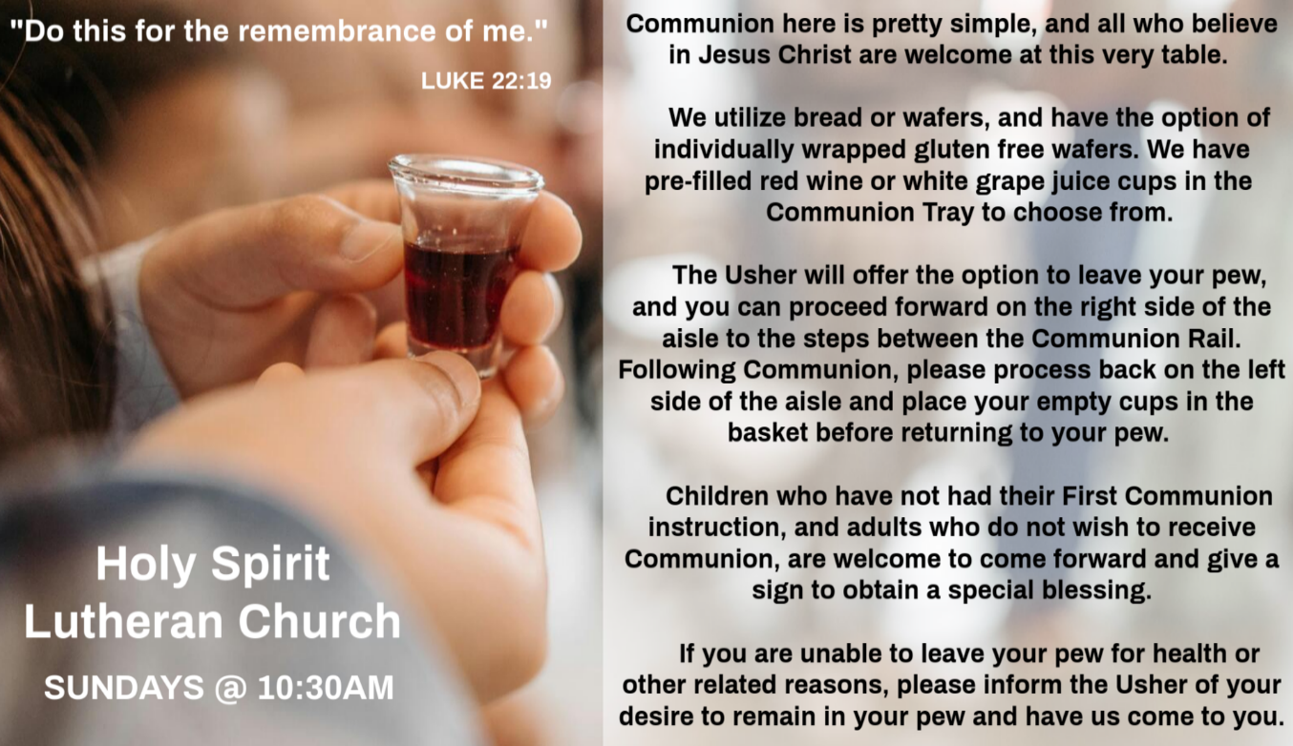

**INVITATION TO COMMUNION**

V. The kingdom of God is set before you.

Eat and rejoice.

**C. Amen.**

(Distribution of Holy Communion)

**COMMUNION HYMN**

(Please enjoy various music offered by our Organist during your

quiet time, prayer, and reflection following Holy Communion.)

(Vicar and Assistant remove Communion Vessels from the Altar.)

(We invite you to stand as you are able.)

**POST COMMUNION BLESSING**

V. May the body and blood of our Lord Jesus Christ strengthen us and keep us

always in His grace.

**C. Amen.**

**GREAT THANKSGIVING**

V. The Lord be with you.

**C. And also with you.**

V. Lift up your hearts.

**C. We lift them to the Lord.**

V. Let us give thanks to the Lord our God.

**C. It is right to give him thanks and praise.**

V. It is indeed right and salutary that we should at all times and in all places offer

thanks and praise to you, O Lord, holy Father, almighty and everliving God. But

chiefly we are bound to praise you for the glorious resurrection of our Lord; for he

is the true Passover Lamb who gave himself to take away our sin, who by his

death has destroyed death, and by his rising has brought us to eternal life. And

so, with Mary Magdalene and Peter and all the witnesses of the resurrection, with

earth and sea and all their creatures, and with angels and archangels, cherubim

and seraphim, we praise your name and join their unending hymn:

**SANCTUS**

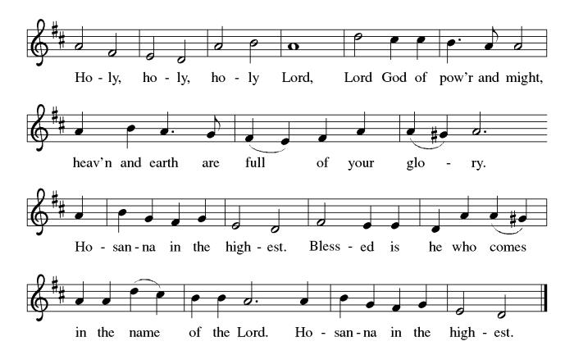

**ANTHEM**

(Special Music for Everyone to Enjoy.)

**All That I Have**

**OFFERING**

V. We now worship God with our tithes and offerings, wine and bread for use in holy

communion, and monetary gifts to support our ministry for service in God’s name.

Our Ushers will be around to your pews to pass the Offering Plates.

(Ushers come forward to get the Offering Plates from the Assistant.)

(Vicar and Assistant prepare the Altar for Communion.)



**OFFERING SONG**

(We invite you to sing along with the music offered by our Organist.)

With One Voice—Blue Book

**732—Create in Me a Clean Heart**

(Usher(s) brings the Tithes and Offerings up front to the Assistant.)

(We invite you to stand as you are able.)

**OFFERING PRAYER**

V. Let us pray,

Creator God,

in your wisdom you bring forth all that is good

and the harvest is plentiful.

Strengthen us at your table with these gifts of the earth

and our labor,

that we may work for the good of all;

through Jesus Christ, our Savior.

**C. Amen.**

**POST COMMUNION CANTICLE**

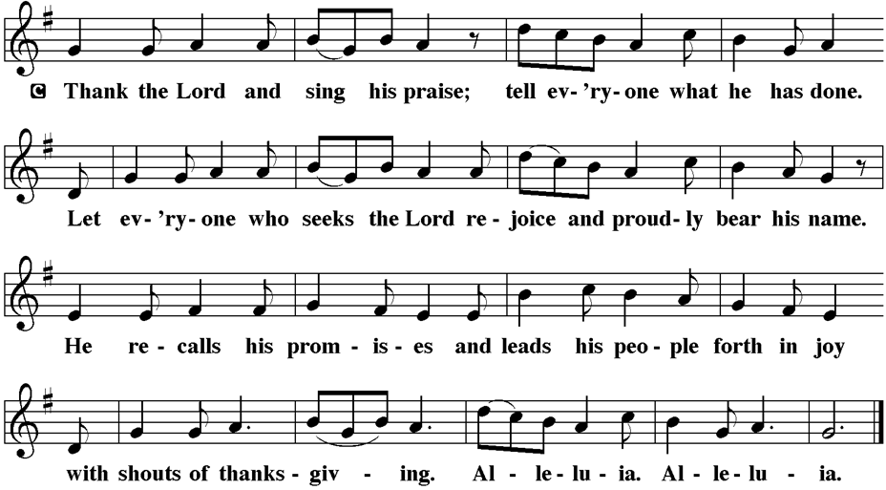

**PRAYER AFTER COMMUNION**

A. Let us pray,

Mothering God,

you gathered us to your table

and we drank deeply of your grace.

Send us out by your Spirit

to love our neighbors as ourselves

and proclaim your love in Jesus’ name.

**C. Amen.**

**BLESSING**

V. The love of God abound in you;

the grace of our Savior Jesus Christ fill your hearts;

and the life of the Spirit

**☩** bless you and give you peace.

**C. Amen.**



**SENDING HYMN**

(We invite you to sing along with the music offered by our Organist.)

Lutheran Book of Worship—Blue Book

**697—Wash, O God, Our Sons and Daughters**

(Assistant extinguishes the Altar Candles half way through the Sending Hymn.)

(Vicar processes out once the Altar Candles have been extinguished.)

(We invite you to be seated.)

**BIRTHDAYS, ANNIVERSARIES, & ANNOUNCEMENTS**

(Offered by Assistant and Congregation.)

**BIRTHDAYS**

23rd Arleen Kinka

24th Lynn Bargstadt

**DISMISSAL**

A. Go in peace. Live by the Spirit.

**C. Thanks be to God.**

**POSTLUDE**

(Music offered by our Organist as we depart following our Worship Service.)

**Higher Ground**

**LICENSES & EXPIRATION DATES**

Worship Service Content is used via permission through Augsburg Fortress Liturgies Annual License #SB144368. The next Subscription Renewal Date is 2/28/2026.

Our Hymns and Worship Music are used via permission through CCLI One

License #11327166. The next Subscription Renewal Date is 1/31/2026.

(Additional Names Added Prior to the Worship Service.)

A. Give perseverance to those of us living with mental illness, and shield us from

discrimination due to race, class, gender, or any other human distinction. God of

grace,

**C. hear our prayer.**

A. We pray for this assembly. Listen to our cries, come to our aid, make us one.

Weave among us the fabric of belonging so that we rejoice in each person

gathered here, and enliven our proclamation of how much you have done for us.

God of grace,

**C. hear our prayer.**

A. We offer our thanksgiving for all people who have died in faith. Keep them in your

peace, comfort us in sorrow, raise us to new life. As we remember their faith and

witness, may we trust your promise that we are yours forever. God of grace,

**C. hear our prayer.**

(Here other intercessions may be offered.)

V. Watch over all of us who are worried and suffering, and especially those whose

names we now say aloud or hold within our hearts (pause). God of grace,

**C. hear our prayer.**

V. Gather all our prayers in your mercy, O God, through Jesus Christ, our Savior.

**C. Amen.**

**SHARING OF THE PEACE**

V. May the peace of the Lord be with you always.

**C. And also with you.**

V. Let us share God’s Peace with one another.

(Please remain in your pews and offer the sign of peace with a peace sign or wave.)



(Following the Sharing of the Peace, we invite you to be seated.)

Al Singer & Family (Frank & Sharon Ford's Friends)

Sherri Lynn (Bob Fritsch's Friend)

John Bannco (Bob Fritsch's Friend)

Nancy Pazarinie (Bob Fritsch's Family)

Jane & Paul Eiben (Rose Lang's Friend)

Joe DiMassimo (Judy Brannan & Mary Melnicoff's Friend)

Tommy Stanford (Sue Waltz's Family)

Audrey McAlister (Sue Waltz's Family)

Joe Waltz (Sue Waltz's Family)

Ronald Velli (Kathy Poehler's Friend)

Denny Papst (Rose Lang’s Friend)

Mike Rhoades (Rose Lang’s Friend)

Jannet Paynter (Leon Stitt’s Friend)

Chris (Judy Brannan's Friend)

Carla Krouse (Skip & Bonnie Millard's Friend)

Helen Ehlers (Judy Brannan's Friend)

Hailey (Fran Green's Friend)

Emily Delaney (Kathy Poehler's Family)

Leanne Bueth (Joan Kilcoyne's Family)

Janett MacFarlane (Carol Amundsen's Friend)

Joe Smith (Heather & Vicar Vince Piekarski’s Family)

Patrick Davenport (Sue Waltz's Friend)

Sonja Anderson (Theresa & Kim McGinley's Family)

Thish Kelly (Theresa & Kim McGinley's Family)

Susan Callahan (Skip & Bonnie Millard's Family)

Bill Garrison (Mike Millard's Friend)

Joanne Shipper (Del McKenna's Family)

Edward Chapleski (Allison Call's Family)

Paul Cibiliew (Vincent Bruno's Friend)

Rob Rech (Heather Piekarski's Friend)

Mary March (Skip & Bonnie Millard's Friend)

Scott Levin (Rose Lang's Friend)

Anthony DeLuca (Church Member)

Daniel Messer (Vincent Bruno's Friend)

Lynne Curlett (Del McKenna's Family)

Alice Ann Dennis (Diana DeNote's Family)

Nancy Taylor (Ted & Diane Bell's Family)

Santa Isabel Lutheran Church (Elizabeth, NJ)

Messiah Lutheran Church (Oakland, NJ)



**WORSHIP MINISTRY**

The most important thing we do each week is gather together as God's people to worship. God is the center and focus of everything we do. Participating in worship is active. Liturgy means the work and actions of the people gathered. Everything we do during the week to prepare for worship, and everything we do as we assist in leading worship is important. We are thankful for all the wonderful work being done. If you are interested in any position let Vicar Vince know so a training can be set-up.

Sign-up sheets are located on the bulletin board between the church offices.



**NEWSLETTER**

Collect information, stories, pictures, and reports for our next seasonal publication. Submit them to Vicar Vince in-person or via email at vpie8282@gmail.com.

**Your Summer Publication will be out to you in the near future.**

**THEOLOGICAL EDUCATION FOR EMERGING MINISTRIES**

Vicar Vince will be back in Gettysburg, PA at United Lutheran Seminary for

Lutheran Heritage, Biblical Foundations, & Lutheran Leadership for Mission intensive classes from **THIS Sunday, June 22nd to Saturday, June 28th.**



**FOOD PANTRY**

**Open every Thursday**, and the **last Saturday of every month**, from **10AM to 1PM**. 69 people were served in May. 378 people have been served in 2025. Donations can be dropped in the basket in the Narthex, placed in the outdoor drop-box by the Church Office door, placed in the money jug in the back of the Church, mailed into the Church Office, or placed in the Offering Plate. Volunteers are needed each week. Sign-up sheets are located on the bulletin board between the church offices.

If you have questions or need training see Heather, Vicar Vince, or Bonnie.

A special thank you goes out to all who donate, pray, and help in any way!

|  |  |  |
| --- | --- | --- |
| **Thursday, 6/26** | **Saturday, 6/28** | **Thursday, 7/3** |
| Tori & Bob | Skip & Bonnie | Tori & Cathie |

**COMMUNITY FOOD DONATIONS, DELIVERIES, & MORE**

Our local North Cape May Acme provides us with Expiring Soon, Recently Expired, and Slightly Damaged Food and Items weekly. Kathy helps those in need by delivering items each Saturday in the community, brings leftover items to the Church for church members in need, and those who visit the food pantry during the week. Additional items are taken over to the Branches Outreach in Rio Grande on Monday.

BettyAnn Rich-White (Church Member)

Chip & Marie Hand (Church Member)

Lynn Bargstadt (Church Member)

Frank & Sharon Ford (Church Member)

Carol Amundsen (Church Member)

Kim McGinley (Church Member)

Judy Brannan (Church Member)

Joan Sommerman (Church Family)

Arleen Kinka (Church Family)

Rick Lang (Church Family)

Suzie Clark (Rose Lang's Friend)

Francis Clock (Dianna DeNote’s Family)

Andrew Hudak (Rose Lang’s Friend)

Viena Murtha (Bob Fritsch’s Friend)

Sharon Waicus (Skip & Bonnie Millard's Friend)

Karen O'Brien (Paul Bowker's Friend)

Dustin Irizzary (Mary Melnicoff's Family)

The Bryan Family (Wanda Bryan's Family)

Craig Brearey (Judy Brannan & Mary Melnicoff's Friend)

Sarah Dutton (Frank & Sharon Ford's Family)

Christina McNasby (Fran Green’s Family)

The Kinkson Family (Judy Brannan's Friends)

Mark Stephen Dennis (Diana DeNote's Family)

Bill Lodge (Skip & Bonnie Millard's Friend)

Patrick & Denise Brannan (Judy Brannan's Family)

Ron Anderson (Bill Kelly's Friend)

Pat Labrae (Kathy Poehler's Friend)

Bud Brearey (Judy Brannan & Mary Melnicoff's Friend)

Mary Skain (Kathy Poehler's Friend)

Bill Rand (Wayne & Eleanor Rand's Family)

Kevin Naylor (Vicki Rinier's Friend)

Robert Chaplin (Mary Melnicoff's Friend)

Jack Wieckouski (Theresa & Kim McGinley's Family)

Carolyn Santarpio (Bob Fritsch's Friend)

Ken Mortensen (Del McKenna's Family)

Harry (Judy Brannan's Friend)

Janet K (Philomena Noak's Friend)

Michael Hart (Diana DeNote's Friend)

Rocco Leonard DeNote (Diana DeNote's Family)

**On the third day he rose again;**

**he ascended into heaven,**

**he is seated at the right hand of the Father,**

**and he will come to judge the living and the dead.**

**I believe in the Holy Spirit,**

**the holy catholic church,**

**the communion of saints,**

**the forgiveness of sins,**

**the resurrection of the body**

**and the life everlasting. Amen.**

**PRAYERS OF INTERCESSION**

(The prayers are prepared locally for each occasion.)

V. Drawn into the embrace of the holy Trinity, we lift our prayers for the wholeness of

the church, the world, and all creation.

(A brief silence.)

A. We pray for the church. Clothe us in Christ, shower us in mercy, send us in love.

Strengthen the faith and witness of Christians across the planet and Christians in

our community. God of grace,

**C. hear our prayer.**

A. We pray for creation. Deliver the earth from disaster, bring forth life amid

uncertainty, inspire wonder at all you have made. Sustain all people who delight

in the well-being of your creation: farmers, agricultural workers, gardeners,

birdwatchers, conservationists, scientists, advocates, and policy makers. God of

grace,

**C. hear our prayer.**

A. We pray for the nations. Pave a way to justice, drown the forces of oppression,

bring peace on earth. Give leaders the will to turn from war and violence. When

people must flee their homes, guide them to safety. God of grace,

**C. hear our prayer.**

A. We pray for people in need. Satisfy all who are poor, soothe those in pain,

accompany all who are sick; especially:

**BULLETIN ENTRY DEADLINE**

The Bulletin is Printed on **Thursdays** during Church Office Hours. Changes need to be submitted to Vicar Vince or Heather no later than **Thursday by 4PM**. Thank you!

**CHURCH OFFICE**

Open **Thursdays from 6PM to 8PM** to serve the Congregation, the Community,

and to continue handling the business of the Church. Feel free to stop in to talk,

pick-up or drop off something, pray in the Sanctuary, or for whatever reason.

**SPECIAL PREACHER FOLLOWING SEMINARY WEEK**

Heather Piekarski has been confirmed and is happy to be here and Preaching on

**Sunday, June 29th**, following Vicar Vince’s week of 3 Intensive Classes. Please note that there will be Holy Communion as Vicar Vince will be back from Seminary.



**DONATION STATION**

Get on the train and place all purchased items in the specified project donation bins located on the counter by the front doors. See Heather for more information.



**WOMEN OF THE CHURCH**

The next monthly meeting will be held on **Monday, July 7th, at 6PM**.

New members are always welcome to attend! Contact Judy for more information.

**S’MORES & SCRIPTURE**

Did you ever look forward to sitting around a fire in the church yard hanging out with some folks, enjoying s’mores, and studying scripture? Come join us on **Saturday, July 12th, at 6PM**. Ask Heather or Vicar Vince for more information.

**COFFEE HOUR**

The Women of the Church will be hosting our next Coffee Hour on **Sunday,**

**July 13th**, following our Worship Service. See Judy or Kathy for more info.

**CHURCH COUNCIL**

Share your comments, concerns, questions, or joys with one of our Church Council Members who can bring them back to our meetings. Visitors are always welcome to attend and listen to what is going on in and around the church. Join us In- Person or on our Conference Call at our next Meeting on **Tuesday, July 15th, at 6PM**.

**75TH ANNIVERSARY MEETING**

I encourage you all to continue thinking how we are going to celebrate this legacy as we continue our preparations during our next Committee Meeting on **Sunday,**

**July 20th, following our Worship Service**. We will review potential Banner Designs and Estimated Costs at this meeting as well.

**SPECIAL PREACHER**

Pastor Chuck Romanowski has been confirmed and is happy to be here and Preaching on **Sunday, July 27th**, while Vicar Vince is on Vacation in Pittsburgh. There will be Holy Communion during this Worship Service.

**BIBLE STUDY & FAITH DISCUSSIONS**

​​​​​Bible Study & Faith Discussions was started in order to focus on various readings,

books, Bible verses, people of faith, and other general topics. Group Members offer

various points of view while reviewing the Bible and various aspects of faith while

being respectful and supportive of each other. **Join us on Tuesdays at 6PM when we return from our Summer Break following Labor Day**.

**SUNDAY SCHOOL & CONFIRMATION**

“Here We Stand” is a program that allows our young folks to go through a 2-year process while focusing on the Bible and Luther’s Small Catechism. **The program is on Summer Break and will resume on Sundays from 9-10AM in September.**

We are also exploring resuming regular Sunday School classes for children of all ages to attend. We are looking at various dates and times in this planning process.

See Heather, Bonnie, & Vicar Vince for more information.

**SPECIAL PREACHER**

Chip Hand has been confirmed and is happy to be here and Preaching on

**Sunday, October 5th**, while Vicar Vince and Heather are on their annual trip to Knoebels. Please note there will not be Holy Communion that Sunday as a result.

possessed by demons had been healed. 37 Then the whole throng of people of

the surrounding region of the Gerasenes asked Jesus to leave them, for they

were seized with great fear. So he got into the boat and returned. 38 The man

from whom the demons had gone out begged that he might be with him, but

Jesus sent him away, saying, 39 “Return to your home, and declare how much

God has done for you.” So he went away, proclaiming throughout the city how

much Jesus had done for him.

V. This is the Gospel of the Lord,

**C. Praise to you, O Christ.**

**SERMON**

(Delivered by Vicar Vince Piekarski.)

V. We invite you to stand as you are able.



**HYMN OF THE DAY**

(We invite you to sing along with the music offered by our Organist.)

With One Voice—Blue Book

**750—Oh, Praise the Gracious Power**

**APOSTLES’ CREED**

V. God has made us his people through our Baptism into Christ. Living together in

trust and hope let us confess our faith together using the Apostles’ Creed.

**C. I believe in God, the Father almighty,**

**creator of heaven and earth.**

**I believe in Jesus Christ, God’s only Son, our Lord,**

**who was conceived by the Holy Spirit,**

**born of the Virgin Mary,**

**suffered under Pontius Pilate,**

**was crucified, died, and was buried;**

**he descended to the dead.**

V. I invite you to stand as you are able, and I invite you to announce the Gospel

Acclamation with me.

**GOSPEL ACCLAMATION**

**C.** **Alleluia. Return to your home, and declare how much God has done for you.**

**Alleluia.** (Luke 8:29)

**GOSPEL READING**

Jesus’ mission includes foreigners and his authority extends to the casting out of

demons. Some who witness Jesus’ work are seized with confusion and fear, but

the man who was healed is commissioned to give testimony to God’s mercy and

power.

V. The Holy Gospel According to Luke, the 8th Chapter (Verses 26-39).

**C. Glory to you, O Lord.**

V. 26 Then [Jesus and his disciples] arrived at the region of the Gerasenes, which is

opposite Galilee. 27 As he stepped out on shore, a man from the city who had

demons met him. For a long time he had not worn any clothes, and he did not live

in a house but in the tombs. 28 When he saw Jesus, he cried out and fell down

before him, shouting, “What have you to do with me, Jesus, Son of the Most High

God? I beg you, do not torment me,” 29 for Jesus had commanded the unclean

spirit to come out of the man. (For many times it had seized him; he was kept

under guard and bound with chains and shackles, but he would break the bonds

and be driven by the demon into the wilds.) 30 Jesus then asked him, “What is

your name?” He said, “Legion,” for many demons had entered him. 31 They

begged him not to order them to go back into the abyss.

32 Now there on the hillside a large herd of swine was feeding, and the demons

begged Jesus to let them enter these. So he gave them permission. 33 Then the

demons came out of the man and entered the swine, and the herd stampeded

down the steep bank into the lake and was drowned.

34 When the swineherds saw what had happened, they ran off and told it in the

city and in the country. 35 Then people came out to see what had happened, and

when they came to Jesus, they found the man from whom the demons had gone

sitting at the feet of Jesus, clothed and in his right mind. And they became

frightened. 36 Those who had seen it told them how the one who had been



The Synod has been contacted! We have been placed on the Bishop’s Calendar for **Sunday, October 19th**. **We will have one Worship Service at 3PM this day.** This congregation is a legacy that we have all lived in and through over all of these years, or maybe just for a short time. However, it is a legacy that we hope and desire to continue to carry on and move forward for those people that will be able to gather and worship with us and following us as well. We are the church carries a strong mentality with it, and it does not just mean within these very walls. We need to celebrate those 75 years of being part of this community, and all that has led up to the very start of this church body as well.

**HOME COMMUNION MINISTRY**

A Minister is available if you have a loved one, or if you desire services. We look forward in sharing the Word and Holy Communion! Please inform Vicar Vince, Kathy, or the Church Office so plans can be made for visits.

**PRAYER SHAWL MINISTRY**

Prayer Shawls, Lap Quilts, Scarves, and other items have been made with love. Blessed items are located in the Narthex, and are free for anyone. Members of the group continue working at home on new stitches and patterns. We are blessed to be able to continue collecting new items. We have a donation station of yarn and other items located in the Narthex. You can find some new supplies for your next creation!

**PRAYER LIST**

Our Prayer List continues to lengthen and we realize the important need for prayers and healing. Sometimes the unfortunate result is that someone has passed away, and the words “The Family & Friends of” appear before someone’s name. However, sometimes we forget names are still on the list and their health has improved or the they are no longer struggling, and they can be removed. Please share the good and bad stories as we continue to pray for strength and healing. Names can be added or removed from the list on the clipboard in the Narthex prior to the Worship Service, by calling the church office, or addressing it on the Conference Call. Please let us know the relation to the person(s) you listed so we can be more mindful with our prayers. Names will stay on the list until removed by the person(s) who requested prayer.

**FAVORITE HYMNS**

Carol is willing to play some of your favorite hymns for the Prelude & Postlude each Sunday during our Worship Service. Feel free to let her know of your suggestions.

**TITHES, OFFERINGS, & ENVELOPES**

2025 Offering Envelopes are available. Please see Heather if you have not received yours, or would like to have some. For we do indeed worship God with our tithes and offerings. We hear this in scripture, “Each of you must give as you have made up your mind, not reluctantly or under compulsion, for God loves a cheerful giver.”

(2 Corinthians 9:7) Feel free to drop your envelopes in the offering plate, mail them to the church, or drop them off in the locked mailbox. Thanks for your continued support in the mission of our church, its ministries, the NJ Synod, and other needs!

**ED GREEN CAPITAL IMPROVEMENT FUND**

We continue raising money for unforeseen costs or repairs.Kathy sells Wawa Tickets for $6, the donation bin is in the back of the church, and we have our Annual Church Rummage Sale. Thanks for your continued donations, prayers, and support!



​​​​​Do you know anyone interested in utilizing our Fellowship Hall for a Party or Event?

It is a suggested $50 refundable security deposit, and $250 for facility use. There is no alcohol or games of chance permitted due to ELCA policy. Please contact Vicar Vince or the Church Office with questions, for info, or to reserve a date and time.

**LIBRARY**

New books are added to our library from time to time. Several are borrowed and read and exchanged. Who knows, you might find one particularly interesting and share that with someone as well. Reading is a great way to pass spare time, learn, and explore. You may find some fresh ideas for prayer, ways to grow more spiritually, ways to grow closer to God, or some opportunities to understand our faith more. Visit the library between the church offices and see what books are there!

We also have an extended library located in Vicar Vince’s office. There are Bibles of various translations, books from his personal collection, books inherited from Pastor Leah, movies, past Bible Study Curriculums, and more. Just ask to check things out!

R. 23 You who fear the Lord, give praise! All you of Jacob’s line, give glory.

   Stand in awe of the Lord, all you offspring of Israel.

  24 For the Lord does not despise nor abhor the poor in their poverty;

neither is the Lord’s face hidden from them;

   but when they cry out, the Lord hears them.

  25 From you comes my praise in the great assembly;

   I will perform my vows in the sight of those who fear the Lord.

  26 The poor shall eat and be satisfied,

   Let those who seek the Lord give praise! May your hearts live forever!

**C. In the midst of the assembly I will praise you.** (Ps. 22:22)

R. 27 All the ends of the earth shall remember and turn to the Lord;

   all the families of nations shall bow before God.

  28 For dominion belongs to the Lord,

   who rules over the nations.

**C. In the midst of the assembly I will praise you.** (Ps. 22:22)

**SECOND READING**

For Paul, baptism is a powerful bond that unites people not only with God but

with other believers. Those who call themselves children of God experience a

transformation that removes prejudices of race, social class, or gender in favor of

true unity in Christ.

R. Our Second Reading is from the 3rd Chapter of Galatians (Verses 23-29).

R. 23 Now before faith came, we were imprisoned and guarded under the law until

faith would be revealed. 24 Therefore the law was our disciplinarian until Christ

came, so that we might be reckoned as righteous by faith. 25 But now that faith

has come, we are no longer subject to a disciplinarian, 26 for in Christ Jesus you

are all children of God through faith. 27 As many of you as were baptized into

Christ have clothed yourselves with Christ. 28 There is no longer Jew or Greek;

there is no longer slave or free; there is no longer male and female, for all of you

are one in Christ Jesus. 29 And if you belong to Christ, then you are Abraham’s

offspring, heirs according to the promise.

R. This is the Word of the Lord.

**C. Thanks be to God.**

 These are a smoke in my nostrils,

  a fire that burns all day long.

 6 See, it is written before me:

  I will not keep silent, but I will repay;

 I will indeed repay into their laps

  7 their iniquities and their ancestors’ iniquities together,

 says the Lord;

 because they offered incense on the mountains

  and reviled me on the hills,

 I will measure into their laps

  full payment for their actions.

 8 Thus says the Lord:

 As the wine is found in the cluster,

  and they say, “Do not destroy it,

  for there is a blessing in it,”

 so I will do for my servants’ sake

  and not destroy them all.

 9 I will bring forth descendants from Jacob

  and from Judah inheritors of my mountains;

 my chosen shall inherit it,

  and my servants shall settle there.

R. This is the Word of the Lord.

**C. Thanks be to God.**

**PSALM**

R. Our Responsorial Psalm is from the 22nd Psalm (Verses 19-28).

**C. In the midst of the assembly I will praise you.** (Ps. 22:22)

R. 19 But you, O Lord, be not far away;

   O my help, hasten to my aid.

  20 Deliver me from the sword,

   my life from the power of the dog.

  21 Save me from the lion’s mouth!

   From the horns of wild bulls you have rescued me.

  22 I will declare your name to my people;

   in the midst of the assembly I will praise you.

**C. In the midst of the assembly I will praise you.** (Ps. 22:22)

**INTERESTED IN BECOMING A NEW MEMBER**

Have you been attending our church for a while? Have you just recently returned to church after being away for a bit? Maybe you transitioned from another church,

or just started to recently attend our church. We are glad to have you, and would love to have you as a member of our Congregation. See Vicar Vince for more info.

**BAPTISM**

We are a church whose unity is in Jesus Christ, who gathers us around word and water, wine and bread. Baptism is a significant part of our faith journey as we come from the baptismal waters to live a new life as children of God. Our baptism sets us out on a lifelong journey that is characterized by our relationship to God, our relationship to our faith community, our relationships in our community and the wider world. Living our baptismal covenant means living a life of growth in the faith practices of discipleship. Please see Vicar Vince for more information.

**FIRST COMMUNION**

Although no particular age for first communion is prescribed by The Use of the Means of Grace, one guideline is offered. Because admission to the Sacrament is by invitation of the Lord to the baptized, "baptized children begin to commune on a regular basis at a time determined through mutual conversation that includes the pastor/vicar, the child, and the parents or sponsors involved, within the accepted practices of the congregation.” Each congregation is encouraged to ask the question of readiness for first communion, establish their own policies regarding age and practice, and accompany that practice with catechesis appropriate to the age of the communicant. If anyone has questions, please see Vicar Vince.

**2025 CHURCH DIRECTORY**

Additional copies are by the Church Office on the bookshelves. We continue keeping it updated and undoubtedly miss a few changes or have made a few errors. There are spaces for changes in info, new people’s info, notes, and your favorite Bible verses. Please continue to inform the Church Office of any changes or updates.

**TAKING FAITH HOME**

Vicar Vince was introduced to Milestones Ministries weekly guides for faith-filled studies and conversations through a Seminary class. A decision was made to pass these along to you. If you missed a week, or lost your insert, check our website for past issues. Feel free to ask questions and provide feedback to Vicar Vince.

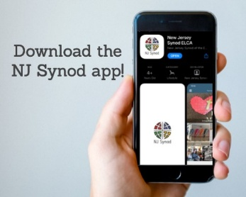

Jersey Jottings is a weekly e-newsletter that connects our synod together with weekly prayer, upcoming events, synod and churchwide activities, mission stories, congregational activities, and more. You can also sign up by going to https://www.njsynod.org/stay-connected and filling out the form! You can also get the app on your smartphone in the Apple App Store or on Google Play on your android.



**VICAR APPOINTMENT ON MARCH 19TH, 2023**

A Memorandum of Understanding on the Matter of Pastoral Appointment

In Theological Education for Emerging Ministries (TEEM) Candidacy

TO: Congregation Council, Holy Spirit Lutheran Church, Villas

FROM: The Rev. Tracie L. Bartholomew, Bishop, New Jersey Synod

Dear Brother and Sisters in Christ,

This memorandum is in support of your discussions with Vincent Piekarski as pastor of Holy Spirit, Villas. Because this is not the usual pattern for completing the educational and candidacy requirements for ordination, it is my hope that this memorandum will both provide guidelines and engage in conversation with those who are invested in this process.

I would say at the outset that because Vincent is an outstanding candidate for the Ministry of Word and Sacrament, we will all want to do whatever is necessary to assure that his placement serves the mission of the church in the best possible fashion.

**PRAYER OF THE DAY**

V. The Lord be with you.

**C. And also with you.**

V. Let us pray,

O Lord God, we bring before you the cries of a sorrowing world. In your mercy set

us free from the chains that bind us, and defend us from everything that is evil,

through Jesus Christ, our Savior and Lord.

**C. Amen.**

(We invite you to be seated for our Readings and Psalm.)

**FIRST READING**

The prophet announces God’s impatience. The people’s self-absorption is

idolatry, and images of practices that displease God fill this reading. Like a

vintner who crushes the grape to release the wine, God will use Israel’s exile to

establish a new community of the faithful.

R. Our First Reading is from the 65th Chapter of Isaiah (Verses 1-9).

R. 1 I was ready to be sought out by those who did not ask,

   to be found by those who did not seek me.

  I said, “Here I am, here I am,”

   to a nation that did not call on my name.

  2 I held out my hands all day long

   to a rebellious people,

  who walk in a way that is not good,

   following their own devices;

  3 a people who provoke me

   to my face continually,

  sacrificing in gardens

   and offering incense on bricks;

  4 who sit inside tombs

   and spend the night in secret places;

 who eat the flesh of pigs,

  with broth of abominable things in their vessels;

 5 who say, “Keep to yourself;

  do not come near me, for I am too holy for you.”

**HYMN OF PRAISE**

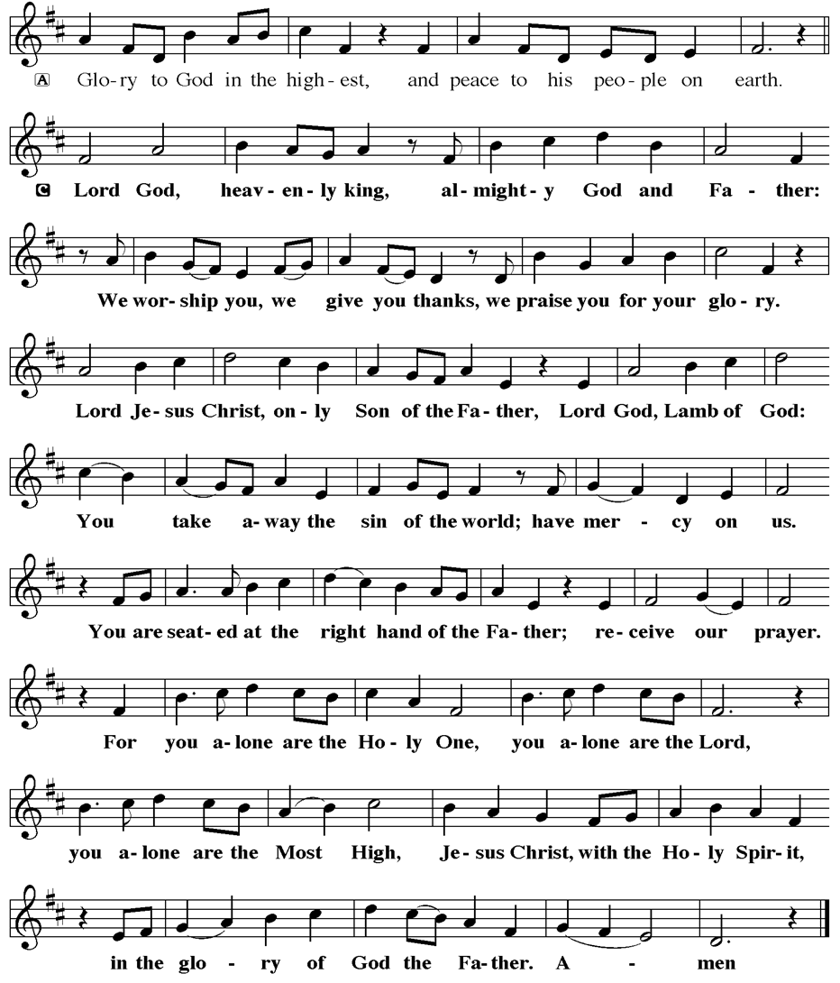

The following notes reflect my own understanding of this matter:

(1) The appointment for Vincent will begin on April 1, 2023. At this time, Vincent

will assume all responsibilities of a regularly called pastor, including presiding at

the Sacrament of Holy Communion and Baptism at Holy Spirit, Villas.

(2) A pastoral appointment in the TEEM process is an option for completing

seminary educational requirements and the steps of the candidacy process.

Upon completion of the candidacy process and seminary education, the

candidate may receive and accept a call to ordained ministry from the

congregation where the appointment is being served.

(3) This appointment is jointly supervised by the Office of the Bishop and the TEEM

pastor’s seminary. A mentoring relationship with a local pastor is required for the

length of this appointment.

(4) The synod of candidacy origin will be responsible for the approval process.

(5) Upon approval for ordination, the congregation would be expected to extend a

call to the pastoral appointee.

(6) Compensation for the TEEM pastor will be according to the guidelines of the New

Jersey Synod. All normal forms of compensation should be in place for the term

of the appointment, including stipulation that base salary and housing shall be in

accord with synod guidelines for first call at time of ordination.

(7) The ELCA Portico benefit plan for lay persons in full-time church service should

be used for the pastoral appointee up to the time of ordination, whereupon the

benefit package is to be converted to the plan for ELCA clergy.

(8) A decision for Pastoral Appointment is made with the agreement of a synod and

its candidacy committee, and the ELCA, normally represented by the regional

staff person of each in consultation with the seminary and its Director for

Contextual Education.

(9) Pastoral Appointment in a TEEM Candidacy is an option that is to serve the

mission of the Church in a particular and vital way and is not to be viewed or

used as a means to circumvent the normal candidacy process and/or first call

placement process.

In the specific case of Vincent, the New Jersey Synod remains responsible for the candidacy and approval process, and has agreed to this proposal for Appointment at Holy Spirit, Villas.

Continued blessings to both Holy Spirit and Vincent Piekarski as you embark on this journey of mutual ministry. As partners in ministry, we walk with you and rejoice in this new relationship.

**VICAR VINCE’S DAY OF REST**

A day of rest can have physical, mental, and spiritual benefits. “Mittwoch,” German for mid-week, or Wednesday, is the day that Vicar Vince will use to recharge and do some other things. Please do not hesitate to reach out if there is an emergency!

**VICE PASTOR UPDATE**

Pastor William Hodgetts continues to attend our monthly Church Council Meetings. Pastor William continues to provide Supervision and Direction for Vicar Vince.

**TRUE DELIVERANCE PRAISE & WORSHIP CENTER**

Reverend Maria Brooks and True Deliverance Praise & Worship Center utilize our facilities from 1-4PM on Sundays. TDPWC helps with the Food Pantry and hosts or assists with other events throughout the year. TDPWC hosts a **Prayer Line** on **Mondays, Thursdays, & Fridays at 5PM** on the **Conference Call 1-657-390-7957**.

**TUESDAY SEWING CIRCLE**

**COFFEE, CHIPS, FELLOWSHIP, QUILTS!**

You all—men included—are warmly invited to join **Holy Trinity Lutheran Church in Wildwood on Tuesday morning at 10 AM**. No sewing skills required! We welcome anyone looking to be part of a friendly group that enjoys doing a variety of activities together. We meet in the front room of the Parish Hall at 2810 Atlantic Ave. There’s parking available behind the church, and you can enter through the rear door. Just bring a sandwich or snack for lunch! For more information, please contact: Louise McHugh at tillie26@verizon.net or Martha Neff at marthaneff1@yahoo.com



**APOSTOLIC GREETING**

V. May the grace of our Lord Jesus Christ, the love of God,

and the communion of the Holy Spirit be with you all.

**C. And also with you.**

**KYRIE**

V. In peace, let us pray to the Lord.

**C. Lord, have mercy.**

V. For the peace from above, and for our salvation, let us pray to the Lord.

**C. Lord, have mercy.**

V. For the peace of the whole world, for the well-being of the church of God,

and for the unity of all, let us pray to the Lord.

**C. Lord, have mercy.**

V. For this holy house, and for all who offer here their worship and praise,

let us pray to the Lord.

**C. Lord, have mercy.**

V. Help, save, comfort, and defend us, gracious Lord.

**C. Amen.**

V. Merciful God,

**C. you free us to love others,**

**but we neglect our neighbors and follow our own way.**

**You lead us by the Spirit of joy and peace,**

**but we turn away from the abundant life you offer.**

**You surround us with patience, kindness,**

**and generosity,**

**but we grow weary in doing what is right.**

**In your mercy, forgive us.**

**Do not give up on us.**

**Heal us, break our bonds,**

**and show us the path of life.**

**Amen.**

V. You belong to Christ Jesus

and you are God’s children through faith.

In the cross of **☩** Christ,

and through the power of the Holy Spirit,

your sins are forgiven.

Clothed with Christ, you are a new creation.

**C. Amen.**



**GATHERING HYMN**

(We invite you to sing along with the music offered by our Organist.)

With One Voice—Blue Book

**716—Word of God, Come Down on Earth**



|  |  |
| --- | --- |
| **2025 FINANCIAL STANDING** | |
| **MAY INCOME** | $8,195.00 |
| **MAY SPENDING** | $5,567.75 |
| **MAY GAIN OR (LOSS)** | $2,627.25 |
| **2025 INCOME** | $32,859.00 |
| **2025 SPENDING** | $35,137.87 |
| **2025 GAIN OR (LOSS)** | ($2,278.87) |
| **ED GREEN CAPITAL IMPROVEMENT FUND** | $12,511.55 |
| **FOOD PANTRY FUND (SOCIAL MINISTRY)** | $12,318.15 |
| **CD** | $25,827.92 |
| **75TH ANNIVERSARY** | $6,525.41 |



**WHAT IS THE EVANGELICAL LUTHERAN CHURCH IN AMERICA?**

The ELCA was formed in 1987 by the merger of three Lutheran Church bodies –

the ALC (American Lutheran Church), the LCA (Lutheran Church in America),

and the AELC (Association of Evangelical Lutheran Churches).

To learn more, go to the ELCA's website at www.elca.org.



**WHAT IS THE NEW JERSEY SYNOD?**

The New Jersey Synod is a geographical grouping of Evangelical Lutheran Church in America (ELCA) congregations that share the mission and ministry of the Church on the New Jersey territory. It is one of 65 synods in the ELCA. The NJ Synod is comprised of 146 congregations, which include over 45,000 baptized members.

**CHURCH STAFF & VOLUNTEERS**

**VICAR, BIBLE STUDY & FAITH DISCUSSIONS,**

**EVENTS, NEWSLETTER, & WEBSITE**

Vicar Vince Piekarski

**VICE PASTOR**

Pastor William Hodgetts

**ORGANIST & PIANIST**

Carol Amundsen

**CHURCH OFFICE, SUNDAY SCHOOL, & FOOD PANTRY**

Heather Piekarski

**CHURCH COUNCIL PRESIDENT**

Mary Melnicoff

**CHURCH COUNCIL VICE PRESIDENT**

Judy Brannan

**CHURCH COUNCIL TREASURER**

Bonnie Millard

**CHURCH COUNCIL SECRETARY**

Vicki Rinier

**CHURCH PROPERTY**

Frank Ford & Wayne Rand

**CONFERENCE CALL CHECK-IN**

(Roll Call and Attendance.)

**WELCOME & ANNOUNCEMENTS**

(Vicar (V), Assistant (A), and Congregation (C).)

**INTRODUCTION**

A. This Sunday’s texts paint startling pictures of the horrific nature of sin. The

church’s repeated celebration of holy communion counters that tragic reality in a

continued showing forth of the death of Jesus until he comes again. It is a

dramatic declaration of “how much God has done for you.”

**PRELUDE**

(Music offered by our Organist before the start of our Worship Service.)

**Holy, Holy, Holy**

**CHIMES**

(Music offered by our Organist before the start of our Worship Service.)

**What a Friend We Have in Jesus**

(We invite you to stand as you are able.)

**CONFESSION & FORGIVENESS**

(All may make the sign of the cross, the sign that is marked at baptism.)

V. In the name of the Father,

and of the **☩** Son,

and of the Holy Spirit.

**C. Amen.**

V. Baptized into Christ, let us confess our sin.

(Silence is kept for reflection.)



We, the Evangelical Lutheran Church of the Holy Spirit, are People of God, who

are called by the Holy Spirit to pray, worship, joyfully proclaim Jesus Christ,

and compassionately witness and serve others in Christian Love.



We are glad that you joined us for Worship today! Thank you for enriching our time together! We would like to get to know you better, and we would like for you to get to know us better too. Brochures, welcome gifts, prayer shawls, Bibles, and other items are available at our welcome areas. Church members are happy to show you around and share about our ministries. Please don’t hesitate to speak up and ask questions. Please make sure you sign-in on our clipboard on the podium in the lobby.



Our Worship Services are conducted in coordination with our Conference Call.

Join us at 657-390-7423, and if that does not allow you to gain access utilize

701-802-5170, with access code 8221190#. You may need to dial 1 first depending on your phone plan. After logging in please announce your name and feel free to talk with others until we get started with our Worship Service.



Candles cost $10 each. Sign-up sheets are located on the bulletin board between the church offices. Please feel free to see Vicar Vince with any questions.

**SANCTUARY CANDLE**

June’s is given to the Glory of God & in memory of

PHILIP ZIMMERMAN, JR. by Phil & Bob Zimmerman.

**ALTAR CANDLES**

June’s are given to the Glory of God & in memory of

DAVID ZWILLING by Bonnie & Skip Millard.

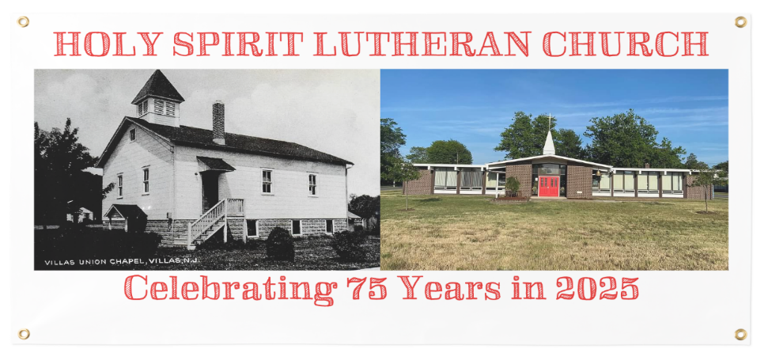

**WELCOME TO**

**HOLY SPIRIT LUTHERAN CHURCH**

A Member of the Evangelical Lutheran Church in America, New Jersey Synod

1220 Bayshore Rd., Villas, NJ 08251, 609-886-2414,

holyspiritlutheran@comcast.net, holyspiritvillas.com, facebook.com/holyspiritvillas

Vicar Vince Piekarski can be contacted at any time for conversation or prayer through call or text at 412-225-0287, or through email at vpie8282@gmail.com.

**2ND SUNDAY AFTER PENTECOST**

**SUNDAY, JUNE 22ND, 2025**

**10:30AM WORSHIP SERVICE WITH HOLY COMMUNION**



