On 12/9/17 and 12/10/17 we went on a two day field trip and hit a few locations near Barstow, Ca. On the first day we did went collecting in the “Powerline” area of Lavic in the morning and in the afternoon we hit the Hector Rd on the way back to Barstow. On the second day we went to the hills behind Calico Ghost Town and in the Mojave River. These are two easy areas and everyone came home with plenty of rock for slabbing and cabbing.
12/9 was a travel day so we started with locations where we could find material quickly. The “Powerline” area of Lavic is on the north end of the Lavic jasper field. It is called Powerline because it runs under large power lines in the area as shown in the photo below. Every once in a while we heard a deep “Whump” sound. The Marines were doing something explosive on the Twenty Nine Palms weapons range which is miles to the south of us. In the background of this photo you can see dust clouds from bombs or artillery. I like to think that they were giving us a 21 gun salute for getting out in the filed.
Powerline area from the highway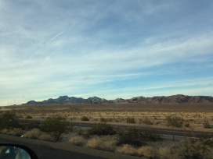
Sayard decides which ones to take home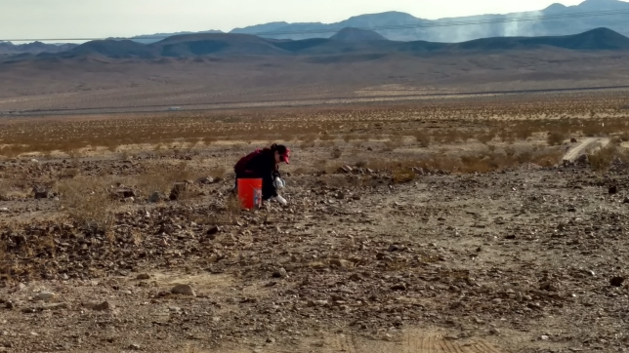
Brent and Brett exploring, Sayard taking a picture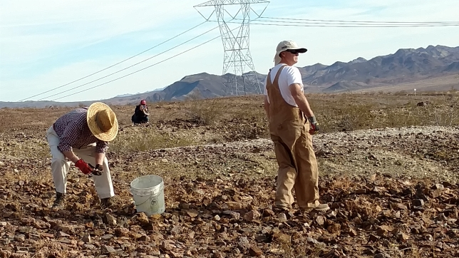
Plenty of rocks (yes those colors are real)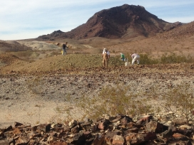
This area of Lavic has the reds, oranges and yellows that Lavic is famous for, but there are also greens and sometimes purples as well.

Kit and Sayard digging fresh rock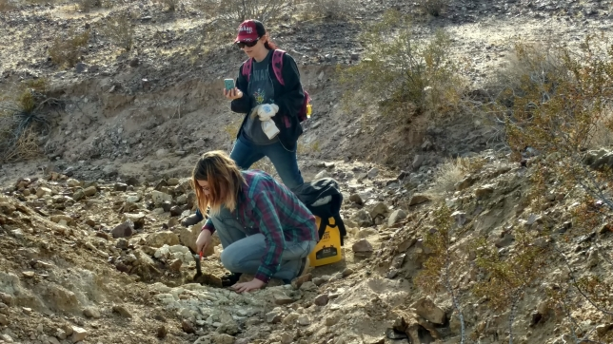
Lots of colorful jasper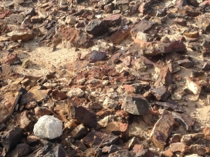
This was surface collecting at it’s easiest. There was so much rock on the ground it took you time to pick them all up so you see if it was the best of the best. Jasper from this area is called Lavic Siding jasper or just Lavic Siding. The name goes back to the old steam engine days. Each “stop” on the line was called a siding. Lavic was the last name of a railroad employee who this siding was named after.

Sayard with a nice piece of orange, red and green Lavic Siding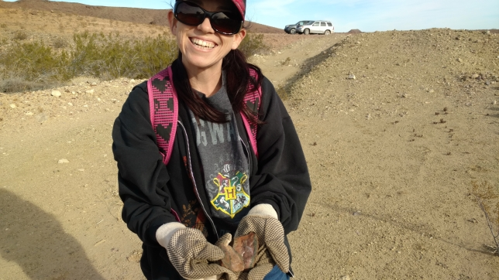
Extra green with mine please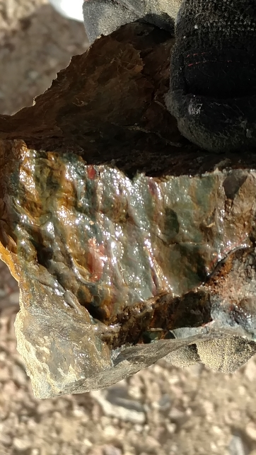
Check out that red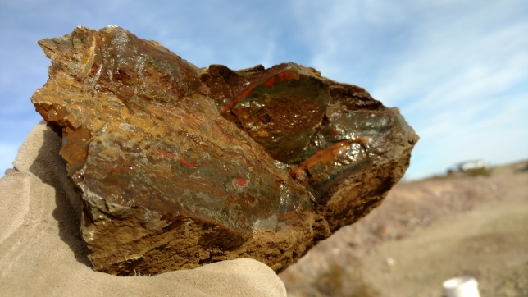
Kit’s treasures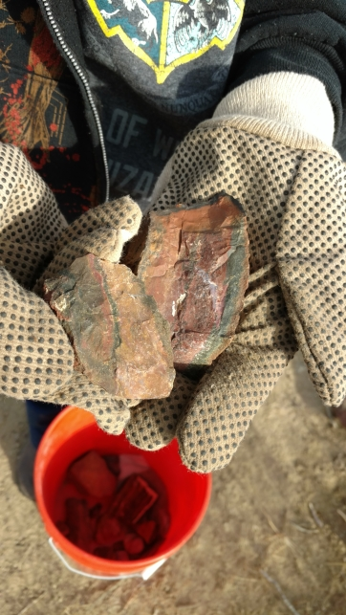
.

Our second stop was Hector Rd. in this area you find chalcedony, common opal and sometimes chapinite. It was on the way back to Barstow where we were all staying, but we were losing sunlight so it would have to be quick. It is just off the highway so it is easy to get to. I usually drive further down further down Hector Rd before stopping, but I saw a lot of rocks in an area and thought it would be good to check out some place new.
View from Hector Rd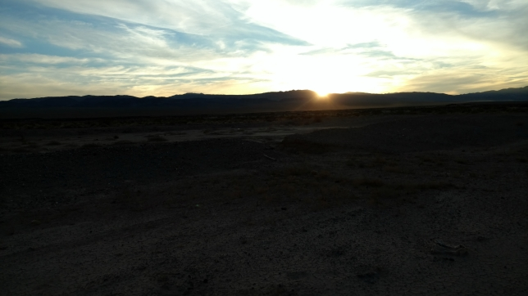
View back towards the cars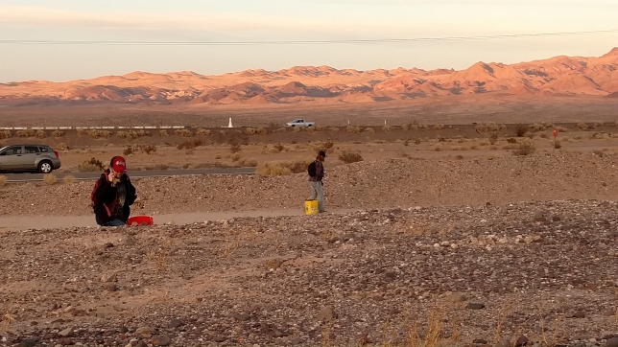
It turns out that was a good decision. Where there are a lot of rocks there is a good chance to find good rocks.
Kit finds a good one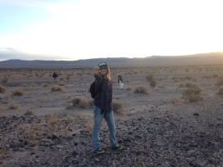
Brent and Brett checking out the finds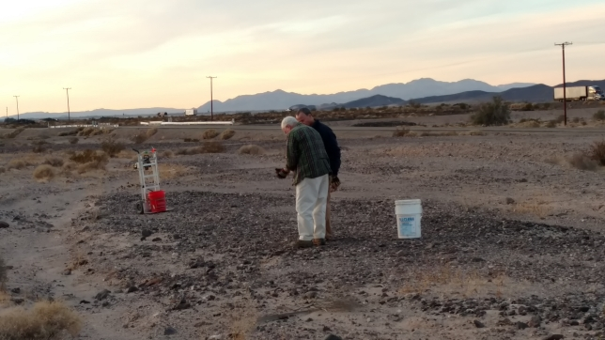
Sometimes chalcedony is kind of boring, just translucent grey or maybe a dirty white. This chalcedony had some interesting webs of pink and red spots. It was also large enough to slab so we should get a number of cabs out of the pieces we collected. Some of our chalcedony pieces look like they may have some common opal in them. Hopefully that does not translate into soft spots in our cabs. We didn’t find any chapinite this time, but there are enough rocks in the area that it is still a possibility when we go back.
Pink spot chalcedony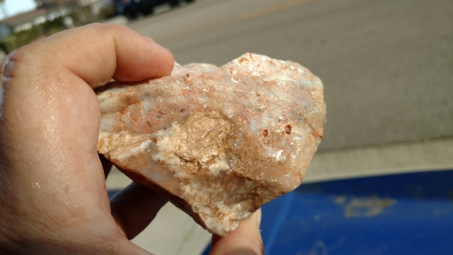
Pink web chalcedony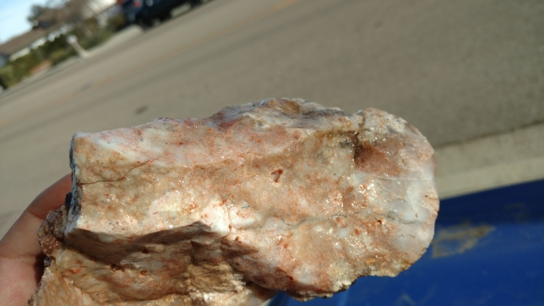
On day two we started out in the hills behind the Calico Ghost town. This area has a wide variety of minerals, but my favorite is the yellow, orange and red moss agate I found on a specific hill. Normally you can drive a car right up to that hill, but over the last year the road eroded to the point I couldn’t take my 4 wheel drive up it. It was not a long hike from where we parked to the site.
Brett and Brent hike in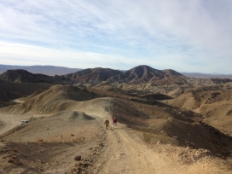
Brett, Brent and Sayard on the first hill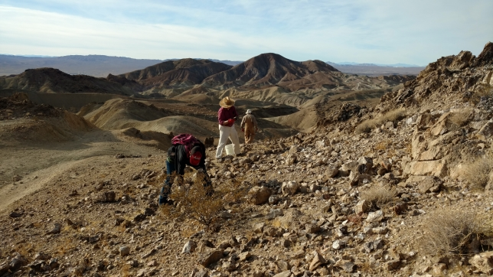
Paul taking a picture of some druzy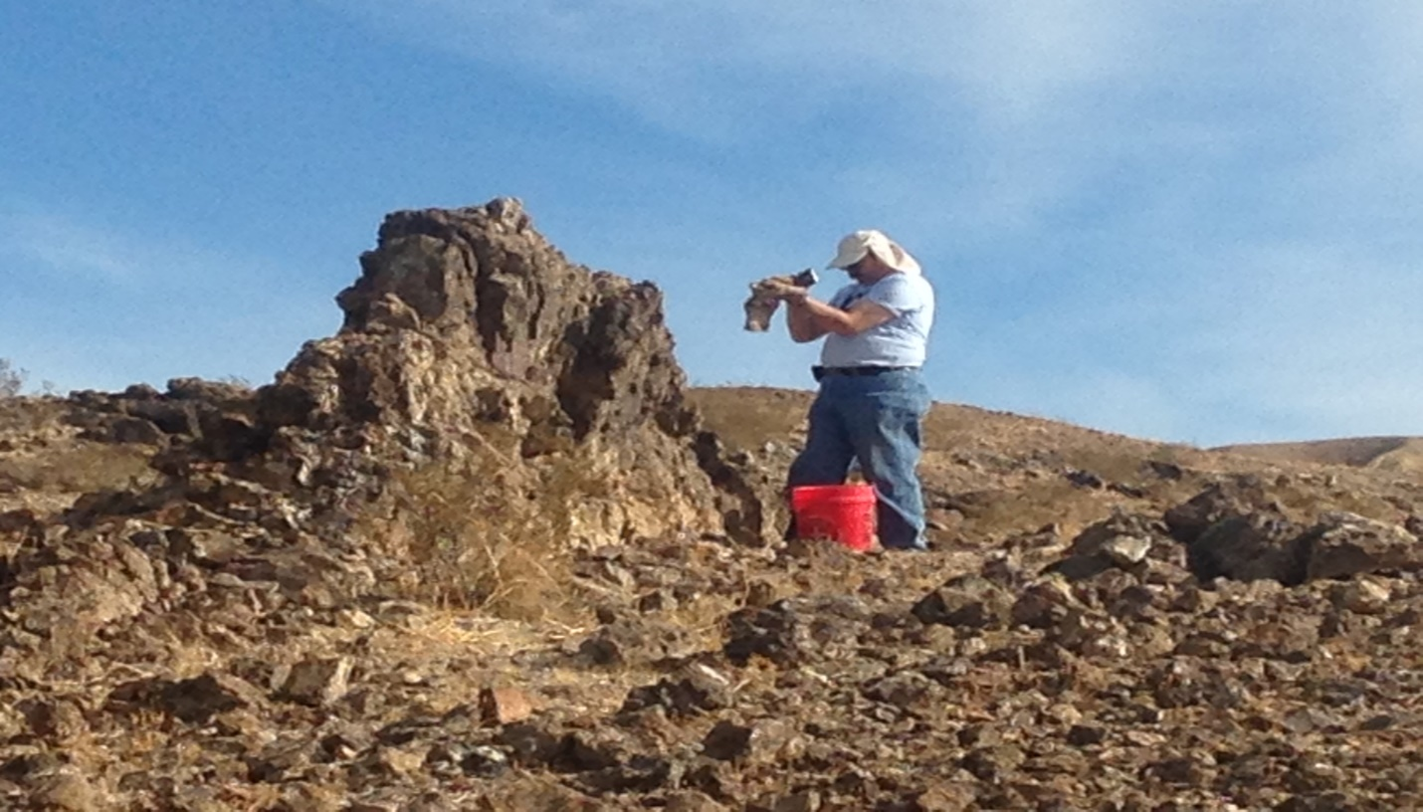
The druzy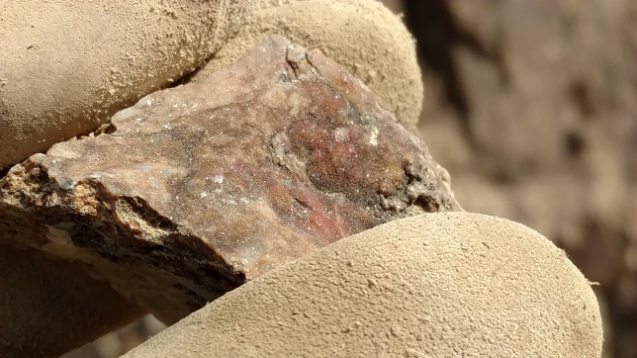
One of the things we found this time which I had not found during my previous trips was a lot of druzy crystals. There was one hill that seemed to have quite a few of them. My focus was on red moss agate. I had found a few small pieces during my last trip and this time I was determined to follow it to the source. Kit finds some druzy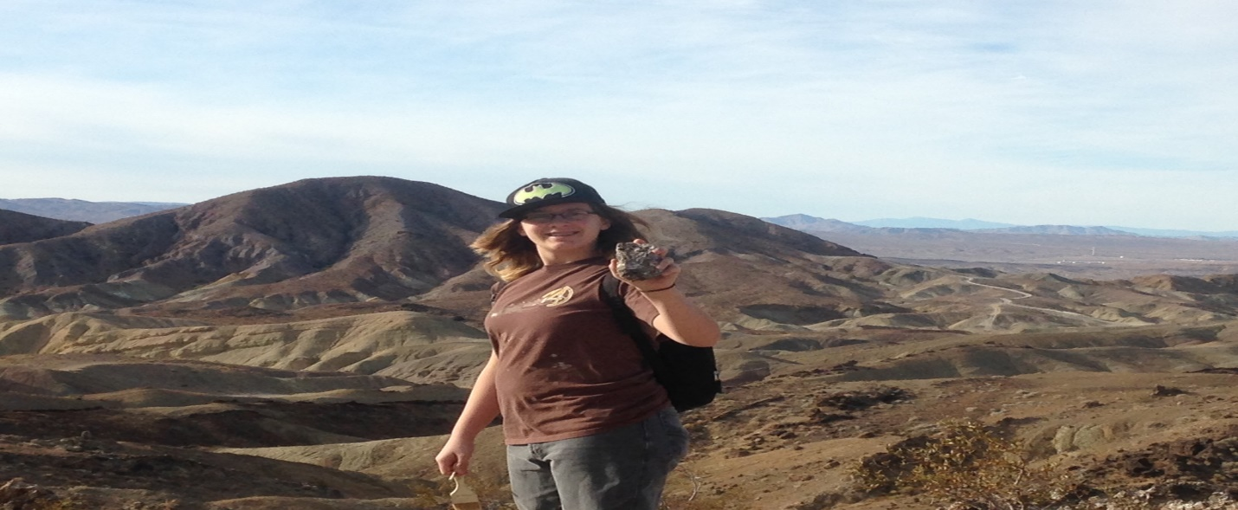
Yelllow moss agate with druzy pocket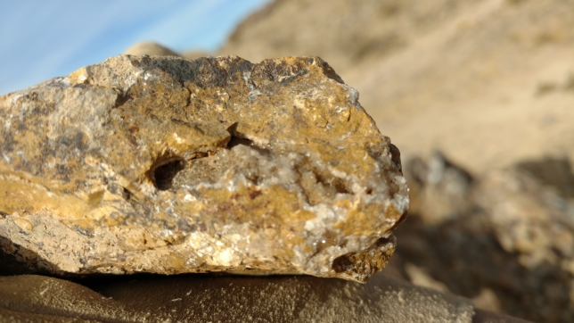
More druzy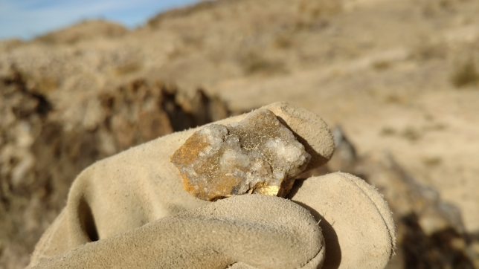
Red moss agate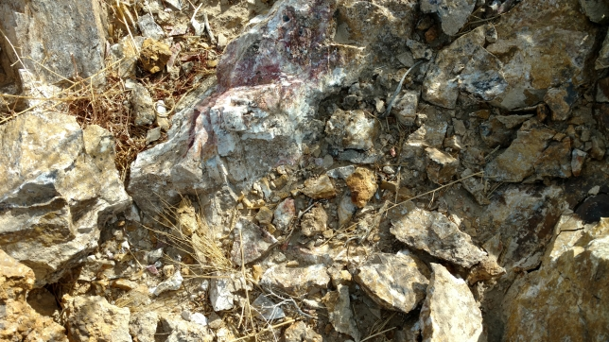
Red moss agate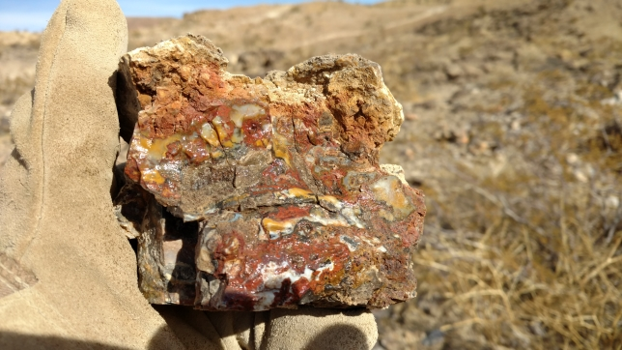
Next we made a quick trip to one of the washes of the Mojave River. On my November exploring trip I found a nice orange, yellow and pink stone. It reminds me of Indian Paint Stone from the Death Valley so my temporary name for it Mojave Paint Stone. So far it looks like a mudstone or a siltstone (fossilized mud). I have a couple of test pieces which I have not finished so I don’t know how well it works yet
Mojave River valley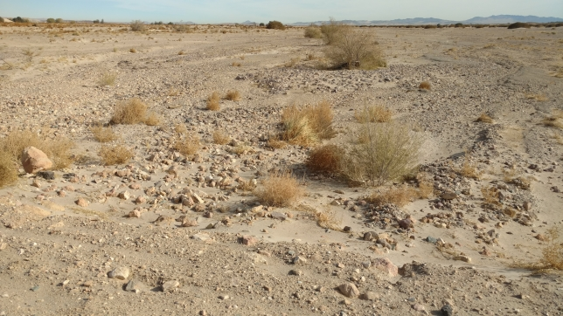
Sayard and Kit dig in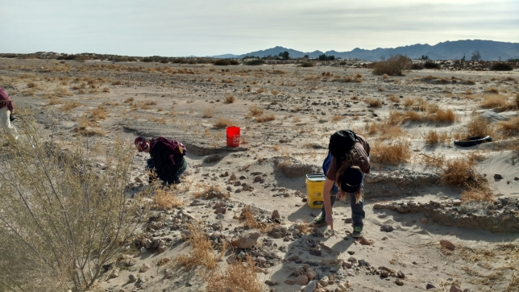

Brett wonders if this is a keeper or not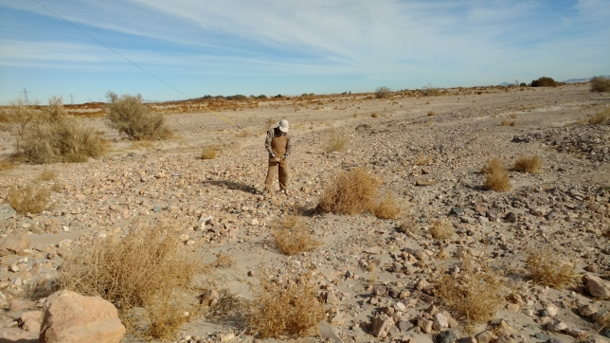
Brent before his bucket got heavy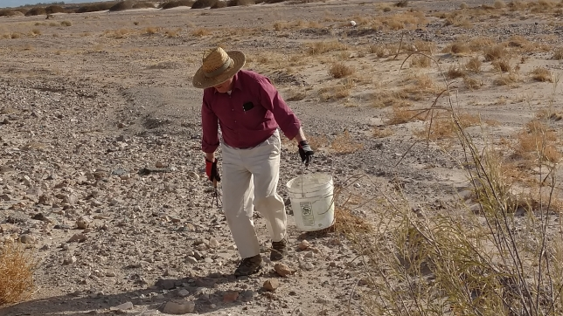
There were a good number of pieces of Mojave Paint Stone sitting on top of the sand. It was another site where it is a question of how many rocks you want to pick up and taking only the best pieces home. This material is often layered which should make some neat cabs if you cut parallel to the layers.

Mojave Paint Stone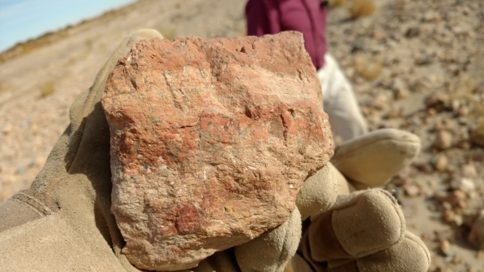
Mojave Paint Stone (look at those layers) 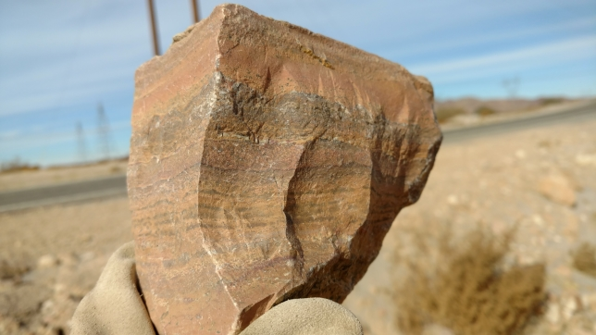

Sand dunes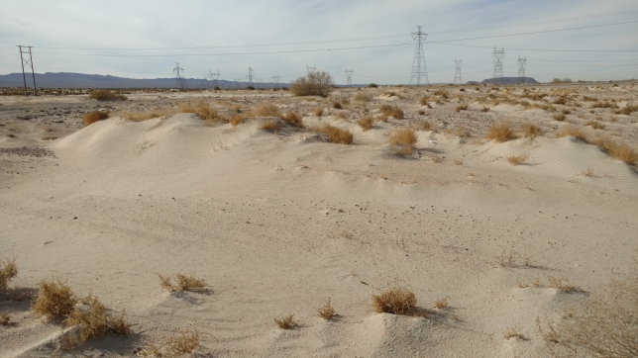
We are definitely not alone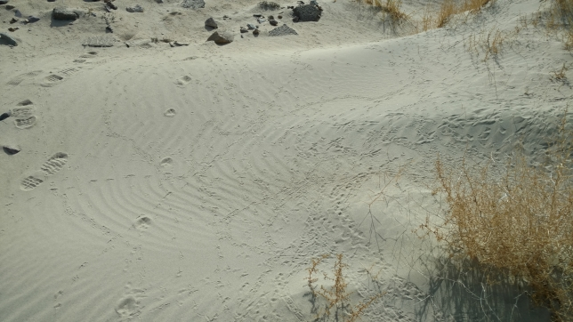
Kit and an interesting rock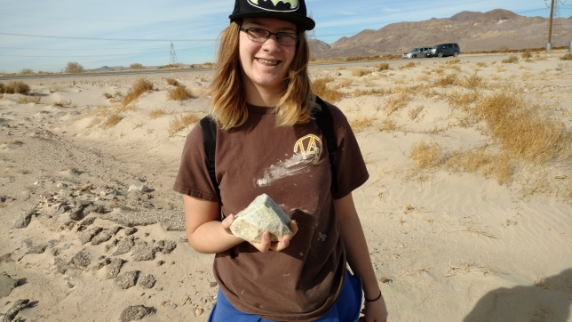
Kit’s interesting rock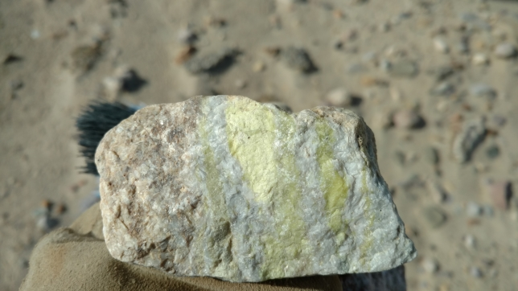
Kit found an interesting specimen. The green apple bands in the white matrix will definitely make some interesting pieces. Since we found it in a river valley it could have come from a long way off. After this stop we headed back to San Diego with full, happy buckets of rock.
The End

