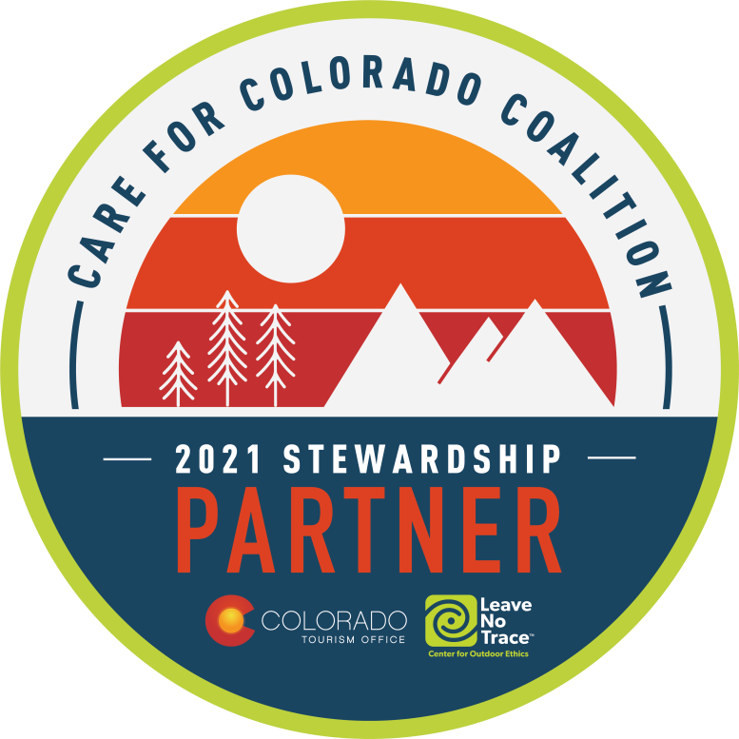

WHAT: RMGA NOVEMBER MEMBERSHIP MEETING –

WHEN: DATE – November 8, 2021
6:00 pm – Networking,
6:30 pm – Short Meeting,
6:45 pm – PROGRAM: Western Slope & the Grand Valley update

WHERE: Virtual
To join via Zoom: https://us06web.zoom.us/j/82290265140
To join via mobile: 720-7072-699; Meeting ID --82290265140#

PROGRAM: Program: Western Slope Update

Grand Junction resident and RMGA’s newest member, Barb Bowman, will tell us what’s new on the Western Slope of Colorado. Yes! There is more to Colorado than the eastern side of the Continental Divide. She will be giving us current information on the Grand Valley including wineries, downtown Grand Junction, jetboating, and lavender farms.

Barb’s presentation will also announce RMGA’s Stewardship Partnership in Care for Colorado. She will lead a discussion on how RMGA members can educate residents and visitors alike on how to protect our important Colorado resources. We will walk away with knowledge on how to include the message of responsible stewardship as we guide visitors and residents through Colorado.

Barb Bowman is currently working with the Colorado Tourism Office as a stewardship contractor to help manage the Care for Colorado coalition. Her career as a destination marketing organization representative has included VISIT Grand Junction (retired after 27 years) and VISIT Durango. From her experiences organizing and leading familiarization tours of destinations for travel writers and meeting planners, Barb now leads tours for tourist visitors in the Grand Junction and Western Slope areas. She has also sat on the boards of directors for the Colorado Tourism Organization and Tour Colorado, among other travel-related organizations. She now manages her own business, Bowman and Associates, LLC. Barb is has been a friend of RMGA for many years.

REFRESHMENT: On Your Own

DIRECTIONS: To Join the Meeting click on above link or copy it to your browser. You may start to join the meeting at 6:00 pm. click on “Join” in the invitation, enter the necessary codes, and wait to be admitted.

PARKING: Your garage, driveway, or curbside.

GUESTS: Members are encouraged to invite potential members as a guest to the meeting.

CONTACT: J. Mark Blaising, Program Chair 303-830-8440 (voice) 303-263-8647 (text)

