12/17/2016 The Sign of the Man Child and the Culmination of Years

On 9/23/2017 there will be an extremely rare sign in the sky that is mentioned in the bible. It's the sign of the "Woman Clothed with the Sun" mentioned in Revelation chapter 12.

Revelation 12:1 And there appeared a great wonder in heaven; a woman clothed with the sun, and the moon under her feet, and upon her head a crown of twelve stars:
2 And she being with child cried, travailing in birth, and pained to be delivered.
3 And there appeared another wonder in heaven; and behold a great red dragon, having seven heads and ten horns, and seven crowns upon his heads.
4 And his tail drew the third part of the stars of heaven, and did cast them to the earth: and the dragon stood before the woman which was ready to be delivered, for to devour her child as soon as it was born.
5 And she brought forth a man child, who was to rule all nations with a rod of iron: and her child was caught up unto YaHuWaH , and to His throne.

The sign of 9/23/2017, the day after the Hebrew Karaite Day of Trumpets 2017:

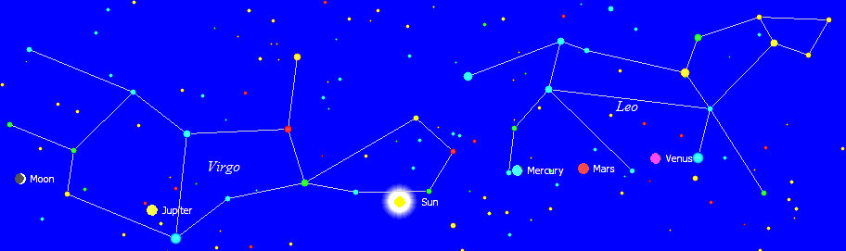

The planet Jupiter is representative of the Messiah. The woman of Revelation 12 is travailing in birth. She is clothed with the sun with the moon at her feet. She is birthing a Man Child who will rule all nations with a rod of iron.

Below is a graphic that illustrates certain events of 100 years ago and their timeline relationship with the Woman Clothed with the Sun of 2017:

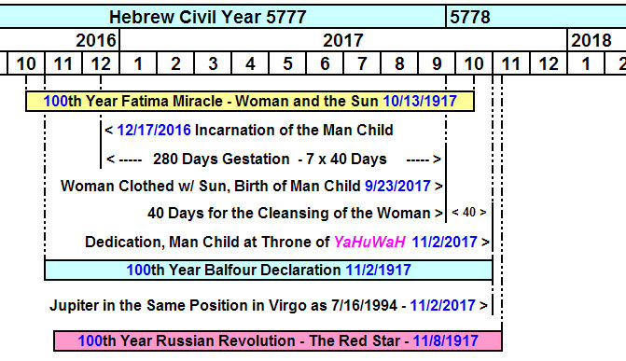

The birth of the Man Child on 9/23/2017 yields a date of 12/17/2016 for his incarnation and 280 day gestation period.

The incarnation or conception event is a time of joy, but the birthing event itself is a time of tribulation, pain, and travail. After the travail and tribulation there is joy that a child is born into the world.

According to the instructions (Torah) of YaHuWaH Elohim, there is a 40 day cleansing period for a woman after she gives birth to a male child. The child is then taken to the Temple for dedication to YaHuWaH Elohim.

11/2/2017

There are 3 events noted on the graphic above that occur on 11/2/2017.

1. The dedication of the man child

2. The 100th anniversary of the Balfour Resolution

3. Jupiter is in the same position in the constellation Virgo on 11/2/2017 as it was on 7/16/1994, the day when comet Shoemaker-Levy began violently striking the planet 21 times.

The Archer and the 21 Arrows

On 7/16/1994 the 21 fragments of comet Shoemaker-Levy 9 began striking the planet Jupiter.

Below is a Hubble Telescope picture of the 21 fragments of the comet on their way to strike Jupiter.

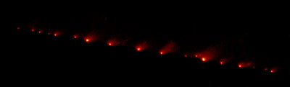

Comet Shoemaker-Levy 9 was originally a single larger comet that began to orbit Jupiter. It was broken up by gravitational tidal forces as it approached Jupiter on 7/7/1992.

Below is a graphic noting the position of the earth's shadow in the sky on 7/7/1992, the day that comet Shoemaker-Levy 9 broke into 21 fragments.

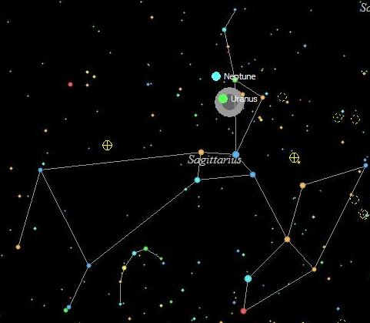
7/7/1992

The Sun, the Earth, Uranus, and the constellation Sagittarius were all in line on 7/7/1992 when comet Shoemaker-Levy 9 fragmented into 21 pieces.

Uranium was discovered in 1789 by Martin Heinrich Klaproth and was named for the planet Uranus which had been discovered by William Herschel on 3/13/1781.

The constellation of Sagittarius is the archer, the shooter of arrows.

Below is a graphic noting the position of the earth's shadow in the sky on 7/16/1994, the day that the 21 fragments of comet Shoemaker-Levy 9 began striking Jupiter.

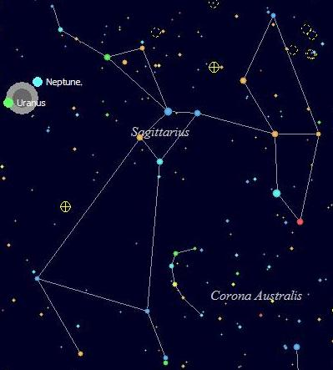
7/16/1994

On 7/16/1994, over two years after the breakup of comet Shoemaker-Levy 9, the Sun, the Earth, Uranus, and the constellation Sagittarius are again in line with each other as the 21 fragments begin to hit Jupiter, each having the destructive power of multiple nuclear weapons.

Two Strange Occurrences

My wife and I traveled 200 miles south to visit with family and pick up some groceries at major market stores on December 5, 2016. On the way home we stopped at a rest stop to walk around and then we had devotions as is our custom at sunset. I opened the bible at random and began to read aloud. The passage was Zechariah 12:1-3.

Zechariah 12:1 The burden of the word of YaHuWaH for Israel, saith YaHuWaH , which stretcheth forth the heavens, and layeth the foundation of the earth, and formeth the spirit of man within him.
2 Behold, I will make Jerusalem a cup of trembling unto all the people round about, when they shall be in the siege both against Judah and against Jerusalem.
3 And in that day will I make Jerusalem a burdensome stone for all people: all that burden themselves with it shall be cut in pieces, though all the people of the earth be gathered together against it.

We then prayed and I started the car to leave. I looked at the gauges and the gasoline gauge went way off the top of the scale and stayed there. That had never happened before. We had 100 miles yet to travel and I hoped there wasn't an electrical short circuit that would disable the car on the way home. The next day we went to a local store and the gasoline gauge slowly returned to a normal reading. It stayed normal through the week.

On December 12, 2016, we again made the 200 mile trip, this time for an unscheduled doctor visit for my wife. On the way home we again stopped at a rest stop. Again it was sunset and we had devotions. I opened the bible again at random and began reading at Jeremiah 50:14.

Jeremiah 50:14 Put yourselves in array against Babylon round about: all ye that bend the bow, shoot at her, spare no arrows: for she hath sinned against YaHuWaH.

We then prayed and I started the car to leave. I looked at the gauges and the gasoline gauge went off the top of the scale and stayed there, but not quite as far as it had the previous week. The gauge slowly returned to normal the next day and has been ok since.

The Babylon of Jeremiah chapter 50 is modern Babylon the Great, the United States of America, and the arrows of Sagittarius the Archer are nuclear tipped missiles.

Jeremiah 50:29 Call together the archers against Babylon: all ye that bend the bow, camp against it round about; let none thereof escape: recompense her according to her work; according to all that she hath done, do unto her: for she hath been proud against YaHuWaH , against the Holy One of Israel.
30 Therefore shall her young men fall in the streets, and all her men of war shall be cut off in that day, saith YaHuWaH.
31 Behold, I am against thee, O thou most proud, saith the Master YaHuWaH of armies: for thy day is come, the time that I will visit thee.
32 And the most proud shall stumble and fall, and none shall raise him up: and I will kindle a fire in his cities, and it shall devour all round about him.

Sodom


Be aware that Isaac was a type of YAHUSHUA Messiah, carrying the wood of sacrifice to Mt. Moriah on his back as our Messiah carried the wood of sacrifice on His back to Golgotha.

Also be aware that Sodom and Gomorrah were destroyed in the year before the man child, Isaac the son of promise, was born.

Genesis 17:17 And YaHuWaH said, Shall I hide from Abraham that thing which I do;
18 Seeing that Abraham shall surely become a great and mighty nation, and all the nations of the earth shall be blessed in him?
19 For I know him, that he will command his children and his household after him, and they shall keep the way of YaHuWaH , to do justice and judgment; that YaHuWaH may bring upon Abraham that which he hath spoken of him.
20 And YaHuWaH said, Because the cry of Sodom and Gomorrah is great, and because their sin is very grievous;
21 I will go down now, and see whether they have done altogether according to the cry of it, which is come unto Me; and if not, I will know.
22 And the men turned their faces from thence, and went toward Sodom: but Abraham stood yet before YaHuWaH.

Abraham was 100 years old when Isaac was born. It's something to think about, as we see heavenly signs of a man child being born in 2017, the culmination of years, and the open flaunting of sodomy in the highest offices of the government of the United States of America.

This is NOT a prophecy of the immediate destruction of the United States, it's just an account of the sequence of events in ancient and modern history.

