The 8th Asian Colloquium and the 4th PCQACL Annual Convention 2007

Production and Acquisition of Control Sample
Assoc. Prof. A. Prijavudhi
Organizer of the External Quality Assessment Schemes
In Clinical Chemistry ( Thailand ),
Faculty of Medical Technology, Mahidol University ( Siriraj Hosp.),
Bangkok, Thailand.

Introduction to EQA organizer and programs
The External Quality Assessment Schemes (Thailand); EQA’s in Clinical Chemistry are organized by volunteer profesion staff on behalf of government sector (Mahidol University) ( Ref. 1). The EQA’s in Clinical Chemistry organization now are well international recognized as WHO SEARO Thailand NEQAS organizer ( SEARO QA News 1998 ) and one of US NIH EQA Providers in the pSMILE project (Patient Safety Monitoring & International Laboratory Evaluation) since 2006. ( http://psmile.org )
Five EQA’s programs in Clinical Chemistry now cover EQAC for 22 general biochemistry routine tests, EQAH for 5 thyroid function tests, EQAT for 7 tumor markers, EQAHb for hemoglobin A1c, and Pilot project EQAU for 9 urine biochem-istry tests. Three kinds of control material including serum, hemolysate and urine, are all our in-house production.
There are several methods of preparing control samples of serum for distribution in the EQA program but most organizers have limited budget and find that the lyophilized control material production is hard to fulfil its acquisition.

Material Collection
EQA material control is preferable human origin to animal and expecting to match fresh human specimen in order to avoid interferences from control matrix or other possible error caused by components in the matrix. Animal origin control is inappro-priate in the methods involving the use of antihuman reagents and in the behaviour of animal enzyme activity different from that of human enzyme. We always use human source for making control material .
Serum from regular blood transfusion donors will be the best available source in country with well-developed blood transfusion services.( Ref.2). In our experience, side-tube sera of donor transfusion blood packs from the government Red-Cross Society (Thailand) blood bank after checking and the reporting results of hepatitis and HIV infection negative, are collected in plastic bottles and store in deep -70 ‘c deep freezer everyday until reaching the required volume. After the sera are separated, rapid freezing to storage temperature is our recommended practice so as to avoid damage to some serum constituents. The act of freezing itself can cause irreversible denaturation of some VLDL and alteration in salts.( Ref.3 )
At the day of preparing EQAC control the frozen serum is thawed and centrifuge in the high speed refrigerated centrifuge to remove any fibrin and lipoprotein coagulum formed during storage but in many laboratories ultrafiltration is often used to remove artifact and any bacteria when filtered down to 0.2 um..
( Ref.4 )

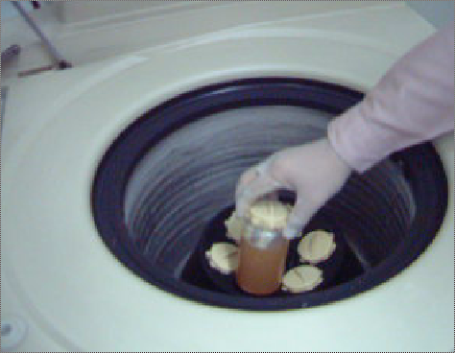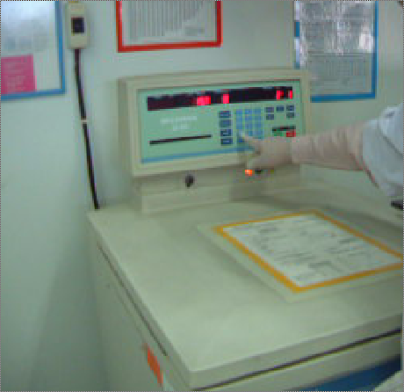
Fig. 1 Refrigerated centrifuge at high speed.

Commercial chemical additives are added in the EQAC control to raise higher concentration while the EQAH and EQAT control material are fortified by collected high con-stituent result patient sera. Commercial enzymes of animal origin like AST/ALT, ALP, LDH are purchased to spike high level control. ( Ref.5 )
The EQAHb hemolysate is derived from EDTA diabetic blood specimens and they are hemolysed by adding 2 timed volume of diltilled water. All possible fibrin and coagulum are removed by course filteration.
The EQAU urine is derived from random fresh normal urine fortified by adding albumin and pure inorganic chemicals.
No need to add any antibiotic, preservative and stabilize agents to control material as they may probably bring to undesired interferences. To our experience for more than 20 years of serum control preparation by lyophilization, the only complete dryness of control material can insure its stability.

Control material stabilized by Lyophilization
Control material stabilized by lyophilization is widely used in the EQA program. In the state of complete dryness it is stable for several years when stored at 5 – 8 ’C. Storage at -20 ‘C improve longer term stability. There are some disadvantages to Lyophization preparation and process :
( Ref.6 )
- The serum must be accurately and precisely dispensed prior to lyophilization.
- It is expensive process and require significant capital expenditure as well as technical kow-how to obtain a satisfactory product. ( Fig.1)
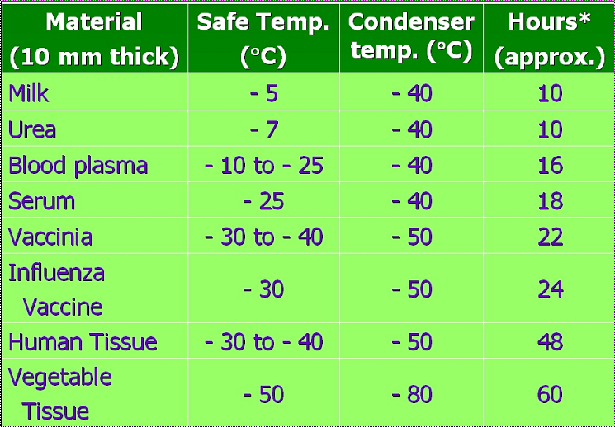
- Reconstitution of the material with an accurate volume of water is necessary prior to use.
- Matrix changes occur during lyophilization and the reconstituted serum may be significantly turbid.
- Where ambient temperature is high, delay process can result in lowering of certain assigned values particularly glucose and SGPT.

However it is most advantage to be transported throughout ambient condition around the world if carried as air freight and immediately stored under refrigerated conditions on arrival at its destination.
Instrument details
To our experience at higher volume serum dispensing, Oxford pipettor is used at its reliably precission and at low volume serum dispensing ( Fig. 1 ), Automatic programmable Gilson 402 Dilutor-Dispenser is used to maintain acquired high precission and comfort at big batch production .

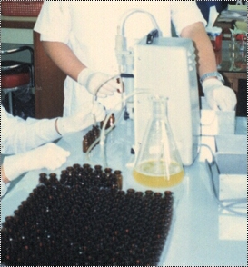
Fig. Conventional Oxford Pippettor

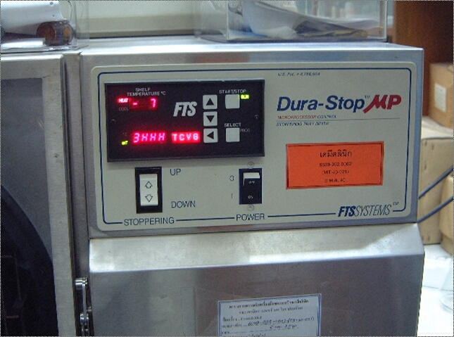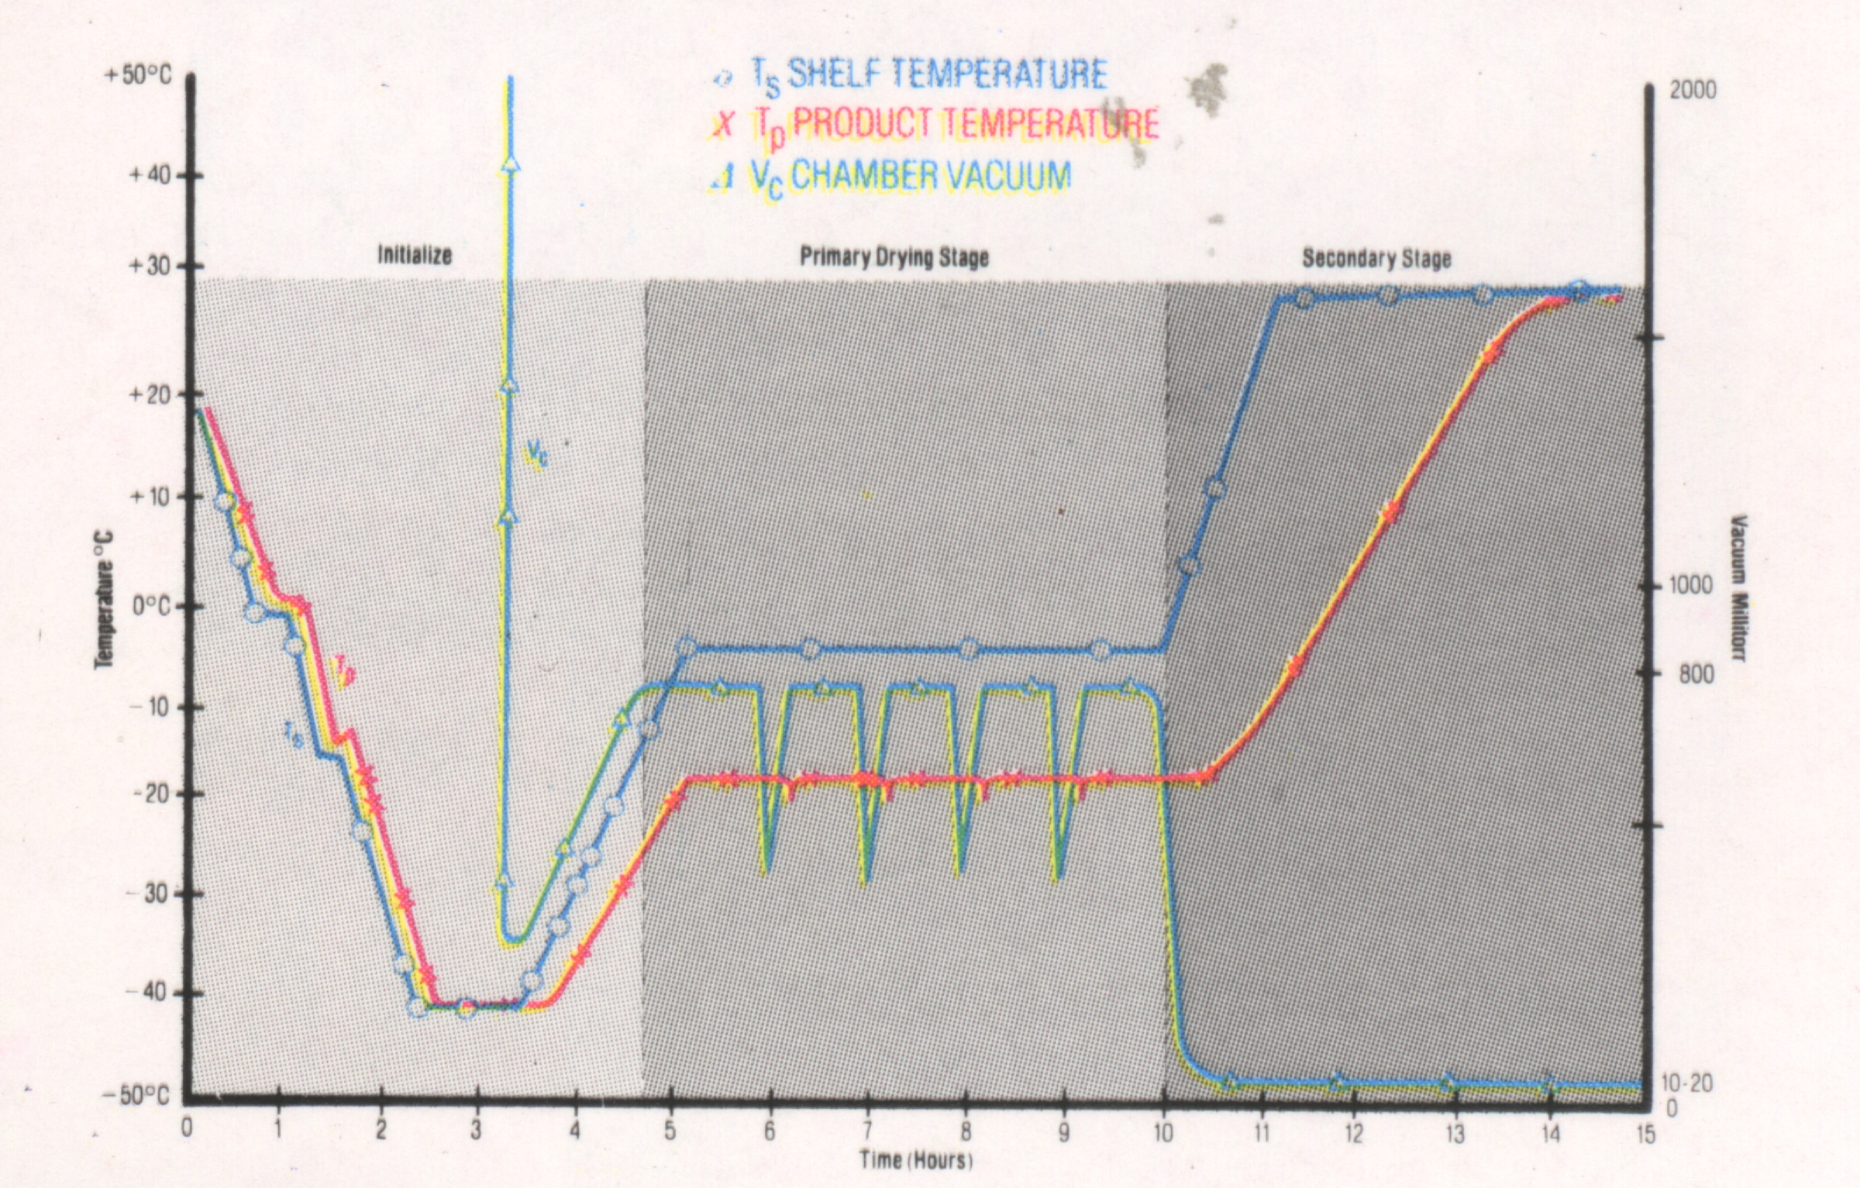
Fig. 2 Dura-Stop freeze-dry unit (left) and monitoring graph of shelf temperature, vaccumm pressure, condensor temperature, and shelf heat temperature.(right)

To yield low vial number of 1-3 ml vial control material less than 1000 vials in a batch, the programmable Dura-Stop freeze-dry unit is used ( Fig. 2 ) . The big programmable freeze-dry LSI QUANTA Dura unit capability production is at big batch up to 10,000 vials production ( Fig. 3 )

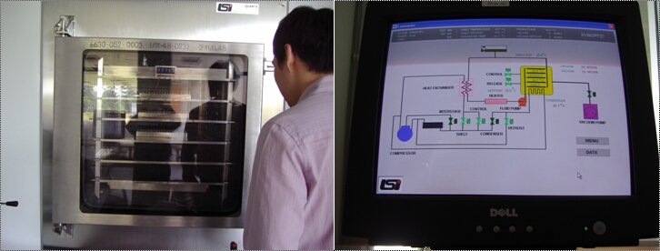
Fig. 3 LSI QUANTA Dura Freeze-dry unit (left) and on-line
computerized remote control monitor.

Acquisitions of control material
The specification of control material should include the physical characteristics of the material. Lyophilised control material characteristics are :
- pH. Control material biological pH is between 7.4 – 7.5
- Solubility . Reconstitution time of soluble homogenous lyophilized control material should be less than 30 minutes while standing at room temperature and solftly swirling from time to times.
- Osmolarity / Viscosity / Density. The nature of human physical characteristics are preferred.
- Stability assessment time storage. The long-term storage at 2 – 8 ‘C for at least two years .

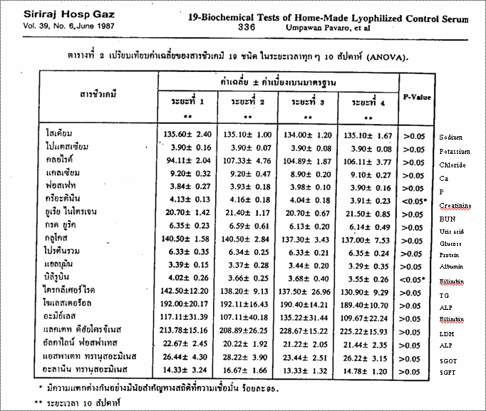
Fig. Table of ANOVA analysis of constituent variance in 1987of innovated home-made lyophilized serum control in one year period.

- Minimal microbial contamination : Some conditions in Lyophilization to insure this characteristic :
  - Deep freeze collected serum storage at -70 ‘C
  - Rapidly prepare the material after complete thawing ( under 6 hours )
  - Check the complete dryness of lyophilised control
Material (supported by function check of the freeze-dry unit menu)
- No denaturation of enzymes or proteins. The control materials are sent to laboratory for random checking constituents values before and after the lyophilization process. Allowable limit of changes are in determination especially for clinical enzymes.
- Optimum residual water. Supported by function check of the freeze-dry unit menu ( residual moisture less than 1 % )
Statistic comparative test to reference. The control material constituent variances are statistic variance checked ( F-test) compare to reference material ( commercial controls ) in a suitable period ( during 2 years) .

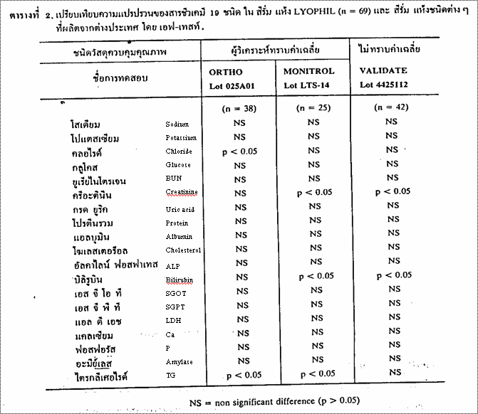
Fig. Paired F-test of home-made lyophised control serum ( LYOPHIL ) constituent values to References value ( commercial ORTHO Lot 025A01, MONITROL Lot LTS 14 , and VALIDATE Lot 4425112 .
Acceptable stability after reconstitution ( at least 8 hours ) for daytime routine operation is another acquisition. ( Ref.7 ) &
( Ref. 8 )
- Acceptable Homogeity. Low vial-to-vial variability acquistion for most routine tests at reasonable %CV( less than 0.5 %CV) e.g. Sodium < 0.2 %.
Volumetric pipette is insisted to pipet distilled water
into vial of control material.
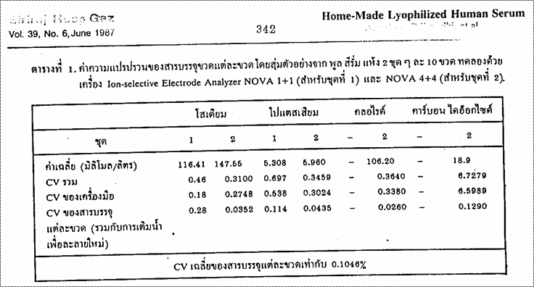
Fig. Inter-vial %CV of automate NOVA electrolytes of home-
made lyophilized control serum are shown in the last line
a) sodium 0.28 and 0.0352 b) potassium 0.114 and
0.0435, c) chloride 0.026 and 0.129. The average inter-
vial %n CV of all electrolytes is 0.104 %

10 ) Commutability. The pilot project survey studies was
assigned and quality assessed. The final conclusion and
hearing of routine patient’s problem as well as principle /
method and instrument classifications are at technical
reasonable determinations and set up. ( Ref. 9 ) The
control materials should prove to go on well in patient
clinical laboratory services.

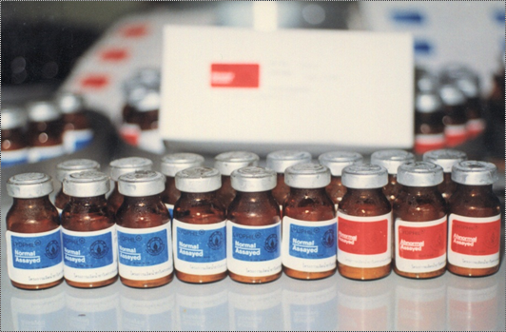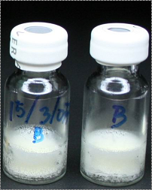
Fig Home-made Lyophil serum control (left) and
urine control (right )

***********************************************

References

- Promptmas C, Prijavudhi A, Pavaro U. Quality assessment in clinical chemistry: a Thailand experience. Southeast Asian J Trop Med Public Health. 1999;30 Suppl 3:46-47
- Middle et al.: Characterisation of serum material for EQA. Clin Chem Lab Med 1998; 36(2): 119-130
- Libeer JC. External Quality Assessment in Clinical Laboratories. European perspectives: today and tomorrow. Universiteit Antwerpen 1993.
- Millipore documentation : filtration of serum AB719, 1975.
- Browning et al.: Preparation of Stabilized Liquid Control Serum to be used in Clinical Chemistry. WHO Doc Lab/86.4 -Appendix 1, 1986.
- Peter Hill et al. IFCC Fundamentals for External Quality Assessment ( EQA). 1996; 30
- Prijavudhi A et al. Preparation of Home-made Lyophilized Human Serum for Quality Control in Clinical Chemistry. Siriraj Hosp Gaz 1987; 39:339–345.
- Pavaro U et al. Long-term Consistency of 19-Biochemical Tests of Home-made Lyophilized Control Serum. Siriraj Hosp Gaz 1987; 39: 331-337.
- Franzini C. Commutability of reference materials in clinical chemistry. J IFCC 1993; 5: 186-193

********************************************

The 8th Asian Colloquium and the 4th PCQACL Annual Convention 2007

Production and Acquisition of Control Sample
Assoc. Prof. A. Prijavudhi
Organizer of the External Quality Assessment Schemes
In Clinical Chemistry ( Thailand ),
Faculty of Medical Technology, Mahidol University ( Siriraj Hosp.),
Bangkok, Thailand.

Abstract

Control material is possible for the starting of EQA program. There are artificial, animal and human sources to be decided for the advantage and disadvantage. The suitable of liquid and lyophilized control form are discussed for EQA suitability. In our experience of EQAS, preparation of freeze-dried control serum for three clinical biochemisttry programs, freeze-dried hemolysate for hemoglobin A1c program, and freeze-dried urine in urine chemistry pilot program have been all home-made. There are many essential acquisitions for the lyophilized control materials e.g., Suitable pH, Solubility limited time, Natural physical characteristics, Long-term Stability of constituents, Minimal microbial contamination, Limited denaturation of protein e.g., enzymes , Optimal residual water, Acceptable homogeity e.g., intervial %CV, Commut-ability, and others . Those details in control material advantage and disadvantage, all Lyophilised control material acquisitions should be discussed in the panel #1 discussions of Production/acquisition of Control Sample.

