**HIGH PINES OWNERS’ ASSOCIATION, INC.**

**SPECIAL BOARD MEETING**

**December 12, 2011**

1. **Meeting Called to Order**

Jim Hadley called the meeting to order at 10:00 AM at his home. Members present included

* Jim Hadley, Director and President
* Mary Scott, Director and Secretary
* Ron Scott, Bylaws Task Force Member and Nominating Committee Member
* Carrie Johnson, HOA Property Manager
  1. **Agenda**
     + Review Annual General Membership Meeting announcement and enclosures
     + Set another date for Board review of the Treasurer’s Report and proposed 2012 annual operating budget
     + Discuss ground rules for conducting a performance review of property manager performance
  2. **Annual General Membership Meeting Announcement**

The board approved the proposed announcement and enclosures. Since the month of December requires some financial accounting closure, the Treasurer’s Report and proposed 2012 Annual Operating Budget will be sent to the General Membership under separate cover no later than January 15, 2012. The timing gives the Membership enough time to review the material in the event ballots are cast by the January 24, 2012 deadline for those who are unable to attend the Membership meeting on January 31, 2012.

* 1. **Next Special Board Meeting**

The Board will meet on January 11, 2012 to review

* The 2012 Treasurer’s Report and proposed 2012 Annual Operating Budget. These documents will be mailed no later than January 12, 2012 to ensure receipt no later than January 15, 2012 by HOA Members.
* The performance of the property manager for calendar year 2011.

**Respectfully submitted,**

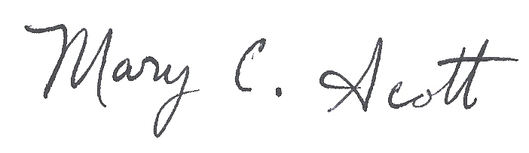

**Mary C. Scott**

Secretary