V. We ask this through Christ our Lord.
C. Amen.

(We invite you to stand as you are able.)

SHARING OF THE PEACE
V. May the peace of the Lord be with you always.
C. And also with you.
V. Now, let us share God’s Peace with one another.



(Please respect your neighbor if they desire to still only offer a peace sign or wave.)

(Following the Sharing of the Peace, we invite you to be seated.)

THE LORD’S PRAYER
(We ring the bell throughout the Lord’s Prayer at all services to
invite those in the community to join in praying the Lord’s Prayer.)
V. May we now join with one another and pray together as Jesus has taught us.
C. Our Father, who art in heaven, hallowed be thy name, thy kingdom come,
thy will be done, on earth as it is in heaven. Give us this day our daily
bread; and forgive us our trespasses, as we forgive those who trespass
against us; and lead us not into temptation, but deliver us from evil. For
thine is the kingdom, and the power, and the glory, forever and ever.
Amen.

HYMN OF THE DAY
(We invite you to sing along with the music offered by our Organist.)
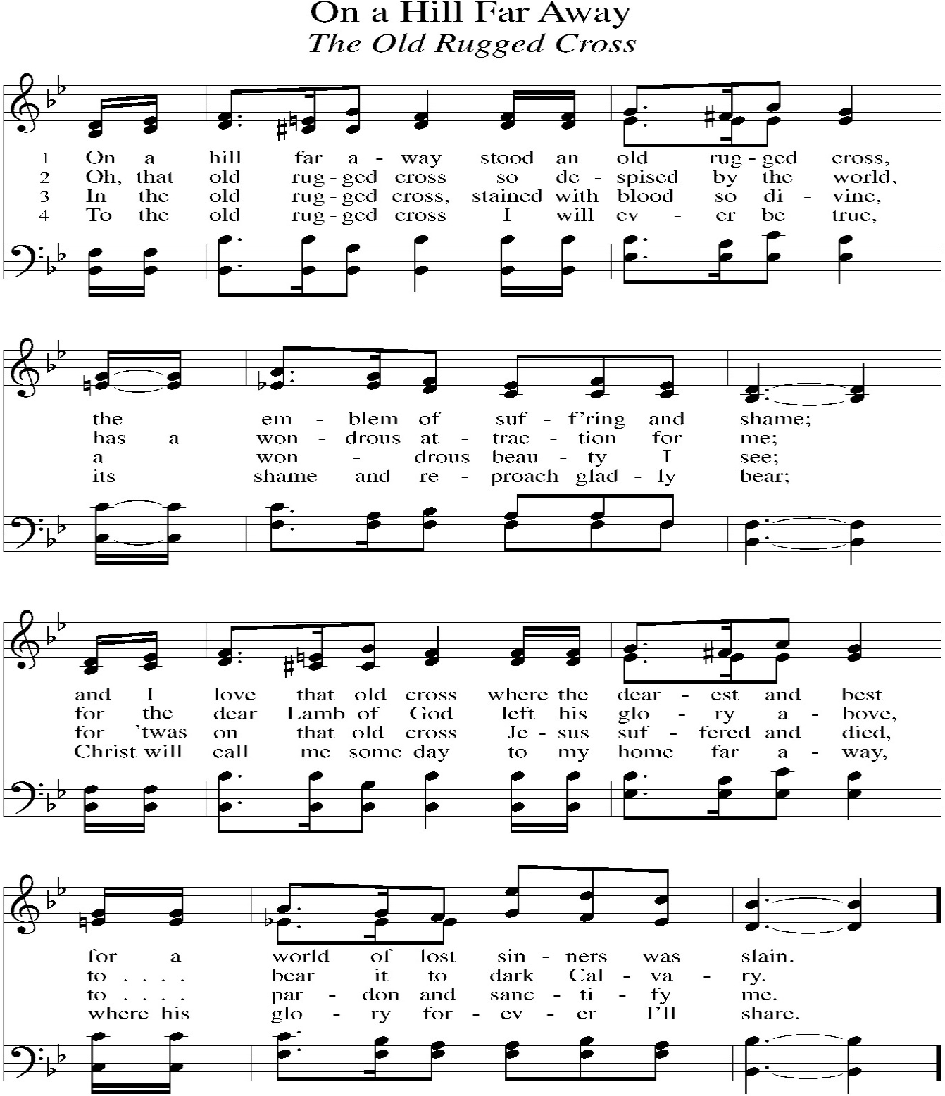
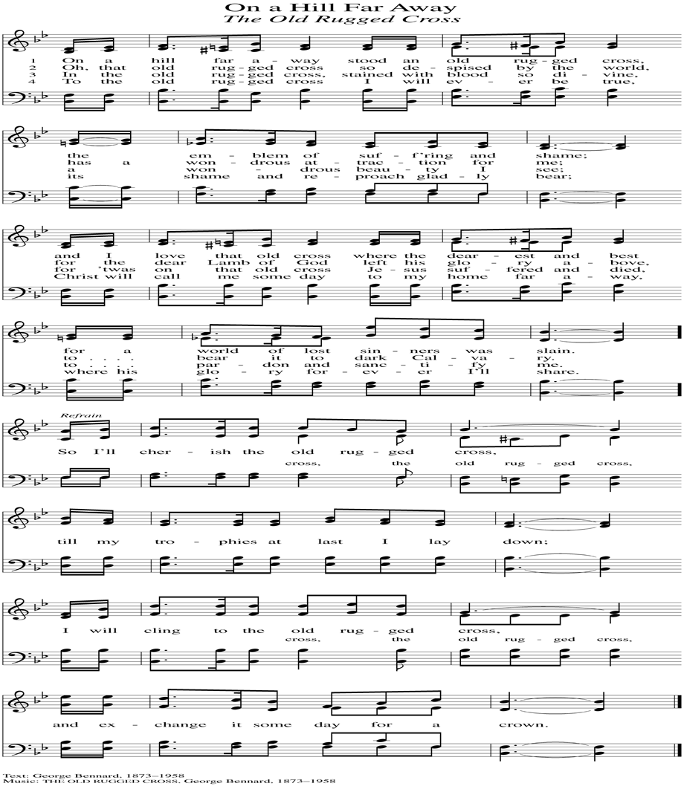

(Lights to be turned off in the church at the end of the hymn.)
A. Let us pray for God's creation.

(Silent prayer.)

V. Almighty and eternal God,
you are the creator of a magnificent universe.
Hold all the worlds in the arms of your care
and bring all things to fulfillment in you.
We ask this through Christ our Lord.
C. Amen.

A. Let us pray for those who serve in public office.

(Silent prayer.)

V. Almighty and eternal God,
you are the champion of the poor and oppressed.
In your goodness, give wisdom to those in authority,
so that all people may enjoy justice, peace, freedom,
and a share in the goodness of your creation.
We ask this through Christ our Lord.
C. Amen.

A. Let us pray for those in need.

(Silent prayer.)

V. Almighty and eternal God,
you give strength to the weary
and new courage to those who have lost heart.
Heal the sick, comfort the dying, give safety to travelers,
free those unjustly deprived of liberty,
and deliver your world from falsehood, hunger, and disease.
Hear the prayers of all who call on you in any trouble,
that they may have the joy of receiving your help in their need.
We ask this through Christ our Lord.
C. Amen.

V. Finally, let us pray for all those things for which our Lord would have us ask.
Watch over all of us who are worried and suffering, and especially those whose
names we now say aloud or hold within our hearts (extended pause).
V. Almighty and eternal God, you give your church unity.
Look with favor on all who follow Jesus your Son.
Make all the baptized one in the fullness of faith,
and keep us united in the fellowship of love.
We ask this through Christ our Lord.
C. Amen.

A. Let us pray for the Jewish people, the first to hear the word of God.

(Silent prayer.)

V. Almighty and eternal God,
long ago you gave your promise to Abraham and your teaching to Moses.
Hear our prayers that the people you called and elected as your own
may receive the fulfillment of the covenant’s promises.
We ask this through Christ our Lord.
C. Amen.

A. Let us pray for those who do not share our faith in Jesus Christ.

(Silent prayer.)

V. Almighty and eternal God, gather into your embrace
all those who call out to you under different names.
Bring an end to inter-religious strife,
and make us more faithful witnesses
of the love made known to us in your Son.
We ask this through Christ our Lord.
C. Amen.

A. Let us pray for those who do not believe in God.

(Silent prayer.)

V. Almighty and eternal God, you created humanity
so that all may long to know you and find peace in you.
Grant that all may recognize the signs of your love and grace
in the world and in the lives of Christians,
and gladly acknowledge you as the one true God.
We ask this through Christ our Lord.
C. Amen.
THE SEVEN LAST WORDS OF JESUS
V. We invite you to be seated for The Seven Last Words of Jesus. Following each
reading a candle will be extinguished.

#1
V. When they came to the place that is called The Skull, they crucified Jesus there
with the criminals, one on his right and one on his left. Then Jesus said, “Father,
forgive them, for they do not know what they are doing.”
(Luke 23:33-34a)

R. My God, my God, why have you forsaken me? Why are you so far from helping
me, from the words of my groaning? O my God, I cry by day, but you do not
answer; and by night but find no rest. Yet you are holy, enthroned on the praises
of Israel. In you our ancestors trusted; they trusted, and you delivered them.
(Psalm 22:1-4)

(The 1st Candle is Extinguished)

#2
V. One of the criminals who were hanged there kept deriding[a] him and saying, “Are
you not the Messiah? Save yourself and us!” But the other rebuked him, saying,
“Do you not fear God, since you are under the same sentence of condemnation?
And we indeed have been condemned justly, for we are getting what we deserve
for our deeds, but this man has done nothing wrong.” Then he said, “Jesus,
remember me when you come in your kingdom.” He replied, “Truly I tell you,
today you will be with me in paradise.”
(Luke 23:39-43)

R. To you they cried and were saved; in you they trusted and were not put to shame.
But I am a worm and not human, scorned by others and despised by the people.
All who see me mock me; they sneer at me; they shake their heads; “Commit
your cause to the Lord; let him deliver—let him rescue the one in whom he
delights!”
(Psalm 22:5-8)

(The 2nd Candle is Extinguished)

#3
V. And that is what the soldiers did. Meanwhile, standing near the cross of Jesus
were his mother, and his mother’s sister, Mary the wife of Clopas, and Mary
Magdalene. When Jesus saw his mother and the disciple whom he loved
standing beside her, he said to his mother, “Woman, here is your son.” Then he
said to the disciple, “Here is your mother.” And from that hour the disciple took
her into his own home.
(John 19:25-27)

R. Yet it was you who took me from the womb; you kept me safe on my mother’s
breast. On you I was cast from my birth, and since my mother bore me you have
been my God. Do not be far from me, for trouble is near, and there is no one to
help. Many bulls encircle me; strong bulls of Bashan surround me;
(Psalm 22:9-12)

(The 3rd Candle is Extinguished)

#4
V. From noon on, darkness came over the whole land[a] until three in the
afternoon. And about three o’clock Jesus cried with a loud voice, “Eli, Eli, lema
sabachthani?” that is, “My God, my God, why have you forsaken me?”
(Matthew 27:45-46)

R. they open wide their mouths at me, like a ravening and roaring lion. I am poured
out like water, and all my bones are out of joint; my heart is like wax; it is melted
within my breast; my mouth is dried up like a potsherd, and my tongue sticks to
my jaws; you lay me in the dust of death. For dogs are all around me; a company
of evildoers encircles me; they bound my hands and feet.
(Psalm 22:13-16)

(The 4th Candle is Extinguished)

#5
V. After this, when Jesus knew that all was now finished, he said (in order to fulfill
the scripture), “I am thirsty.” A jar full of sour wine was standing there. So they put
a sponge full of the wine on a branch of hyssop and held it to his mouth.
(John 19:28-29)

V. Almighty and eternal God,
you have shown your glory to all nations in Jesus Christ.
By your Holy Spirit guide the church and gather it throughout the world.
Help it to persevere in faith, proclaim your name,
and bring the good news of salvation in Christ to all people.
We ask this through Christ our Lord.
C. Amen.

A. Let us pray for our bishops, for our pastors, for our vicars, for our deacons, for all
servants of the church, and for all the people of God.

(Silent prayer.)

V. Almighty and eternal God,
your Spirit guides the church and makes it holy.
Strengthen and uphold our bishops, pastors, vicars, deacons,
other ministers, and lay leaders.
Keep them in health and safety for the good of the church,
and help each of us in our various vocations
to do faithfully the work to which you have called us.
We ask this through Christ our Lord.
C. Amen.

A. Let us pray for those preparing for baptism.

(Silent prayer.)

V. Almighty and eternal God,
you continue to bless the church.
Increase the faith and understanding of those preparing for baptism.
Give them new birth as your children,
and keep them in the faith and communion of your holy church.
We ask this through Christ our Lord.
C. Amen.

A. Let us pray for our sisters and brothers who share our faith in Jesus Christ.

(Silent prayer.)

V. Let us pray,
Almighty God, look with loving mercy on your family, for whom our Lord Jesus
Christ was willing to be betrayed, to be given over to the hands of sinners, and to
suffer death on the cross; who now lives and reigns with you and the Holy Spirit,
one God, forever and ever.
C. Amen.

APOSTLES’ CREED
V. God has made us his people through our Baptism into Christ. Living together in
trust and hope let us confess our faith together using the Apostles’ Creed.
C. I believe in God, the Father almighty,
creator of heaven and earth.

I believe in Jesus Christ, God’s only Son, our Lord,
who was conceived by the Holy Spirit,
born of the Virgin Mary,
suffered under Pontius Pilate,
was crucified, died, and was buried;
he descended to the dead.
On the third day he rose again;
he ascended into heaven,
he is seated at the right hand of the Father,
and he will come to judge the living and the dead.

I believe in the Holy Spirit,
the holy catholic church,
the communion of saints,
the forgiveness of sins,
the resurrection of the body,
and the life everlasting. Amen.

V. We invite you to be seated to focus on our Prayers of Intercession.

PRAYERS OF INTERCESSION
A. Let us pray, brothers and sisters, for the holy church throughout the world.

(Silent prayer.)

R. I can count all my bones. They stare and gloat over me; they divide my clothes
among themselves, and for my clothing they cast lots. But you, O Lord, do not be
far away! O my help, come quickly to my aid! Deliver my soul from the sword, my
life from the power of the dog! Save me from the mouth of the lion! From the
horns of the wild oxen you have rescued me. I will tell of your name to my
brothers and sisters; in the midst of the congregation I will praise you:
(Psalm 22:17-22)

(The 5th Candle is Extinguished)

#6
V. When Jesus had received the wine, he said, “It is finished.” Then he bowed his
head and gave up his spirit.
(John 19:30)

R. You who fear the Lord, praise him! All you offspring of Jacob, glorify him; stand in
awe of him, all you offspring of Israel! For he did not despise or abhor the
affliction of the afflicted; he did not hide his face from me but heard when I cried
to him. From you comes my praise in the great congregation; my vows I will pay
before those who fear him. The poor shall eat and be satisfied; those who seek
him shall praise the Lord. May your hearts live forever! All the ends of the earth
shall remember and turn to the Lord, and all the families of the nations shall
worship before him. For dominion belongs to the Lord, and he rules over the
nations.
(Psalm 22:23-28)

(The 6th Candle is Extinguished)

#7
V. Then Jesus, crying out with a loud voice, said, “Father, into your hands I
commend my spirit.” Having said this, he breathed his last.
(Luke 23:46)

R. To him, indeed, shall all who sleep in[b] the earth bow down; before him shall bow
all who go down to the dust, and I shall live for him. Posterity will serve him;
future generations will be told about the Lord and proclaim his deliverance to a
people yet unborn, saying that he has done it.
(Psalm 22:29-31)

(The 7th Candle is Extinguished)
V. We invite you to stand as you are able.

CLOSING PRAYER
A. Let us pray,
Merciful God, your Son was lifted up on the cross to draw all people to himself.
Grant that we who have been born out of his wounded side may at all times find
mercy in him, Jesus Christ, our Savior and Lord, who lives and reigns with you
and the Holy Spirit, one God, now and forever.
C. Amen.

BENEDICTION
V. May the Lord bless us and keep us. May the Lord make his face shine on us and
be gracious to us. May the Lord look upon us with favor and give us peace.
C. Amen.

IT IS FINISHED
V. In the beginning God created the heavens and the earth….

In the proper time God hung on a cross. The Creator was sacrificed for
creation….

God convincing all people once and for all that forgiveness still follows failure….

The mission was finished. All that the master creator needed to do was done and
done in splendor….

His creation could now come home….

“It is finished!”

(Lights to be turned on in the back of the church so everyone can exit safely.)

(Feel free to pray silently before departing the church quietly.)

LICENSES & EXPIRATION DATES
Worship Service Content is used via permission through Augsburg Fortress Liturgies Annual License #SB144368. The next Subscription Renewal Date is 2/28/2027.
Our Hymns and Worship Music are used via permission through CCLI One
License #11327166. The next Subscription Renewal Date is 1/31/2027.

CONFERENCE CALL CHECK-IN, WELCOME, & ANNOUNCEMENTS
(Vicar (V), Assistant (A), Reader (R), and Congregation (C).)

INTRODUCTION
A. “Tenebrae” is an ancient word for shadows or darkness. This evening, the altar
will darken as candles are extinguished and lights are turned off. The enveloping
darkness will bring us closer to Christ’s death for all people.

PRELUDE
(Music offered by our Organist at the start of our Worship Service.)
Processional to Calvary

(We invite you to stand as you are able.)

GATHERING HYMN
(We invite you to sing along with the music offered by our Organist.)
Lutheran Book of Worship – Green Book
92 Were You There

(We invite you to remain standing as you are able.)

GREETING
V. In the name of the ☩ Father, the Son and the Holy Spirit.
C. Amen.

V. Behold the life-giving Savior who was crucified for the world.
C. O come let us worship Him.

V. By His blood He purchased for God
C. people of every race and tongue, folk and nation.

V. Now let the wicked abandon their ways,
C. and their sinful thoughts.

V. Let them turn to the Lord for mercy,
C. to our God who is generous with forgiveness.

PRAYER OF THE DAY
V. The Lord be with you.
C. And also with you.

We, the Evangelical Lutheran Church of the Holy Spirit, are People of God, who
are called by the Holy Spirit to pray, worship, joyfully proclaim Jesus Christ,
and compassionately witness and serve others in Christian Love.


We are glad that you joined us for Worship today! Thank you for enriching our time together! We would like to get to know you better, and for you to get to know us better too. Brochures, welcome gifts, prayer shawls, Bibles, and other items are available throughout the church. We would be happy to show you around and share about our ministries. Please do not hesitate to speak up and ask questions.
Also, please make sure you sign-in on our clipboard on the podium in the lobby.


Our Worship Services are conducted in coordination with our Conference Call.
Join us at 657-390-7423 or 701-802-5170, with access code 8221190#.
You may need to dial 1 first depending on your phone plan. After logging in please announce your name and feel free to talk with others until we get started.

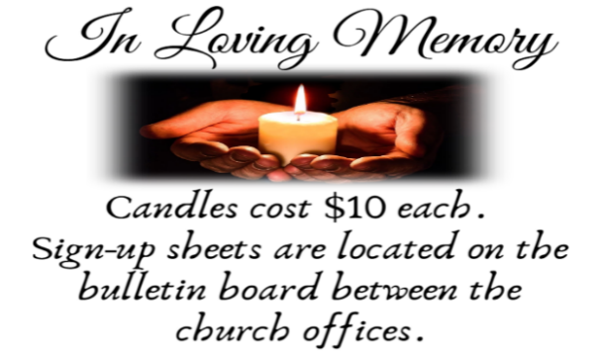
SANCTUARY CANDLE FOR APRIL
Given to the Glory of God & In Memory of
EDWARD & LINDA SCHUBERT by Vicki, Bob, Evan Rinier.
ALTAR CANDLES FOR APRIL
Given to the Glory of God & In Memory of
JOSEPH “MAC” MCKENNA & JAMES P ROONEY by Del McKenna & Children.


EASTER VIGIL INVITATION
Father Marcel has extended an invitation again this year to celebrate the Easter Vigil together. Please consider joining us at St. Simeon’s By The Sea in North Wildwood, on Saturday, April 4th, at 5PM. Vicar Vince will assist with various points of the service. Vicar Ken from Holy Trinity in Wildwood will be delivering the Sermon. Please see Vicar Vince with any questions, or to confirm your interest in attending.


WHAT IS THE EVANGELICAL LUTHERAN CHURCH IN AMERICA?
The ELCA was formed in 1987 by the merger of three Lutheran Church bodies –
the ALC (American Lutheran Church), the LCA (Lutheran Church in America), and the AELC (Association of Evangelical Lutheran Churches). Learn more at elca.org.

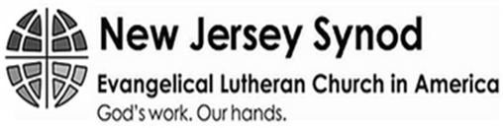
The New Jersey Synod is a geographical grouping of Evangelical Lutheran Church in America (ELCA) congregations that share the mission and ministry of the Church on the New Jersey territory. It is one of 65 synods in the ELCA. The NJ Synod is comprised of 143 congregations, which include over 45,000 baptized members.

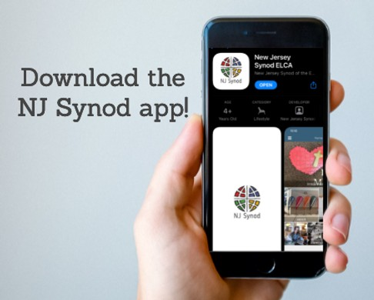
There is a weekly e-newsletter connecting our synod together with weekly prayer, upcoming events, synod and churchwide activities, mission stories, congregational activities, & more. Download the app or sign up at www.njsynod.org/stay-connected.
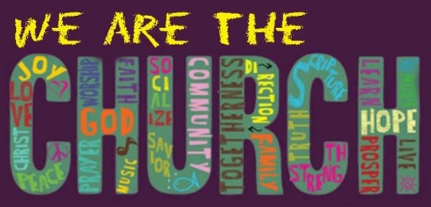

CHURCH STAFF & VOLUNTEERS
VICAR
Vicar Vince Piekarski
VICE PASTOR
Pastor William Hodgetts
ORGANIST & PIANIST
Carol Amundsen
CHURCH OFFICE, SUNDAY SCHOOL, & FOOD PANTRY
Heather Piekarski
CHURCH COUNCIL PRESIDENT & CHURCH PROPERTY
Wayne Rand
CHURCH COUNCIL VICE PRESIDENT & WOMEN OF THE CHURCH
Judy Brannan
CHURCH COUNCIL TREASURER
Bonnie Millard
CHURCH COUNCIL SECRETARY
Vicki Rinier

WELCOME TO
HOLY SPIRIT LUTHERAN CHURCH
A Member of the Evangelical Lutheran Church in America, New Jersey Synod
1220 Bayshore Rd., Villas, NJ 08251, 609-886-2414,
holyspiritlutheran@comcast.net, holyspiritvillas.com, facebook.com/holyspiritvillas
Vicar Vince Piekarski can be contacted at any time for conversation or prayer through call or text at 412-225-0287, or through email at vpie8282@gmail.com.
GOOD FRIDAY
THE SERVICE OF TENEBRAE
FRIDAY, APRIL 3RD, 2026
6PM WORSHIP SERVICE
