**Naunton Parish Council**

Clerk’s Report for

**Monday 15th September 2025**

|  |  |  |
| --- | --- | --- |
| Agenda item 3 | July minutes for approval | 3 - 5 |
| Agenda item 6 | 1. GCC Community 20’s and Safer Roads initiatives 2. Speedwatch, Autospeedwatch, GCC speed monitoring | 6  8 |
| Agenda Item 8 | External lighting in Naunton | 10 |
| Agenda item 10 | Neighbourhood planning options - GRCC | 11 |

**Agenda item 3 – July Minutes for approval**

MINUTES: of Naunton Parish Council Meeting held on Monday 28th July 2025 at 7.00 pm.

PRESENT: Parish Councillors: Charles Hanks, Keith Russell, David Pickup, Nicki Gibberson.

APOLOGIES None as all Councillors attended.

IN ATTENDANCE: Maxi Freeman, Clerk

MEMBERS OF THE PUBLIC: One

1. **To receive Declarations of Interest in items on the agenda (Localism Act 2011)** None.
2. **To hear representations from the public** regarding items on the agenda. One member of the public said she would like to speak to item 8.
3. **Approval of minutes of the previous meeting (March 2025)** The meeting approved the minutes, and the Chairman signed them. Action: Clerk to post to website.
4. **Matters Arising.** None.
5. **Clerks Report.** Councillors noted the information regarding the changes to the 5-year housing land supply formula which has resulted in a change in the land bank from 7.3 years to 1.8 years and the impact this is likely to have on planning applications. Also, background to GDPR/DPA changes and devolution progress.
6. **Planning applications**

To comment:

[25/02145/FUL](https://publicaccess.cotswold.gov.uk/online-applications/applicationDetails.do?activeTab=documents&keyVal=SZ4U5NFIKGW00) Lavender Hill Farm. Erection of agricultural building to form cover over existing solid manure heap. Deadline 14th August. Councillors had no objections. Action: Clerk to post comments to CDC planning portal.

[25/01732/FUL](https://publicaccess.cotswold.gov.uk/online-applications/applicationDetails.do?activeTab=documents&keyVal=SXFT0RFIJOR00) The Stables, Brockhill Quarry. Erection of a permanent equestrian manager's dwelling, incorporating office/entertainment space, and the relocation of the existing timber lodge building, all in association with the existing equestrian enterprise. Deadline 29th July. Councillors had no objections but a query as to why the mobile home was being moved rather than demolished. There was also a question as to why the number of stables was not going to increase at a time of expansion. Action: Clerk to post comments to CDC planning portal.

25/02056/TCONR The Old Rectory. Works to trees in conservation areas for Ash - Remove lower limb x3 Yew - Reduce in height by 3m in branch length and prune all side laterals to match. Liquid amber - Fell to ground level. Councillors had no objections to this tree maintenance. Action: Clerk to post comments to CDC planning portal.

To confirm comments made between meetings:

[25/01509/FUL](https://d.docs.live.net/e454897bfa903060/PARISH%20COUNCILS/Naunton%20PC/Agendas%20%5e0%20Minutes/Agendas/2025%20-%202026/July%202025/Comments) Land and building east of 3 Littlesworth. Erection of self-build two-storey dwelling and detached garage, demolition of dilapidated barn. Naunton PC commented: ‘Naunton PC has no objections to this application. There is a slight concern that the garage is very close to the road, which may make entering and leaving more difficult than if the garage was further from the road, with better visibility. Application refused by Highways Officer. Awaiting decision.

1. **Dog waste disposal signs.** Action:Cllr Gibberson to continue project.
2. **‘20’s Plenty’ signage**. Action: Cllr Gibberson to design sign using existing templates from providers**.** Councillors agreed on the need for ten signs around the village, as shown on the map drawn up by Cllr Hanks.
3. **Neighbourhood Plan**. Action: Cllr Gibberson to review draft steps and confirm main objectives of the plan.
4. **Neighbourhood Plan Funding.** Councillors agreed to support the petition to reinstate NDP funding. Action: Clerk to sign petition on behalf of the PC.
5. **Assets and risk assessment**. Cllr Hanks specified the items to be repaired from the Greenfields quote. Action: Clerk to confirm requirements to Greenfields.
6. **Defibrillator** **battery** Cllr Gibberson had heard from the manufacturer. Action: Cllr Gibberson to follow up.
7. **Grant for the Dovecote Renovation Trust.** Councillors decided to provide a grant of £1000 to the DRT using the authority provided by LG(MP)a 1976 s.19(3). Action: Clerk to arrange payment.
8. **New website and emails.** Councillors decided on the following**:**

Domain name: naunton-pc.gov.uk

Primary colour: Sage (or as close as Parish Online can get)

Headshots & header image: Action: Cllr Gibberson to arrange photography.

Clerk to let Parish Online know decisions.

Councillors agreed that the clerk would be paid for the extra 2 hours to carry out a data audit for new GDPR regulations.

Councillors were not in favour of any changes under the Community Governance Review.

1. **Finances**
2. **To receive current accounts and bank reconciliation**

Current account balance A/c 00462740: £29,917.12 (21st July 2025)

Deposit account balance A/c 01612290: £492.36 (21st July 2025)

Councillors approved the bank balances and the reconciliation. The Chairman signed the reconciliation.

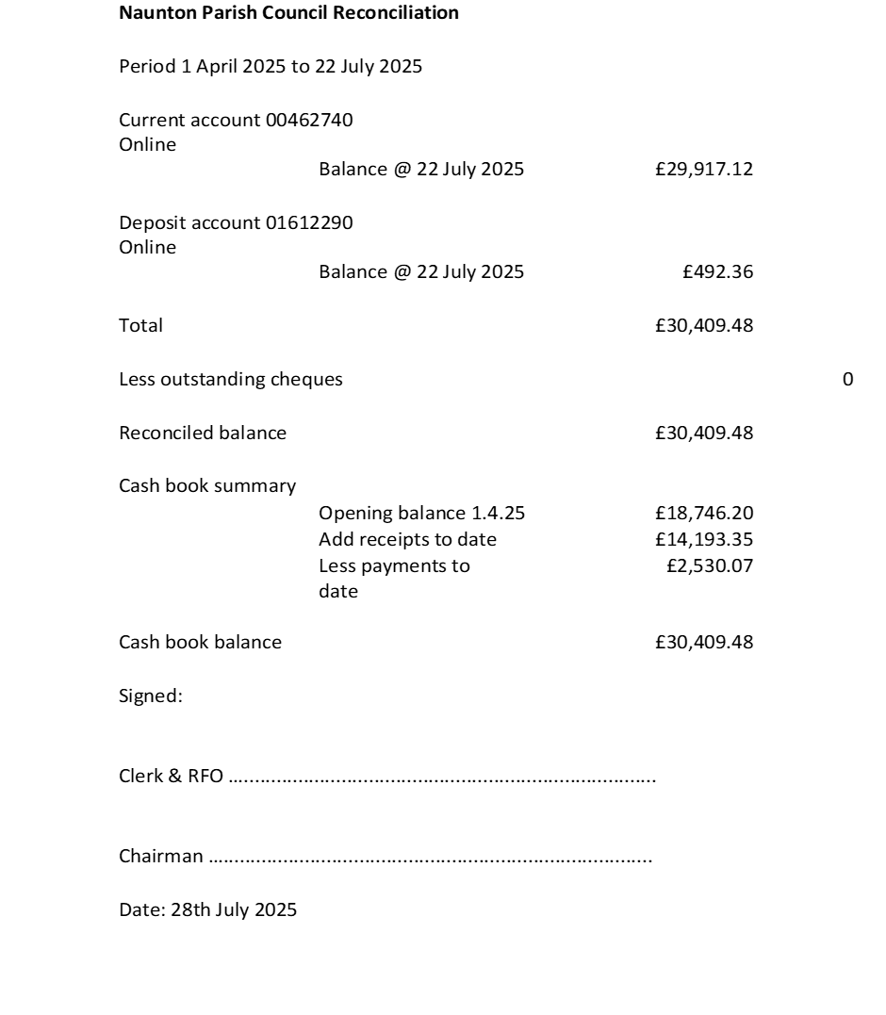

1. **Payments and receipts**

|  |  |  |  |  |
| --- | --- | --- | --- | --- |
| **The following payments were approved:** | | | | |
| Epay | M Freeman | Clerk’s salary June/July @ £230.07 p.m. | LGA 1972 s.112 (2) | £406.14 |
| Epay | HMRC | Tax @£24.60 p.m. | LGA 1972 s.112 (2) | £49.20 |
| Epay | Naunton Dovecote Trust | Grant towards renovations | LG(MP)a 1976 s.19(3). | £1,000 |

1. **Items for the next meeting:**

*None.*

The next meeting will take place on Monday 15th September 2025.

…………………………………………………………………………………..

Chairman Date 15th September 2025

**Agenda item 6 (a) – GCC Community 20s and Safer Roads initiatives**

Letter from GCC Cllr Roger Whyborn, Cabinet member for Sustainable Transport and Road Safety

Dear Councillor,

Community 20s and Safer Roads initiatives I am writing to inform you about an important initiative that Gloucestershire County Council is undertaking to enhance the safety and quality of life in our communities. Over the next three years, we are seeking to implement lower speed limits, across rural and urban areas of Gloucestershire where there is public support and where they are appropriate for the location. This will include ‘Community 20s’, 20mph limits where communities live and work.

The benefits of reduced speed limits are well documented. They contribute significantly to improving road safety, reducing the number and severity of accidents, creating a safer environment for vulnerable road users and encourage more cycling and walking. Additionally, lower speed limits have been shown to enhance the overall quality of life by reducing traffic noise and pollution, promoting healthier lifestyles, and fostering a greater sense of community.

To ensure the successful implementation of this initiative, we will be assessing requests for speed limit reductions so we can plan their delivery over the three-year period. It is essential that requests have the support of parish councils, or district councillors in unparished areas, and county councillors.

• Our **Community 20s engagement** will seek to understand the appetite for 20mph limits to be the norm in your area on roads where communities live and work and/or which are used by vulnerable road users such as children and older people.

• Our **Safer Roads initiative** will focus on reducing speed limits, on roads where there have been casualties.

In most cases, particularly for 20mph speed limits, we expect these will be signage-only schemes and therefore traffic calming works are outside the scope and will not be funded by us. Parish, town, and district councils may wish to fund traffic calming measures with our approval.

Initially we want to understand the level of interest in our proposals hence we’d like your feedback, as an **expression of interest** at this stage on two issues:

1. Whether you would like to be considered for Community 20s on some roads within your area, (yes or no). and

2. Whether there are other (higher speed) roads that you feel would benefit from a reduction in speed limit where you currently have safety concerns (yes or no).

We are asking that you provide this **initial feedback to us by 19 September**. It’s also important for us to confirm that the responses are formally supported by the parish or town council (in parished areas) hence the online forms will also ask you to confirm the date or meeting at which this was considered. I appreciate that many communities have already made their feelings known on this subject, but this is a new programme, and we would ask you to bear with us by responding to this letter.

Unfortunately, we are not able to just put up the signs introducing the new speed limits and each request will require investigation and consultation with the police and emergency services and other partners like bus companies where a speed reduction request is on a bus route. We started working on the speed reduction initiative as soon as we came to power and are committed to its delivery. However, if we receive the number of requests we are expecting it could take several years to implement them. We will keep you informed of what is going on, but please be patient so that we can focus on delivery.

We will provide a weblink on our website https://www.gloucestershire.gov.uk/road-initiatives/ to enable you to provide feedback (yes or no) on both these issues, and which provides some more detail about the initiative, including frequently asked questions. In due course we will also provide a link from the webpage to an intuitive mapping tool which we’ve developed to capture your specific feedback. It will allow you to highlight roads and lengths of roads within your area, where you feel a lower speed limit is appropriate and also add relevant comments to the map.

Alongside the webpage we also have a dedicated email address, should you need to contact us about any issues or questions about the online response form: [*speedlimits@gloucestershire.gov.uk*](mailto:speedlimits@gloucestershire.gov.uk)*.*  There will of course be **a full public engagement process in every area** once an initial design has been produced, and it will be comprehensive. This will be informal and additional to the statutory consultation process which we are required to undertake.

We believe that our ‘Community 20s’ and ‘Safer Roads’ initiatives will bring substantial benefits to our communities, and we look forward to working with you to make our roads safer and our areas where communities live and work more pleasant for everyone.

Thank you in advance for your feedback.

Yours sincerely,

Cllr Roger Whyborn Cabinet member for Sustainable Transport and Road Safety

**Agenda item 6 (c )– Traffic management options emailed to parish resident**

Suggestions that would require resident time, but not village funding:

**Speedwatch guns** are the onlymeasures which require resident time, but no funding.  You say that you don't think people would want that, but they are highly effective in slowing traffic down, either when wielded by volunteers from the village wearing high viz jackets or by police. Perhaps you could survey residents to see whether they would be prepared to form a local Speedwatch group.  See below for details.  However, if the cameras are used in the 60 mph section you will just remind people to keep to the 60 mph limit (which applies until they reach the 30 mph limit sign).  If they're used below the 30 mph sign, then they should (!) slow down before entering the village itself.

Suggestions that do not involve significant resident time, but do require funding:

**1. Reducing the speed limit between Foxhill and the golf course**

Any change to a speed limit would require a Road Traffic Order ( for speed limits, parking restrictions, weight limits, one way street and banned turns, prohibitions).  RTOs have to be approved by GCC, then go to parliament at a cost of £12 - 15,000 to the parish and take appx 18 months.

It is unlikely that GCC would support this because:

* The national speed limit of 60 mph applies outside built up areas.  The Foxhill - golf course section of road is not in a built up area.

* There are no natural hazards e.g. sharp bends/ low or poor visibility or facilities where people gather e.g. schools, shops.

* There are no records of fatalities on that road.   Fatalities can encourage GCC to act.

If you check the data for accidents on that road:

* there were 2 road accident in Naunton between 2018 and 2021 -

[casualties-from-road-traffic-collisions-2019-21-by-parish.pdf](https://www.gloucestershire.gov.uk/media/svxaqvgb/casualties-from-road-traffic-collisions-2019-21-by-parish.pdf)

* one serious and one slight accident are recorded on the GCC collision  map: [GCC WebMaps](https://gcc.dynamicmaps.co.uk/MapThatPublic/Default.aspx). One in 2021 and one in 2023.  I'm not sure why the data differs, it's police data held by GCC.

If you think there are more accidents, then you will need to organise a diary of accidents with evidence. That may help to build the case for GCC to act.

Of course,  there is no certainty that a lower speed limit would be effective, especially as the road is relatively straight, which encourages faster driving.

**2. Reducing the speed limit down the hill into Naunton** would need an RTO as above. It is legal to drive at up to 60 mph until the 30 mph sign.   Moving the 30 mph sign might help but there would need to be a case for GCC to approve an RTO. The Wardens Way might help to build a case, as might information from GCC speed tubes, but there have not been any fatalities.  There is also the issue of cost.

**3. Naunton welcomes careful drivers signs**

Provided GCC Highways is happy with this, it should be possible to put these signs up, although GCC is always concerned about sign proliferation. GCC does not generally allow non-GCC signs to be installed on their posts. The village/PC would have to fund the signs, cost dependent on materials, as well as possibly more posts.  GCC controls the installation of posts.   I have not been able to find data showing how effective these signs are.  As an example, please visit [Please Drive Carefully Road Sign R2 Reflective 900x600mm for post mounting | SSP Direct](https://www.securitysafetyproducts.co.uk/security/safety-signs/please-drive-carefully-road-sign-r2-reflective-900x600mm-for-post-mounting.php) for pricing.£101.50 plus £70.20 for a suitable post. Installation cost should also be added.

**4. Speedtubes**.  These have no effect on speed.  They are there purely to record actual speeds and volumes of traffic.  The results can be included when making a case to GCC Highways to act on speeding/safety issues.  See below for costs.

**5. VAS (vehicle Activated Signs**) equipment has significantly reduced speeding in some parishes.  But there are places where the temptation to speed is too great.  Some drivers even accelerate to see how high they can get the VAS speed to go!

**6. Autospeedwatch**.  Replaces Speedwatch volunteers with a special camera.  Glos police doesn't take direct input from the camera but volunteers can provide the information to the police. Consequences are the same as the manual Speedwatch.  Cost is £779 + VAT for year 1, then £179 + VAT p.a. from year 2 onwards.   Unless there are already posts where they  can be installed, GCC will need to approve their installation and carry it out.  If privately owned land (i.e. Not by GCC) is needed for the posts, their agreement will be needed.

Best

Maxi

Maxi Freeman

Clerk & RFO to Naunton Parish Council

Further information is available at: <https://www.gloucestershire.gov.uk/roadsafety/road-safety-community-hub/speeding/>

**Agenda item 8: Draft letter re: lighting of properties in Naunton**

Following comments at the end of the May meeting, Councillors may like to consider the following draft and its distribution:

Dear xxxx

Residents of Naunton have become increasingly aware of the volume of external lighting at some homes and are concerned about its impact on local dark skies, climate change and human and animal health. Please see the note below for more details of the impact of night-time lighting or visit the Cotswold National Landscape Board website: [Dark Skies - Cotswolds National Landscape](https://www.cotswolds-nl.org.uk/our-work/advice-and-guidance/dark-skies-guidance/).

The most dangerous external lighting is blue-colour range (i.e. cool wavelengths rather than warm) LED lights. While these are sometimes sold as a means of improving security, there is no clear evidence that they work. There is, however, research to show that bad outdoor lighting can decrease safety by making property easier to see. It can also create glare and deep shadows, which makes it easier for criminals to move around without being seen. Statistics also show that most property crime occurs during the day.

To help restore the unique dark skies above Naunton in the Cotswold National Landscape and to safeguard wildlife, please would you consider the following changes:

* Install motion sensors or dimmers to ensure lights are only on when needed.
* Choose warm-coloured LED bulbs with minimal blue light emission.
* Shield outdoor fixtures so that light is directed **downward** and does not spill into the night sky.
* Turn off lights when they are not required, particularly overnight.

Your help would be much appreciated.

Yours sincerely

**Agenda item 10 – Neighbourhood planning changes**

