5/31/2017 Uranus, Uranium, and Jerusalem

Our Creator Elohim have placed the lights in the heavens for signs (Hebrew - distinguishing mark, warning), seasons, days, and years. Genesis 1:14

The Planet Uranus

Uranus was discovered 3/13/1781 by Sir William Herschel.

The planet Uranus is named after the Greek god of the sky, Ouranos. All the other planets are named after Roman gods.

Uranus is visible to the naked eye but wasn't recognized as a planet because it moved so slowly through the sky. Its period is 84.016846 years, or 30,687.15 days.

A man named Bode who determined the orbit of Uranus also named the planet.

In 1789 a friend of Bode, Martin Kalproth, named his newly discovered element, Uranium, in support of Bode's choice. So, the element Uranium derives it's name from the planet Uranus which derives it's name from Ouranos, the "Greek god of the sky".

At the North Pole

The "sides of the north" in scripture refers to the symbolic location of YaHuWaH 's throne, and His dwelling place in heaven.

Almost everyone has dismissed the "blood moon tetrad" of 2014-2105 on YaHuWaH 's Feast Days as having passed without relevance. Most think they can be ignored and forgotten, but there are some aspects of that lunar eclipse sequence that are unusual.

On 10/8/2014 there was a total lunar eclipse during the Feast of Sukkot (Feast of Tabernacles). An observer standing at the North Pole would see the moon pass over the planet Uranus during the eclipse totality. Here's a view of the planet Uranus emerging from behind the moon while the moon was still in the deepest part of earth's shadow during the "blood moon".

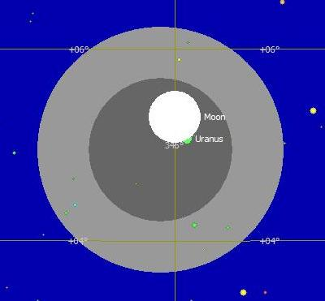
Above: Uranus popping out from behind the moon, both Uranus and the moon being in the deepest part of earth's shadow, during the lunar eclipse of 10/8/2014.

As viewed from the North Pole, symbolic of the place of YaHuWaH 's throne, because of parallax, the Moon appeared to hide Uranus during the "blood moon" part of the eclipse on 10/8/2014.

The North Pole, Uranus, event in the blood moon of 10/08/2014 was revealed to me around 4/16/2015. Less than a week later Hillary Clinton was in the news for helping sell 20% of the Uranium interests of the United States to Russia. The destruction of Babylon is described as arrows (missiles) coming from the north.

Jeremiah 50:9 For, lo, I will raise and cause to come up against Babylon an assembly of great nations from the north country: and they shall set themselves in array against her; from thence she shall be taken: their arrows shall be as of a mighty expert man; none shall return in vain.

The Solar Eclipse of 8/21/2017 and Uranus

We have previously noted that the total solar eclipse of 8/21/2017 will be the first total solar eclipse to completely cross the United States from coast to coast since the eclipse of 6/8/1918. The 100th year from 6/8/1918 will begin on 6/8/2017, and the eclipse of 8/21/2017 will fall during that 100th year.

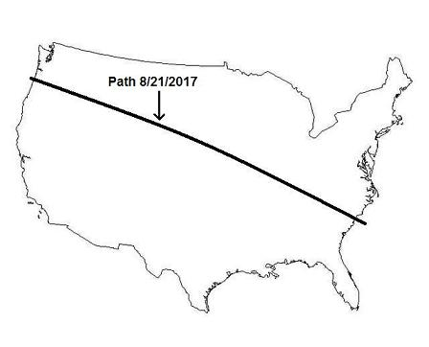
Above: The path of the total solar eclipse of 8/21/2017.

We have also shown that the solar eclipse of 6/8/1918 was exactly 49 inclusive years to the day from the taking of Jerusalem on 6/7/1967 by Israel in the Six Days War. This fact ties the eclipse of 6/8/1918 with Jerusalem and also the United States.

The Path of the Total Solar Ecipse of 6/8/1918
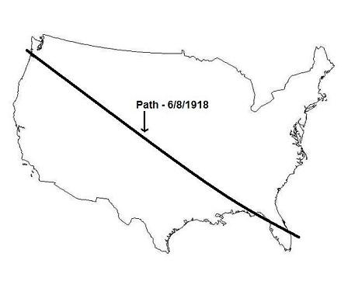
Above: The path of the total solar eclipse of 6/8/1918, the last total solar eclipse to completely cross the United States from the Pacific ocean to the Atlantic ocean prior to the total solar eclipse of 8/21/2017.

Earth's Shadow on 8/21/2017 and the Position of Uranus on 6/8/1918

Because the solar eclipse of 8/21/2017 and 6/8/1918 are related because of their long paths, and because they tie the United States with Jerusalem via a 49 years (7 x 7 years) timeline, we need to investigate these solar eclipses further.

Below is a graphic showing the position of Uranus, symbolizing Uranium, in the 6/8/1918 eclipse compared with earth's shadow during the 8/21/2017 solar eclipse.

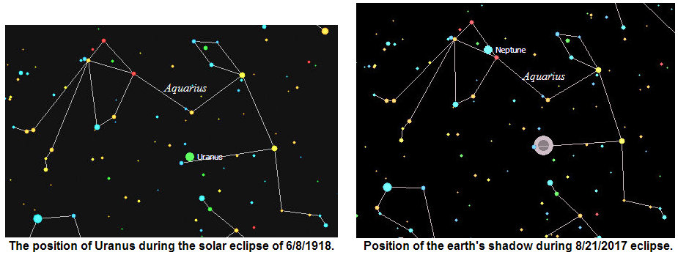

Above: The earth's shadow during the total solar eclipse of 8/21/2017 precisely targets the location of the planet Uranus, symbolic of Uranium, as it was during the total solar eclipse of 6/8/1918. Note that both appear in the constellation Aquarius, previously identified as the "Water Bearer".

A man bearing a pitcher of water was to be a sign to YaHuShua's disciples, leading them to the place where they would eat the Passover. Mark 14:13

The Passover involves a threshold (Hebrew "Saph") sacrifice, as investigated in a previous article. We also know that Jerusalem will be a cup (Hebrew "Saph", place of threshold sacrifice) of trembling to all who burden themselves with the city. In other words, Jerusalem will be the threshold, the doorway, to a lot of bloodshed for the nations who step onto YaHuWaH 's turf with evil intent.

It looks like the "man in the sky with the pitcher of water" shows us that uranium is involved in the destruction of Babylon the great. This was revealed to me on 5/31/2017 by YaHuWaH Elohim.

