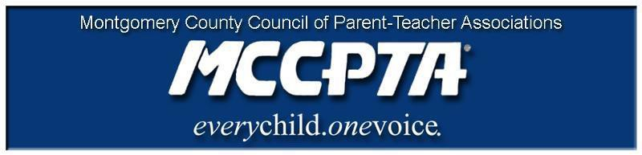

DELEGATES’ ASSEMBLY MEETING AGENDA
Tuesday, November 30, 2021
Meeting Held on Zoom

7:00 pm WELCOME

- Approve Agenda; Approve October 26, 2021 minutes

7:05 pm SPEAKERS

- Restorative Justice Director, Mrs. Jarandby
- Role of the Ombudsman

7:45 pm NEW BUSINESS

- MCCPTA Standing Rules
- VP Programs - Charisse Scott - Work Plan & Budget adjustment for the Engagement (Programs) subcommittee
- Health & Wellness Committee - Letter to the MSDE about in-school Masking requirement
8:15 pm COMMITTEE REPORTS

- Membership Committee
- All Reports, including all work plans – https://mccpta-my.sharepoint.com/:f:/g/personal/office_mccpta_org/Eu5vwxNipqxHqCVEyXv-9ywBzcDMw_1UqOvbGrEJrsV23g?e=gNKSLb

8:30 pm OFFICER REPORTS

- Cynthia Simonson, President
- Rodney Peele, Vice President- Educational Issues
- Rochelle Fink, Vice President- Administration
- Charisse Scott, Vice President- Programs
- Laura Mitchell, Vice President- Advocacy
- Francesco Paganini, Treasurer
- All Reports - https://mccpta-my.sharepoint.com/:f:/g/personal/office_mccpta_org/Eju9FfL4HWBKhUsxfku-JqQBQ5NSqr41CExWX39vR0w2vA?e=Hs28Ba

9:00 pm ANNOUNCEMENTS & ADJOURNMENT

DATES:

- December 8, 2021 – BOD Meeting, 7 pm on Zoom
- January 12, 2022 – BOD Meeting, 7 pm on Zoom
- January 25, 2022 – DA Meeting, 7 pm on Zoom
- February 9, 2022 – BOD Meeting, 7 pm on Zoom
- February 22, 2022 – DA Meeting, 7 pm on Zoom

