Pleasant Township Board of Trustees Meeting Highlights
Date _January 23, 2024______________ Next Resolution No._ 24--1-23-2024_ _
*This is not official minutes, only notes taken by Trustee Hunter
- Call to Order -- The meeting tonight will also be on WebEx.
- Please stand for moment of silence. --Pledge of Allegiance--Roll Call (Ed-attending by Web-X)
- Visitors –
- Hanna Poling with the Southwest Messenger via WebEx.
- Minutes to approve- No minutes
- Financial Reports – Motion to pay expenditures.
- Department Reports
- Franklin County Sheriff’s Report- Community Liaison, Deputy Adkins
01/09/2024 through 01/23/2024
Total Calls for Service/Self-Initiated Runs: 126
Total Reports Taken: 15
Total Arrests/Citations: 4
Burglaries: 0
Traffic Crashes: 11
Medic Runs: 20
Thefts: 4
Missing Persons: 0
Stolen Vehicles: 2
Stolen Vehicles Recovered: 2
Suspicious Persons/Vehicles: 9
Vandalism: 1
Traffic Offenses: 17
Motorcycle/ATV/Bike Complaints: 1
On 01/10/2024, Deputies responded to the 6100 Block of Gay Road on the report of Identity Theft. An unknown individual/s attempted to transfer money from the homeowner's account. Investigation is ongoing.
On 01/12/2024, Deputies responded to a burglary in progress at the 6100 Block of London-Groveport Road. The individuals fled before Deputy's arrived. After the initial investigation, several suspects have been identified. This investigation is ongoing.
On 01/13/2024, Deputies responded to the 5900 Block of Harrisburg-Georgesville Road on the report of a medical emergency. Deputies worked along with Pleasant Twp Medics, but the individual was pronounced deceased. This investigation is ongoing.
On 01/16/2024, Deputies responded to the 6900 Block of W. London-Groveport Road on the report of a motor vehicle theft. Two unknown individuals had allegedly taken a 2015 Dodge Charger along with a wallet and several bank cards. There are no suspects at this time; this investigation is ongoing.
On 01/26/2024, Deputies responded to the 6300 Block of Harrisburg Pike on the report of two suspicious vehicles. During the investigation, it was determined that both had been reported stolen. Both were recovered, and the investigation is ongoing.
- Road Department- Robert Bausch, Superintendent
- Truck #21 at ELW
- Truck #22 going to get new tires
- Snow and ice
- Low clearance sign Denton Rd.- The sign belongs to Franklin County Engineers, Robert has contacted them and asked them to put a sign on Stahl Rd.
  - Received 2 complaints about the sign being down, semis turning around in their driveway causing ruts in their yard.
- 1 burial
- Mileage certification to sign
Unresolved items
- Any updates on the rocks/boulders in the right-of-way on Oakhurst Dr.
  - Received the form letter from Pete waiting on the weather to break.
- Any updates on Gay Rd. about repairs due to heavy rains washing the roadway and gravel away. (meeting on 8-8-23 we said we’d keep it on the agenda till resolved in some way.)
- Fire Dept. – Chief Whiting
Apparatus
- All apparatus is back. (Prairie replaced tires on E-2)
- Replaced all valves on the tanker.
- Still need an exhaust system.
- E-231 upcoming will need new tires on the rear (original)
Staffing
- Ben Noonan's effective start date is January 24.
- Part-time
- Add Chance Diehl
Resolution__24_to hire Chance Diehl as parttime firefighter/Paramedic
- Add Dylan Neff
Resolution_25_to hire Dylan Neff as parttime firefighter/EMT
Training
- Paramedic School ongoing.
- Ice rescue school.
Station
- Need to look at modifying township bathrooms.
- Bad valve in the apparatus bay; we are going to replace it in-house.
Community Risk Reduction
- Levy Update
- The issue number is #17
- The Union is organizing door-to-door walks and looking at informational session dates.
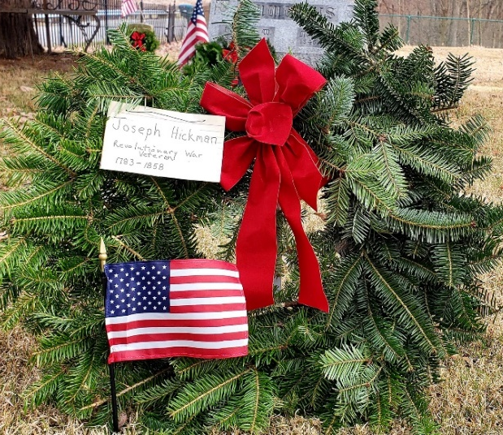
- Installing smoke detectors as needed
Communications (Dispatch)
- Fairfield Township
- No issue to report.
- Announcements-
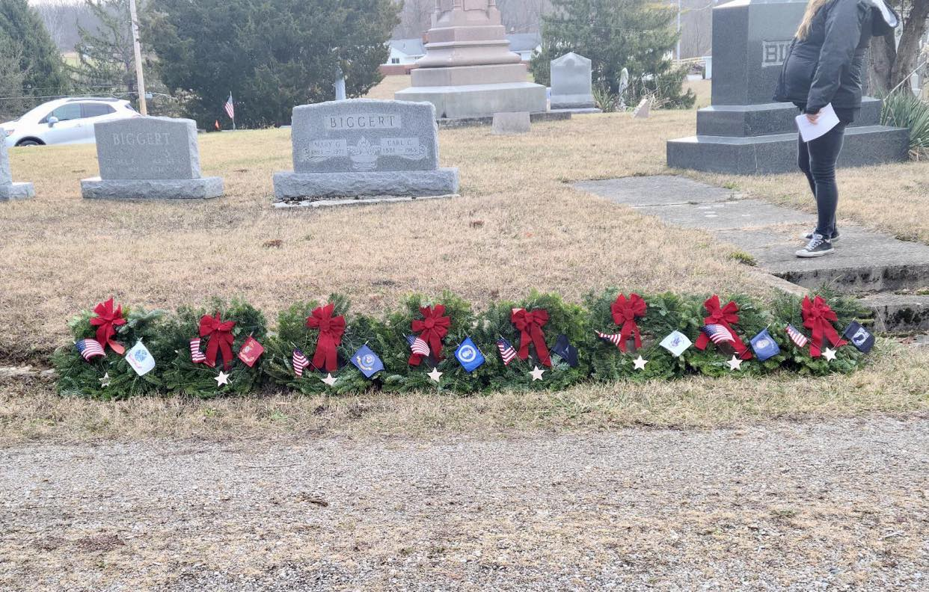
Wreaths Across America – Well we all did it!!! During the phenomenal match program, we reached the goal of 200 wreaths for December. These are enough wreaths to honor each veteran laid to rest at Oak Grove, Ebenezer, and Gundy cemeteries. Thank you to all who donate, attend the service, lay the wreaths and a big thank you to the coordinator, Carrie Cole for putting this all together.
- Clerk Updates- Paula
- Miscellaneous correspondence
- David Donofrio sent email reminder the Go Daddy Microsoft 365 email essentials will auto renew on 2/1/24 for $71.88 for a year.
- Paula received the following email, we need to appoint two trustees to this Board and the fire department needs to appoint two then that board appoints and outside person. Dear PAULA WILKINS
Annual certification and board members due
As part of the VFDF (Volunteer Firefighters Dependents Fund), each fire department member must annually establish a VFDF Board comprised of five members that would be responsible for reviewing claims and making recommendations to SFM, if the need arises due to a line of duty injury or death and provide the 'Assessed Value' or dollar value assigned to the political subdivision or fire district for purposes of measuring applicable taxes by January 31st of each year. This Value amount can be obtained from the county auditor.
An assessment will be invoiced whenever the fund is reduced to ninety-five percent or less of its basic capital account. (O.R.C. 146.09). Assessments invoices are charged on a sliding scale based on the current assessed property valuation, whenever the fund is low and not on a calendar schedule.
In the past, this certification has been mailed, however for the certification is now available electronically.
Sincerely,
Division of State Fire Marshal
- Appoint 2 trustees ___Randi Good____ __Nancy Hunter_____
- Appoint 2 from the fire dept. __Chief Whiting____ _Lt. Kuno___
- Appoint 1 from the outside _Ken Yarnell___
  - Resolution___26__ to adopt for FEMA the Hazard Mitigation Funding Program
  - Paula received a check for $10,000 for the MARCS (radios) grant.
- Speaker Sheets-
- Jeff Karn questions about the levy, personal trainer, and the sale of the medic.
- Adjourn

