Mars UP Church

Apostles’ Creed
I believe in God the Father Almighty, Maker of heaven and earth; and in Jesus Christ His only Son our Lord; who was conceived by the Holy Ghost, born of the Virgin Mary, suffered under Pontius Pilate, was crucified, dead and buried; He descended into hell; the third day He rose again from the dead; He ascended into heaven, and sitteth on the right hand of God the Father Almighty; from thence He shall come to judge the quick and the dead. I believe in the Holy Ghost, the holy catholic church; the communion of saints; the forgiveness of sins; the resurrection of the body; and the life everlasting. Amen.

Gloria Patri
Glory be to the Father, and to the Son, and to the Holy Ghost. As it was in the beginning, is now and ever shall be,
world without end.
Amen. Amen.

Come Holy Spirit, Come
Before the Service – Speak to God!
During the Service – Let God speak to you!
After the Service – Speak to each other!

(*Please stand, if able)
Welcome and Mars Messages

Prelude

Call to Worship

Leader: When God appeared on earth, in the person of Jesus,
most of the world did not recognized him, and
therefore did not worship him.

People: Today we ask for the faith that will open our eyes
to see Jesus for who he is, that we might worship
in truth.

Leader: People of God, behold, and see your God!

People: We open our eyes to see his glory. We open our
ears to hear his wisdom.

Leader: We open our hands to offer him Gifts.

People: We open our mouths to sing his praise, and our
hearts to offer him our love.

Opening Prayer

*Hymn 90 (vs. 1,2,4) “Joyful, Joyful We Adore Thee”

Scripture Ephesians 1:15-20
Ephesians 3:14-20
The
Lord’s Prayer

Our Father,
who art in heaven,

hallowed be Thy
name,

Thy kingdom come,
Thy will be done,
on earth
as it is in heaven.

Give us this day
our daily bread;

and forgive us
our debts,
as we forgive
our debtors;

and lead us not
into temptation,
but deliver us
from evil.

For Thine
is the kingdom,
and the power,
and the glory,
forever. Amen.

The Doxology

Praise God
from whom
all blessings flow;
praise Him
all creatures
here below;
praise Him above,
ye heavenly host;
praise Father, Son,
and Holy Ghost.
Amen.

Children’s Chat 185
“Jesus Loves Me”

Morning Message Rev. Paul Aiello
“Who Do You Say That I Am?”

*Hymn 688 (vs. 1,2,4)
“Shepherd, Lead Us”

Prayers of the People and Lord’s Prayer

*Hymn 589 (vs. 1-2)
“Here I Am Lord”

*Benediction

*Congregational Response (Everyone sings)
The time has come, O Lord, for us to leave this place;
Guide us and protect us and lead us in Thy grace;
Wherever life may take us as we go our separate ways;
Help us share with others the things we’ve shared today;
May the peace of God the Father
And the love of Christ His Son
Guide us in the days ahead and strengthen us each one;
May the blessings of the Spirit fill us from within;
God bless us and return us to this fellowship once again. Amen.

*Postlude

Flowers are presented today to the Glory of God and in loving memory of Vernon and Margaret Carpenter on their anniversary by the Olsen Family

Church Staff
Rev. Brian Hauser
Pastor
pastor@mars-up.org
724-689-3412

Mrs. Shelly Bocheff
Administrative Assistant
marsup@mars-up.org

AV TEAM
Alma Staskiewicz, Lisa Barbour, Marie Matthews, Bill Guesman, John Ivory, Mike Bocheff, Herb Wellman

Mars United Presbyterian Church

232 Crowe Ave
PO Box 805
Mars, Pennsylvania 16046
724-625-1365
www.mars-up.org
marsup@mars-up.org

Church Office Hours:
Mon -Thurs from 9 a.m. -2:30 p.m.
MUP Session

Class of 2025 Class of 2024 Class of 2023
John Ivory Alma Staskiewicz Lisa Barbour
Susan Cox Louise Fox Mary Ann Croop
Jay Wilson Marie Matthews Don Lewis
Herb Wellman

Clerk of Session: Herb Wellman
Morning Worship:
10:00 am

2nd Sunday after Pentecost

Prayer of Preparation
Lord, we come to you today with so many things on our hearts.

You call us to be in relationship of trust and love with you and you offer healing to us for those portions of our lives that are broken and injured.

Help us to be open to your mercy and healing love. For we ask this in Jesus’ Name.
AMEN.

MUP Deacons

Class of 2025 Class of 2024 Class of 2023
Jill Cooper Steve Martin Sharon Gibb
Robyn Beckwith Marge Nicklas Carol Kopar
Missy Wells Pat Auld Alice Leonberg

Moderator: Steve Martin

MUP Music Committee
Keith Nichols – Chair
Sally Olsen – Clerk
Alma Staskiewicz
John Ivory
Linda Lees
Karl Kennedy

Mars United Presbyterian Church
Welcome!

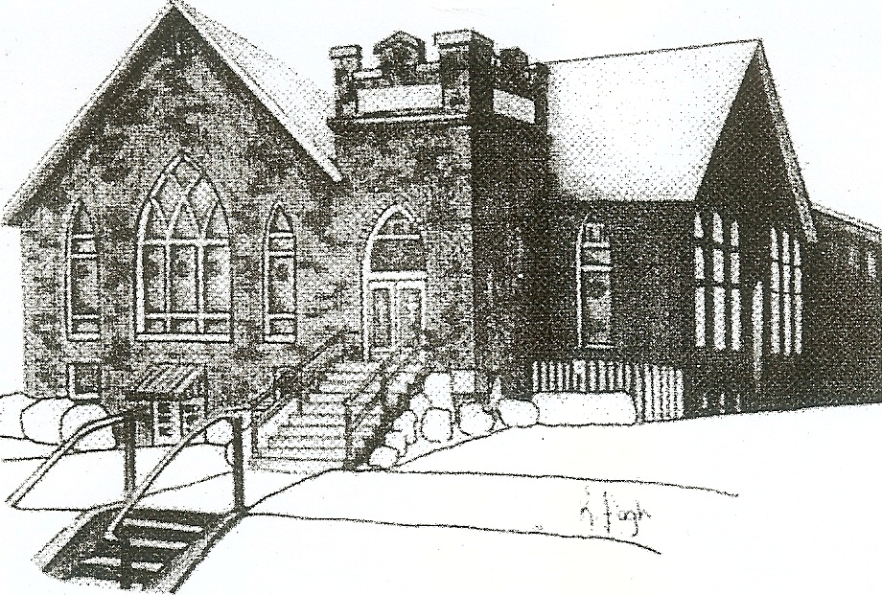
We are your hometown church: Faithful to Tradition, Loving in Fellowship, & Reaching for Tomorrow!

June 11, 2023

We welcome you and we are glad you’ve chosen to Worship with us today!

CALENDAR: June 11th – June 18th

Church Office Hours: Monday -Thursday from 9 a.m. – 2:30 p.m.

Today, June 11, 2023
VOLUNTEERS☺

LAST SUNDAY’S In-House ATTENDANCE: 52

LAST SUNDAY’S OFFERING:
Operating Funds: $2161.00
Kindness: $50.00
Mission: $60.00
Bldg Improv. $10.00
Per Capita $43.77
Total: $2324.77

Tarry N Talk Hosts
Worship/Membership committee

10:00 a.m. THE MORNING WORSHIP SERVICE
11:15 pm Deacon Meeting
Monday, June 12, 2023
Tuesday, June 13, 2023
9:00 am A team
7:00 pm AA
7:00 pm Stewardship Meeting
Wednesday, June 14, 2023
9:00 am Material Girls
Thursday, June 15, 2023
7:00 pm Session Meeting
Friday, June 16, 2023
Saturday, June 17, 2023
Sunday, June 18, 2023 Father’s Day
10:00 am THE MORNING WORSHIP SERVICE

Welcome to all who are Worshiping with us today!

Guests
We sincerely hope our service is a blessing to you. We ask that our guests please take a few minutes to complete one of the Connect Cards found in the pew holder.

Should you have questions regarding any aspect of our church, including membership, please contact Pastor Brian or the church office during the week at 724-625-1365. Thank you for being with us today.

PRAYER – JOYS & CONCERNS
Lou Beckwith Paige Lauten
Paige Barbour (daughter of Andrew and Steph Barbour) Sandy Wahl
Reid Christopher Hall (June Stirling’s nephew) Sue Morris
Lindy McCartney (Lisa Barbour’s Sister) Patty Jackson

ANNOUNCEMENTS
Bulletins are printed Thursday mornings; let us know if you have an announcement…

CAP RECYCLING PROJECT The plastic cap recycling program is coming to an end. The final day to drop off caps is Monday, JUNE 12th. Thank you to all who donated and helped with this Eagle Scout project.

VACATION BIBLE SCHOOL “STELLAR” Registration for VBS is available now online at www.mars-up.org. July 9th thru July 13th 6:00 to 8:30 pm. SPECIAL OPENING SUNDAY AFTERNOON- Families join us for a HOT DOG BEAN kickoff at 5:00 pm in MUP Fellowship Hall

GRIEFSHARE SUMMER MEETINGS Griefshare will continue to hold one monthly meeting during the summer. Meetings will be held on June 19th, July 17th, and August 21st. The fall session will resume on September 18th at 6:30 For more information, please contact Denise @ ddemarco5@yahoo.com
MOTHERS OF PRESCHOOLERS (MOP) group will meet again in the Fall of 2023. To register or questions contact church office or Ashley Hauser at 814-270-9101. More detailed info to follow!!
MUP JUNE NEWSLETTER Hard copies of the June newsletter are available in Tarry N Talk. If you would like added to the mailing or emailing list, please contact the office.
CARD SHOWER We are having a card shower for Pat Jackson. If you are able, please send a card to Pat Jackson 1038 Masonic Drive Sewickley, PA 15143

