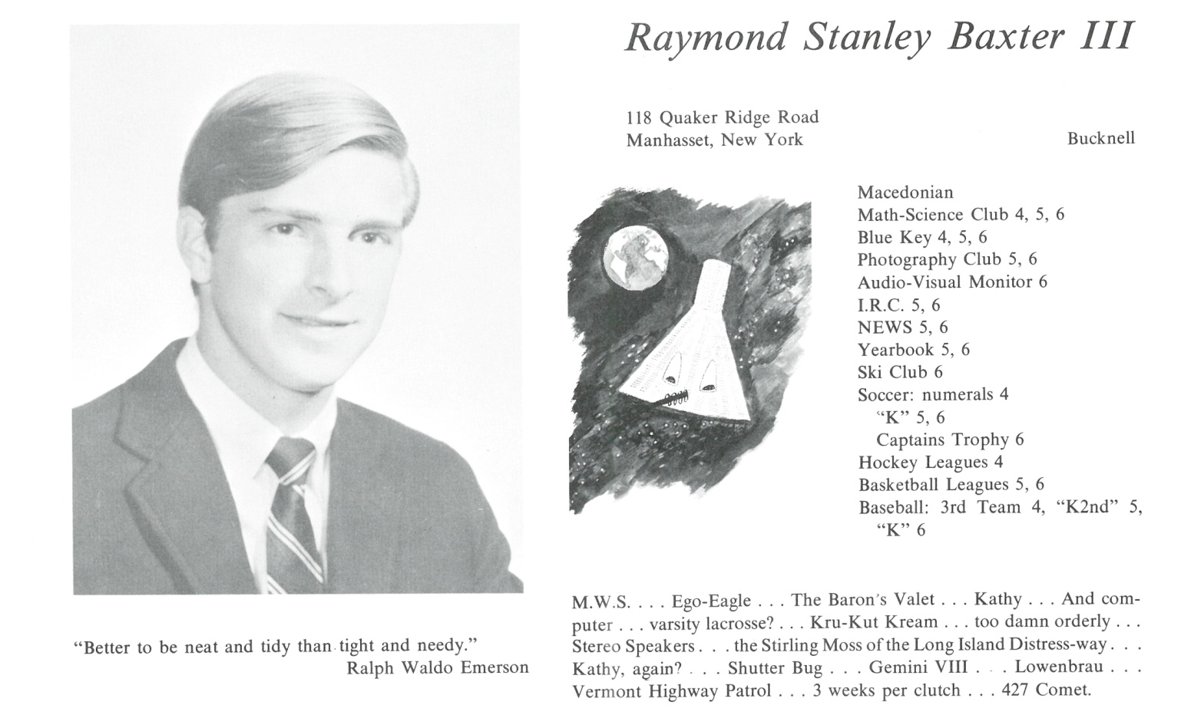

______________________________________________________________

______________________________________________________________ ______________________________________________________________ ______________________________________________________________ ______________________________________________________________ ______________________________________________________________ ______________________________________________________________ ______________________________________________________________ ______________________________________________________________

Attach Picture in .jpg Format

______________________________________________________________

______________________________________________________________

___________________________________________________________________________________ _________________________________________________________________________________________________________________________________________________________________________________________________________________________________________________________________________________________________________________________________________________________________________________________________________________________________________________________________________________________________________________________________________________________________________________________________________________________________________________________________________________________________________________________________________________________________________________________________________________________________________________________________________________________________________________________________________________________________________________________________________________________________________________________________________________________________________________________________________________________________________________________________________________________________________________________________________________________________________________________________________________________________________________________________________________________________________________________________________________________________________________________________________________________________________________________________________________________________________

___________________________________________________________________________________