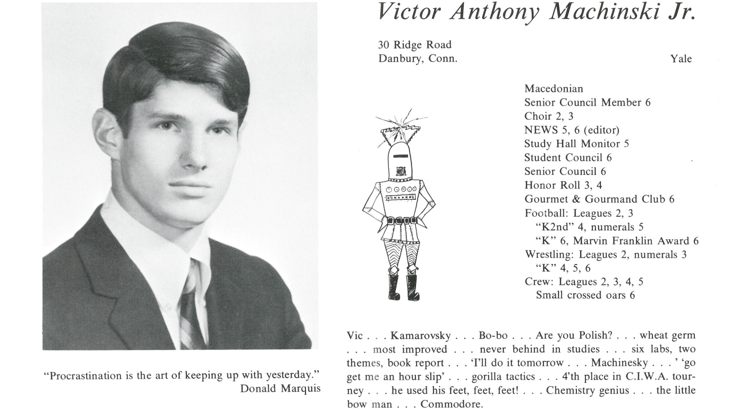

Victor A. Machcinski, Jr.

Well, I forgive the editor who misspelled my name 50 years ago. The missing second “c” has plagued me my whole life. But, as Mr. Armstrong might have said back in the day, it’s just a pimple on the ass of progress. As I’m sure has been true of many others, the progression forward since 1967 has not been a straight line, but there’s no reason that it should have been. The bottom line is that I have been immeasurably blessed.

First and foremost, blessed with parents who are at the top of my special Pantheon of people who have shaped and guided me and acted as powerful forces of goodness and strength.

For starters, they sent me to Kent. To quote Coach Franklin, Kent School is an “island of plenty in a sea of misery.” If you don’t believe it, think hard and try again. I recall the many special influences at Kent among the masters and coaches: Lee Ahlborn, Bish Colmore, O.B. Davis, Tom Andrews, Hart Perry, Peter Bragdon, Conal Keogh and Harold Bredberg. There are more. Many fond memories, concluding with a trip to Henley. Many friends made among classmates, teammates, schoolmates that have lasted a half century. I’m very privileged to have had all of these associations.

After graduating Yale and bombing my med school fantasies, I took three years off and played music professionally with two classmates and a fabulous bass player from Hamden. A fun detour that included arranging and recording an original song written by our keyboards player that Rod Stewart made into a hit years later, called “Some Guys Have All the Luck.” When the next step was playing showcases in NYC dressed in drag, law school beckoned—understandably, a wise choice for me.

What stands out most is meeting my wonderful wife, Mary Ellen, for which I am most grateful. Our relationship was one of the best things that came out of *U.S v. IBM*. And then, three wonderful children of whom I am very proud. My girls, Meaghan and Caitlin, are treasures. And my son, Scott—a West Point graduate and First Lieutenant in an armor brigade, now deployed—is a daily inspiration. My children have given me more joy than I deserve.

No, it hasn’t been a straight line. Sept. 11 crashed down upon us, literally, with devastating impact, but my family persevered and became stronger with the support of each other, our friends and our faith. My career in securities arbitration and litigation has taken some beneficial twists and turns since then, and for that I feel fortunate.

Thank you, Kent School, and very best regards to my 1967 classmates.



______________________________________________________________

______________________________________________________________ ______________________________________________________________ ______________________________________________________________ ______________________________________________________________ ______________________________________________________________ ______________________________________________________________ ______________________________________________________________ ______________________________________________________________

Attach Picture in .jpg Format

______________________________________________________________

______________________________________________________________

___________________________________________________________________________________ _________________________________________________________________________________________________________________________________________________________________________________________________________________________________________________________________________________________________________________________________________________________________________________________________________________________________________________________________________________________________________________________________________________________________________________________________________________________________________________________________________________________________________________________________________________________________________________________________________________________________________________________________________________________________________________________________________________________________________________________________________________________________________________________________________________________________________________________________________________________________________________________________________________________________________________________________________________________________________________________________________________________________________________________________________________________________________________________________________________________________________________________________________________________________________________________________________________________________________

___________________________________________________________________________________