05/07/2016 London’s First Muslim Mayor and the Coming Flood of Fire

The Erection of a Spiritual Door for Allah to Enter London 4/19/2016

The Arch of Baal in Palmyra, Syria, was the entrance to the ancient Temple of Baal. It was destroyed by ISIS fighters last year on 10/4/2015, Sukkot Day 7.

A replica of the Arch of Palmyra in Syria was erected in London on April 19, 2016, the day of pagan child sacrifice when infants are burned alive in honor of Baal (Bel, Allah).

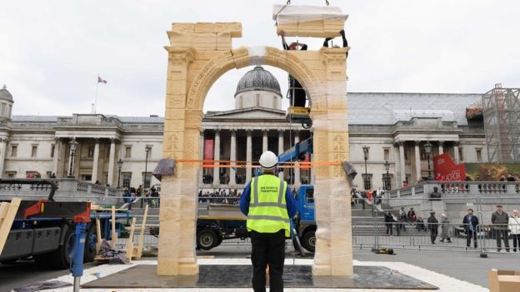
Replica of the Arch at the Temple of Baal in Palmyra, Syria being erected in central London 4/19/2016.
Photo Courtesy AFP.

Baal, Bel, Hubal, and Allah the moon god were the same ancient god, the present day god of Islam. http://www.british-israel.ca/Islam.htm#.Vy47lyHHfIw

The Arch of Baal erected in London is a spiritual portal, a spiritual doorway, for the ancient god(s) also known as Allah to enter London. The Arch is scheduled to be moved to many other cities around the world in coming months.

London's First Muslim Mayor

Please note that on 5/5/2016, 2 weeks and 2 days after the Palmyra Arch was erected in London, the people of London elected their first Muslim Mayor, Sadiq Khan.

http://www.timesofisrael.com/muslim-londoners-jubilant-as-son-of-pakistani-immigrant-elected-mayor/?utm_source=The+Times+of+Israel+Daily+Edition&utm_campaign=4aa5acd111-2016_05_07&utm_medium=email&utm_term=0_adb46cec92-4aa5acd111-55467209

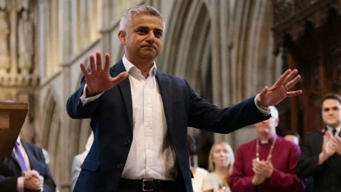
Sadiq Khan, first Muslim Mayor of London.
Photo Courtesy AFP, Mui Yok

It should also be noted that 5/5/2016 was also the 27th day of the 1st month on the Jewish Hillel calendar, Yom HaShoah, Holocaust Remembrance Day in Israel.

Owing to the early Aviv this year, the day 5/5/2016 may actually be the 27th day of the 2nd month. According to the Septuagint the fountains of the deep in Noah's day were opened on the 27th day of the 2nd month.

So we have the first Muslim Mayor of London being elected on Holocaust Remembrance Day, 5/5/2016, just two weeks and two days after the door for the entrance of Allah was set up in central London. That particular day, 5/5/2016, also being the date for the fountains of the abyss to be opened to bring forth the flood to destroy all life on the earth in Noah's time according to the early Aviv this year and the Septuagint.

If you live in the USA, please pray and depart far from the cities if you feel led by YaHuWaH Elohim to do so. The Messiah in Matthew 16:3 and Luke 12:56 tells us to discern the signs of the times. We're coming to the end of 70 years, the amount of time that has probably been allotted for modern Babylon (the USA) to nurture and protect modern Israel. The cities of modern Babylon will be destroyed by fire in one hour. Jeremiah 50 and Revelation 18 The destruction of modern Babylon may come earlier than most people think.

Please repent of sins, read the bible and current events, pray, and get out of the way of the destruction by fire that's coming.

