Mars UP Church
Come Holy Spirit, Come
Before the Service – Speak to God!
During the Service – Let God speak to you!
After the Service – Speak to each other!

(*Please stand, if able)
Welcome and Mars Messages

Prelude

Apostles’ Creed
I believe in God the Father Almighty, Maker of heaven and earth; and in Jesus Christ His only Son our Lord; who was conceived by the Holy Ghost, born of the Virgin Mary, suffered under Pontius Pilate, was crucified, dead and buried; He descended into hell; the third day He rose again from the dead; He ascended into heaven, and sitteth on the right hand of God the Father Almighty; from thence He shall come to judge the quick and the dead. I believe in the Holy Ghost, the holy catholic church; the communion of saints; the forgiveness of sins; the resurrection of the body; and the life everlasting. Amen.

Gloria Patri
Glory be to the Father, and to the Son, and to the Holy Ghost. As it was in the beginning, is now and ever shall be,
world without end.
Amen. Amen.

The
Lord’s Prayer

Our Father,
who art in heaven,

hallowed be Thy
name,

Thy kingdom come,
Thy will be done,
on earth
as it is in heaven.

Give us this day
our daily bread;

and forgive us
our debts,
as we forgive
our debtors;

and lead us not
into temptation,
but deliver us
from evil.

For Thine
is the kingdom,
and the power,
and the glory,
forever. Amen.

The Doxology

Praise God
from whom
all blessings flow;
praise Him
all creatures
here below;
praise Him above,
ye heavenly host;
praise Father, Son,
and Holy Ghost.
Amen.

*The Call to Worship Psalm 29
Leader: Ascribe to the LORD glory and strength
People: We will worship the LORD in holy splendor.
Leader: The voice of the LORD is over the waters; the
God of glory thunders, the LORD, over mighty
waters.
People: The voice of the LORD is powerful; the voice
of the LORD is full of majesty.
Leader: The LORD our God sits enthroned over the flood;
the LORD sits enthroned as king forever.
People: May the LORD give strength to his people!
May the LORD bless his people with peace!

*Hymn “Come, Now is the Time to Worship”

Call to Confession

Prayer of Confession
We are incredibly stubborn, O Lord. We have entered the season in which Your Light has been given to the world, your blessings have been poured out on the world, and yet all we can think about is our own problems, our own needs, our own desires. Help us to desire you, Lord. Help us to yearn for your presence. Pour your baptismal waters over us again, cleansing us from our self-pity and arrogance. Nourish and heal us so that we may joyfully serve you. Wash away our jealousy, greed, and all negative thoughts and behaviors that stand in the way of our truly being the people you have called us to be. Again let us receive the blessings offered in creation, in the birth and baptism of Jesus, and in the ministry of the saints of light. We ask this in Jesus’ Name.
Assurance of Pardon
Gloria Patri
Children’s Chat

Scripture Acts 10:34-43
Matthew 3:13-17

Morning Message Rev. Brian Hauser
“Consenting Adults”

*Hymn 589 “Here I am Lord”

Prayers of the People and Lord’s Prayer
Offering
*Doxology
*Offering Prayer

Service of Installation of Elders and Deacons

ELDERS DEACONS
John Ivory Jill Cooper
Susan Cox Robyn Beckwith
Jay Wilson Missy Wells

*Communion Hymn 250 “Let Us Break Bread Together”

Celebration of the Lord’s Supper

*Hymn 444
“I Love to Tell the Story”

*Benediction

*Postlude

MUP Session

Class of 2025 Class of 2024 Class of 2023
John Ivory Alma Staskiewicz Lisa Barbour
Susan Cox Louise Fox Mary Ann Croop
Jay Wilson Marie Matthews Don Lewis
Herb Wellman

Clerk of Session: Herb Wellman

MUP Deacons

Class of 2025 Class of 2024 Class of 2023
Jill Cooper Steve Martin Sharon Gibbs Nancy
Robyn Beckwith Marge Nicklas Carol Kopar
Missy Wells Pat Auld Alice Leonberg

Moderator: Steve Martin

MUP Music Committee
Church Staff
Rev. Brian Hauser
Pastor
pastor@mars-up.org
724-689-3412

Mrs. Shelly Bocheff
Administrative Assistant
marsup@mars-up.org

AV TEAM
Alma Staskiewicz, Lisa Barbour, Marie Matthews, Bill Guesman, John Ivory, Keith Nichols, Mike Bocheff, Herb Wellman

Mars United Presbyterian Church

232 Crowe Ave
PO Box 805
Mars, Pennsylvania 16046
724-625-1365
www.mars-up.org
marsup@mars-up.org

Church Office Hours:
Mon -Thurs from 9 a.m. -2:30 p.m.
Keith Nichols – Chair
Sally Olsen – Clerk
Alma Staskiewicz
John Ivory
Linda Lees
Karl Kennedy

Mars United Presbyterian Church
Welcome!

Morning Worship:
10:00 am

Baptism of the Lord

Prayer of Preparation
Lord, we come to you today with so many things on our hearts.

You call us to be in relationship of trust and love with you and you offer healing to us for those portions of our lives that are broken and injured.

Help us to be open to your mercy and healing love. For we ask this in Jesus’ Name.
AMEN.

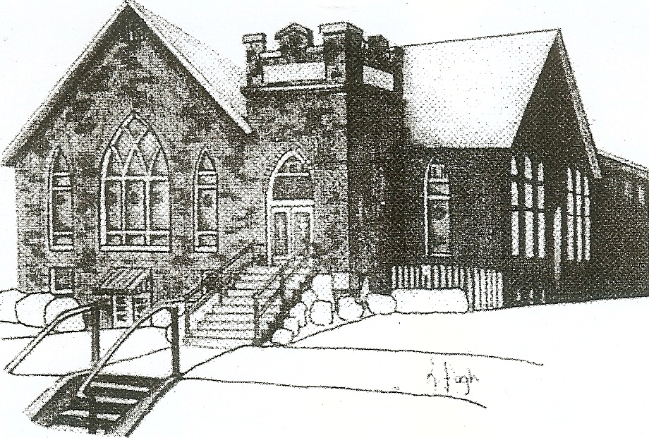
We are your hometown church: Faithful to Tradition, Loving in Fellowship, & Reaching for Tomorrow!

January 8, 2023

We welcome you and we are glad you’ve chosen to Worship with us today!

CALENDAR: January 8th, 2023 – January 15th 2023

Church Office Hours: Monday -Thursday from 9 a.m. – 2:30 p.m.

Today, January 8, 2023 Communion
VOLUNTEERS☺

LAST SUNDAY’S In-House ATTENDANCE: 27

LAST SUNDAY’S OFFERING:
Operating Funds: $2395.00
Kindness: $30.00
Mission: $10.00
Per Capita: $87.54
Total: $2522.54

Tarry N Talk Hosts
Stewardship Committee

9:00 am Sunday School Hour
10:00 a.m. THE MORNING WORSHIP SERVICE
11:15 am Deacon Meeting
Monday, January 9, 2023
Tuesday, January 10, 2023
9:00 am A team
7:00 pm AA
Wednesday, January 11, 2023
9:00 am Material Girls
Thursday, January 12, 2023
6:00 pm Girl Scout Troop 20790
7:00 pm Cub Scouts
Friday, January 13, 2023
Saturday, January 14, 2023
Sunday, January 15, 2023
9:00 am Sunday School Hour
10:00 am THE MORNING WORSHIP SERVICE

Welcome to all who are Worshiping with us today!

Guests
We sincerely hope our service is a blessing to you. We ask that our guests please take a few minutes to complete one of the Connect Cards found in the pew holder.

Should you have questions regarding any aspect of our church, including membership, please contact Pastor Brian or the church office during the week at 724-625-1365. Thank you for being with us today.

PRAYER – JOYS & CONCERNS
Lou Beckwith Paige Lauten
Paige Barbour (daughter of Andrew and Steph Barbour) Sandy Wahl
Reid Christopher Hall (June Stirling’s nephew)
Lindy McCartney (Lisa Barbour’s Sister)

ANNOUNCEMENTS
Bulletins are printed Thursday mornings; let us know if you have an announcement…

SANCTUARY FLOWERS 2023 The new sign-up list for 2023 is available in the Tarry ‘n Talk. Please be sure to indicate (by circling the “S”) if your flowers can be delivered to shut-ins.
TARRY ‘N TALK REFRESHMENTS/MUFFINS 2023 Please be sure to stop and sign up if you are willing to provide refreshments on Sunday morning. You can use the church kitchen or your own, or even bought goodies are appreciated.

PER CAPITA ASSESSMENT
It is that time of year, our individual Per Capita Assessment is due to the Butler Beaver Presbytery. We are requested to pay $43.77 to them per member of congregation of confirmation age and older. You can place your assessments in the offertory and ear mark it for your Per Capita Assessments. The BBP help provide support in negotiating salaries, insurances and pensions with our pastors and employees. Most importantly they provide a resource for us to tap into when we are in need of guidance. Please consider paying your Per Capita Assessment as soon as possible as we partner with our Presbytery to become stronger, smarter and more cohesive. As always, we give thanks for your generosity and support.
OLD UNION PRESBYTERIAN CHURCH will hold a Lego Tournament on Saturday, January 14th, from 10:00 to 2:00, for 1st-6th graders to demonstrate their creativity in five events. For more information or to sign up, please contact Old Union Church at 724-538-8672
CONGREGATIONAL MEETING There will be a Congregational meeting on February 5th, 2023 after worship to discuss the annual report from 2022.

MUP SKI TRIP It’s that time again! Time for Mars UP Church to take to the slopes for an exciting day of fun and fellowship together at Peak N Peak Ski Resort! The date of the ski trip will be Saturday, February 11th. This event is open to all!!! We will leave the church at 7:00am and ski/snowboard for the day. Watch for more details to follow or talk to Pastor Brian.

