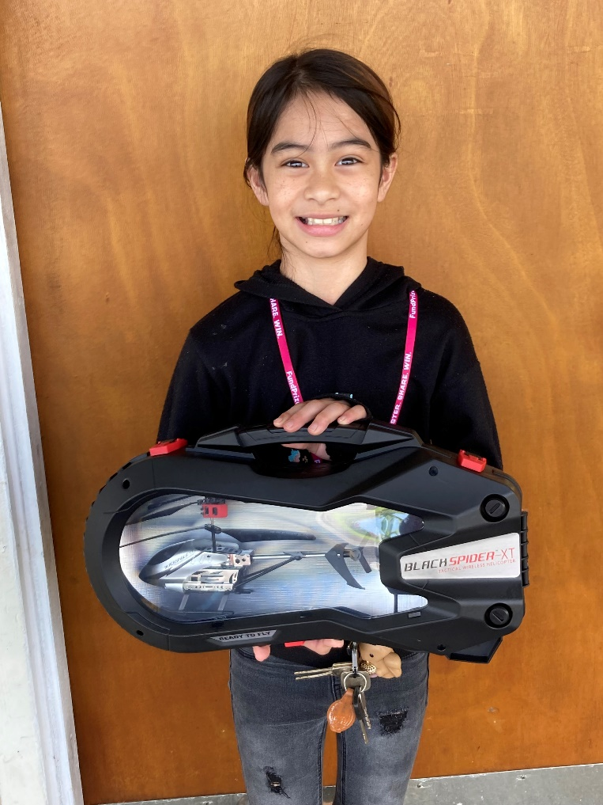
Playground Drawing Contest Winner:
Congratulations to Matisyn,
Winner of a Black Spider XT Helicopter

