Pleasant Township Board of Trustees Meeting Highlights
Date December 9, 2025______________ Next Resolution No._62 —12-9-2025_ _

- Call to Order -- The meeting tonight will also be on WebEx.
Please stand for a moment of silence.
Pledge of Allegiance--Roll Call
- Visitors –

- Minutes to approve- No minutes

- Financial Reports – Paula – Etna Insurance payment – $35,330.31, didn’t have the exact figure but it was just under $60,000. IRS payment $10,483.77. Total bills since last meeting of $36,068.66

  - Has it been resolved? Why does the invoice for Stryker say it starts 8/20/25 thru 8/19/26 we approved with resolution 48 on 10/14/25. That should be corrected before we pay and it was for $10,401.00 did not have the $4,538.36 we were double charged for. (Chief is still working on this)

  - MOTION to pay expenditures.

- Department Reports

- Franklin County Sheriff’s Dept-Community Liaison, Deputy Adkins, 1120- Cell: 614-809-5843
none

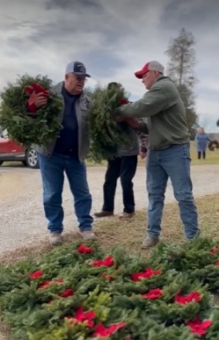
- Road Department- Robert Bausch
- Timberlake grant-has been denied but there is hope that we may get some later.
- Young Rd-getting estimate from County for mill & fill work
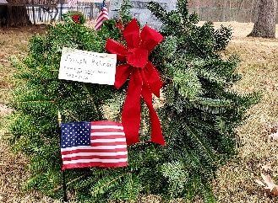
- Snow and ice
- Mold remediation - $1,555.89
- Haul salt
- Tree down Pennsylvania cemetery
- Equipment repair
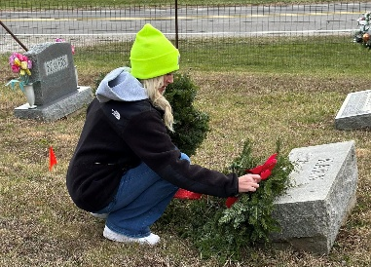
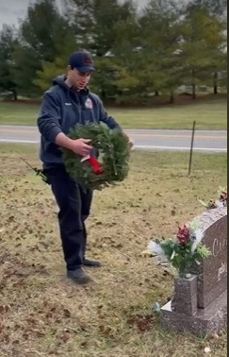
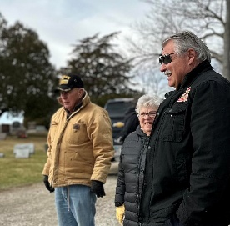
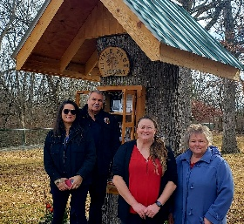
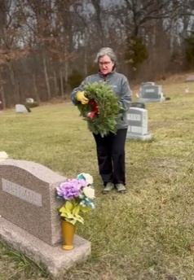

- Wreathes across America Saturday, December 13, 2025 at noon, Oak Grove Cemetery.

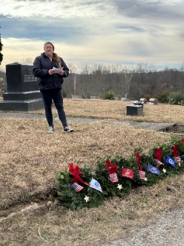
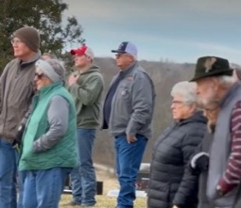
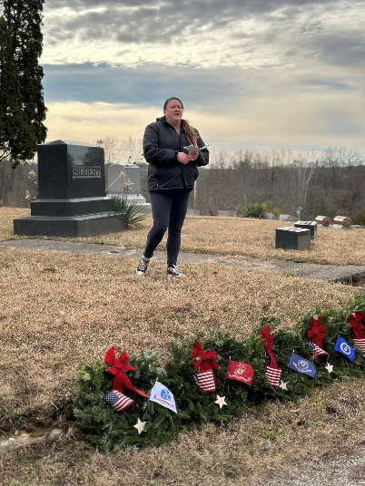
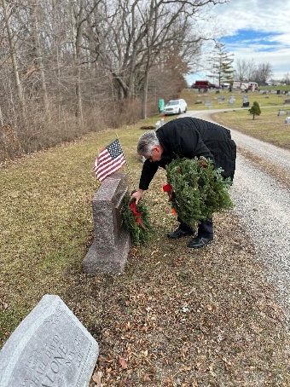

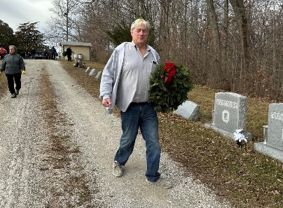
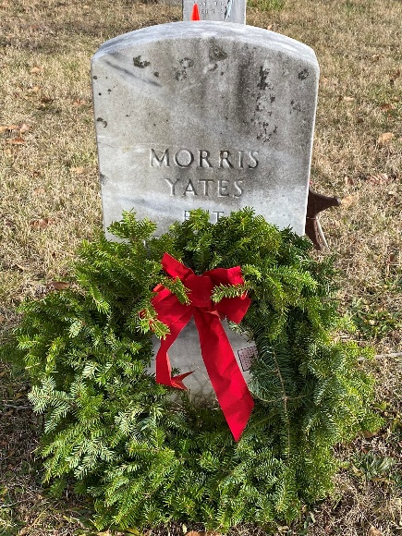

- Fire Dept. – Chief Whiting
- Apparatus
  - Boat 231 (reported 10-14-25)
  - Replaced two tires on E-231
- Personnel
- Equipment
- Training
  - EMS Training
  - Hands on training with all our new hires
- Station
  - Concrete front ramp (ongoing)
  - Waiting on Quote for back door. Received quote of $5,883.75 , Resolution_62_ to use the same company that did the side door for no moe than $5,883.75. Ed suggested to have them keyed the same.
  - Work to start after initial payment
  - Block Repair (In the spring, the building will need to be painted once repaired)
- CRR
  - Smoke Alarms
  - Building Presentation
  - Pancakes with Santa at Darby Elementary, Saturday at 9:00 a.m.
Has Paula received a copy of Carroll's letter of resignation? Not yet, still looking for it.
- Old Business-
- New Business –
- Announcements -.
- Clerk Updates- Paula
- Miscellaneous correspondence
- Speaker Sheets- (come to the podium to be heard on WebEx)
Ken Yarnell discussed research he has done on various types funding for possible building renovations and/or storm shelter building. Ken agreed to head a citizens committee for this research. Alicia Gieger volunteered to be on his committee.
- Adjourn – 7:25 p.m.

