Coach,
The 1st Annual Bethel Wildcat Powerlifting meets will be Tuesday, February 4th for the Junior High, Wednesday, February 5th for High School.
Entry fees all meets will be $150.00 per team. Five or less lifters will be $125.00.
For the high school meet, medals will be given to the top 5 lifters in each weight class/division. Team champions as well as team runner-ups will be awarded in both the small and large high school divisions.
The junior high meet will be broken up by grades, 7th graders will compete against 7th graders, 8th graders against 8th, and 9th graders against 9th. I will also give a 7th, 8th, and 9th team championship plaque. Medals will be given to the top 3 lifters in each weight class.
A hospitality room will be available for the coaches. There will be a full concession for the lifters. No ice chests will be allowed in the gym. Lifters should bring a couple of dollars to cover breakfast and concession costs.
Weigh-in will be from 7:00 a.m. to 8:30 a.m. for all meets. I will also have an early weigh-in on Wednesday for the small high school lifters and Thursday for the large high school lifters. Coaches please let me know if you need to attend the early weigh-. There will be a coaches’ meeting at 8:30. Lifting will begin at 9:00 a.m. on all days.
Please call and confirm if you plan to attend either the junior high or high school meet or both meets.
Please make checks payable to Bethel Powerlifting.
Sincerely,
Coach Joey Ginn
Any Questions, please contact me at:
(405) 623-8960 or ginnj@bethel.k12.ok.us
or
Brandon Blizzard
(405) 727-0763 - blizzardb@bethel.k12.ok.us
J.H. Weights 105-114-123-132-145-157-168-181-198-220-HWT
H.S. Weights 123-132-145-157-168-181-198-220-242-275-HWT

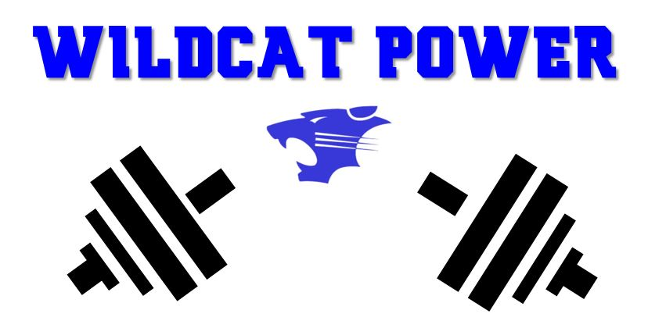

2020 1st Annual Bethel Wildcat Powerlifting Meet
Bethel Football
36000 Clearpond Rd. Shawnee, OK 74801
School:_______________________Coach:_________________
Name of Lifter:________________Weight:__________________
We, the undersigned, agree not to hold the Oklahoma Football
Coaches Association and/or Bethel Public Schools and officials liable in the event of an accident. We further agree to abide by all rules and regulations established by the O.F.B.C.A.
____________________________ ________________________________
(Signature of Lifter) (Signature of Parent)
____________________________
(Signature of Coach)
NOTE:
1. Each lifter is to have this form completed and signed before competition.
2. Each coach is to run off as many copies of the form as needed.

