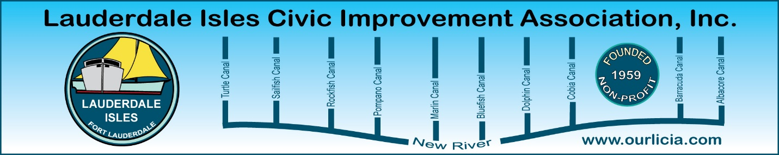
Minutes of the Lauderdale Isles Civic Improvement Association Board Meeting Zoom call
April 17, 2025
The meeting was called to order by President Earl Prizlee at 7:05pm.
Roll call was taken.
Present: Earl Prizlee, Geoff Rames, Karen Rames, Dick Cahoon, Dawn Hanna, Glo Knowles, Penny Shea, Trent Simpson, Andrew Silverman, Eric Silva, Jackie Zumwalt and Julie Gordon.
Absent: Rick Cunningham, Aynsley Geramanis, Joann Kratky.
FLPD report: Officer Jackson advised the case # is 34-2504-067141 for the accident on Duck Cay Lane where our sign was involved. Officer Gagliardi handled this case and we can follow up on Mon/Tues to find out what happened to the sign.
There was 1 crime, an auto theft, on Andros Lane. The car was abandoned and there was no arrest. A gun was left in the car, and it is missing. Regarding the cars parked at the end of Andros Lane, she went out as did Code to check it out after our last Board meeting discussion and did not find any cars parked illegally and no violations were issued.
Earl to send Officer Jackson a reminder of the date and time of our May General Meeting and that it will be in person.
Code Compliance: Officer Edward Eason provided the report. His ninety-day update includes 33 cases pending compliance, 30 cases closed and 2 complied, going to magistrate or pending a fine. Cases include driveway in disrepair, cars parked on lawns, derelict vehicles, debris on roof and bulk trash out on the wrong day. He stated bulk trash can be put out 24 hours in advance of the bulk pickup day. Code will give the homeowner 48 hours to remove, or it is removed by the City, and the homeowner is charged. Karen said we need to include an article in the next newsletter about bulk pickup as too many people are putting it out far in advance.
Treasurer reports: Andrew to provide the last 2 Treasurer reports. Earl said he will meet with Andrew to walk him through the process and get them done.
March General meeting minutes and February Board meeting minutes: Penny motioned to approve, Dawn seconded and all approved.
Community Center update: Earl said this project was not sufficiently funded due to the need for a lift station which costs $500,000 - $700,000. Commissioner Sorensen found the money to fund the lift station so our project will move forward as originally planned. Earl and Geoff will continue to question the lift station.
May General Meeting: The next General Meeting is May 15. Earl will ask our new City Manager to attend, and we will also ask Marty Kiar, our Property Appraiser, to attend and present. Discussion as to whether to have the meeting in person or Zoom was discussed. Majority of people would like to proceed with an in-person meeting. Suggested doing a homeless update via Zoom if neither can attend.
LICIA newsletter: Geoff needs articles for the next newsletter and will send out the deadline. Earl will write an article about the restaurants on the water and about the company he worked with for his new boat canvas. Geoff asked Eric to write an article about the 25 foot building height amendment that passed and what he went through with the height issue. Geoff request the newsletter be delivered the week before the General Meeting.
New Business: A resolution was proposed. Motion made by Karen, Penny seconded and all approved. See below details.
Geoff advised Marco Aguilera has been selected as our Chief Waterway Officer starting April 28.
Duck Cay Lane sign: We need to find out what happened to the sign after the accident. Geoff will talk to homeowner and Rick Cunnigham, Lane Rep for Duck Cay.
Motion made by Dawn to adjourn the meeting. Karen seconded and all approved. The meeting ended at 8:20 pm.
Submitted by Karen Rames, Secretary

April 17, 2025
To: LICIA Board of Directors
Fr: LICIA Executive Committee
Re: Resolution for Board Approval at the April 17, 2025, LICIA Board Meeting
At the end of the LICIA General Meeting on March 20, 2025, a member of the LICIA Board made extremely disparaging and demeaning comments to a neighbor while exiting the meeting. These comments were so nasty that a City of Fort Lauderdale official who witnessed them accompanied the offended neighbor when she brought them to the attention of the Executive Committee after the meeting.
As far as the Executive Committee members can recall, something like this has never occurred before. Furthermore, such comments by a Board member at any time are unacceptable and for this to occur in front of a City official severely tarnishes the sterling reputation of our Association in the City.
The Executive Committee therefore proposes the following
Resolution: Conduct Unbecoming of a Member of the Board of Directors:
Comments by a Member of the Board of Directors made directly to any person attending an LICIA meeting or event that are demeaning, disparaging, insulting, malicious, or in any other way derogatory in nature, shall be considered conduct unbecoming of a Board Director, and the Executive Board shall notify that Member that they will be removed from their position as a Director at the next LICIA Regular or Special Board Meeting, in accordance with LICIA Bylaws Article IV, Sections (D) (1)&(2). This resolution is effective April 17, 2025 and shall be incorporated into the LICIA bylaws at the next revision to those bylaws.

