4/29/2016 Genesis Chapter 6 and the Mystery Ship

The summer Olympics will begin August 5, 2016, in Rio de Janiero, Brazil. Past articles have shown how the modern Olympic Games are symbolic of the Nephilim during the time before the flood of Noah. According to Genesis 6:3 the time allotted to the Nephilim in Noah's day was 120 years. The modern Olympics began in 1896. If we add 120 years to 1896 we arrive at 2016.

A replica of Noah's Ark has been constructed in the Netherlands and is scheduled to be arriving in Brazil in July. It is scheduled to be visiting various cities in Brazil and South America and then visit the United States. Here's a newspaper article link to the info: http://www.timesofisrael.com/dutch-noahs-ark-replica-sailing-to-rio-for-olympics/?utm_source=The+Times+of+Israel+Daily+Edition&utm_campaign=790b53650c-2016_04_29&utm_medium=email&utm_term=0_adb46cec92-790b53650c-55467209

Although the newspaper article says the Ark will sail to Brazil, it will probably be towed or somehow be transported by another ship.

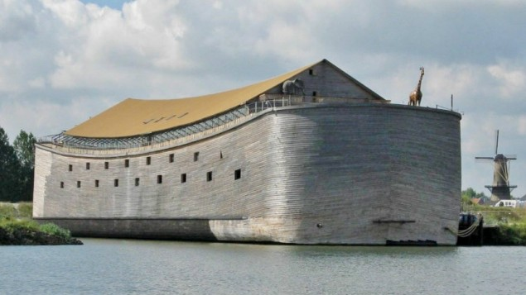
The 2500 ton replica of Noah's Ark that is scheduled to be transported to Brazil this summer.

I became aware of the information concerning the above mentioned Ark on 4/29/2016, the 20th day of the 2nd Hebrew month (early Aviv). It was on the 20th day of the 2nd month (Septuagint) that Noah and his family entered the Ark. Seven days later the fountains of the deep were opened on the 27th day of the 2nd month (Septuagint).
The deep today is known to science as the "black hole", a place where the gravity is so powerful that nothing can escape. The book of Revelation mentions a place called a bottomless pit where the Destroying Angel and his demons are imprisoned. Some people think the bottomless pit of Revelation is the black hole of modern science.

There are scientists in Switzerland attempting to produce microscopic black holes in the Linear Accelerator at CERN. It may be that man has finally acquired the knowledge, the key, that will open the bottomless pit and loose the Destroyer upon the earth. The warning was given to mankind in Genesis. YaHuWaH Elohim warned Adam "In the day that you eat of tree of knowledge you will die".

YaHuWaH Elohim is sending us signs. The replica of Noah's Ark will be in Brazil in 2016, concurrent with the 2016 Brazil Olympic Games .

The 120 years of Genesis 6 were completed from 1896 to 2016. The replica of Noah's Ark is completed. Both meet in Brazil this summer. Take notice! It's time for the fountains of the abyss to be opened and the Destroyer loosed.

The modern Olympics memorialize the ancient gods of Mt. Olympus. Those ancient gods and their progeny the Nephilim are still the enemies of YaHuWaH Elohim today.

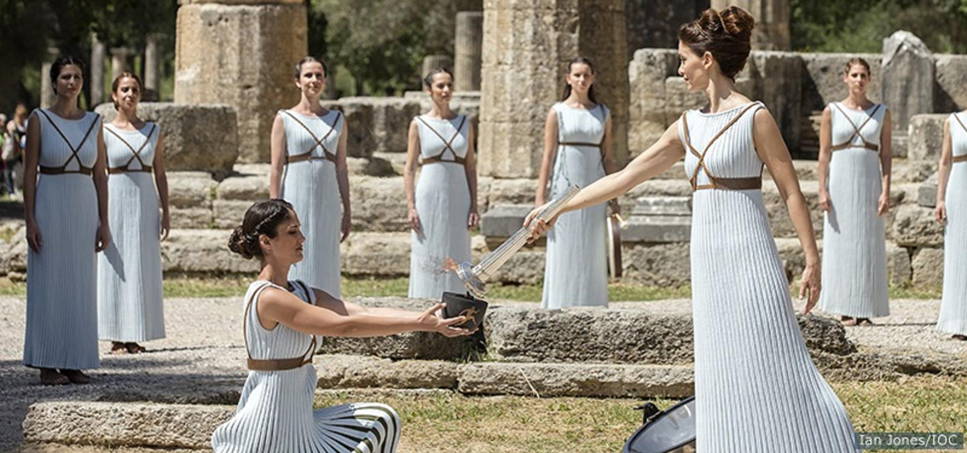
The Rio Olympics Torch Lighting Ceremony in the City of Olympia, Greece, on 4/21/2016

The Ark is scheduled to arrive in Rio de Janiero in September, 2016, for the Paralympics, about a month after the Olympic Games.

What do Einstein, the Universe, and September have to do with YaHuWaH 's Mystery Ship? - Ride Captain Ride: https://www.youtube.com/watch?v=pKppSotWL3o

