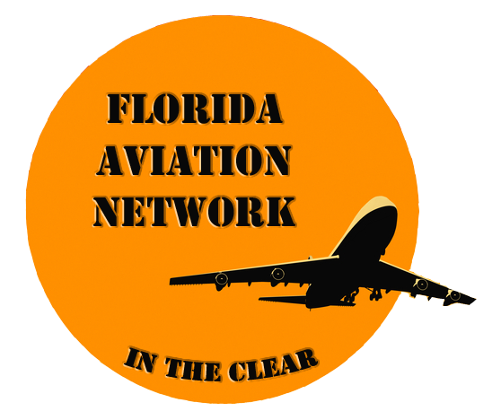 | Florida Aviation Network  T-Shirt & Oxford Dress Shirt  Order Form
Florida Aviation Network T- Shirts are Dark Heather or Maroon and include the Studio Logo Embroidery. No name on this shirt. The cost of the shirts are $16.50 Each + shipping

Florida Aviation Network Dress Shirts are French Blue and include the Studio Logo Embroidery. No name on this shirt. The cost of the shirts are $34.50 Each + shipping

(Please Print Clearly)

Name________________________________________________________________
Street Address:___________________________City__________________________
State_____________________________Zip___________Phone ________________
Note: No Name Embroidery

T-Shirts
Color Dark Heather – Qty_____________
Adult Shirt Size: ( S, M,L,XL,to 5XL):___________
Color Maroon – Qty______________
Adult Shirt Size: ( S, M,L,XL,to 5XL):___________

Dress Shirts
Men’s Edwards Oxford – French Blue QTY______
Men’s 1027 (S,M,L to 4 XL)___________________
1077 Long Sleeve

Ladies Edwards Oxford – French Blue QTY______
Ladies 5027 (S,M,L to 4 XL)___________________
5077 Long Sleeve

Attached is my Check # __________made out to “NASF” for :_$________

For more information please go to web site www.FloridaAviationNetwork.com. Hover over “About” and click on “Crew Support.”

You may mail your order form and check to:
Obie Young, 8316 Crosswicks Drive, Orlando, Fl 32819
FAN T-Shirt-Dress Shirt Order Form.doc/OSY/F/ProCrew/ Handbook/ 4-Forms/05-14-2013

