8/5/2017 Lucifer in the Sky with Diamonds

A total solar eclipse will cross the United States from the west coast to the east coast on 8/21/2017. For those who are in the path of totality and observe the eclipse, the King star Regulus, signifying Israel's Messiah, will suddenly appear in the sky next to the eclipsed sun when the sky goes black in the daytime during the eclipse.

Because the earth is a sphere, there will be a place on the earth in the moon's shadow that is nearer to the moon during the eclipse than any other place. That place is in or near southern Illinois near the town of Carbondale.

On 4/8/2024 there will be another total solar eclipse that will cross the United States, but that one will cross the country from southwest to northeast.

These two solar eclipses will place an "X" on the United States.

It's interesting that the path of the 4/8/21024 solar eclipse will cross the path of the 8/21/2017 solar eclipse about 6 miles SSW of Carbondale, Illinois, the region noted above as being closest to the moon during the eclipse of 8/21/2017.

Below is a map the shows how the centerlines of the paths of the two total solar eclipses will intersect near Carbondale. The centerline of a solar eclipse is the place on the earth where the center of the moon aligns with the center of the sun during the eclipse, resulting in the maximum duration of the eclipse timewise.

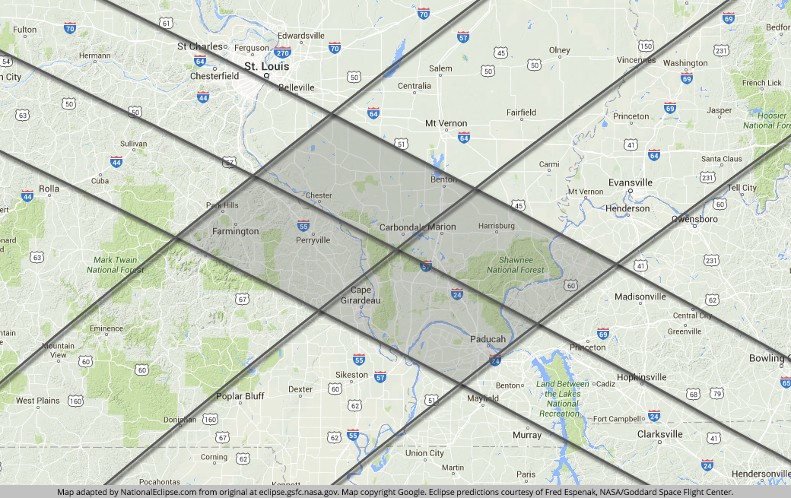

In the graphic above we see that Carbondale, Illinois, is very near the center of the intersection of the paths of the 2017 and 2024 solar eclipses.

Coal is comprised of carbon. Carbondale was named for the large deposit of coal in the vicinity. It is located in a section of Illinois known as "Little Egypt". The town of Cairo (as in Cairo, Egypt) is located nearby.

Carbon is a chemical element comprised of 6 protons, 6 neutrons, and 6 electrons.

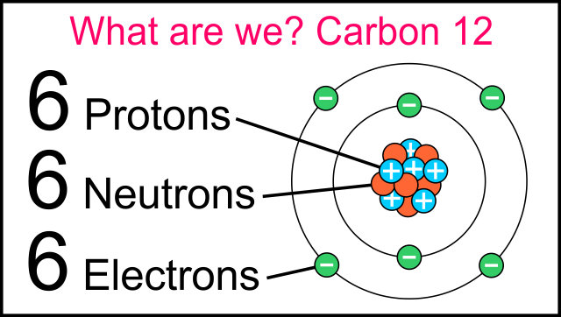

From the information presented above, we can associate the total solar eclipses of 2017 and 2024 with Carbondale, Illinois, and from thence to the element Carbon with its triple 6 composition, and from thence to the number 666.

Because a diamond is compressed carbon, the association of carbon and the number 666 with the Serpent in the garden of Eden is made in the verses below.

Ezekiel 28:11 Moreover the word of YaHuWaH came unto me, saying,
12 Son of man, take up a lamentation upon the king of Tyrus, and say unto him, Thus saith the Master YaHuWaH ; Thou sealest up the sum, full of wisdom, and perfect in beauty.
13 Thou hast been in Eden the garden of Elohim; every precious stone was thy covering, the sardius, topaz, and the diamond, the beryl, the onyx, and the jasper, the sapphire, the emerald, and the carbuncle, and gold: the workmanship of thy tabrets and of thy pipes was prepared in thee in the day that thou wast created.
14 Thou art the anointed cherub that covereth; and I have set thee so: thou wast upon the holy mountain of Elohim; thou hast walked up and down in the midst of the stones of fire.

We see from Ezekiel 28:13 above that a diamond (carbon - "666") is one of the Serpent's covering stones, and that 666 and the United States are the focus of the 2017 and 2024 solar eclipses revealed by our Creator Elohim.

Additional information is available here: http://www.joybysurprise.com/the-four-tavs.html

