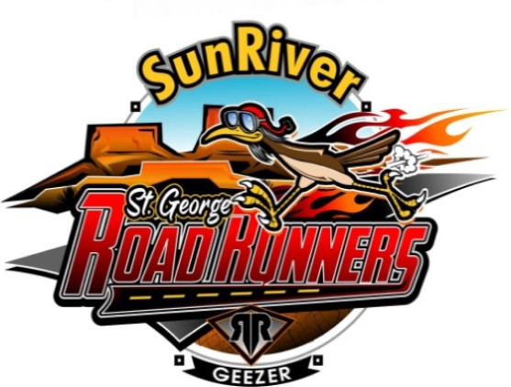
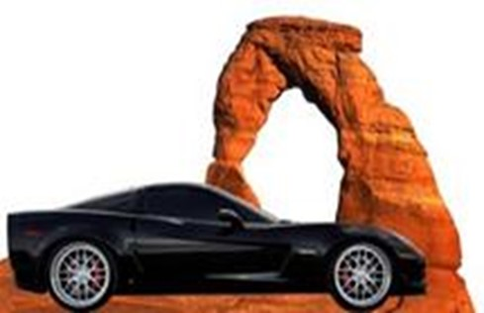

Thank a Veteran Charity Run
Hosted by Color Country Corvette Club
& Sun River Roadrunners Car Group

Saturday, April 10, 2021

Meet at 9:30am for coffee and donuts at the end of Sun River Parkway.

- The run will begin at Sun River Parkway where you will draw your first card and directions.
- From there we proceed through the Virgin River Gorge to the Flying J/Pilot Truck Stop at Exit 9 in Littlefield, AZ, where you will draw your second card.
- From there we proceed over Utah Mountain on old Highway 91 to Gunlock Drive and then to Gunlock Reservoir parking area where you will draw your third card.
- From there we will proceed to the Veyo Pie Shop in Veyo where you will draw your fourth card.
- We then proceed along Rte. 18 through Dammeron and Diamond Valleys back to the Sun River Parkway where you will draw your fifth card.

There is a $10 per poker hand donation to the event. No limit on the number of hands. Extra cards per hand can be drawn for $5 per card, at the last stop (limit one card, per stop, per hand). Please have correct change.
The person with the winning hand splits the pot with the
Southern Utah Veterans Charity. Ties will be determined by a card draw at the end.

At the end of the run we will have a brief awards ceremony along with light refreshments at the Sun River Parkway.

Note: Route and stops are subject to last minute changes.

