Rail Fence Block Susan Greene: 2023
CUTTING:
From each of the three fabrics cut four (4) strips 2 ½ by 6 ½ inches.
Unfinished size will be 12 ½ inches. Please do not trim.
Choose three fabrics for this block. Fabric A: a light value, Fabric B: a medium value, and Fabric C : a dark value.
(strong contrasts between the values) Any combination of colors, prints or batiks will be fine. I want a “scrapy” look.
ASSEMBLY: STEP 1
Use ¼ inch seams throughout.
Stitch Fabric A strip to Fabric B strip. Press away from fabric A. Make four (4)

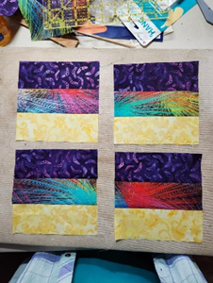
ASSEMBLY: STEP 3
Arrange sections so that Fabric A (light value) meets in the center.
Stitch together as shown. Press seams away from the light valued fabric.
ASSEMBLY: STEP 2
Stitch Fabric C to Fabric B.
Press away from Fabric C.
On each four from Step one.

