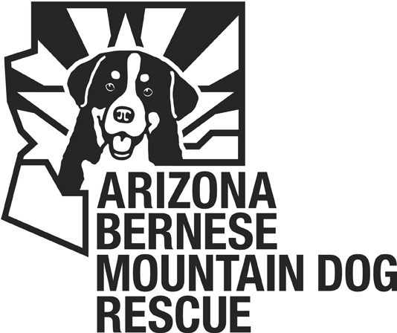

Congratulations of the adoption of your Bernese Mountain Dog named__________. Please review and sign the terms of adoption previously agreed upon during your application process.

Terms of Adoption
- Return policy: If for any reason, the adoption is not found to be satisfactory for the rescue dog or the family, the ABMDR requires that the dog be returned. The rescue dog MUST NOT be sold or given away, but returned to the ABMDR if for any reason the adoption is unsatisfactory for the adopting family. If the dog is returned within 14 days of adoption, a full refund of the adoption fee will be given. After 14 days, no portion of the fee will be returned. Furthermore, the ABMDR reserves the right to take back any rescue dog that is being neglected or not properly cared for.
- The rescue dog must be licensed in accordance with existing laws in your town and rabies vaccine must be kept current.
- The adopting family agrees to provide adequate shelter, food, all necessary medical care, and agrees that their rescue dog will not be allowed to run free without proper supervision. Failure to do so may result in the dog being surrendered to the ABMDR.
- If AKC registration papers are available for the rescue dog, they will be given to the new owner. The documents will be held for thirty days, after which the adoption will be considered completed.
- I will provide for this dog a loving home and accept this dog as a member of my family. I will provide food, water, adequate exercise and safe shelter at all times.
- I will provide veterinary care, including all vaccinations and medical tests required for good health.
- I understand that ABMDR has no further responsibilities for this dog, medical or otherwise.
- I ensure that this dog will wear obvious identification at all times.
- I will accept and cooperate with the removal of this dog from my home if there should be a violation of this agreement.
- I will pay an adoption fee of $375. This includes a $50 refundable fee if an obedience course is completed with this dog within 6 months of this adoption.

VOLUNTARY RELEASE/WAIVER OF LIABILITY
This Voluntary Release/Waiver of Liability (the “Release”) is made and entered into between the undersigned and The Arizona Bernese Mountain Dog Rescue. (“ABMDR”) effective as of the below-indicated date. The undersigned desires to adopt an animal from ABMDR, and as an inducement to ABMDR to agree to the adoption, the undersigned hereby represents, acknowledges and agrees as follows:
1. I acknowledge that, due to the unpredictable nature of animals, certain risks and dangers may occur while caring for an animal, including risks of injury to person and property, and that I have voluntarily agreed to make the adoption contemplated herein with full knowledge of such risks and hereby voluntarily assume all of such risks.
2. I agree that I will not make any claims against, sue, or attach any property of ABMDR, its directors, officers, agents, employees and/or volunteers for any injury or damage caused by any animal(s) adopted from ABMDR.
3. I hereby voluntarily release, discharge, waive and relinquish any and all actions or causes of action for personal injury, property damage or wrongful death occurring to me or third parties as a result of any action or activity of any animal(s) adopted by me from ABMDR, wherever and however the same may occur which I may have against ABMDR or any of its directors, officers, agents, employees or volunteers, whether the same shall arise by the negligence of said persons or otherwise. IT IS MY INTENTION BY THIS INSTRUMENT TO EXEMPT AND RELIEVE HLDR FROM ALL LIABILITY FOR PERSONAL INJURY, PROPERTY DAMAGE OR WRONGFUL DEATH CAUSED BY NEGLIGENCE OR OTHERWISE.
4. I hereby agree to hold ABMDR and its directors, officers, agents and/or employees harmless and indemnity them from and against any liability, claims, judgments or expenses I may incur arising out of my adoption of an animal from ABMDR and/or my ownership or care of any such animal thereafter.
5. I HAVE CAREFULLY READ THE FOREGOING, AND I UNDERSTAND THAT TOGETHER THEY CONSTITUTE A DISCLAIMER OF LIABILITY BY HLDR AND A RELEASE OF ALL CLAIMS BY ME, MY HEIRS, EXECUTORS OR ASSIGNS. I UNDERSTAND THAT I ASSUME ALL RISKS INHERENT IN MY DECISION TO ADOPT AN ANIMAL FROM GCSBMDC AND ANY RELATED ACTIVITIES. I VOLUNTARILY SIGN BELOW TO EVIDENCE MY ACCEPTANCE OF THE ABOVE PROVISIONS.
6. It is understood that the dog being adopted herein from ABMDR has shown and been treated medically for the physical ailment(s)described below:_________________________
__________________________________________________________________________
7. If any portion of this Release is held invalid, it is agreed that the balance hereof shall continue in full legal force and effect.
8. This Release is governed by the laws of the State of Arizona applicable to agreements entered into and fully performed therein.
Executed at _________________________, Arizona on ____________________, 200__.
______________________________________ ______________________________________
Signature of Pet Adopter Print Name

