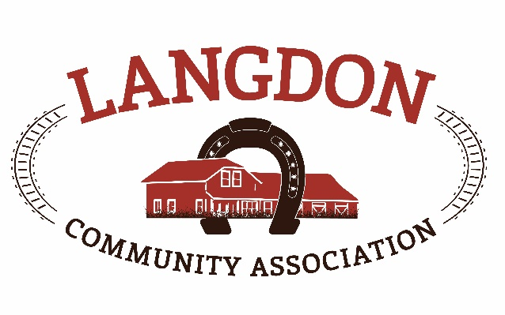
Langdon Community Association
Box 134
Langdon, AB T0J 1X0
www.goodlucktown.ca

LCA Meeting – November 15, 2020
Location: Fieldhouse

In Attendance:
Chrissy Craig – Chair
Jessica Smythe – Vice Chair
Tom Craig – Capital Projects
Nicole Porquet-Seitz – Director
Crystal Upstone - Treasurer
Corrie Carrobourg – Director
Dave & Heather Miller – Fieldhouse
Nicki Black – Secretary
Tony Baker
Scott Pike – Parks
Brian Hogg

Meeting called to order at 1935

- Approval of Agenda:
  - Motion to approve the agenda with additions: Jessica & Corrie
- Approval of Minutes:
  - Motion to approve the minutes from October 18, 2020: Nicole & Heather

- Reports See Below reports
Next LCC meeting – January 17, 2021, 6:30 – 7:30pm, before LCA meetings.

- Standing Business
  - Tasks review – reviewed and updated
  - Risk Management – by law review was sent out before the meeting for all to review. Two main points of discussion, 1. Should LCA board dissolve where do funds go to and 2. Increase range for directors to 7 – 15 members. Full reviews will take place once documents are done.
  - Succession Planning – email members link to succession plan in Sharepoint.
  - Education – Online Federation of Calgary Communities resources and education class for new board members or new board positions. Courses have been sent out and free to register. Chrissy will forward current courses available.
  - Strategic Planning – no new discussion
  - Langdon Community Campus – Still on schedule for Spring 2021 opening. Dugout frames are in, grass all growing successfully. There will be an unveiling for opening. Sponsors are happy with the outcome of the work.
  - Newsletter content – use content from previous meeting notes.

- Discussion
- Benches for the rink – Due to covid the skate shacks will be closed for the season. The aluminum bench at the rink and the bleachers from the diamonds can be moved for skaters to use.
- Door knocking campaign – LCC will no longer be able to have volunteer recruitment evenings so they have moved to a door knocking campaign. Synergy kids will be going house to house with information cards and group information. LCA would like to participate with a flyer (newsletter type) with information about the association. Jessica and Chrissy to work on flyer.
- Christmas Lights – Mountain View have made a $900 donation towards Christmas lights. Jessica and Crystal will work out the lights needed for the rink and Fieldhouse and what options will be suitable.
- Fire Extinguisher course – emergency management offering a free course to community members if we are willing to host in the Fieldhouse. Course will be 1 hour 10 max per class and safe to do indoors. Kids will be welcome too.
- Budget review – new 2021 budget will need to be approved in December. Budget is very tight for next year due to Covid restrictions. Any additions or adjustments need to be sent to Chrissy before the next meeting.
- Motions
  - Approved by email – none
  - Approved at meeting – none

Adjourned 2035h

Reports
Events report –
Funds development report – Applied for the Langdon Recreation grant that is due Nov 15.- Awarded in January
Applied for CFEP for Quad Diamonds- Awarded in March
If you have grant money in your department, this needs to be used up by the end of the year. Contact Chrissy if you are not sure if been used up.
Communication report –
Parks report – Flooding has started this week to get the rink up running. According to AHS guidelines we can not use the skate shacks as we can not ensure proper social distancing can be followed. The skate shacks will be closed for the season.
Program report –
Fieldhouse report – The Fieldhouse is now connected to town water. Last weekend, there was no water at the hall, Ray from trust was called in and found that the inverter on the pump had quit. He finished the town hook up last Sunday. Ray was back at the fieldhouse on Nov 13 to clean up the mechanical room. He removed the softener, iron filter and cleaned up the room. A tankless hot water tank was installed as part of this services. Thank you to Rocky view Utilities and Rocky view County for paying for this to be completed. No more water testing will be needed. The water well is still connected to the outdoor tap to be used for irrigation. A conversation will be had with garden society about water well maintenance.
Capital Projects Report –
Bingo Report –

Future Meeting (calendar invites sent to your goodlucktown.ca emails)
All meetings at 730pm at The Fieldhouse unless noted

Next meeting December 6, 2020

