CAPE FEAR POULTRY ASSOCIATION

APA/ABA SANCTIONED DOUBLE OPEN SHOW
JUNIOR SHOW AND YEPA JUNIOR SHOWMANSHIP

THE CAPE FEAR POULTRY ASSOCIATION MEMBERS WISH TO EXTEND A SPECIAL INVITATION TO YOU, YOUR FAMILY, AND YOUR FRIENDS TO EXHIBIT BIRDS WITH US.
SHOW DATE
DECEMBER 9, 2023
Entry Deadline – DECEMBER 4, 2023
JOHNSTON COUNTY LIVESTOCK ARENA
520 COUNTY HOME ROAD
SMITHFIELD, NORTH CAROLINA 28577

COMPETITION OPEN TO THE FOLLOWING:
BANTAMS, LARGE FOWL, WATERFOWL, TURKEYS, AND GUINEAS

JUDGES: RONNY LEDFORD, TATER BRITT, BART PALS, & ZEB SKOW
*********************************************************************************************
WEBSITE
www.capefearpoultryassociation.com
(Entry Forms & Catalog available online)

EVENTS SCHEDULE
FRIDAY, DECEMBER 8, 2023 SATURDAY, DECEMBER 9, 2023 SHOW HALL OPENS 4:00 PM FOR EXHIBITORS SHOW HALL OPENS AT 6:00 AM FOR EXHIBITORS
NC TESTERS AVAILABLE FOR NPIP TESTING ONLY NC TESTERS AVAILABLE FOR NPIP TESTING ONLY
4:00 PM to 8:00 PM 6:00 AM TO 8:55 AM
Meet & Greet 5:30 pm – 7:00 pm CONCESSIONS: OPENS 7:00 AM AND CLOSES 2:30 PM

ALL BIRDS MUST BE COOPED IN NO LATER THAN 8:55 AM
NC TESTERS WILL LEAVE AT THIS TIME

JUDGING BEGINS AT 9:00 AM
Judges and Clerks will break for lunch between 12:00 and 1:00 pm. Close of Show and Awards around
3:00 pm (or sooner) SHOW HALL CLOSES AS SOON AS ALL EXHIBITORS ARE COOPED OUT.

SHOW RULES AND REGULATIONS
- Competition is open to all breeds of poultry listed in the APA and ABA Standards. All entries, exhibitors, and visitors are subject to the following rules and regulations.
- Open Show Entry fee is $6.00 per bird. We are accepting entries as single birds only. Double cooping is available on a limited basis at a fee of $5.00 per double cooped entry. Clean up fee of $2.00 per exhibitor. Junior Entry fee is $3.00 per bird, a double coop is $3.00, and clean up fee is $1.00.
- Birds are entered at the sole risk of the owner. Cape Fear Poultry Association will not be responsible for the loss or accident to any birds or persons. Ample supervision of the birds and facilities will be provided. Birds are to be handled only by the owner, Judge, or CFPA Administration.
- Every person making an entry is responsible for the entry fee, even if the individual is unable to attend. Please make Checks and Money Orders payable to Cape Fear Poultry Association. All fees must be paid before birds are cooped in. All returned checks are subject to a $35.00 return fee!
- deadline for all MAIL-IN entry forms MUST BE RECEIVED BY DECEMBER 4, 2023, AND must be accompanied by the entry fee. Any entries RECEIVED AFTER
DECEMBER 4, 2023, WILL BE RETURNED.
- ALL POULTRY for exhibition in NC shall originate from U.S. Pullorum-Typhoid Clean Flocks or have a negative Pullorum-Typhoid Test within 90 days, 30 DAYS FOR OUT OF STATE BIRDS, of the day of the exhibition. All NC owned birds must be tested by agents of the N.C. Department of Agriculture. For North Carolina birds and for out of state birds from U.S. Pullorum-Typhoid clean states, these test requirements may be satisfied by a negative test conducted by an N.C. Department of Agriculture agent at the time of entry. Poultry for exhibition shall not have been vaccinated with a live virus vaccine within the last 30 days preceding the exhibition. Each bird must be identified with a “tamper-proof” band at the time of the Pullorum-Typhoid test. A copy of the Pullorum-Typhoid test chart must accompany birds to the exhibition. Birds are subject to examination (including blood tests and swabs) by a representative of the N.C. Department of Agriculture. Birds will not be accepted who are infected with or showing any clinical signs of a contagious disease or infested with lice or mites. OUT OF STATE BIRDS shall be admitted provided they are from an area that is not under quarantine for infectious disease and have a negative ANITGEN detection test for Avian Influenza performed within 21 days prior to the exhibition, or paperwork proving flock is AI certified. YOU MUST HAVE YOUR AI TEST PAPERWORK WITH YOU AT THE SHOW TO COOP IN.
- ALL PERSONS SELLING POULTRY ON THE PROPERTY AT THE SHOW MUST HAVE DISPLAYED A CURRENT LICENSE/CERTIFICATE FOR POULTRY/RATITE DEALER card AND BIRDS MUST MEET THE NC HEALTH REQUIREMENTS AS STATED ABOVE.
- To obtain your exhibitor number please go to the ENTRY CHECK-IN table before cooping in.
- Aisles are “CLOSED “during judging. Only the JUDGE, CLERK, and Show Officials are allowed
in these areas.
- The club provides feed, BUT IT IS YOUR RESPONSIBILITY TO FEED AND WATER YOUR BIRDS.
- NO ALCOHOLIC BEVERAGES ARE ALLOWED ON PREMISES!! SMOKING IS NOT ALLOWED IN THE BUILDING. THIS IS COUNTY OWNED COMPLEX.
- All matters not covered herein will be addressed as needed by the Executive Board of the club, and/or Judges. ALL DECISIONS ARE FINAL. The Show Committee reserves the right to refuse any entry submitted.
- No entries will be taken from any state having active AI.
- The Cape Fear Poultry Association will use every precaution to guard against accidents, mistakes, loss, or damage, but will not be responsible should any occur.
- The CFPA reserves the right to substitute and/or add judges, as necessary.
- ABSOLUTELY NO EARLY COOPING OUT! This rule will be strictly enforced by the CFPA Administration. Please remember that your entry form SIGNATURE states that you understand and agree to follow this rule. PLEASE RESPECT YOUR FELLOW EXHIBITORS by observing this rule! No exceptions unless approved by the CFPA Administration.

JUNIOR SHOW RULES AND REGULATIONS
The rules and regulations for the Junior Show are the same as the open show,
Including the following guidelines:
1. The Junior Show is open for ages 5 to 18 years of age. Showmanship is open for ages 5 to 18.
2. The Junior exhibitors are solely responsible for cooping and grooming their birds.
3. The Junior exhibitors are judged separately from the open exhibitors.
4. Juniors are NOT required to show in the Junior Show. They CAN show in BOTH
shows if they make SEPARATE entries for both shows. However, the same bird
CANNOT be shown in BOTH SHOWS.
5. Junior exhibitors are required to handle their birds.
6. Junior exhibitors must be present to receive any awards they may win.
7. Please specify on the JUNIOR entry form, the exhibitor’s age at the time of the show, and
indicate if you will participate in the showmanship program. Please do not use the open show entry form for a junior entry.
ENTRY FEES are $3.00 per bird, $3.00 double coop, $1.00 cleanup fee.

ENTRIES
PHONE ENTRIES: Deadline – Monday. DECEMBER 4, 2023
CALL-IN TIME: 10:00 AM – 9:00 PM – Donna Worthington - 252-827-2491or 252-341-8706
6:00 PM – 9:00 PM – Wilbur Hanley – 984-279-8384

EMAIL ENTRIES: Deadline Monday, DECEMBER 4, 2023, by Midnight
allow 24 hours for acknowledgment of entry,
PLEASE INCLUDE ALL INFORMATION AS SHOWN ON THE ENTRY FORM
PLEASE “NO ENTRIES” by TEXT or MESSENGER
EMAIL TO: donna.worthington@aol.com

MAIL ENTRIES: MUST be IN HAND no later than DECEMBER 4, 2023
Mail to: Donna Worthington - 118 Kincalf Lane, Macclesfield, NC 27852
Please verify your name and address to make sure it is listed the same as the APA and ABA to ensure that your earned points from the show are recorded correctly.

OPEN SHOW AWARDS

CHAMPION OF SHOW PLAQUE/$100.00
RESERVE CHAMPION OF SHOW PLAQUE/$75.00
***************************************************
Champion Land Fowl and Reserve Land Fowl are paper awards made only on the APA Show Report

CHAMPION LARGE FOWL PLAQUE/$50.00
RESERVE CHAMPION LARGE FOWL PLAQUE/$25.00

CHAMPION BANTAM PLAQUE/$50.00
RESERVE CHAMPION BANTAM PLAQUE/$25.00
THE FOLLOWING BREED CLASSES FOR BOTH THE OPEN SHOW AND JUNIOR SHOW WILL RECEIVE ROSSETTES FOR CHAMPION AND RESERVE CHAMPION
AMERICAN, ASIATIC, ENGLISH, MEDITERRANEAN, CONTINENTAL, AOSB, MODERN GAME BANTAMS, OLD ENGLISH GAME BANTAMS, SCCL, RCCL, FEATHER LEGGED, AOCCL, BANTAM DUCKS, TURKEY, GEESE, DUCKS, GUINEA, AND WATERFOWL
JUNIOR SHOW AWARDS
CHAMPION OF SHOW PLAQUE/$20.00
RESERVE CHAMPION OF SHOW PLAQUE/$10.00
SHOWMANSHIP
A TROPHY WILL BE GIVEN FOR 1ST AND 2ND PLACE IN THESE THREE CLASSES
JUNIOR, INTERMEDIATE, AND SENIOR CLASS
PARTICIPATION RIBBONS WILL BE GIVEN TO EVERYONE PARTICIPATING IN THE NOVICE CLASS
AND PRE-JUNIOR CLASS
YEPA (APA/ABA) SANCTIONED SHOWMANSHIP
NOVICE CLASS AGES 8 & UP (HAS NEVER DONE SHOWMANSHIP) PRE-JUNIOR CLASS: AGES 5-7
JUNIOR CLASS: AGES 8-10 INTERMEDIATE CLASS: AGES: 11-13 SENIOR CLASS: AGES 14-18
(ALL SHOW PERSONS SHOULD BE CLEAN, WELL GROOMED, AND NEATLY DRESSED)
Junior Exhibitors must have a separate bird for showmanship (no additional cost). If you are not an Exhibitor in the Junior Show, you will need to have a bird available and there is a $3.00 fee for showmanship.

CAPE FEAR POULTRY ASSOCIATION SHOW EVENTS
CHINESE RAFFLE ***** 50/50 DRAWING
A BIG “THANK YOU” TO ALL THE CLUB MEMBERS FOR THEIR DONATIONS. TICKETS WILL BE ON SALE STARTING AT $1.00 PER TICKET – SO GET YOUR TICKETS AND TRY YOUR LUCK AT WINNING YOUR FAVORITE ITEM. THE RAFFLE TICKETS WILL BE DRAWN STARTING AT 12:30 PM
BUY A TICKET STARTING AT $1.00 FOR A CHANCE TO WIN CASH IN THE 50/50 DRAWING. YOU WILL RECEIVE ONE HALF OF THE CASH COLLECTED FROM THE TICKET SALES

SILENT AUCTION
THIS IS WHERE YOU WILL FIND QUALITY BIRDS FROM SOME OF THE TOP BREEDERS. BECAUSE THE INTENT IS TO PROVIDE FANCIERS AN OPPORTUNITY TO ACQUIRE QUALITY BIRDS TO EXPAND THEIR FLOCK OR BREEDING PROGRAM, THERE WILL BE A REASONABLE MINIMUM STARTING BID PLACED ON ALL OF THE BIRDS. A SPECIAL THANK YOU FOR YOUR DONATIONS. THE BIDDING WILL END AT 1:30 PM
“MEET AND GREET”
CAPE FEAR POULTRY ASSOCIATION MEMBERS INVITE OUR EXHIBITORS TO JOIN THEM FOR LIGHT REFRESHMENTS FRIDAY, December 8, 2023, FROM 5:30 PM TO 7:00 PM AT THE JOHNSTON COUNTY LIVESTOCK ARENA. THIS WILL BE EVERYONE’S TIME TO SAY “HELLO” TO OLD FRIENDS AND MEET NEW FRIENDS”! WE WANT TO THANK EACH OF YOU FOR YOUR SUPPORT OF OUR CLUB AND SHOW. COME JOIN US
ACTIVITY TABLE
THIS IS WHERE THE YOUNG AND OLD CAN PLAY GAMES, COLOR, CROSSWORD PUZZLES, CRAFT CREATIONS, and more. HOPE EVERYONE ENJOYS THEIR TIME WHILE AT OUR SHOW!!

CONCESSIONS
BREAKFAST WILL BE AVAILABLE AT 7:00 AM
LUNCH WILL BE AVAILABLE AT 11:00 AM
THANK YOU FOR YOUR SUPPORT BY EATING IN WITH US!!!

EASTERN REGIONAL MEET

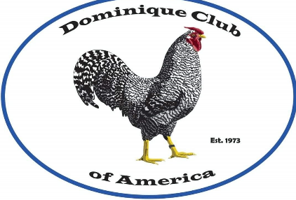
DOMINIQUE CLUB OF AMERICA
Joining the Dominique Club has many benefits.
Informative Quarterly Newsletters. Awards & Trophies at sponsored shows,
Breeders Directory, Master Breeder Awards.
For more information and to join the club,
please visit our website: www.dominiqueclub.org
Regional Meet – White Card – Special Meet – Blue Card

DISTRICT MEETS

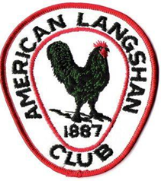
AMERICAN LANGSHAN CLUB
To enjoy the benefits of the American Langshan Club, you must be a current member of
the club. The club offers a quarterly newsletter, special awards, and recognition
for its members.
PLEASE SEND DUES (PAYABLE TO AMERICAN LANGSHAN CLUB) TO
MICHELLE OAKLEY, 15643 ST. RT. 720, LAKEVIEW, OHIO 43331 977-539-6588
YOUTH MEMBERSHIP $5.00, ADULT MEMBERSHIP $15.00,
LIFETIME MEMBERSHIP $200.00
District Meet – Blue Card – Special Meet – White Card
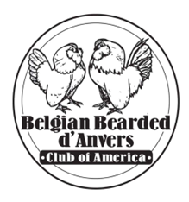
BELGIAN BEARDED D’ANVERS CLUB OF AMERICA
If you would like to join the club dues are $12 per year, $20 for two years per Adult Single Membership. Dues for Junior Members are $10 per year or $18 for two years. We do offer a Family Membership which includes 1 Adult and up to 3 youth living in the same household for $20 per year, or $35 for two years. ***All memberships start the first full month after membership is received, and run for a full 12-24 months Website: https://danverclub.webs.com
You can fill this out and submit it via postal mail to the Club Secretary or
Email: secretaryBBDCA@gmail.com
District Meet – White Card - Special Meet – Blue Card

STATE MEETS

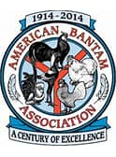
AMERICAN BANTAM ASSOCIATION
Individual membership dues are the same for individuals, partners, couples, and families (with no limit on number of children but only one household). All members receive a free copy of the latest available yearbook and quarterly, membership card, coupons, information brochure, etc. Email: bantamclub@gmail.com
American Bantam Association
PO Box 127, Augusta, NJ 07822 973-271-3335
State Meet – Blue Card - Special Meet – White Card

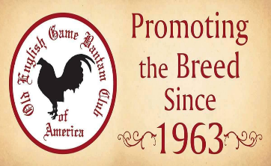
OLD ENGLISH GAME BANTAM CLUB OF AMERICA

Membership: Available to individual, family, partnership, or club at $20.00 or $22.00
If using PayPal annually for US residents and $25.00 for International.
Quarterly newsletters and a yearbook are also included with your membership.
State Meet – Blue Card - Special Meet -White Card

SPECIAL MEETS
AMERICAN POULTRY ASSOCIATION
David Adkins, Secretary PO Box 9 Lucasville, OH 45648
Phone: 740-876-4845 Email: apasecretaryadkins@gmail.com
Annual dues are $20.00 for one year and $50.00 for three years. Junior Membership dues are $20.00 for one year and $50.00 for three years. Outside of the US and Canada memberships are $40.00 for one year. An Endowment Trust Life Membership is $395.00. Please visit our website for details regarding your membership, what you will receive as a member of the APA and information on how the Points Program works for you.

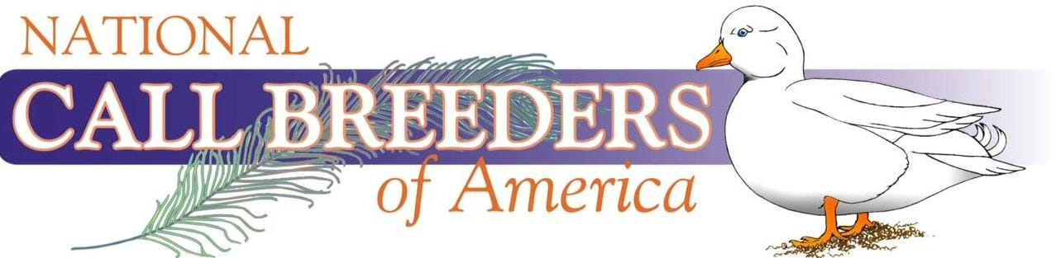

Join a large group of Call duck breeders, exhibitors, and enthusiasts from around the world today! Your membership includes our official Yearbook, occasional newsletters, and the ability to start collecting points at our shows. Compete for numerous awards including the yearly high-point exhibitor, master breeder, and master exhibitor. Join us today and connect with fellow members!
VISIT OUR WEBSITE: WWW.CALLDUCKS.ORG for more information and membership information.

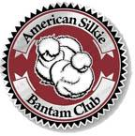
AMERICAN SILKIE BANTAM CLUB
ASBC Meet Awards: Special, District, and State meet – receive Flat Ribbons for Best of Breed and Reserve of Breed. Must have two exhibitors present and 10 Silkies shown to receive awards.
Points are awarded regardless. Awards mailed twice a year, January, and June
Secretary/Treasurer - Michelle Patterson
PO Box 1162, Chatsworth, Ga. 30705
admin@americansilkiebantamclub.org

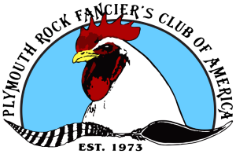
PLYMOUTH ROCK FANCIER’S CLUB OF AMERICA

Membership of the Plymouth Rock Fancier’s Club Includes: A subscription to the Plymouth Rock Quarterly Newsletter. Eligibility to earn club points and awards. Option to be included in our public Plymouth Rock Breeder’s Directory. Members-only classified advertising on the PRFC website. (Additional fee applies.) Eligibility to vote and participate in all club elections.
Annual membership runs from January 1 to December 31 of the calendar year.
Adult Membership – $20 Annual membership for any individual 18 years old and over.
Junior Membership – $10 Annual membership for youth under 18 years of age.
Contact: Jill Burks, 978 Chestnut Hill Rd., Cambridge, NY 12816 - plymouthrockfanciersclub@gmail.com

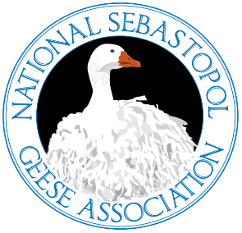
NATIONAL SEBASTOPOL GEESE ASSOCIATION
The goal of the Association is to bring together a community of admiration of the Sebastopol Goose. Promoting the breed for the unique characteristics that the Sebastopol Goose is known for.
Memberships: Single $20.00, Family $30.00 Adult with Breeder Directory, $35.00, Family with breeder director $$5.00. Contact: nationalsebastopo@gmail.com Phone: 517-812-7521
Paid memberships are due yearly on or before March first. To renew your membership simply fill out the appropriate form. If you are a Junior and age out, your membership will expire the year of your 19th birthday.
Members Eligible for Club Awards

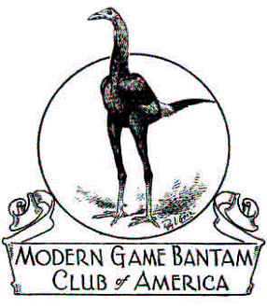
MODERN GAME BANTAM OF AMERICA
Secretary/Treasurer: Alexis & Sheldon Macha
2590 CR 191, Littlefield, Texas 79339
mghcaseretary@outlook.com
AWARD REQUIREMENTS-ONLY PAID UP MGBCA MEMBERS, PRIOR TO JUDGING ARE ELIGIBLE FOR CLUB AWARDS, THERE MUST BE A MINIMUM OF 28 MODERNS ENTERED, WITH A MINIMUM OF 3 MEMBERS SHOWING
ANNUAL DUES $20.00- SEND DUES TO THE SECRETARY OR MAY BE PAID TO THE DISTRICT DIRECTOR

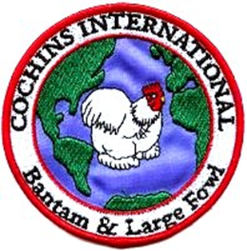
COCHINS INTERNATIONAL
Membership runs from January 1 to December 31 of each year. Regular individual membership and family membership dues are $15.00, junior membership (under age 18) is $7.50, however junior members do not earn Master Breeder points. If a junior wishes to earn points, then he/she must purchase a regular individual membership and compete in an open show. We hope you will consider joining Cochins International.
Cochins International c/o Gail Carlson
14809 East 267th Street, Harrisonville, MO 6470
Email: HappyHens1@hotmail.com

AMERICAN BRAHMA CLUB
PROMOTING THE MAJESTIC ONES
Join the American Brahma Club to support the promotion of the Brahma breed (both large fowl and bantam) by awards, annual national show, and newsletters. Membership is only $20/year, $50/3 years for adults, $20.00/year for juniors (18 and under) contact:
Diana Delaney - 12312 L Drive North, Battle Creek, MI 49014 Email: dld7557@aol.com

AVAILABLE LODGING

COMFORT INN BECKY’S LOG CABIN 126 CLEVELAND CROSSING DRIVE 2491 US HWY 70 BUSINESS EAST
GARNER, NC 27577 SMITHFIELD, NC 27577
PHONE # 919-773-1110 PHONE # 919-934-1534
½ MILE OFF I-95 AT EXIT 95
LODGING, RESTAURANT, AND LOUNGE

SUPER 8 MOTEL
735 INDUSTRIAL PARK DR
SMITHFIELD, NC 27577
PHONE: 919-989-8988

*************************************************************************************************************************

DRIVING DIRECTIONS
JOHNSTON COUNTY LIVESTOCK ARENA
520 COUNTY HOME ROAD
SMITHFIELD, NC 27577 - PHONE # 919-934-9569

COMING FROM I-95 NORTH OR SOUTH TAKE EXIT 95 WEST (SMITHFIELD) ON TO
HWY 210/70 (MARKET STREET) GOING WEST 2.7 MILES THEN VEER OFF TO THE LEFT ONTO
HWY 210. CONTINUE ON HWY 210 ABOUT 6.6 MILES TURN RIGHT ON TO COUNTY HOME ROAD, GO ABOUT 1/4 MILE AND WE ARE ON THE RIGHT.

COMING FROM I-40 NORTH OR SOUTH TAKE EXIT 319 EAST (TOWARD COATS CROSSROADS) ON TO HWY 210 EAST, CONTINUE ON HWY 210 ABOUT 7.9 MILES UNTIL YOU SEE COUNTY HOME ROAD ON THE LEFT, TURN ON TO COUNTY HOME ROAD, GO DOWN ABOUT 1/4 MILE WE ARE ON THE RIGHT.
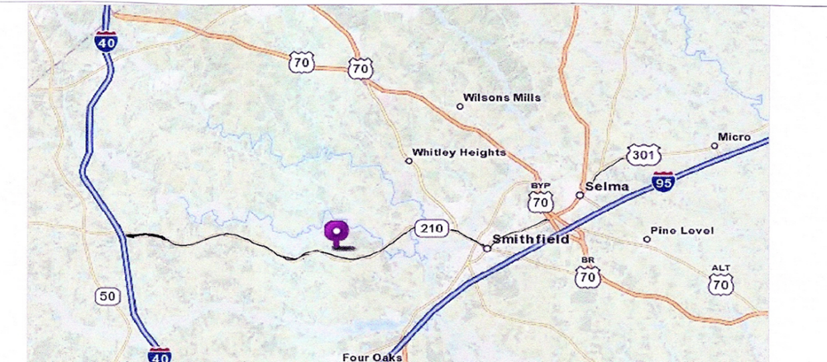

Exhibitor #_________ Received ___________ Amount Paid_________ Check no._________ Received by __________
CAPE FEAR POULTRY ASSOCIATION OPEN SHOW ENTRY FORM
DATE OF SHOW: DECEMBER 9, 2023 ENTRY DEADLINE: DECEMBER 4, 2023

I, ___________________________________________, do hereby acknowledge and agree that by attending and participating in this show, I do so at my own risk due to the uncertainty of the COVID-19 Virus. I make the following entry subject to the rules and regulations in the show catalog. By making this entry I give Cape Fear Poultry Association permission to use my contact information (address, phone #, email) for the Exhibitors List, club members, etc., I agree and accept the NO EARLY COOPING OUT rule. I understand all entry fees must be paid, even if I am unable to attend. I acknowledge and accept the North Carolina State Health Requirements for exhibiting poultry in North Carolina.
STREET ADDRESS_________________________________________________________ PHONE: (________) ________ ______________
CITY______________________________________________________________________________STATE_____________ZIP___________
EMAIL ADDRESS ____________________________________________________________________________________________________
**PLEASE USE YOUR SAME NAME AND ADDRESS AS RECOGNIZED BY THE APA/ABA & BREED CLUBS
SO, YOU WILL RECEIVE YOUR POINTS**.
UNDER TYPE USE “L” LARGE FOWL, “B” BANTAM, “T” TURKEY, “Ga” GUINEA, “D” ALL DUCKS “G” ALL GEESE
UNDER VARIETY use Bearded or Non-Bearded, SC (single comb) or RC (rose comb) only if it applies with that color or breed.
FORMS MAY BE COPIED FOR MORE SPACE, MORE THAN ONE ENTRY
BREED | VARIETY | TYPE | COCK | HEN | COCKEREL | PULLET | TOTAL  BIRDS
EXAMPLE: PLYMOUTH ROCK  EXAMPLE: SILKIE  EXAMPLE: RHODE ISLAND | WHITE  Bearded or non-bearded- Color  Red or White SC or RC | L  B  L | 1 DC  2  3 DC | 2  3  2 | 3 DC  4  4 DC | 2  5  3 | 8  14  12
Total number of birds entered_______ X $6.00 per bird Entry Fee ________________
Number of double coops ______ X $5.00 (Please specify bird for Double Coop) DC Fee _________________
Clean-Up Fee $2.00 per Exhibitor Clean UP $ 2.00
Total Amount Due $______________
Send the completed form with check or money order payable to Cape Fear Poultry Association
C/O Donna Worthington, 118 Kincalf Lane, Macclesfield, NC 27852
Phone: 252-827-2491 or 252-341-8706 Email: donna.worthington@aol.com
Pay Pal available on web site www.capefearpoultryassociation.com
Exhibitor #_________ Received ___________ Amount Paid_________ Check no._________ Received by __________
CAPE FEAR POULTRY ASSOCIATION JUNIOR SHOW ENTRY FORM
DATE OF SHOW: DECEMBER 9, 2023 ENTRY DEADLINE: DECEMBER 4, 2023
JUNIOR AGE __________ JUNIOR SHOWMANSHIP YES ______ NO______
I, ___________________________________________, do hereby acknowledge and agree that by attending and participating in this show, I do so at my own risk due to the uncertainty of the COVID-19 Virus. I make the following entry subject to the rules and regulations in the show catalog. By making this entry I give Cape Fear Poultry Association permission to use my contact information (address, phone #, email) for the Exhibitors List, club members, etc., I agree and accept the NO EARLY COOPING OUT rule. I understand all entry fees must be paid, even if I am unable to attend. I acknowledge and accept the North Carolina State Health Requirements for exhibiting poultry in North Carolina.
STREET ADDRESS_________________________________________________________ PHONE: (________) ________ ______________
CITY______________________________________________________________________________STATE_____________ZIP___________
EMAIL ADDRESS ____________________________________________________________________________________________________
**PLEASE USE YOUR SAME NAME AND ADDRESS AS RECOGNIZED BY THE APA/ABA & BREED CLUBS
SO, YOU WILL RECEIVE YOUR POINTS**.
UNDER TYPE USE “L” LARGE FOWL, “B” BANTAM, “T” TURKEY, “Ga” GUINEA, “D” ALL DUCKS “G” ALL GEESE
UNDER VARIETY use Bearded or Non-Bearded, SC (single comb) or RC (rose comb) only if it applies with that color or breed.
FORMS MAY BE COPIED FOR MORE SPACE, MORE THAN ONE ENTRY
BREED | VARIETY | TYPE | COCK | HEN | COCKEREL | PULLET | TOTAL  BIRDS
EXAMPLE: PLYMOUTH ROCK  EXAMPLE: SILKIE  EXAMPLE: RHODE ISLAND | WHITE  Bearded or non-bearded- Color  Red or White SC or RC | L  B  L | 1 DC  2  3 DC | 2  3  2 | 3 DC  4  4 DC | 2  5  3 | 8  14  12
Total number of birds entered_______ X $3.00 per bird Entry Fee ________________
Number of double coops ______ X $3.00 (Please specify bird for Double Coop) DC Fee _________________
Clean-Up Fee $1.00 per Exhibitor Clean UP $ 1.00
Total Amount Due $______________
Send the completed form with check or money order payable to Cape Fear Poultry Association
C/O Donna Worthington, 118 Kincalf Lane, Macclesfield, NC 27852
Phone: 252-827-2491 or 252-341-8706 Email: donna.worthington@aol.com
Pay Pal available on web site www.capefearpoultryassociation.com

