RSAI Regional Meeting Minutes
RSAI SW District 3-year term expires Sept. 2019
Paul Croghan
RSAI NE District 3-year term expires Sept. 2021
RSAI NW District 3-year term expires Sept. 2020
RSAI SE District 3-year term expires Sept. 2020
One At-large position expires Sept 2019 (Dennis McClain, Clay Central Everly CSD)
Southwest Region

Riverside CSD – Jr/Sr. High School
18997 Hwy 59, Oakland
June 20, 2019 – 4 pm

Attendees:
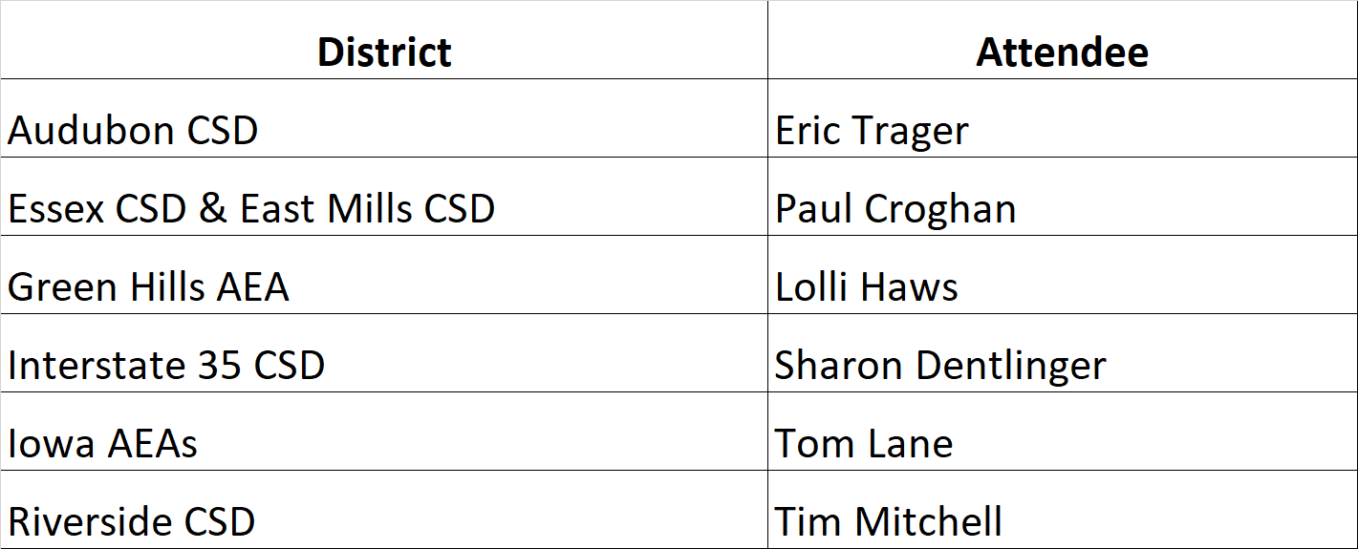
Tim Mitchell, Riverside CSD, convened the meeting at 4:05 pm. Paul Croghan connected via conference call at 4:15.
- Approval of Agenda: Tim Mitchell, Superintendent, Riverside, moved approval of the agenda.
Sharon Dentlinger, Superintendent I-35, seconded. Vote: approved unanimously.
- Election of RSAI District SW Representative to the Leadership Group. Thanks to Paul Croghan for serving as SW region representative for the current expiring term. Terms are specified in bylaws. Ongoing office is a 3-year term. (RSAI Leadership Group meets virtually each month for approx. an hour, has responsibilities at the RSAI Annual Meeting in October, sets up date and location for this regional meeting and assists with staffing trade show booths at ISFIS and IASB conferences.)
  - Nominations:
Paul Croghan, Essex CSD & East Mills CSD, was nominated by Tim Mitchell, Riverside CSD. Eric Trager, Audubon CSD, seconded the nomination. There were no other nominations.
  - Election: The vote was unanimously approved.
- Election of RSAI District Liaison representing District SW to the RSAI Legislative Group (Annual Election). Thanks to Tim Mitchell, Riverside Supt., for serving in 2017-18! Rep. attends Legislative Group meeting in Des Moines at ISFIS, Aug. 9, 2019, and supports legislative advocacy during the 2020 Session.
Nominations: Tim Mitchell, Riverside CSD, was reappointed by unanimous consent.

- Consideration of Proposed Amendments to RSAI Bylaws if any (Requires 2/3 majority) none were proposed
- Review of the 2019 Legislative Session and Data Supporting Key Issues Critical to RSAI member districts: Margaret Buckton, ISFIS, reviewed the legislative action of the 2019 Session on RSAI priorities from pages 4-5 of the RSAI Legislative Digest and answered questions about RSAI Priorities and other legislative action.
- Establish RSAI District legislative priorities for the upcoming Iowa Legislative Session to forward to the RSAI Legislative Group
- Remove State Penny from the list
- Keep transportation and formula equity on the list, but emphasis formula equity.
- Teacher shortage and quality instruction: Relationship to low SSA need to be strengthened. Need data on the gap in teacher pay with similar professions in private sector or with general income growth in Iowa. This pressure will continue. Need to grow your own including para’s. Consider how to support Iowa Learning Online going forward.
- SSA: continue as a priority. Use business language – need to invest, consider a specific percentage ask or they will always go low.
- Student MH is a priority. Work on SSB 1240 telehealth. Concerned about access. The $2 million to AEA for training and the clearinghouse of resources is not a one-time expenditure – must continue.
- Sharing Incentives and Efficiencies: Expand operational sharing incentives cap so districts that are maxed can add a social worker.
- Not sure about school safety and whether that needs to continue.
- Funding for at-risk students – poverty/low income is not sufficiently funded in the formula and the cap (2.5%-5.0%) is arbitrary.
- Continue Quality Preschool.
- Any other business Discussed the Formula – should Iowa consider a three-year averaging on declining enrollment with the next formula review?
- Adjourn:
Paul Croghan motioned for adjournment,
Eric Trager, superintendent Audubon, seconded.
Vote: unanimous vote to adjourn 5:30 p.m.
Save the date: 2019 RSAI Annual Meeting
Oct. 16, 2019 4:30-7:30PM (includes working dinner)
FFA Enrichment Center (DMACC Campus)
1055 SW Prairie Trail Parkway, Ankeny, Iowa 50023
Conduct annual business, set Legislative Priorities, and plan for successful advocacy

