1,1, 5778 - Aviv 1, 2018

3/19/2018 The Anointed Prince and the Flying Tav

The information that is presented in these articles is mostly history and timelines that are referenced to astronomical events. These are not prophetic guesses or "made up" hypotheses, but facts that anyone can find by just looking at the reference data. What is found usually doesn't agree with current religious beliefs, but, none the less, it is factual, even if it doesn't seem to fit popular beliefs. It is what it is. I usually don't know what the information means, if anything, but there seems to be a coherence to it.

All I know is that our Creator Elohim have structured their creation to point out certain people and things to us at this particular time in history.

What I believe is that, if it was important for our heavenly Father to purposely structure His creation in this way, there must have been a purpose, and I would think it would have to have been an important purpose for some reason, even if I don't understand why He did things the way He did.

YaHuWaH Elohim usually times events from the time a decree is given, not when the actual physical endeavor is undertaken to fulfill the event.

We know that prophecy can have multiple fulfillments. History repeats itself, according to the book of Ecclesiastes, and there's nothing new under the sun.

We also believe that there are spiritual decoys that will attempt to deceive us in the latter days.

YaHuWaH Elohim will point out the truth to His chosen ones, while others who are hostile to Him will be deceived and destroyed.

In the graphics below is some of the information that YaHuWaH Elohim has revealed to me during the past several years, with some revealed in just in the last few days. I don't know what it all means, but it is presented so that you might be aware that it exists, and perhaps be able to discern something from it as we travel through time and history.

On 4/1/1969 a decree was given by the Israeli Knesset to rebuild Jerusalem. There is a prophecy in the book of Daniel that relates the timing of a coming anointed Prince with a decree to rebuild Jerusalem.

Daniel 9:25 Know therefore and understand, that from the going forth of the commandment to restore and to build Jerusalem unto the Anointed Prince shall be seven weeks (sevens), and threescore and two weeks (sevens): the street shall be built again, and the wall, even in troublous times.
26 And after threescore and two weeks shall the Anointed be cut off, but not for himself: and the people of the prince that shall come shall destroy the city and the sanctuary; and the end thereof shall be with a flood, and unto the end of the war desolations are determined.

The Decree of 4/1/1969

Below is a graphic showing a relationship between the decree to rebuild Jerusalem given on 4/1/1969 and the Feast of Shavuot (Pentecost) on 6/92019. There are 7 sevens of years from 4/1/1969 to 4/1/2018. And there are 62 literal weeks from 4/1/2018 to 6/92019. This timing relationship fits the description given in Daniel 9:25 of 7 shabua and 62 shabua.

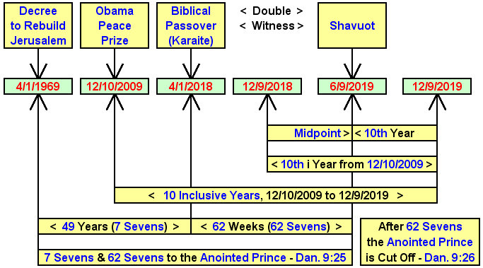

Note in the graphic above that the midpoint of the 10th year from Barack Obama receiving the Nobel Peace Prize in Norway on 12/10/2009 is 6/9/2019, the Feast of Shavuot (Pentecost).

Alarm bells should be ringing because YaHuWaH 's Feast days are those special days that He Himself has reserved for His own purposes. I know the information above doesn't fit with the popular end of the age theology, but there it is, and it's factual.

The Flying Tav

On 1/6/2010 a strange object was discovered in the heavens. Astronomers had never before seen anything like it, and one prominent astronomer said "What is it?". It was designated as Comet P2010 A/2 but years later renamed asteroid 354P.

The alleged "comet" appeared to be a flying "X" in the heavens. An "X" mark is a Paleo Hebrew Tav, literally an "end mark", and the last letter in the ancient Paleo Hebrew alphabet.

On 12/10/2016, exactly 7 years to the day from Barack Obama receiving the globally prominent Nobel Peace Prize in Norway on 12/10/2009, the flying end mark appeared to abruptly change direction in the heavens as depicted in the graphic below.

Below: The flying Tav pointed to the constellation Leo, symbolic of the Lion of Judah, YaHuShua, Israel's true coming Messiah, exactly 7 years to the day after Barack Obama received the Nobel Peace Prize. The red line in the graphic below shows the comet's path.
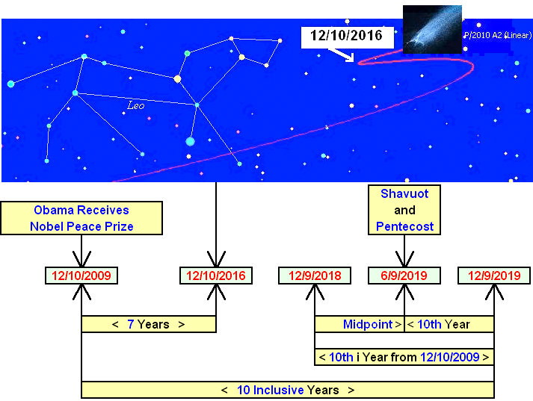

In the bible the number 7 (and multiples thereof) denotes completion, and the number 10 (and multiples thereof) denotes perfect completion.

Note in the graphic above that the central chiastic emphasized event date is 6/9/2019, YaHuWaH Elohim's Feast of Shavuot.

The Pope, North Korea, and the Flying Tav

Below is a graphic that shows an interesting relationship between the date that comet P2010 A2 was discovered and the date of the resignation of Pope Benedict.

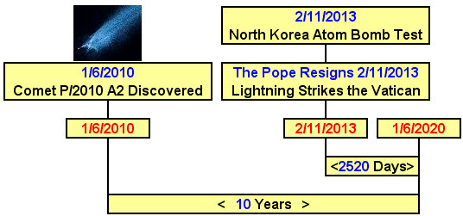

Note that the quantity "2520" was encoded into the "handwriting on the wall" event on October 11, 539 BC that spelled the doom of the ancient national superpower, the Kingdom of Babylon.

Summary

The information above is provided by YaHuWaH Elohim to you for your instruction, benefit, and perhaps consternation.

YaHuWaH Elohim is the naturally supernatural Author who writes in the heavens and in the lives of individuals.

I give Him all the glory and thanks for the revelation of this, and other information, that shows to us a microscopic fraction of His many marvelous and mighty works.

