You Are Invited to a Snow Angel Making Party by Susan Cressy
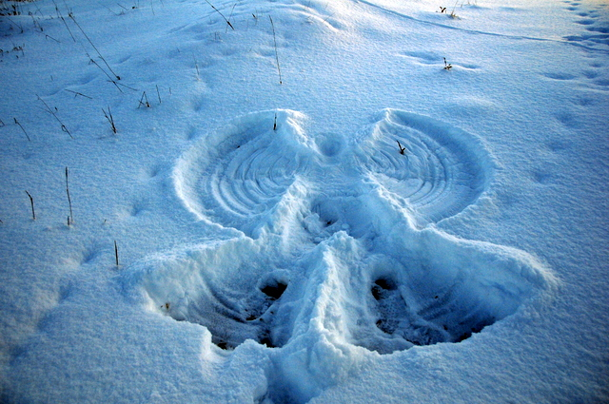
What is Free, Fun, Frosty and Fabulous?? The 5th Annual Snow Angel Making Party at Highlands Gate, 4381 Wolf Grove Road, Lanark Highlands, Sunday February 15, 2015 from 1:00 - 4:00 pm. If you haven't made a snow angel in a while, this is your chance to join with others in the art of making a winter impression! The act of making a snow angel produces an inexplicable sense of joy, relaxation and contentment, making more than one angel multiplies the feeling, and when a whole group of people are making snow angels together, the collective energy is simply wonderful! The invitation is open to everyone and anyone so bring your friends and family. There is a play structure with a curly slide, horses to feed carrots to, sliding hills and 85 acres of fields and forest to snow shoe and cross country ski. There will be a campfire with hot cider and good cheer and you are welcome to bring something to cook over the fire or a treat to share. Dress for the weather and wear a coat with a hood so you don't get snow down your neck when you are flailing in the snow. Everyone is welcome so spread the word and we will see if we can fill the field with angels.
From Almonte, continue on Almonte Street, through the lights at the ESSO station, it turns in the Wolf Grove Road, drive 20 kms through the flashing yellow light in Middleville and then look for the 2nd laneway on your left after the flashing light in Middleville.

