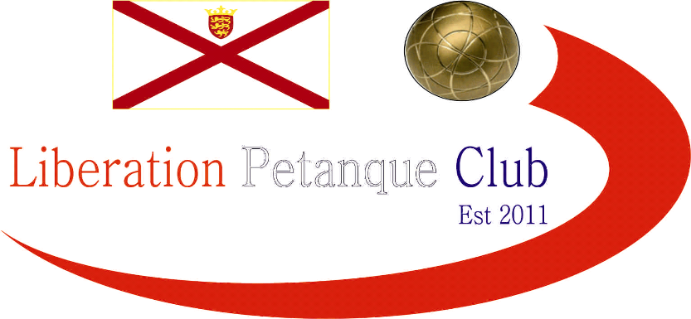



Winter 2016-2017 Season

Week 5

3rd December 2016

Christmas Doubles Open

In Aid of

Jersey Childrens Charity


Sponsored By Sponsored By

Liberations 2nd Charity tournament of the year played this time at Millbrook Park with the Winter weather easing up for a beautiful sunny day. 15 teams took park playing in groups of 5 and therefore 4 matches each.

Organiser Callum with regular doubles partner Andrew and favourites to win the competition lost 3 out of the 4 matches in the first half of the day.

Brian Harris & Paul Le Moine were one of three teams to win all four matches including handing out a fanny certificate to Chris & Jake Romeril 13 – 0 one of Jersey’s top doubles teams!

Ross Payne playing with Mike Fennel also won all four, which included a 13 – 4 win over Stephen Leathem & Matthew Scholefield to win the group. Stephen & Matthew had earlier handed out a certificate to Andy & Lorna Limbrick 13 – 0. Matt Pinel & Richard Nevitt won Group A also with four wins.

Teams were then split into the main and the plate competition.

The plate saw a midday recovery for Callum & Andrew who beat Andy & Lorna Limbrick 13 – 10 in the final.

The main competition saw Brian & Paul, Ross & Mike, Matt & Richard and James & Geoffroy move through to the semi finals.

Semi Finals

Ross & Mike 9 v 13 Matt & Richard

Brian & Paul 5 v 13 James & Geoffroy

3rd Place went to Brian and Paul beat Ross & Mike 13 – 3.

The final was a close affair but yet again Geoffroy was on the losing team in a final as missed chances by James & Geoffroy saw Matt Pinel & Richard Nevitt win the competition 13 – 11.

Well Done to everyone taking part raising money for a great charity Jersey Childrens Charity.

NEXT WEEK

Singles League - Premier League - 10.00am
- Division 1 - 11.00am

WEBSITE www.liberationpetanque.co.uk
EMAIL liberationpc@gmail.com

Kind Regards
Report Editor
Liberation Petanque Club

CLUB SPONSORED BY

