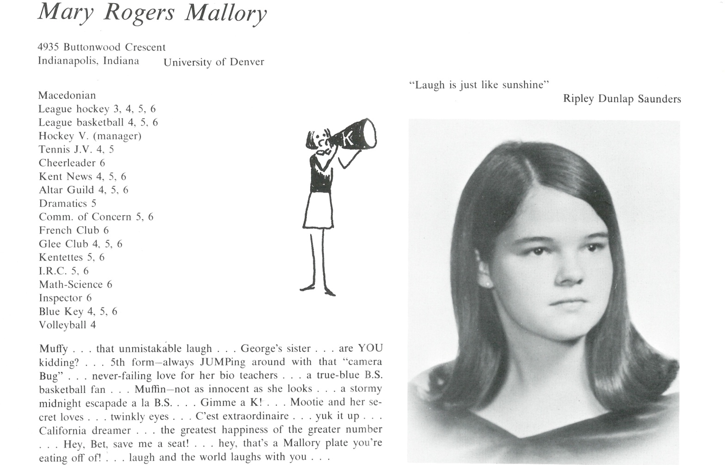

Mary “Muffy” R. Mallory

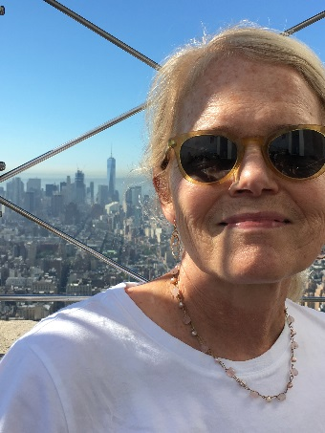I am now living in Orinda California.

Retired.

Because I have been the class secretary for many years, my life has kind of been an open book.

After Kent, I attended and graduated from the University of Denver having majored in Political Science. I moved to Washington, DC, hoping to somehow get involved in politics. Not a great idea: Richard Nixon, Vietnam War, no jobs! From DC, I volunteered for New York Mayor John Lindsay’s presidential campaign and worked in Florida and Wisconsin. It didn’t last long but it was one of the most fun times of my life. I managed to make connections that allowed me to move to and get a job in New York. I worked in his Press Office, which was so much fun. Many notables visited the Mayor and I got to hang out around them like the groupie that I was. I went to Paralegal School and in 1974 embarked on a paralegal career that basically carried me through to retirement from the Criminal Section in Economic Fraud of the US Attorney’s Office in San Francisco in October 2015. I worked in law firms in NYC, Chicago and finally, San Francisco, a city I have loved since my childhood. I was very lucky to land here.

I have had some interesting experiences, including working at a law firm that was targeted by a disgruntled client who shot 8 people, most of whom were at our firm. It inspired a lifelong passion to try to regulate firearms and to keep assault rifles off the streets and guns out of the hands of those who should never own one.

While in SF, I got married, had a wonderful boy, George, who is 27 and a burgeoning musician and got divorced. For over 5 years now, I have volunteered at the East Bay SPCA as a canine companion. I have increased my hours since retirement and it has brought me more joy than I had thought possible. While I have lived in the Bay Area for over 30 years, I am still an East Coast girl at heart. I am glad that I have so many friends to visit, including my sister and many Kent friends. I don’t miss Kent but I do miss the people. I still think of how lucky we were to have each other.

P.S. I am still a fan of the 66 basketball team and the dreamy Coach Wood!



______________________________________________________________

______________________________________________________________ ______________________________________________________________ ______________________________________________________________ ______________________________________________________________ ______________________________________________________________ ______________________________________________________________ ______________________________________________________________ ______________________________________________________________

Attach Picture in .jpg Format

______________________________________________________________

______________________________________________________________

___________________________________________________________________________________ _________________________________________________________________________________________________________________________________________________________________________________________________________________________________________________________________________________________________________________________________________________________________________________________________________________________________________________________________________________________________________________________________________________________________________________________________________________________________________________________________________________________________________________________________________________________________________________________________________________________________________________________________________________________________________________________________________________________________________________________________________________________________________________________________________________________________________________________________________________________________________________________________________________________________________________________________________________________________________________________________________________________________________________________________________________________________________________________________________________________________________________________________________________________________________________________________________________________________________

___________________________________________________________________________________