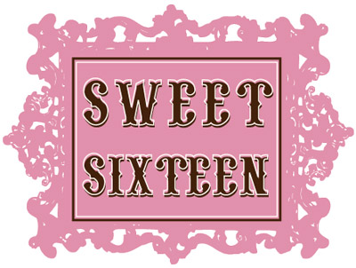

Cotton Candy Cocktails

Tacos
Sliders
Mac & Cheese
Grandma Pizza
Pigs in a Blanket
Chicken Fingers & Fries
Mini Grilled Cheese Sammies

Ice Cream Sunday Bar
