PRICE | Per Day | Extra Day | Weekly
CHAIRS
Brown Folding Plastic | 1.40 | .70 | 4.20
Brown Folding quantity over 250 discounted 10%
White Folding Plastic or Fanback Style | 2.20 | 1.10 | 6.60
White Folding Garden | 3.50 | 1.75 | 10.50
Grey Padded Arm | 2.00 | 1.00 | 6.00
Bistro (White Resin) | 2.30 | 1.15 | 6.90
Grey Padded | 2.75 | 1.38 | 8.25
Director - wood | 5.00 | 2.50 | 15.00
Bar Stool (with back) | 5.00 | 2.50 | 15.00
Chair Covers |  |  | 2.00
TABLES
8’ x 30” Banquet | 8.00 | 4.00 | 24.00
8’ x 18” Lecture | 8.00 | 4.00 | 24.00
8’ quantity over 100 | 7.50 | 3.75 | 22.50
6’ x 30” Banquet | 7.50 | 3.75 | 20.70
6’ x 18” Lecture | 7.50 | 3.75 | 20.70
4’ x 30” Banquet | 6.35 | 3.18 | 19.15
4’ x 18” Lecture | 6.35 | 3.18 | 19.15
5’ Round – 60” | 9.40 | 4.70 | 28.25
4’ Round – 48” | 7.80 | 3.90 | 23.40
30” Round | 6.95 | 3.48 | 20.85
44” White Patio | 8.40 | 4.20 | 25.20
42” High Bar | 9.75 | 4.88 | 29.25
Bridge / Card | 5.75 | 2.85 | 17.25
TABLE LINEN
One time charge More sizes avail. upon request
Black Spandex Cover 42” & 30” high tables |  |  |  | 8.00
90” x 90” |  |  |  | 7.25
54” x 120” (fits 6’ and 8’) |  |  |  | 8.00
108” Round |  |  |  | 11.50
120” Round |  |  |  | 12.50
18” x 18” Napkins |  |  |  | .48
TABLE PLASTIC
White Plastic has a Linen Finish One time charge
36” x 120” (fits 8’) |  |  | 6.00
36” x 96” (fits 6’) |  |  | 5.00
54” x 60” (fits Card) white or black |  |  | 4.50
54”x120” (fits 8’) white or black |  |  | 7.30
54”x96” (fits 6’) white or black |  |  | 6.20
68”x68” (fits 5’ round) white 7.85

PRICE | Per Day | Extra Day |  |  | Weekly
AUDIO VIDEO EQUIPMENT
Metal Truss Lecturn | 100.00 | 50.00 |  |  | 300.00
20” combo | 55.00 | 27.00 |  |  | 165.00
DVD Player | 25.00 | 12.50 |  |  | 75.00
20” Flatscreen | 50.00 | 25.00 |  |  | 150.00
27” Flatscreen Television 100.00 50.00 200.00
42” Flatscreen Television 225.00 112.50 450.00
17” ComputerMonitor | 50.00 | 25.00 |  |  | 150.00
19” Computer | 75.00 | 37.50 |  |  | 225.00
27” Computer | 100.00 | 50.00 |  |  | 300.00
LCD Video Projector | 200.00 | 100.00 |  |  | 600.00
Overhead Projector | 30.00 | 15.00 |  |  | 90.00
Video Cart | 20.00 | 10.00 |  |  | 60.00
Video Screen-72”x72” | 35.00 | 17.50 |  |  | 105.00
P.A. Systems
50+ 2 powered speakers, mic, mixer  Up to 50 people  powered speaker, mic | 225.00  120.00 | 112.50  60.00
DRAPE, SKIRTING & CARPET
Per linear foot Drape |  |  | 1-3 Days
12’ High (limited colours) |  |  |  | 5.50
10’ High (limited colours) |  |  |  | 4.40
8’ High |  |  |  | 2.75
5’ High (limited colours) |  |  |  | 2.50
3’ High |  |  |  | 1.90
Table Skirting
40” high |  |  |  | 2.05
28” high |  |  |  | 1.55
Catering
Wine Glasses per day
6.5 oz 4.85 dz.
8.5 oz Capri 4.85 dz.
15 oz Stemless/Water glasses 4.85 dz.
Beer Glasses
12.5 oz 4.85 dz.
14 oz 4.85 dz.
Pitchers
60 oz clear plastic 2.25 ea.
3L Stainless Steel 2.75 ea.
Misc.
Punch Bowl-chrome w/ 12 glasses 9.00

PRICE | 1-3 Days |  | Weekly
STAGING
16” high (black top)
4’ x 4’ – 24 units available |  | 30.00 | 90.00
Steps |  | 8.50 | 17.00
32” high (black top)
4’ x 4’ – 24 units available |  | 30.00 | 90.00
Steps |  | 17.50 | 35.00
Stage Skirting – per foot
16” |  | 1.30 | 2.50
28” |  | 1.55 | 3.00
TENTS
Additional Delivery Fees (includes set-up) |  |  | Per Day
10’ x 10’ |  |  | 130.00
10’ x 20’ |  |  | 250.00
20’ x 20’ |  |  | 325.00
20’ x 30’ |  |  | 425.00
20’ x 40’ |  |  | 500.00
30’ x 30’ |  |  | 700.00
40’ x 40’ |  |  | 900.00
30’ x 60’ |  |  | 1300.00
40’ x 60’ |  |  | 1700.00
Water barrels |  |  | 7.50
30’ Side Walls |  |  | 25.00
50% non-refundable deposit required for tent rentals upon booking
Tents bigger than 20’x30’ require a permit
PORTABLE DANCE FLOOR
Each unit is 1’ x 1’ Black Marble like finish
14’ x 14’ (2 – styles available) |  |  |  | 323.40
Per square foot per day up to 14’ x 14’ |  |  |  | 1.65
OUTDOOR USE MUST HAVE WOOD SUBFLOOR
STANCHION / SIGN
32” Chrome Trumpet base |  |  | Per Day  6.50
Rope - 6’ or 10’ (Burgundy Velour) |  |  | 6.50
Sign Stand (22” x 28”) |  |  | 12.00

Price
Per Day
DECORATING ACCESSORIES
Archway (White/Gold) | 45.00
Artificial Trees 4’ or 6’ – Live 2’-3’ | 14.00
Benches | 40.00
Bird Cage (White / Gold) | 45.00
Chair – Wing Back (Dusty Rose) | 50.00
Coat Rack 5’ (fits 25 coats) | 9.25
Coat Hangers | .05
Coat Tree | 5.50
Coffee & End Table set (Wood & Chrome) | 45.00
Mirror (48” x 12” floor/ silver easel style) | 15.00
Picket Fence (8’ section – White) | 16.00
Theme Props, Decorations & Costumes (call for quote)
PARTY ACCESSORIES
Popcorn Machine | 65.00
Popcorn & Bags (serves 10) | 2.65
Chafing Dish (Sterno $2.50 extra) | 12.00
Coffee Percolator (40 Cup capacity) | 10.00
Coffee Percolator (100 Cup capacity) | 15.00
Small Round Refreshment Tub 19”x10”d | 10.00
FUN FAIR
Prize Wheel or Crown & Archor | 25.00
Games  Ball Toss, Ring Toss, Bean Bag Toss, Basketball, Darts, Golf, Tic Tack Toe | 20.00
Game Booth (Colourful Drapery) | 30.00
White Picket Fence 8’ Sections | 16.00
MISCELLANEOUS
Draw Drum – Small | 20.00
Draw Drum – Large | 25.00
Easel | 12.00
Flipchart | 12.00
Garbage container (40 gallon) | 8.00
Scissors (32” Ceremonial) | 10.00
Couches Black leather/Grey fabric Sec. | 90.00
Brown Patent Club Chairs 30” 45.00
Office Steno Chairs | 12.50
Executive Office Chairs | 25.00
4’ x 3’ Poster Panels (HP or VP) – 1-3 day | 16.50
6’ Pole with foot | 16.50
SHOW SERVICES
DRAPERY
Trade shows, booths, stages, dividers, open houses, etc. Call for quote
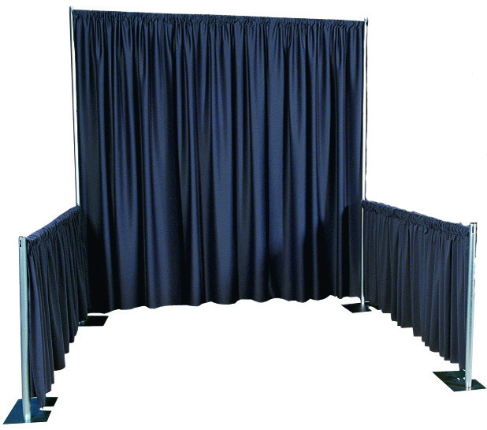
SKIRTED TABLES
All table sizes – 3 sides skirted & plastic tablecloth
44.00 per 1-3 days Qty. Discount

CARPET 1-3 Day use
4’ Runner (Red/Black) 2.00 running ft
6’ wide aisle - 1.55 per running ft
Large area over 50’ x 20’ 0.50 sq ft
Booth carpeting – call for quote
Installation extra
DISPLAY SYSTEMS 1-3 day use
Octanorm / Folding Stackable / Table Top
Custom Booth Design & Set-up
Call for quote

DISHWARE
10" Pearl White Dinner Plates $5.30 dz
8" Pearl White Salad Plates $4.20 dz
6" Pearl White Dessert Plates $4.00 dz
Pearl White Soup Bowl $4.20 dz
Pearl White Cup and Saucer Sets $5.30 dz
Cartier Dinner Fork $4.00 dz
Cartier Dessert Fork $4.00 dz
Cartier Teaspoon $4.00 dz
Cartier Butter Knife $4.00 dz

Prices subject to change without notice.
January 2018
Call or email for delivery rates

YOUR Special Event Professionals

Serving Customers for 42 years

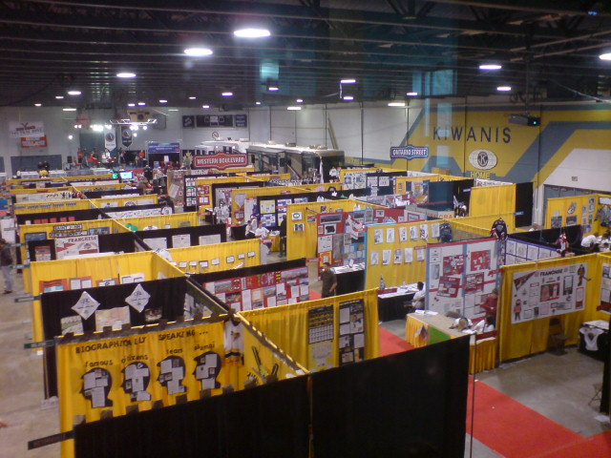

Corporate Events
Trade Shows
Displays
Tournaments
Weddings
Backyard / Indoor Parties
Fundraisers

95 Baffin Place, Waterloo, ON N2V 2C1
519-746-8955
800-563-4246
Fax
519-746-2188
info@hahnrentals.com
http://www.hahnrentals.com
Business Hours 8:30AM -5:00PM Mon-Fri

