11/28/2016 The Special Day, November 29, 2016

As I write this on 11/28/2016, Israel's IDF has struck the Islamic State in Syria for the very first time. Note that it was on this day according to the Hebrew Hillel calendar and the Septuagint in Genesis 7:11 that the floodwaters of the deep were broken up on the 27th day of the 2nd month and Noah's flood began.

November 28, 2016, also marks the completion of exactly 69 years since the United Nations partitioned the Promised Land on 11/29/1947 and gave part to Arabs and part to Jews. Although tomorrow will be known as the 69th anniversary of the UN partitioning of the Promised Land, it will actually be the very first day of the 70th year.

The number 70 is prominent in the bible. It's the fullness of the number 7 multiplied by the completeness of the number 10. The number 70 was symbolic of the total number of nations in the ancient world.

November 29, 2016, may appear to be an uneventful day, but be assured it's a special day in the eyes of our Creator Elohim. There are several astronomical events that YaHuWaH Elohim has ordained to point to that particular day, and the day after.

The Lunar Tetrads

There has been quite a bit of attention given to a rare series of lunar eclipses falling on the appointed Feast Days of YaHuWaH Elohim since they were discovered by Pastor Mark Biltz in 2008. A lunar tetrad is a series of 4 total lunar eclipses in an unbroken row. Lunar tetrads occur now and then throughout history, but rarely on the appointed Feast Days of our Creator Elohim.

We are commanded by YAHUSHUA our Messiah to watch for things that out of the ordinary so that we will know when His arrival time is approaching. If we have a general indication of His arrival time, we can prepare to meet Him by repenting of sins and taking care to walk a set apart life acceptable unto Elohim. Our Messiah has told us that world conditions will be nearly intolerable just before He arrives. Therefore we should prepare for extremely difficult times if we see certain signs that His coming is near. Please see Matthew chapter 24.

Here's a graphic showing the series of rare lunar tetrad eclipse sequences falling on YaHuWaH Elohim's appointed Feasts of Passover and Tabernacles in the over 1000 year period between 1492 AD and 2565 AD.

There is the possibility of another lunar tetrad on YaHuWaH 's Feast Days that would only be valid by the human observation of a nearly total lunar eclipse and the early ripening of the Aviv barley in the year 2109. This possible 2108-2109 lunar tetrad can be dismissed by us for now, as it can only be verified by someone living in the Spring of the year 2109.
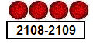

Most of us are aware that important historical events occurred in the lives of the Jewish people in conjunction with the lunar tetrad sequences above. In 1492 the Jews were expelled from Spain and their properties seized. Also in 1492 Christopher Columbus sailed for America just 5 days after the Spanish Inquisition was announced. Israel became a sovereign nation again in 1948 after losing its sovereignty 2009 years earlier in 63 BC. In 1967 Israel captured Jerusalem from Jordanian control in the Six Days War. There isn't any identifiable overt event in the lives of the Jewish people surrounding the 2014-2015 tetrad, such as outright major war, yet. But there are events associated with the 2014-2015 lunar tetrad that have great spiritual significance.

Events Associated with the 2014-2015 Lunar Tetrad Sequence

Here's a graphic indicating two major events linked with the 2014-2015 lunar tetrad:

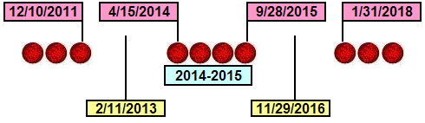

Note that Christian leaders including Jan Crouch of TBN, Paula White, and Ken and Gloria Copeland met with Donald Trump and laid hands on him and prayed for him on the 26th floor of the Trump Tower on 9/28/2015, the day of the last lunar tetrad eclipse in the graphic above.

2/11/2013

Note the midpoint date, 2/11/2013, precisely midway between the last total lunar eclipse of 12/10/2011 and the first lunar eclipse of the 2014-2015 lunar tetrad on 4/15/2014. Be aware that 2/11/2013 is the day that Pope Benedict announced his resignation and lightning struck the Vatican.

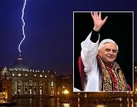

Pope Benedict was the 265th Pope. In ancient Greek culture the measure of a fish was the quantity 265 divided by 153, which was their way of calculating the cube root, the mathematic value 1.732 used to calculate the diagonal dimension of a cube. The measure of a fish is alluded to in John chapter 21 and the net containing 153 great fishes. The measure of a fish is known as the Vesica Pisces, and is the fish symbol of Christianity.

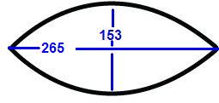
The completed Vesica Pisces and the end of Christianity.

Because Pope Benedict was the 265th Pope, he completed the "Christian" fish. The 266th Pope, Pope Francis, is "outside" the symbolic fish. Also, Pope Francis is a militant Jesuit, the very first Jesuit Pope in history.

Our Creator Elohim have pointed to this important historical event on 2/11/2013, the resignation of Pope Benedict and the completion of the Roman Catholic Vesica Pisces, using the lunar tetrad sequence of 2014-2015. We need to notice the above because it was important enough for our Creator to point to it by using His creative abilities during the creation of His Universe.

11/29/2016

Please note the second midpoint date of 11/29/2016. It's the midpoint date from the last total eclipse of the lunar tetrad on 9/28/2015 to the next total lunar eclipse on 1/31/2018. November 29, 2016, is the first day of the 70th year from the United Nations partitioning of the land promised entirely to Jacob and his descendants by YaHuWaH Elohim. The United Nations partitioned the land on November 29, 1947.

The graphic below shows total solar eclipses that are part of a sequence of solar eclipses that place an "X", a Paleo Hebrew Tav, on various regions of the earth. The Tav is the last letter in the Hebrew alphabet. The Tav has a certain meaning, it literally means "the end". In the book of Revelation our Messiah refers to Himself as the Alpha and Omega, the beginning and the end. In the Hebrew alphabet, the alpha is the Aleph and the Omega is the Tav. Our Messiah identified Himself as the Aleph and the Tav, the first and last letters of the Hebrew alphabet.

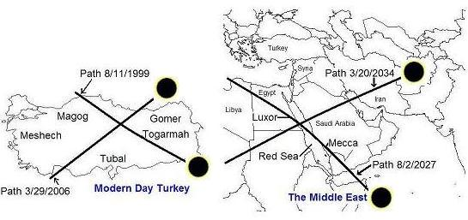
These solar eclipse Tavs were placed on Islamic portions of the earth by our Creator Elohim. The center date of these Tavs, from the first total solar eclipse on 8/11/1999 to the last solar eclipse on 3/20/2034, is 11/29/2016.

Note that the date, November 29, 2016, is pointed to by both lunar eclipses and solar eclipses.

The Strange Tav Comet

There was a strange "X" shaped comet that was discovered on 1/6/2010, just 6 days before the Haiti earthquake that killed over 230,000 people. Scientists had never before seen a comet shaped like it. We need to pay attention to things that are out of the ordinary. Moshe saw a bush that burned but wasn't consumed. He stepped aside to watch the strange sight and ended up being used by YaHuWaH Elohim to save his people Israel.

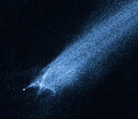
Comet P2010 A2 / LINEAR
The Strange Comet

Please note that 11/30/2016 is exactly 2520 days from 1/6/2010. 2520 days are exactly 7 prophetic years, 7 x 360 days = 2520 days.

Seven prophetic years indicate a prophetic completion on 11/30/2016, one day after 11/29/2016 and the 69th anniversary of the partitioning of the land belonging to Israel by the UN. A special Tav comet, ordained for us by our Creator Elohim, marks that prophetic completion.

Our Creator is very interested in letting His people know that He is in control of Heaven and Earth, and everything involved. Very few people will know of these events that have occurred, and will occur, in the heaven and on the earth pointing to 2/11/2013 and 11/29/2016.

Only our Creator Elohim can determine the orbital mechanics of the earth and moon and use heavenly bodies themselves to relay messages to us that no man or devil can change in order to try to deceive us. The events mentioned above help us to know that there is indeed a Creator Elohim who has powers and abilities beyond human understanding to precisely order the courses of planets, moons, comets, and stars, and also the affairs of nations.

Further Info Concerning the Strange Tav Comet

On December 10, 2016, comet P2010 A2 mentioned above will appear to sharply reverse course as it approaches and points to the constellation of Leo. The constellation Leo is symbolic of the Lion of Judah, our Messiah YAHUSHUA.

Here's a graphic showing the path of the strange "X" comet:

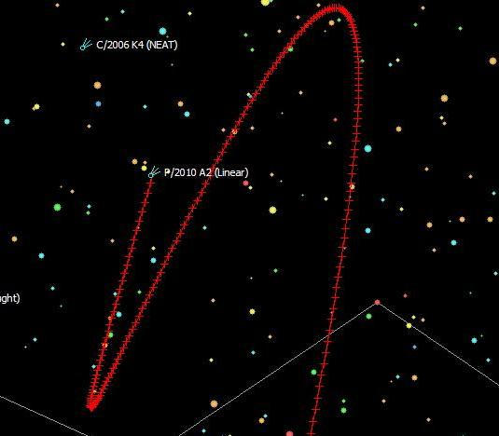

Below is a graphic that shows the date of the sharp pointed reversal:

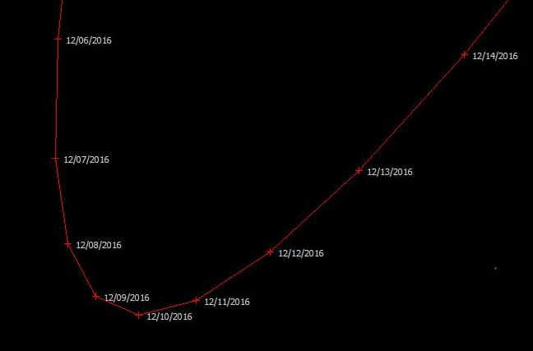

The strange "X" comet appears to reverse direction above on 12/10/2016, precisely 7 years to the day after President Obama received the Nobel Peace Prize in Norway on 12/10/2009. President Obama received the Nobel Peace Prize just hours after a strange whirling light (below) appeared in the sky over Norway:


An errant missile caused this strange whirling omen in the sky over Norway hours before President Obama received the Nobel Peace Prize on 12/10/2009 in Norway.

President Obama is a marked man.

Timeline Graphic

Here's a graphic of 50 and 70 year timelines for the nation of Israel:
