l

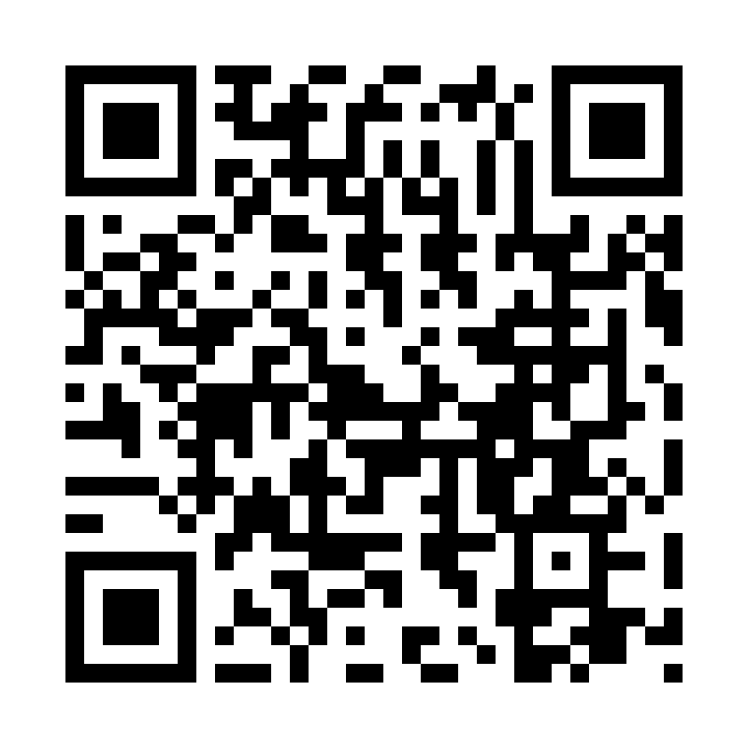

Catholic Church *cluster* of Davenport

St. Francis of Assisi – Harrington

Immaculate Conception Catholic Church – Davenport

St. Michael Catholic Church – Reardan

St. Kateri Tekawitha Catholic Church – Ford

Sacred Heart Catholic Church – Wellpinit

***Mailing Address***: Immaculate Conception Catholic Church - Davenport

1310 Adams St., Davenport, WA 99122-9454

(509)725-1761

***Office manager***: Jackie – [icdavenport@dioceseofspokane.org](mailto:icdavenport@dioceseofspokane.org)

Immaculateconceptiondavenport.org

Any information for the bulletin needs to be to Jackie

***Pastor*** – Fr. Brain Sattler

Sacramental requests:Call Fr. Brian 503-989-7585

**The Holy Sacrifice of the Mass**

**Daily** Tues. Davenport at 9am and 5:30pm, Wed. & Fri. Davenport 9am, Reardan Thurs. 9am.

**Saturday**  Harrington mass at 5:30pm **Sunday** Rosary at 8am in Davenport

Davenport at 8:30am**,** Reardan at 10:30am, Ford 12:30pm (1st-2nd-3rd Sunday in Ford) (4th Sunday in Wellpinit)

**Confessions** – half hour before Sunday mass.

**Tuesday** 9 am mass and 5:30 pm mass, adoration to follow.

**15th Sunday in Ordinary Time**

*BIG welcome to Fr Brian Sadler on his new assignment to our cluster of parishes!

We will have coffee and goodies after mass July 13 to welcome him. Please bring what you can and say Hi to Fr Brian Sadler!

Kathy Woods made a signature quilt for Fr Sean. Called “Thank you for being a friend” from Davenport cluster. We want **all** to sign it, so it will be making rounds. We would like to present it to him at a mass as some point, looking like late August.

**Get a hold of Jackie if you still need to sign the quilt, if you missed it at your parish!**

**Mass Intentions:** July 12 Sat. 5:30pm in Harrington July 13 Sun. (8:30am) Pro Populo (10:30am) For vocations to the priesthood (12:30pm) private intention July 15 Tues. 9am and 5:30pm July 16 Wed. 9am July 17 Thurs. 9am July 18 Fri. 9am