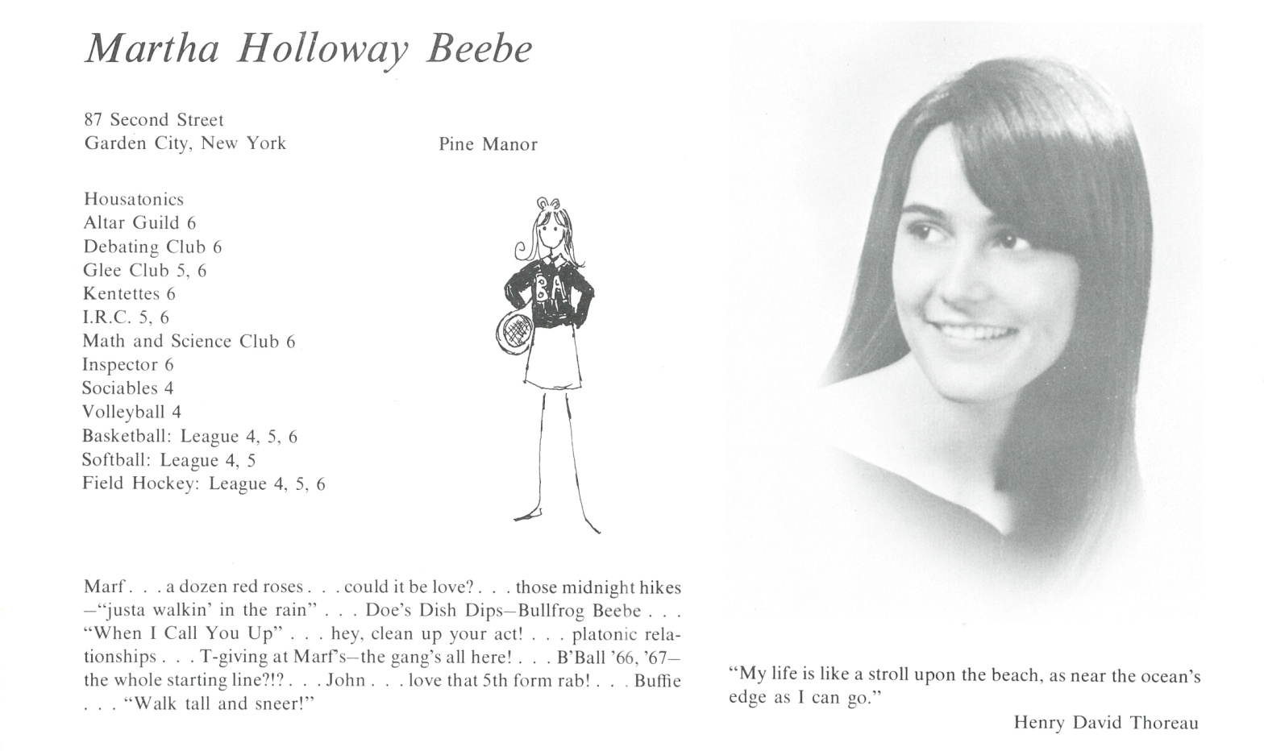

Martha Beebe Knowles

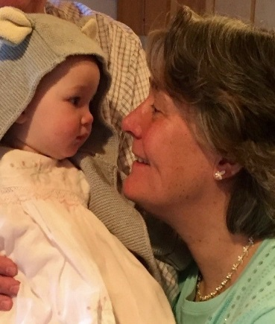

Marf married Kek Knowles in 1975 and moved to Rye, New York where we are still living. We have two children, William (Kent ‘98) and Eliza Knowles Park and are lucky enough to currently have three grandchildren: Will, Sam and Eleanor.

I am still working full-time for a family office in Rye and hope one day to retire and spend more time in the family home in Lake Placid and with our wonderful children and grandchildren and two grand dogs.



______________________________________________________________

______________________________________________________________ ______________________________________________________________ ______________________________________________________________ ______________________________________________________________ ______________________________________________________________ ______________________________________________________________ ______________________________________________________________ ______________________________________________________________

Attach Picture in .jpg Format

______________________________________________________________

______________________________________________________________

___________________________________________________________________________________ _________________________________________________________________________________________________________________________________________________________________________________________________________________________________________________________________________________________________________________________________________________________________________________________________________________________________________________________________________________________________________________________________________________________________________________________________________________________________________________________________________________________________________________________________________________________________________________________________________________________________________________________________________________________________________________________________________________________________________________________________________________________________________________________________________________________________________________________________________________________________________________________________________________________________________________________________________________________________________________________________________________________________________________________________________________________________________________________________________________________________________________________________________________________________________________________________________________________________________

___________________________________________________________________________________