REGULAR MEETING

MAY 15, 2025

The Regular Meeting of the Town Board of the Town of Hampton, County of Washington and the State of New York was held at the Town Hall, 2629 State Route 22A, Hampton, New York, on the 15th day of May 2025.

PRESENT: David K. O’Brien------------Supervisor

Donald Sady----------------- Councilman - absent

Tamme Taran----------------Councilwoman - absent

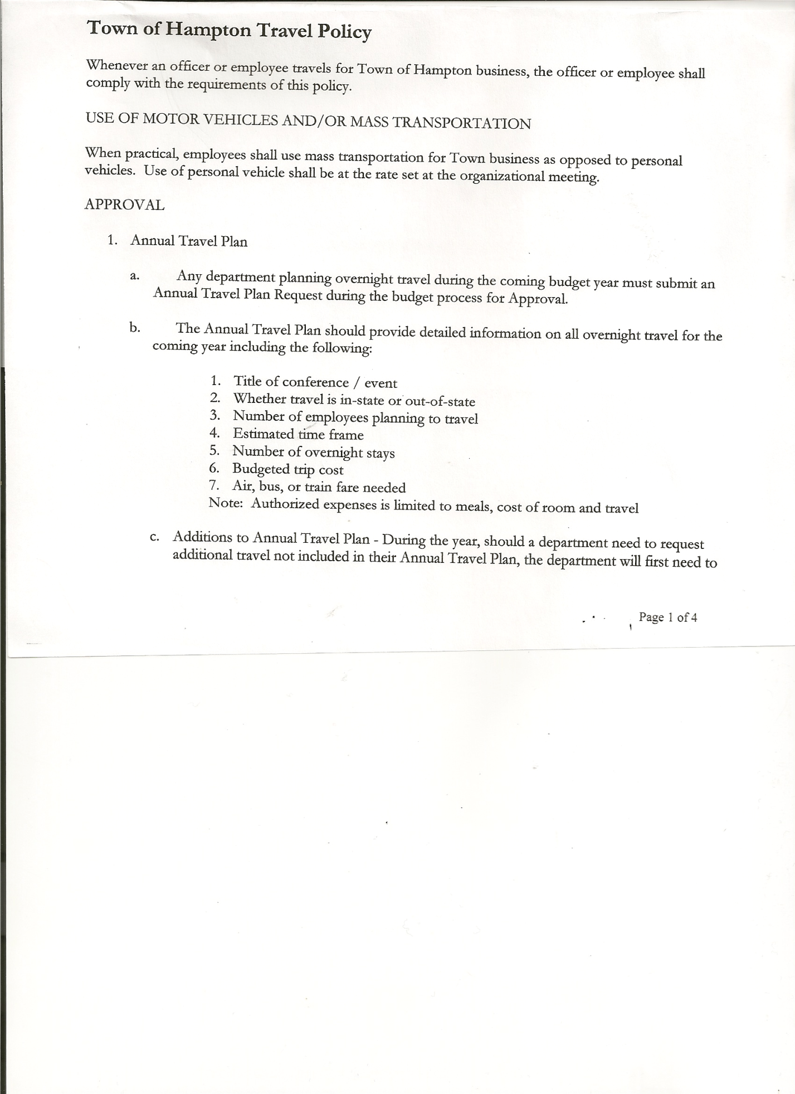 Michael Pietryka------------Councilman

Andrea Kugler---------------Councilwoman

Rebecca Jones---------------Town Clerk

Camilla Shaw----------------Deputy Town Clerk

Tyler McClure---------------Highway Superintendent - absent

Planning Board Member (s):… Bonnie Hawley, Chair, Richard Cole and Matthew Pratt

Others present at the Town Hall: EJ Conzola (NYVT Media Reporter), Artie Pratt, Leonard Reed

and retired Dr. Richard Leach and Dr. Eileen Spillane

The Regular Meeting was called to order by Supervisor O’Brien at 7:30pm, followed by the Pledge of Allegiance. Location of Fire Exits was given. Quorum of board members present.

Congratulations to Brad & Ali Mitchell, owners of the Milestone Golf Course on the birth of their baby boy Callum.

Supervisor O’Brien recognized Town Clerk, Rebecca Jones for her RMC (Registered Municipal Clerk) renewal.

Healthcare Coalition for the North Country District 21….A presentation by Dr. Spillane and Dr. Leach (retired Glens Falls Hospital infectious disease Dr.) on Medicaid and possible cuts.

Supervisor O’Brien added that the State picks up where Medicaid doesn’t pay. Following the presentation, a resolution was proposed to the Board for their consideration. Board members present will discuss at next meeting when all members are present.

**RESOLUTION NO. 48-2025**

**APPROVAL OF THE MINUTES**

On a motion of Councilman Pietryka, seconded by Councilwoman Kugler, the following resolution was ADOPTED: AYES 3 O’Brien, Pietryka, Kugler

NAYS 0

ABSENT 2 Sady, Taran

RESOLVED, the Regular Town Board Meeting Minutes for April 17, 2025 are approved.

Dog Control Officer….no report

TOWN BOARD MEETING

MAY 15, 2025 PAGE 2

Tax Collector Report….The Town Clerk/Collector had Board Members review and sign bank reconciliation statements for the Tax Collector Account dated April 30th, 2025.

Bonnie Hawley, Chair Planning Board….Planning Board Meeting was held May 14th, 2025, copy of the minutes is attached. Next meeting will be June 11th, 2025 @7:00 at the Town Hall.

Tyler McClure, Highway Superintendent…submitted his report, copy of which is attached.

Supervisor O’Brien read the report in Tyler’s absence.

**SUPERVISOR’S REPORT/COUNTY UPDATES/COMMUNICATIONS**

**RESOLUTION NO. 49-2025**

**APPROVAL OF THE SUPERVISOR’S MONTHLY REPORT**

On a motion of Councilman Pietryka, seconded by Councilwoman Kugler, the following resolution was ADOPTED: AYES 3 O’Brien, Pietryka, Kugler

NAYS 0

ABSENT 2 Sady, Taran

RESOLVED that, the Supervisor’s Monthlyreport be accepted as submitted for **APRIL.**

ACCOUNT 04/01/25 Receipts Disbursed 04/30/25

Citizens Cemetery $ 3,029.22 $ .12 $ .00 $ 3,029.34

Citizens Total $ 3,029.22 $ .12 $ .00 $ 3,029.34

GFNB Fire, Trust & Agency $ 1,000.82 $ 0.00 $  0.00 $ 1,000.82

GFNB Fire, Trust & Agency ICS $ 66,718.00 $ 0.00 $ 0.00 $ 66,718.00

GFNB Health Insurance $ 2,591.23 $ $ $ 2,591.23

GFNB Trust & Agency $ 6,337.57 $ 4,403.47 $ 7,348.02 $ 3,393.02

GFNB General Fund $ 7,834.24 $ 9,868.74 $ 13,745.62 $ 3,957.36

GFNB General Fund ICS $ 63,385.91 $ 5,463.74 $ 0.00 $ 68,849.65

GFNB Total $147,867.77 $ 19,735.95 $ 21,093.64 $146,510.08

GFNB Highway Fund $ 21,758.61 $ 25,000.00 $ 37,594.36 $ 9,164.25

GFNB Highway Fund ICS $ 353,037.65 $ 1,125.97 $ 25,000.00 $329,163.62

GFNB Capital Reserve $ 1,005.02 $ 00.00 $ 00.00 $ 1,005.02

GFNB Capital Reserve ICS $ 137,758.90 $ 472.85 $ $138,231.75

GFNB Total $ 513,560.18 $ 26,598.82 $ 62,594.36 $477,564.64

TOTALS $664,457.17 $ 46,334.89 $ 83,688.00 $627,104.06

All Board Members present signed Supervisor’s Report.

**OLD BUSINESS**

Bond….paperwork has been prepared, waiting to see when truck will be ready.

**NEW BUSINESS**

Matt Pratt representing the Fire Department spoke about “Length of Service Awards Program” (LOSAP) a financial incentive program to maintain members. Getting more information for next meeting.

NYS requiring municipalities to establish and maintain an official website with a “.gov” domain name. Supervisor O’Brien working on this.

TOWN BOARD MEETING

MAY 15, 2025 PAGE 3

Website redesign…Quote received from GoDaddy is $3,080.11 (Includes one-time build fee, unlimited website updates for the year and hosting for the year). Annual Hosting Renewal is: $275.88 starting 4/2026. Supervisor O’Brien will check for other quotes and discuss at the next meeting.

Board of Assessment Review….Mr. Rountree has resigned from the Board. Supervisor O’Brien posted the opening…four people showed interest. Following a discussion, the following resolution was introduced:

**RESOLUTION NO. 50-2025**

**BOARD OF ASSESSMENT REVIEW APPOINTMENT**

On a motion of Councilwoman Kugler, seconded by Supervisor O’Brien, the following resolution was ADOPTED: AYES 3 O’Brien, Pietryka, Kugler

NAYS 0

ABSENT 2 Sady, Taran

RESOLVED, to appoint Herb Sady to the Board of Assessment Review. Herb will attend training at the County prior to the Board of Assessment meeting on June 3rd.

**RESOLUTION NO. 51-2025**

**AUDIT OF CLAIMS**

On a motion of Councilman Pietryka, seconded by Councilwoman Kugler the following resolution was ADOPTED:

AYES 3 O’Brien, Pietryka, Kugler

NAYS 0

ABSENT 2 Sady, Taran

RESOLVED that the bills have been reviewed by the Town Board and are authorized for payment in the following amounts.

General Fund No. 51 through No. 62 $ 6,411.44

Highway Fund No. 56 through No .67 $ 16,809.04

Total both funds $ 23,220.48

The Town Clerk’s report for April 2025 was submitted to the Board. The Town Clerk had Board Members review and sign bank reconciliation statements for the Town Clerk Account and Special Town Clerk Account dated April 30th, 2025.

**RESOLUTION NO. 52-2025**

**MEETING ADJOURNED**

On a motion of Councilman Pietryka, seconded by Councilwoman Kugler the following resolution was ADOPTED:

AYES 3 O’Brien, Pietryka, Kugler

NAYS 0

ABSENT 2 Sady, Taran

RESOLVED that the meeting adjourned at 8:45pm.

Respectfully submitted,

Rebecca S. Jones, RMC

Town Clerk